Exploratory Data Analysis of U.S. Aviation Incident Data
Team 3
February 13 2026

Introduction
This exploratory data analysis (EDA) examines a large historical dataset of aviation incidents in the United States. Each record represents a single accident and its associated sequence of operational events, capturing how an incident unfolds from an initial trigger through intermediate events to a final outcome. The dataset includes temporal information (date and time of occurrence), geographic location, aircraft characteristics, environmental conditions such as visibility, and ordered event sequences describing accident progression. Aviation incidents are inherently heterogeneous and sequential in nature, varying widely in cause, severity, and operational context. Understanding the distributions, dependencies, and structural properties of this data is therefore a necessary prerequisite to any predictive or modeling effort. In particular, the presence of rare but high-severity outcomes, long-tailed event categories, and multi-step event sequences poses challenges for standard machine learning approaches that assume independent, identically distributed observations. The goal of this EDA is to characterize when and where aviation incidents occur, identify dominant aircraft manufacturers and event types, examine temporal and geographic patterns, and assess class imbalance in accident outcome severity alongside event-sequence complexity. We additionally explore how early-stage events condition downstream severity outcomes. The insights obtained from this analysis inform feature engineering decisions, model selection, and evaluation strategies in subsequent modeling work.

Dataset Overview and Preprocessing
The dataset was constructed by merging multiple relational tables from the NTSB database, including accident-level metadata (events), ordered operational event sequences (Events_Sequence), aircraft characteristics, and associated lookup tables. The primary accident table contains approximately 30,000 records with over 70 variables spanning numeric, categorical, and timestamp-based fields. The final event-level dataset contains 55,115 rows and 87 columns, representing 23,950 unique aviation incidents. Numeric fields include time, year, month, airport distance, elevation, wind direction, and injury counts, while categorical variables capture aircraft manufacturer, weather classification, visibility category, and event descriptions. Several administrative metadata fields (e.g., NTSB notification and docket variables) are entirely missing (100% missingness), and no duplicate rows were detected after preprocessing. Prior to analysis, event sequences were sorted chronologically by accident identifier, aircraft key, and occurrence number. Records with missing severity labels were removed, and severity was restricted to four valid classes: NONE, MINR, SERS, and FATL. Timestamp reconstruction was performed using event date and time fields where available; however, approximately 15% of records lacked complete temporal information. After reconstruction, all incidents exhibited zero measurable elapsed time across their sequences, indicating insufficient temporal resolution to model event spacing. Consequently, event order is treated as ordinal rather than continuous time in subsequent sequence analyses.

Summary Statistics
Descriptive statistics for key numeric fields reveal substantial dispersion:
- Event time ranges from 0000 to 2359 with a mean of 1550.
- Event year spans 2008–2026.
- Airport distance exhibits a highly skewed distribution with extreme outliers.
- Injury totals are heavily right-skewed, with most accidents involving zero or very few injuries.
Geographic latitude and longitude fields contain extreme values, suggesting potential encoding irregularities that require validation before spatial modeling.

Weather Condition and Severity
Figure 1 shows the joint distribution of weather condition category and injury severity. Most incidents occur under Visual Meteorological Conditions (VMC), reflecting the predominance of general aviation operations in clear-weather settings. However, Instrument Meteorological Conditions (IMC) incidents exhibit a disproportionately higher share of fatal outcomes relative to their total frequency. This indicates that although IMC incidents are less common overall, they carry elevated severity risk. Weather therefore interacts nonlinearly with outcome severity and should be treated as a structured categorical feature rather than collapsed into a binary variable.
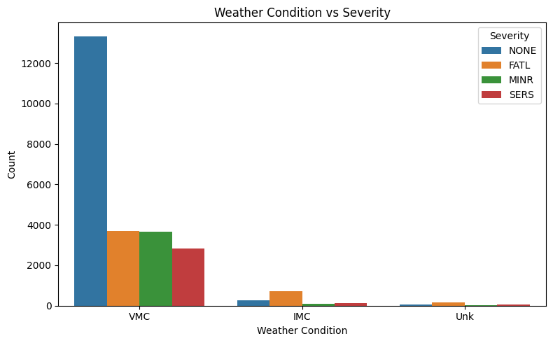
Joint distribution of weather condition and injury severity. IMC incidents exhibit a relatively higher proportion of fatal outcomes.

Temporal Distribution of Incidents
Figure 2 illustrates the temporal structure of aviation incidents across both seasonal and diurnal dimensions. The left panel shows the total number of recorded incidents by month, revealing a pronounced seasonal pattern. Incident frequency increases steadily from winter into spring, peaks during the summer months, and then declines toward the end of the year. This trend is consistent with higher flight volume and increased operational exposure during warmer months. The right panel displays the probability density of events by hour of day, demonstrating that incidents are not uniformly distributed throughout the day. Instead, events are concentrated during daytime and early evening hours, with a clear peak in the late afternoon to early evening period.
Taken together, these results indicate strong temporal dependencies in incident occurrence that are driven largely by exposure rather than intrinsic risk. If this distinction is ignored, temporal variables may appear artificially predictive despite primarily reflecting flight volume. As a result, time-of-day and seasonal features are best treated as contextual or exposure-related covariates, or incorporated through stratification or normalization, rather than used directly to predict accident severity.
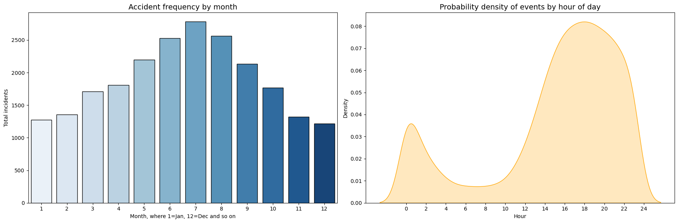
Temporal distribution of aviation incidents. The left panel shows total incident counts by month, while the right panel shows the probability density of incidents by hour of day.

Event Sequence Length Distribution
Temporal fields in the NTSB data exhibit substantial limitations. Approximately 15% of records are missing either event date or event time information. Moreover, after reconstructing timestamps and computing intra-incident time differences, all incidents exhibit zero total elapsed time across their event sequences, indicating that temporal resolution is insufficient to reliably measure event spacing. As a result, event order is treated as ordinal rather than continuous time in downstream sequence modeling, and temporal deltas are excluded as predictive features.
Figure 3 shows the distribution of event sequence lengths across all recorded aviation incidents, where sequence length is defined as the number of discrete events describing the progression of an accident. The majority of incidents are characterized by short sequences, with one to three events accounting for most observations and a mean sequence length of approximately 2.27 events. Sequence lengths range from a minimum of 1 event to a maximum of 9 events, confirming the presence of rare but substantially more complex accident progressions. However, the distribution exhibits a pronounced right tail, with a smaller number of incidents involving substantially longer and more complex event chains.
This long-tailed structure indicates significant heterogeneity in incident complexity. Treating all sequences equivalently would overweight frequent simple cases while underrepresenting rarer, more complex incidents. This suggests the need for sequence-aware modeling approaches, weighting schemes, or evaluation metrics that explicitly account for variation in sequence length and complexity.
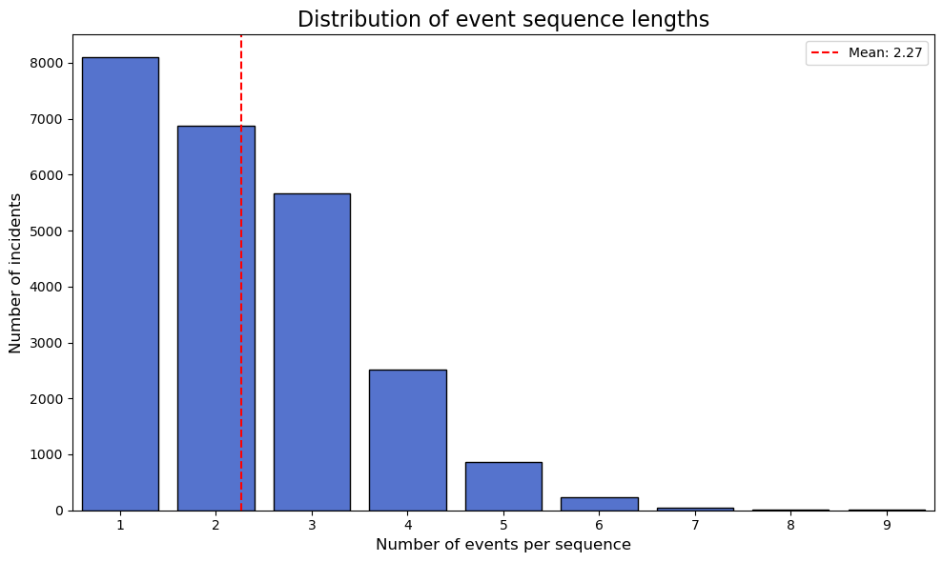
Distribution of aviation incident event sequence lengths. The dashed vertical line indicates the mean sequence length.

Outcome Severity Conditional on Initial Event
Figure 4 examines how accident severity varies as a function of the initiating event in an incident sequence. Loss-of-control events occurring during critical flight phases, particularly initial climb loss of control in flight, are associated with substantially higher proportions of fatal outcomes, indicating limited recovery margin once control is lost shortly after takeoff. In contrast, events initiated during landing or ground operations are dominated by non-injury outcomes, suggesting greater opportunities for mitigation and survivability. Engine power loss events exhibit intermediate severity profiles, reflecting variability in operational context and response.
Ignoring the initial event type, or treating it symmetrically across phases of flight, risks obscuring important asymmetries in severity outcomes. For this reason, initial event classification emerges as a high-priority feature or conditioning variable in both predictive and causal analyses.
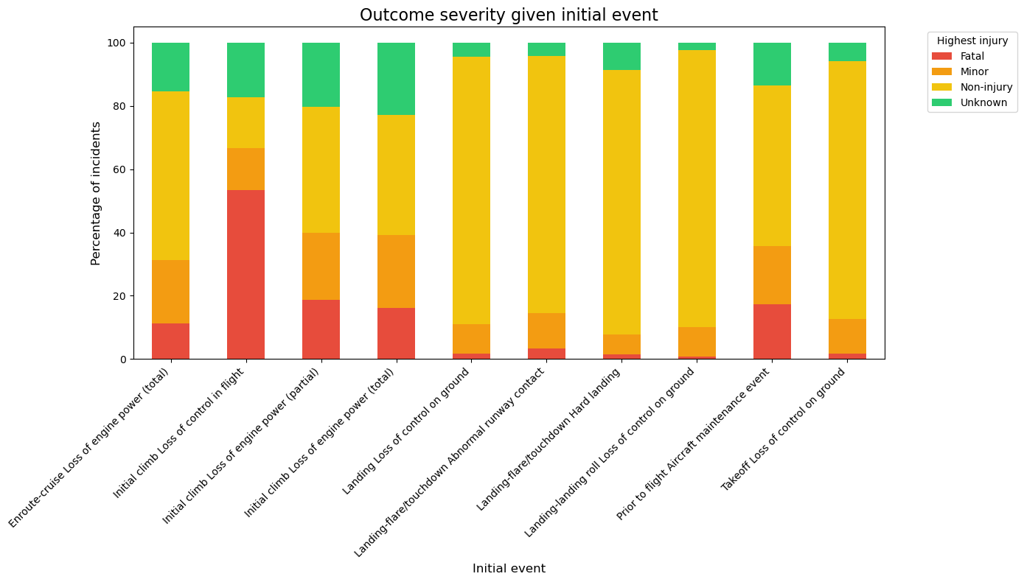
Outcome severity conditional on initial event. Bars show the percentage distribution of highest injury severity outcomes for incidents grouped by their initiating event type.

Class Imbalance in Accident Severity
Figure 5 shows the marginal distribution of highest injury severity across all aviation incidents in the dataset. The outcome variable is highly imbalanced, with incidents involving no reported injuries comprising the majority of observations. Fatal accidents represent a substantially smaller fraction of the data, while minor and serious injury cases occupy an intermediate range.
In absolute terms, the dataset contains 15,229 non-injury cases, 6,180 fatal cases, 4,000 minor injury cases, and 3,299 serious injury cases. While non-injury incidents dominate the distribution, fatal outcomes constitute a non-negligible minority, underscoring the operational importance of accurate severe-case identification.
This imbalance has important implications for both modeling and evaluation. Classifiers optimized for overall accuracy would tend to favor non-injury outcomes and could achieve deceptively high performance while failing to identify rare but operationally critical severe cases. Addressing this requires evaluation metrics that emphasize minority classes, such as precision–recall, as well as class-weighted objectives or resampling strategies where appropriate.
In addition, injury severity labels may be affected by reporting bias and post-incident investigation uncertainty, particularly for minor and non-injury cases. This introduces label noise that further complicates supervised learning and reinforces the need for careful interpretation of model performance.
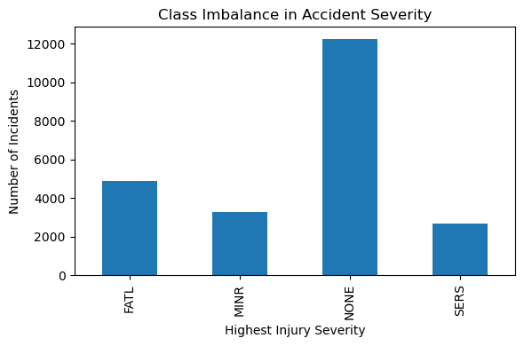
Distribution of highest injury severity across aviation incidents, illustrating strong class imbalance.

Aircraft Manufacturer Distribution
Figure 6 presents a Pareto analysis of aircraft manufacturers involved in recorded aviation incidents. A small number of manufacturers—most notably Cessna and Piper—account for a disproportionately large share of total incidents, with the top four manufacturers contributing roughly 80% of all recorded cases. The remaining manufacturers form a long tail with relatively few incidents each.
This concentration largely reflects market share effects within general aviation rather than manufacturer-specific risk. Treating manufacturer as a flat categorical variable would introduce severe class imbalance and unstable estimates for rare makes. This motivates aggregation of low-frequency manufacturers, hierarchical encoding, or regularization strategies to improve generalization.
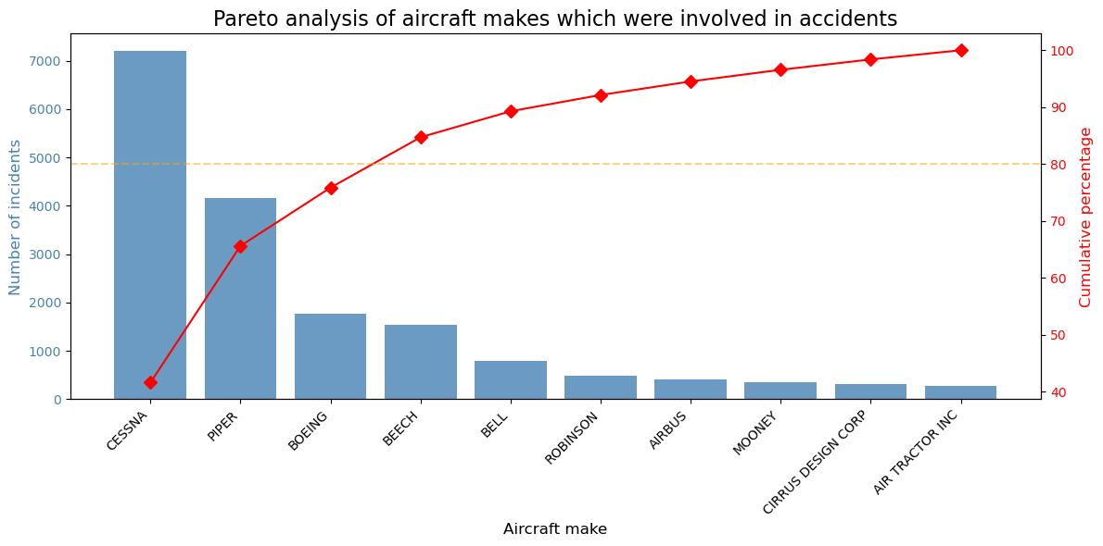
Pareto analysis of aircraft manufacturers involved in aviation incidents.

Visibility and Accident Sequence Complexity
Figure 7 shows the relationship between visibility conditions and accident sequence complexity. While median sequence lengths remain similar across visibility categories, reduced visibility conditions exhibit substantially greater variance and heavier upper tails, indicating an increased likelihood of multi-stage accident progressions.
This pattern violates assumptions of homoscedasticity and suggests that sequence complexity should be modeled conditionally on environmental context. Ignoring this interaction risks underestimating the probability of complex failure chains in low-visibility scenarios.
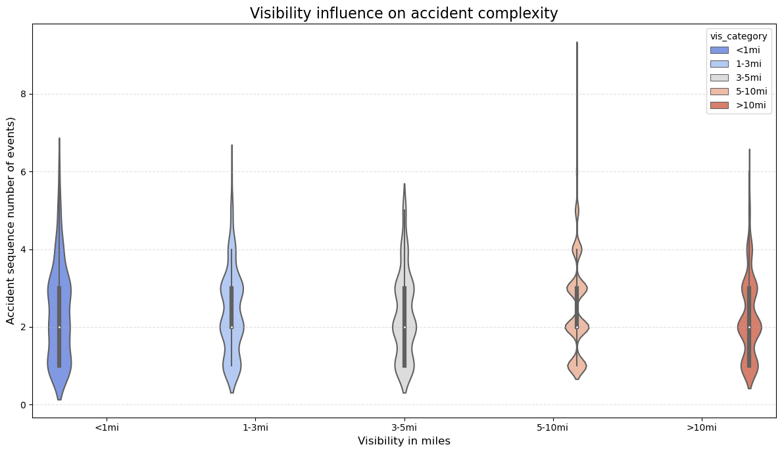
Distribution of accident sequence lengths across visibility categories.

Geographic Distribution of Aviation Incidents
Figure 8 visualizes the spatial distribution of aviation incidents across the continental United States. High-density regions align closely with areas of elevated aviation activity, including major metropolitan areas, training hubs, and high-traffic airspace corridors.
These patterns indicate that geographic density primarily reflects exposure rather than intrinsic regional risk. Using raw geographic features without normalization could therefore conflate traffic volume with accident propensity, motivating the use of exposure-adjusted rates or geographic stratification.
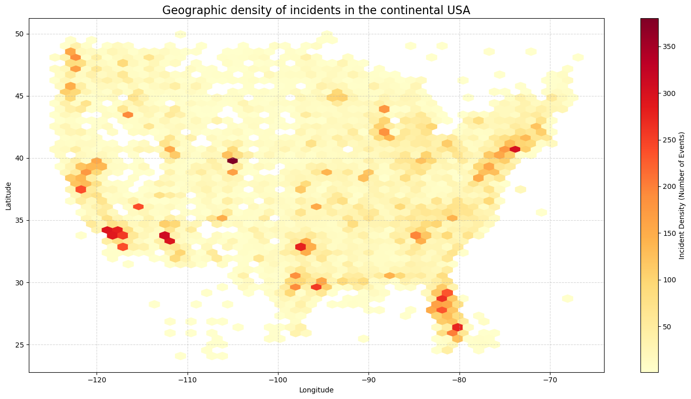
Geographic density of aviation incidents in the continental United States.

Event Sequence Structure and Transition Patterns
Figure 9 illustrates common transitions between events in aviation incident sequences. Loss-of-control and emergency descent events act as highly connected hubs, frequently leading to catastrophic outcomes, while landing-related events tend to terminate sequences with fewer downstream transitions.
This structure highlights the path-dependent nature of accident dynamics. Modeling approaches that assume independent events or ignore transition structure will fail to capture these constraints. These findings motivate sequence-based models, such as Markov processes or recurrent architectures, that explicitly encode transition probabilities.
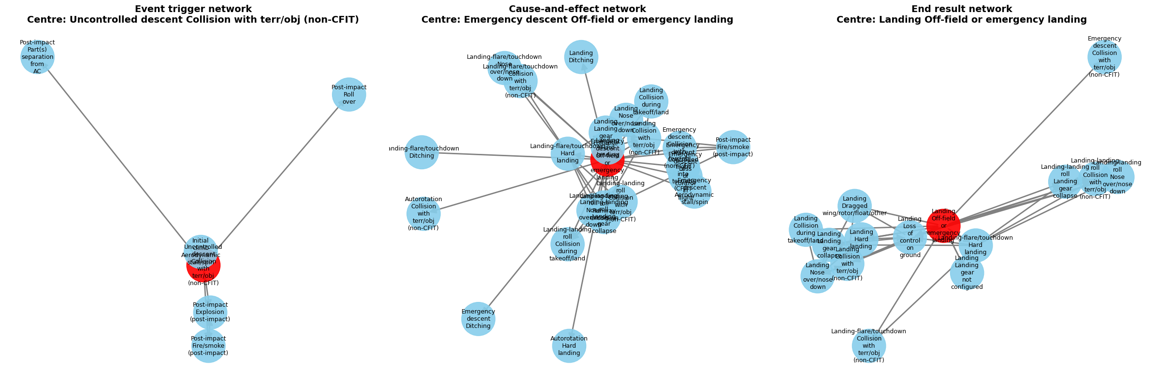
Directed event-sequence network illustrating common transitions between aviation incident events.

Feature Correlation and Dependency Structure
Figure 10 summarizes the pairwise correlations across our primary features. What stands out most is the overall sparsity of the matrix; outside of a few specific clusters, there is very little linear dependence between variables. We do see localized correlations between sequence-related features, which confirms the intuitive link between accident complexity and final severity—essentially, as the chain of events grows, the likelihood of a fatal outcome increases. Importantly, the overall sparsity of linear relationships suggests that most predictive signal does not arise from simple additive effects among numeric variables. Instead, structured dependencies appear to emerge from conditional interactions, particularly between event sequence characteristics and outcome severity.
From a technical standpoint, this lack of global correlation is actually a positive finding, as it suggests we won’t have to contend with significant multicollinearity issues. However, the presence of these small, structured dependencies indicates that the "story" is in the interactions rather than the individual variables. This reinforces my decision to move toward flexible, nonlinear models—like Gradient Boosted Trees or Recurrent Neural Networks—that can capture these conditional effects and "path-dependent" risks without needing to aggressively reduce the dimensionality of the data.
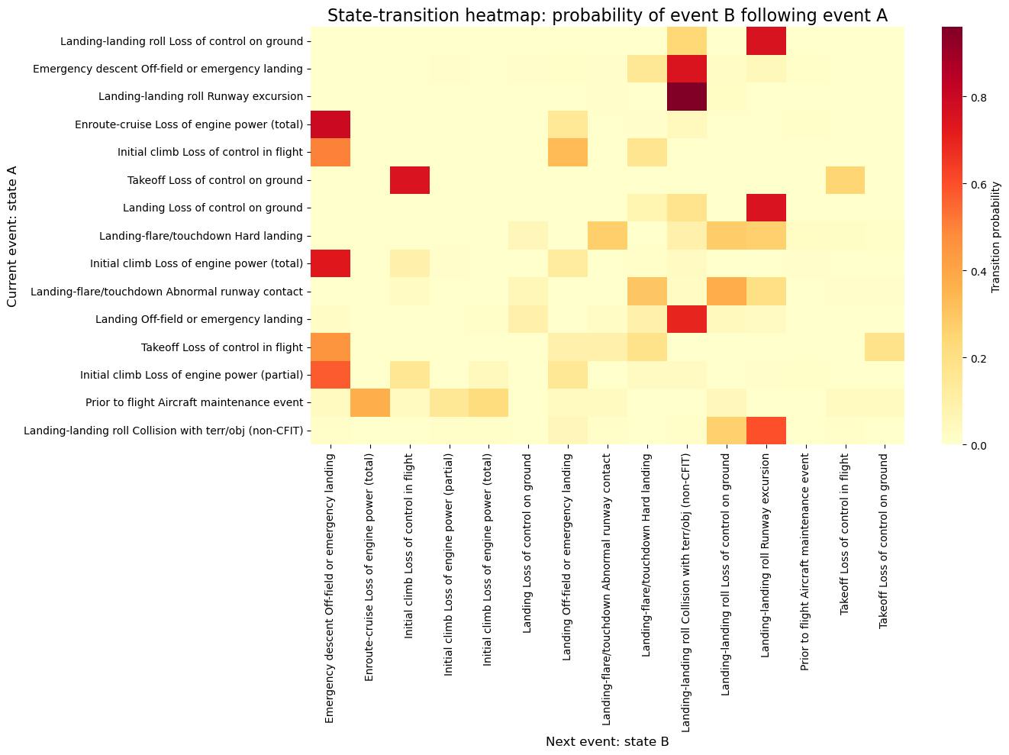
Correlation heatmap of selected numerical and encoded features.

