Sequential Modeling of Aviation Accident Progression for Industrial Systems Analytics
Matthew Jarvis
Jordan Gewing-Mullins
February 27, 2026

Introduction
Enrisk’s primary scope of work is data analytics consulting for industrial systems, particularly multi-stage manufacturing processes in which failures emerge through ordered event cascades. Industrial fault detection problems frequently require modeling sequences of machine states rather than treating observations as independent samples. Understanding how events transition from one stage to the next is central to diagnosing root causes and predicting system failures. To develop modeling expertise transferable to Enrisk’s industrial machining data, we analyzed an aviation accident dataset as a proxy sequential system. Aviation incidents unfold as ordered chains of occurrence codes (e.g., loss of engine power followed by emergency landing), making them well-suited for evaluating sequential modeling approaches. The goal of this project was to model next-event prediction and determine which modeling frameworks best capture the structural dependencies governing accident progression.

Problem Definition
Given a partially observed sequence of occurrence codes $(e_{1},e_{2},…,e_{t})$, the objective is to predict the subsequent event $e_{t+1}$. This formulation allows us to directly evaluate how much contextual information is needed to meaningfully model accident progression. Our primary research questions were as follows. First, how deep are temporal dependencies in aviation accident sequences? Second, does increasing contextual history improve predictive accuracy? Third, do neural architectures outperform classical probabilistic models in this domain? Finally, what structural properties of the dataset explain the observed performance differences? All models were evaluated using Top-1 accuracy on a held-out test set.

Dataset and Exploratory Data Analysis
The aviation accident dataset contains 23,950 incidents and 55,115 event-level rows, spanning 1,515 unique occurrence codes. The mean sequence length is 2.27 events. As shown in Figure 1, the distribution of sequence lengths is heavily concentrated at two and three events, with relatively few longer sequences. This immediately suggests that the available temporal context is limited.
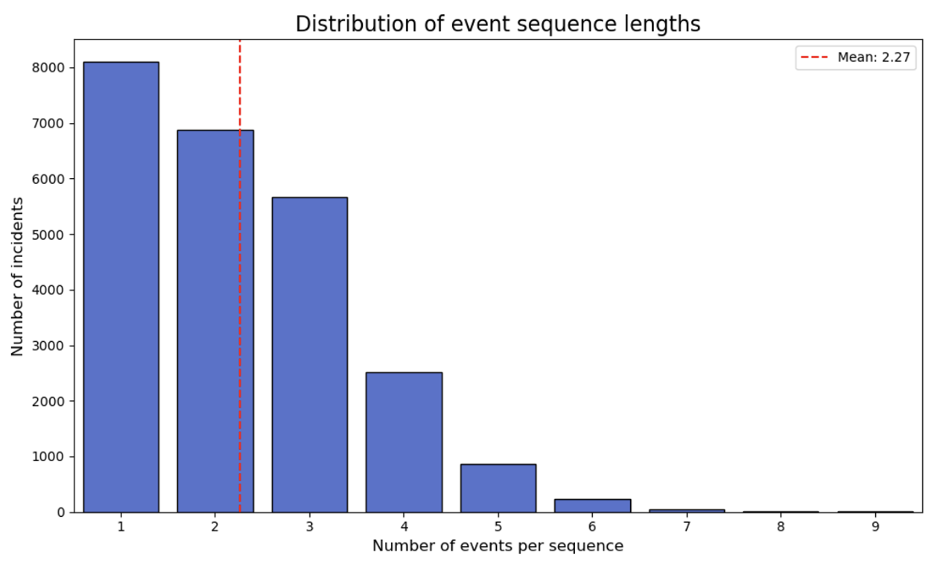
Distribution of event sequence lengths.
Temporal analysis revealed non-uniform distributions across months and hours of day (Figure 2). Incidents peak during warmer months and exhibit higher density during daytime operational hours. These patterns indicate environmental and operational effects but do not directly address transition structure.
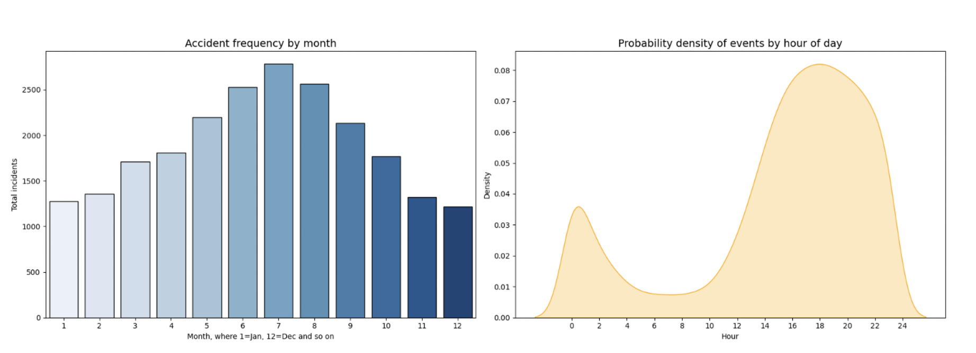
Temporal distribution of aviation incidents by month and hour.
The most informative insight emerged from the transition heatmap (Figure 3). The state-transition matrix shows that transition probabilities are highly concentrated on a small subset of event pairs. Several near-deterministic cascades appear, such as engine failure leading to emergency landing. The matrix is strongly directional and non-symmetric, reflecting irreversible operational progression. Additionally, transitions largely occur within operational phase clusters such as takeoff, cruise, and landing.
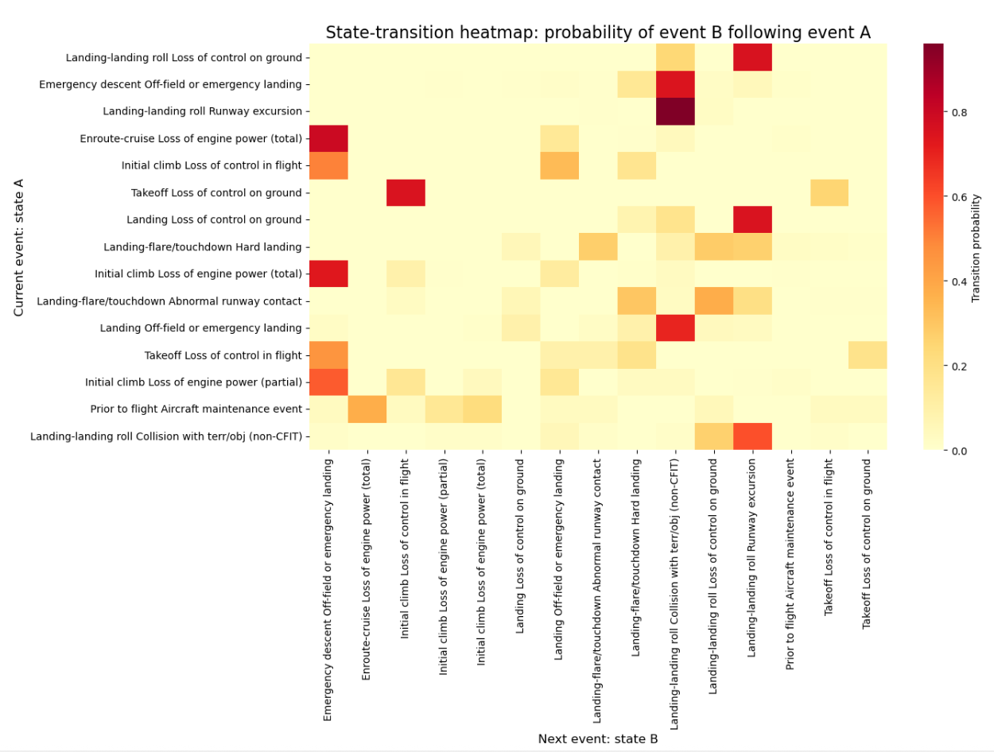
State-transition heatmap showing probability of event B following event A.
The state-transition heatmap (Figure 3) reveals several important structural properties of accident progression. First, transition probability mass is highly concentrated in a small subset of event pairs. Rather than exhibiting diffuse connectivity across many states, the matrix contains localized regions of high intensity, indicating that specific event types strongly predict a narrow set of subsequent outcomes. This suggests that accident evolution is not stochastic in a broad sense but is governed by constrained pathways. Second, several near-deterministic cascades are visible, where certain initiating failures almost always lead to specific follow-up events (e.g. loss-of-engine-power events frequently transition directly into emergency landing states). These high-probability edges indicate structured failure escalation patterns rather than independent event occurrences. Next, the transition matrix is strongly directional and asymmetric. The probability of transitioning from state A to state B is not mirrored by the reverse transition, reflecting the irreversible progression of operational phases. Once an aircraft moves from cruise into an emergency descent or landing phase, the sequence does not revert to earlier operational states. This asymmetry is consistent with real-world system dynamics and supports modeling approaches that encode ordered dependency. Additionally, transitions cluster within operational phases such as takeoff, cruise, and landing. The heatmap shows dense intra-phase transitions and comparatively sparse inter-phase transitions. This phase-local structure implies that most predictive information is contained within recent context rather than distributed across distant stages of the sequence. Finally, there is limited probability mass assigned to distant or unrelated states. The absence of widespread low-probability transitions suggests that higher-order context may provide diminishing returns, as the dominant predictive signal is already captured within a small neighborhood of recent events. These observations motivated the evaluation of explicit Markov models with increasing context length.

Methodology

Graph-Based Markov Models
We constructed directed graphs in which nodes represent occurrence codes and edges represent observed transitions between consecutive events. Edge weights correspond to empirical transition frequencies estimated from training data. The dataset was partitioned into training and held-out test sets using an 80/20 split at the incident level to prevent leakage across sequences. All transition probabilities were estimated exclusively from training data.
We evaluated Markov models of order 1 through 4, estimating conditional probabilities of the form:
$$P(e_{t+1}∣e_{t},e_{t−1},…,e_{t−k+1}).$$
Laplace (add-1) smoothing was applied to mitigate zero-probability transitions arising from rare or unseen contexts. For higher-order models, we implemented a hierarchical back-off strategy: when a context of order $k$ was not observed in the training set, the model reverted to order $k−1$ until a valid conditional distribution was available. This ensured full coverage at inference time while preserving higher-order specificity when supported by data.

Neural Sequence Models
To test whether latent long-range structure exists beyond explicit transition modeling, we evaluated three neural architectures implemented in PyTorch. Event sequences were encoded as integer indices corresponding to the 1,515 unique occurrence codes. For neural models, sequences were padded to a fixed maximum length and masked to prevent padded positions from influencing gradient updates. The dataset was split using the same 80/20 incident-level partition as the Markov models, with a validation subset drawn from the training data for hyperparameter tuning. The baseline model consisted of an embedding layer (dimension 32 or 64), followed by a single-layer LSTM with 64 or 128 hidden units. Dropout rates of 0.2 and 0.4 were evaluated to control overfitting. The final hidden state was passed to a fully connected layer producing logits over the event vocabulary. Models were optimized using the Adam optimizer with categorical cross-entropy loss and trained for up to 20 epochs, with performance monitored on the validation set. The hybrid model extended this architecture by incorporating structured metadata features, including weather condition, visibility, time-of-day indicators, and airport elevation. These features were normalized and processed through a parallel feed-forward branch. The resulting metadata representation was concatenated with the LSTM hidden state prior to the final classification layer. Finally, the attention-based model replaced recurrence with a multi-head self-attention mechanism applied to event embeddings. The attention outputs were aggregated using global pooling before classification. This architecture allows each event position to attend to all others within the sequence, enabling modeling of non-local dependencies without relying on sequential recurrence.

Results
Markov model performance improved from order 1 to order 3, with accuracy increasing from 31% to 43%, as shown in Table 1. However, performance declined at order 4 (33%), indicating context sparsity and overfitting.
Markov model performance by order.
Order | Accuracy
1 | 31%
2 | 35%
3 | 43%
4 | 33%
To further understand how contextual depth contributes to prediction, we examined the back-off usage distribution shown in Figure 4. This figure reports the number of predictions sourced from each Markov order after applying the hierarchical back-off strategy. The majority of predictions originate from order-2 contexts (146 instances) and order-1 contexts (103 instances), while order-3 contexts contribute less frequently (63 instances), and order-4 contexts are comparatively rare (30 instances). The global fallback distribution is almost never used (4 instances), indicating that lower-order contexts generally provide sufficient coverage.
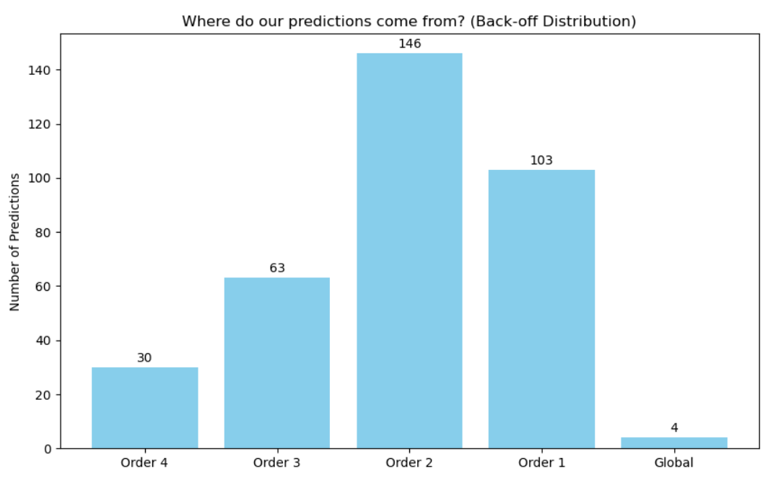
Distribution of prediction sources by Markov order under hierarchical back-off.
This distribution provides direct empirical evidence that the effective dependency depth of aviation accident progression is shallow. Although third-order context yields the highest overall accuracy, most individual predictions rely on shorter context windows. The limited usage of higher-order contexts reflects sparsity in longer event histories and supports the conclusion that predictive signal is concentrated within the most recent one to three events.
The LSTM baseline achieved 29.5% Top-1 accuracy (48.6% Top-3). Increasing LSTM units improved performance modestly, while heavy dropout reduced accuracy. The hybrid model provided a marginal improvement to approximately 31%, suggesting that contextual features add limited incremental signal. The attention-based model achieved approximately 30–33% accuracy, comparable to the LSTM but still below the order-3 Markov model.
LSTM Hyperparameter Grid Search Results
Embedding Dim | LSTM Units | Dropout | Top-1 Accuracy | Top-3 Accuracy
64 | 128 | 0.2 | 0.2948 | 0.4857
32 | 128 | 0.2 | 0.2923 | 0.4721
64 | 128 | 0.4 | 0.2828 | 0.4817
32 | 128 | 0.4 | 0.2698 | 0.4551
32 | 64 | 0.4 | 0.2433 | 0.3999
64 | 64 | 0.2 | 0.2418 | 0.4187
64 | 64 | 0.4 | 0.2368 | 0.4083
32 | 64 | 0.2 | 0.2152 | 0.3552
To evaluate whether exogenous contextual information improves predictive performance, we extended the LSTM architecture by incorporating a parallel metadata branch. In addition to the ordered event sequence, the model received structured features including weather condition, visibility, time-of-day features, and airport elevation. The metadata representation was concatenated with the LSTM hidden state prior to the final classification layer.
The hybrid model achieved approximately 31% Top-1 validation accuracy, representing only a modest improvement over the sequence-only LSTM baseline. Training curves (Figure 5) show steady convergence without severe overfitting, as training and validation accuracy remain relatively aligned. However, the plateau in validation accuracy suggests that contextual metadata contributes limited incremental signal beyond event transitions.
This result indicates that predictive structure in the dataset is primarily driven by local event dependencies rather than environmental covariates. While contextual features such as weather correlate with severity outcomes, they appear less influential in determining the immediate next event within a failure cascade.
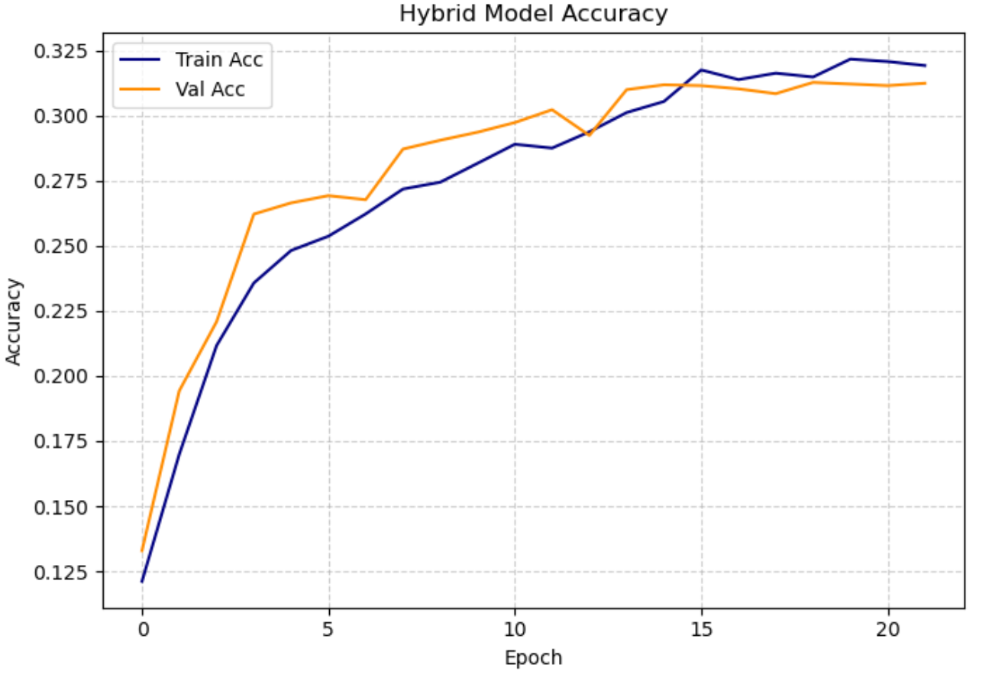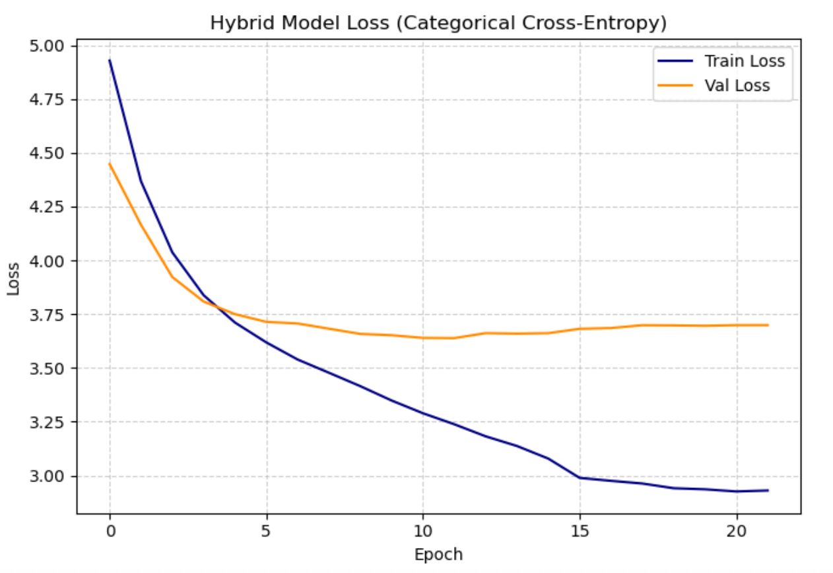
Training and validation curves for the hybrid LSTM + metadata model.
To further investigate whether longer-range dependencies could improve predictive performance, we implemented an attention-based sequence model that replaces recurrence with multi-head self-attention. This architecture allows each event in a sequence to attend to all other events, potentially capturing non-local dependencies more flexibly than an LSTM.
The attention model achieved validation accuracy between 30% and 33%, comparable to the LSTM baseline and still below the Order-3 Markov model. As shown in Figure 6, training accuracy continues to increase steadily across epochs, while validation accuracy plateaus early and fluctuates within a narrow range. The loss curves tell a similar story: training loss decreases consistently, but validation loss stabilizes after the initial epochs and does not meaningfully improve. This divergence indicates that the model has sufficient capacity to fit the training data, yet the additional representational flexibility does not translate into better generalization.
Taken together, these results suggest that the dataset does not contain substantial long-range temporal structure beyond the most recent few events. Increasing architectural complexity—from LSTM to hybrid to attention—does not produce meaningful gains, reinforcing the conclusion that predictive signal is concentrated in shallow, local transition dynamics.
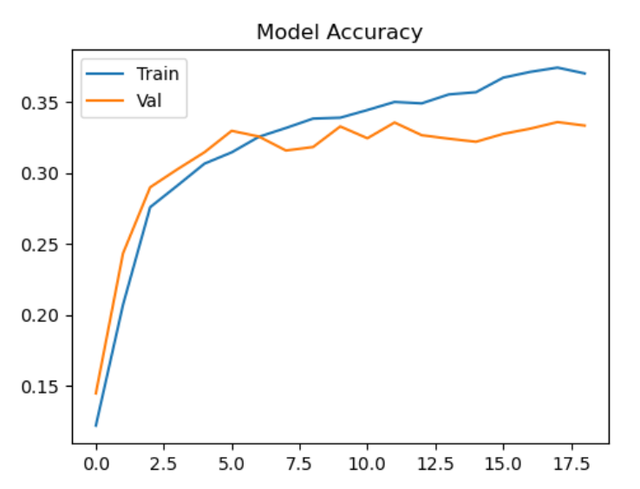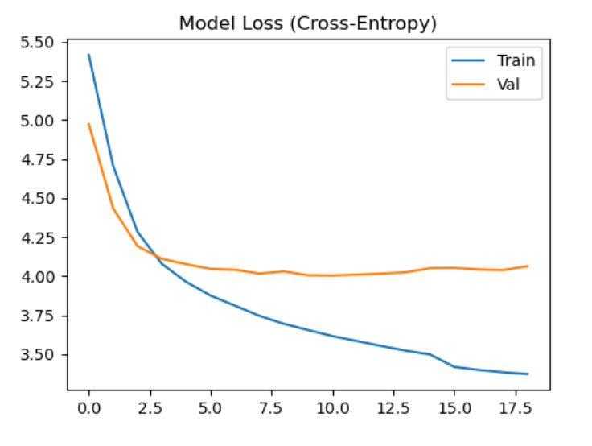
Training and validation curves for the attention-based sequence model.

Discussion
The superior performance of the order-3 Markov model aligns directly with the structural properties observed during exploratory analysis. The short mean sequence length (2.27 events) inherently constrains the depth of usable temporal context. Because most accident sequences contain only two or three events, the effective predictive horizon is limited. The transition heatmap revealed concentrated probability mass within localized clusters and several near-deterministic cascades, indicating that accident progression follows constrained pathways rather than diffuse stochastic dynamics. In such settings, conditional dependence is primarily local. A third-order Markov model captures this limited contextual window effectively without incurring the sparsity penalties observed at order four.
Neural architectures typically outperform classical probabilistic models when long-range, distributed, or latent dependencies exist that cannot be expressed through explicit transition counts. However, the aviation dataset does not exhibit such structure. Both the LSTM and attention-based models achieved validation accuracy in the 30–33% range, despite having substantially greater representational capacity. Training curves indicate that these models can fit the training data, yet validation performance plateaus early. This suggests that additional architectural flexibility does not unlock new predictive signal; rather, it introduces additional parameters that must be estimated from relatively short and sparse sequences.
The back-off distribution further reinforces this interpretation. Although the third-order Markov model achieves the highest overall accuracy, most individual predictions rely on order-1 and order-2 contexts. This indicates that higher-order context improves aggregate performance but is not consistently available across sequences. In other words, predictive depth exists but remains shallow. The fourth-order model likely suffers from combinatorial sparsity, where the number of possible context combinations grows faster than the data can support.
These findings illustrate an important modeling principle: performance depends not on model sophistication but on structural alignment between model assumptions and the underlying generative process. When event cascades are short and tightly constrained, explicit conditional modeling can outperform deep neural approaches. Moreover, graph-based Markov models offer interpretability advantages that are valuable in industrial fault detection contexts. Transition probabilities can be inspected directly, enabling engineers to trace predicted cascades and identify dominant failure pathways.
For Enrisk’s industrial machining applications, the implications are pragmatic. If machine failure sequences exhibit similarly short, phase-local cascades, variable-order conditional models may provide accurate and computationally efficient solutions. However, if industrial systems contain longer operational histories, overlapping fault modes, or sensor-derived latent states, neural architectures may become more advantageous. The key determinant is not model class but dependency structure.
Ultimately, our results emphasize the importance of diagnosing sequence depth prior to selecting modeling frameworks. Rather than defaulting to deep learning architectures, practitioners should evaluate transition concentration, effective context length, and sparsity patterns to determine whether classical probabilistic models may suffice. In this case, the structural characteristics of aviation accident progression favor shallow conditional modeling over complex neural representations.

Limitations
Several limitations of this study should be considered when interpreting the results. The most significant constraint is the short average sequence length of the dataset (2.27 events). Because most accident sequences contain only two or three events, the effective temporal horizon available for modeling is inherently limited. While we evaluated higher-order Markov models and neural architectures capable of representing long-range dependencies, the dataset itself provides little opportunity to exploit deep contextual structure. As a result, our conclusion that dependency depth is shallow is grounded in the empirical properties of this dataset rather than a broader statement about sequential systems in general.
A related issue is sparsity in higher-order contexts. With 1,515 unique occurrence codes, the number of possible multi-step histories grows combinatorially. Even with smoothing and back-off strategies, many third- and fourth-order contexts are observed infrequently. This sparsity likely contributes to the degradation observed in the fourth-order Markov model and limits the extent to which neural models can learn stable representations for rare transitions.
Our evaluation also focused primarily on Top-1 and Top-3 accuracy. Although these metrics are appropriate for next-event prediction, they do not fully characterize probabilistic model quality. We did not perform a systematic comparison of cross-entropy values across model families, nor did we assess calibration. It is therefore possible that certain models produce better-calibrated probability distributions even if their top prediction accuracy is lower.
Finally, while aviation accident sequences provide a useful proxy for staged failure systems, they may not perfectly reflect the structure of industrial machining processes. Industrial systems may exhibit longer operational histories, denser sensor streams, or different forms of dependency structure. The extent to which our modeling conclusions transfer to Enrisk’s proprietary industrial datasets will require direct empirical validation.

Future Work
Future work will focus on applying these modeling frameworks to Enrisk’s proprietary industrial sensor data. Potential improvements include variable-order Markov models, more advanced smoothing techniques, probabilistic scoring evaluation, and hierarchical clustering of occurrence codes to reduce sparsity.

Conclusion
This study demonstrates that aviation accident progression exhibits structured but shallow sequential dependency. A third-order Markov model achieved the highest predictive accuracy (43%), outperforming LSTM and attention-based neural models. The results highlight the importance of aligning model complexity with structural depth and provide a methodological foundation for sequential modeling in industrial fault detection systems.

