Operational Strategy and Team Roles
To ensure a smooth implementation of this specification, the project team is organized into three distinct operational functions:
- Lead Architect: They will oversee the design specification’s evolution and ensure the developers strictly adhere to the boundaries defined in the system architecture diagram.
- Interface Designer: They will manage the JSON Schema updates, API versioning control (like /v1/ to /v2/), mock server creation, and the complete Swagger/OpenAPI documentation ecosystem.
- Integration Lead: They will direct the integration checkpoints between the Core Chat database and the AI telemetry messages published over the broker, which basically ensures zero performance interference on the primary application thread.

Team Formation and Role Assignment
- Lead Architect: Jordan Hanna
- Interface Designer: Ti’Asia Gause
- Integration Lead: Cal Reed

Project Scenario
“Your team has been hired as software architects for a mid-sized technology company developing a new customer service platform. The platform must include a mandatory AI-powered chatbot feature that can handle basic customer inquiries, escalate complex issues to human agents, and learn from interaction patterns. The system must serve 10,000 concurrent users, integrate with existing customer databases, and be maintainable by a team of junior developers.”

System Architecture Design Specification
Project: AI-Powered Customer Service Platform
Target Scale: 10,000 Concurrent Users
Team Capability: Maintainable by Junior Developers

Executive Summary and Design Rationale
This specification will outline a more modular, decoupled architecture for a mid-sized customer service platform with an AI chatbot. The system will balance strict separation of concerns with basic communication patterns that will ensure high availability, support those 10,000 concurrent users, and lastly, remain accessible to us junior developers.
​
Architectural Pattern: Layered Microservices with Event-Driven AI
The system will use a layered microservices architecture and an event-driven choreography pattern to handle the heavy tasks like the AI learning analytics. The challenge, however, is that there is a tradeoff between monolithic and microservices.
While a pure monolith would be easier for our team overall to manage, it can create a massive blast radius and probably would not be able to scale to 10,000 concurrent WebSocket and REST connections. As for microservices, if it were an extreme mesh that was introduced, then it might potentially have excessive operational complexity. As a solution to this tradeoff, we could manage a hybrid approach where we would only use three independent services with isolated databases.
Finally, there is a tradeoff for both synchronous and asynchronous AI. For synchronization, REST and WebSockets could deliver low latency for more real-time customer interactions. For asynchronous AI, it could run interaction learning and continuous analytics with a message broker. So, if the AI training pipeline bottlenecks, the live customer chat engine could still remain fully operational.

Modular Design Principles Applied
Regarding technical accuracy, there are some principles to make note of. Firstly, for separation of concerns, the distinct modules would handle the user interface, core business logic, database operations, and AI orchestration. Secondly, there would be low coupling and high cohesion, with the AI gateway completely isolating the LLM/Chatbot engine. The Core Platform would also remain unaffected by how the AI would generate the text, since it would only require a standard JSON response. Lastly, making it developer-friendly, where the system uses the standard REST APIs for synchronous requests and a Message Broker (like RabbitMQ/SQS) for asynchronous background tasks, avoiding any more complexities with the gRPC meshes that keep the onboarding simple for our team.

(Jordan Hanna (Lead Architecture) - Operational Strategy and Team Roles, Team Formation and Role Assignment, Project Scenario, System Architecture Design Specification, Executive Summary and Design Rationale, Architectural Pattern: Layered Microservices with Event-Driven Drive AI, Modular Design Principles Applied)

System Architecture Diagram

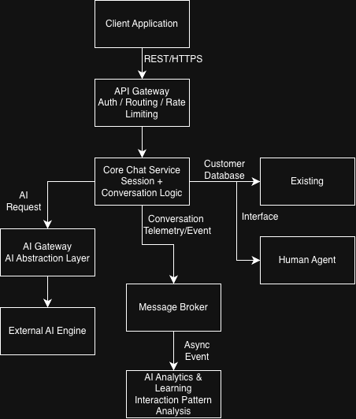
(Ti’Asia Gause (Interface Designer); Jordan Hanna (Lead Architect))

Module Boundaries and Data Flow
- Inbound Inquiries
  - User Submission: The user can send a message through the Client application.
  - API Routing: The API Gateway can intercept the message and route it directly to the Core Chat Service.
- AI Processing
  - Flag Evaluation: The Core Chat Service can check if the session is flagged for automated handling.
  - Gateway Request: If flagged, it can request a response from the AI Gateway.
  - Prompt Enrichment: The AI Gateway can then gather minimal context, structure the prompt, and send it to the External AI Engine.
- Escalation
  - Confidence Scoring: The system can then evaluate the confidence score of the AI’s generated response.
  - Agent Alert: If the core does fall below the threshold, then the Core Chat Service can update the session state.
  - Live Hand-off: The service can trigger a WebSocket connection event to immediately alert a human agent.
- Learning Loop
  - Data Publication: The system then publishes the completed conversations to the Message Broker.
  - Asynchronous Processing: The AI Analytics & Learning module would ingest the telemetry data in the background.
  - Performance Protection: This asynchronous pipeline basically ensures continuous model optimization without degrading live system performance.

Interface Contracts
- REST API Endpoint: Chat Processing
POST /api/v1/chat/message
This basically is to process the incoming user messages, determine if an AI or a human agent should deal with the response, and return the generated content.
(Cal Reed (Integration Lead) - The reason for the control on between the AI determining its conditions for responding vs a human response will come down to the complexity of the AI’s capabilities. For instance, for rapid processing, continuous interface with multiple users can strain the system’s resources. A quick inquiry can be routed to the AI interface utilizing key words that link back to automated responses. Should those key words being used not be identified, or if the response was unclear to the user, then shifting to a human agent is more beneficial for reliable information sharing. The complexity will be determined by both human and technology resources.)
Headers
- Content-Type: application/json
- Authorization: Bearer <JWT_TOKEN>
Request Body: json
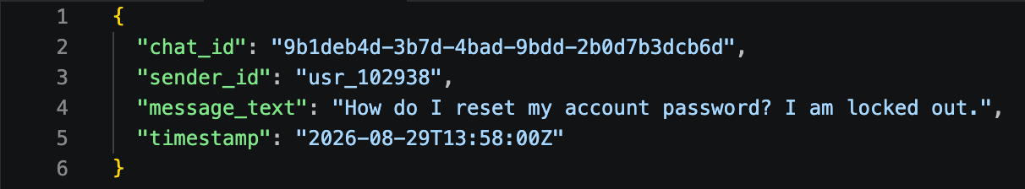
​
Response Body (200 OK - AI Handled): json
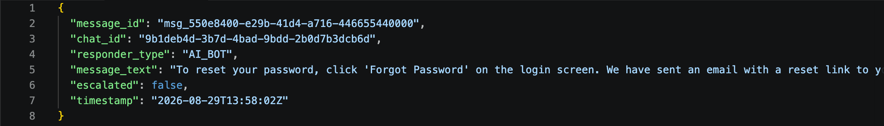
​
Response Body (200 OK - Escalated to Human): json
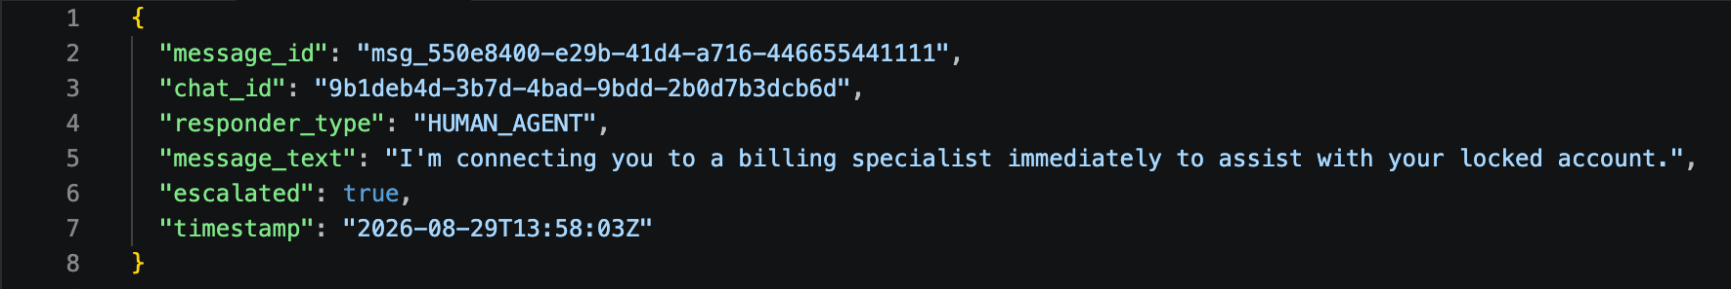
​(Jordan Hanna (Lead Architect) - Module Boundaries and Data Flow, Interface Contracts)
Data Contracts, Validation, and Error Handling
Error Handling & Validation: json
400 Bad Request: Thrown if the required fields are missing or empty.
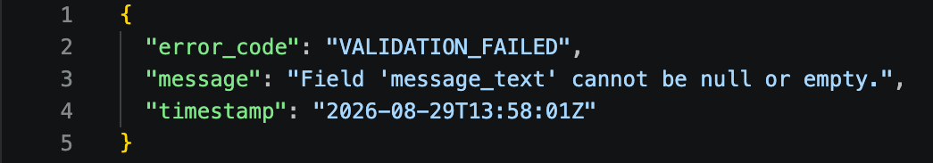
​
429 Too Many Requests: Returned when a client exceeds the configured request rate limit. The API Gateway uses rate limiting and traffic controls to help protect system capacity under high concurrent load.
- Component Interface: AI Gateway Service
This backend interface will abstract the AI engine, and our team interacting with this component can only call these high-level methods (go).
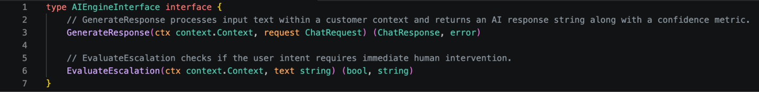
Data Contracts
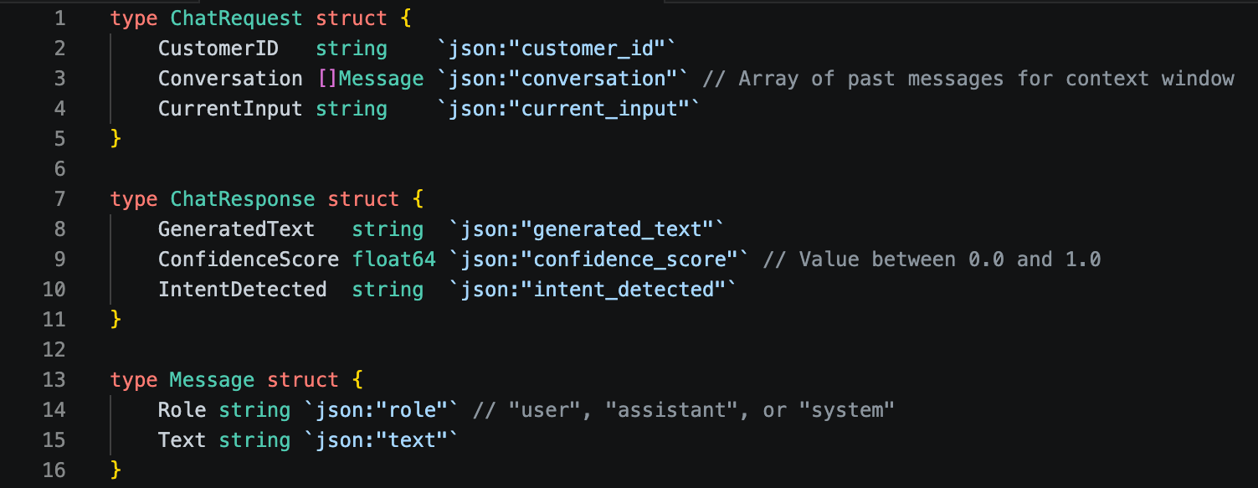
To make the interfaces between the Client Application, Core Chat Service, AI Gateway, and supporting services unambiguous, the system will use JSON-based data contracts with explicit field types, required fields, and validation rules. The primary chat request will use the following structure:
{
"sessionId": "string",
"messageId": "string",
"message": "string",
"customerId": "string"
}

Validation Rules
sessionId: required string; must identify an active chat session.
messageId: required string; must be unique within the session to prevent duplicate processing.
message: required string; cannot be empty or contain only whitespace; maximum length is 4,000 characters.
customerId: required string; must correspond to an authenticated customer.
- The Authorization header must contain a valid JWT token.
- The API Gateway must reject malformed JSON before the request reaches the Core Chat Service.
- Requests exceeding the configured rate limit return HTTP 429 Too Many Requests.
The Core Chat Service returns a standardized response so the client does not need to know whether the response originated from the AI system or a human agent.
{
"sessionId": "string",
"messageId": "string",
"response": "string",
"handledBy": "AI | HUMAN",
"confidenceScore": "number",
"escalated": "boolean",
"timestamp": "string"
}
confidenceScore must be between 0.0 and 1.0 when handledBy is AI. If the confidence score falls below the configured threshold, escalated is set to true, handledBy becomes HUMAN, and the Core Chat Service initiates the human-agent handoff described in the architecture. For human responses, confidenceScore may be null.

AI Gateway Component Interface
The AI Gateway remains isolated from the Core Chat Service so that the underlying external AI engine can be changed without requiring changes to the primary chat application. The Core Chat Service communicates with the AI Gateway through a limited interface:
generateResponse(sessionId: String, message: String)
→ AIResponse

calculateConfidence(response: AIResponse)
→ Number

validateResponse(response: AIResponse)
→ Boolean
The AIResponse contract contains:
{
"response": "string",
"confidenceScore": "number",
"requiresEscalation": "boolean"
}
The confidence score must remain between 0.0 and 1.0. A failed AI response, invalid response structure, or unavailable external AI engine must not cause the Core Chat Service to fail. Instead, the AI Gateway returns an error to the Core Chat Service, which can route the customer to a human agent.

Standard Error Contract
All API errors will use a consistent structure:
{
"errorCode": "string",
"message": "string",
"requestId": "string",
"timestamp": "string"
}
The following errors are supported:
HTTP Status | Error Code | Condition
400 | INVALID_REQUEST | Required field missing, empty, malformed JSON, or invalid field value
401 | UNAUTHORIZED | JWT token missing, invalid, or expired
404 | SESSION_NOT_FOUND | Requested chat session does not exist
409 | DUPLICATE_MESSAGE | Message ID has already been processed
429 | RATE_LIMIT_EXCEEDED | Client exceeds configured request/rate limits
502 | AI_SERVICE_ERROR | External AI engine fails or returns an invalid response
503 | SERVICE_UNAVAILABLE | Required platform service is temporarily unavailable
500 | INTERNAL_ERROR | Unexpected server-side failure
Using standardized contracts and error responses reduces coupling because each component only needs to understand the agreed interface rather than the internal implementation of another component.
Component Interface Summary
Component | Responsibility | Interface | Input | Output
API Gateway | Routes requests and applies authentication/rate limiting | REST | HTTP/JSON request | Routed request or error
Core Chat Service | Manages sessions and conversation logic | REST / WebSocket | Chat message | AI or human response
AI Gateway | Abstracts the external AI engine | Internal service interface | Session/message/context | AI response + confidence
Human Agent Interface | Handles escalated conversations | WebSocket | Escalation event | Agent response
Message Broker | Transfers asynchronous interaction events | Event messages | Conversation telemetry | Queued event
AI Analytics & Learning | Processes interaction patterns | Event consumer | Telemetry event | Analytics/model-learning output
Customer Database | Provides existing customer information | Database/API | Customer/session lookup | Customer data
(Ti’Asia Gause (Interface Designer) - API contracts, data contracts, validation rules, error handling, and interface definitions.)
(Cal Reed (Integration Lead) - Ideally, with a junior development team, allowing AI to manage much of the workload with regard to the front-facing application or processing allows the team to continue managing and refining the overall desired design of the system.)

Design Rationale
The proposed architecture applies separation of concerns by assigning each major component a clearly defined responsibility. The API Gateway is responsible for handling incoming requests, authentication, routing, and rate limiting rather than containing customer-service business logic. The Core Chat Service manages conversation sessions and determines whether an interaction should be handled by the AI system or escalated to a human agent. The AI Gateway isolates the external AI engine from the Core Chat Service, allowing the underlying AI implementation to be changed without requiring changes to the primary chat application. The Message Broker and AI Analytics & Learning components are separated from the real-time chat process so that interaction analysis can occur asynchronously without interfering with live customer conversations. This organization supports the team's goal of maintaining the system with a junior development team because each component has a focused responsibility and a clearly defined interface.
The architecture also attempts to maintain high cohesion and low coupling. High cohesion is achieved by keeping related responsibilities together within individual components. For example, the Core Chat Service contains conversation and session-management responsibilities, while the AI Gateway contains AI-specific integration responsibilities. Low coupling is supported through defined REST interfaces and the AI Gateway abstraction rather than allowing the Core Chat Service to directly depend on the external AI engine. The asynchronous Message Broker further reduces coupling between the Core Chat Service and AI Analytics & Learning because the chat service can publish interaction events without waiting for analytics processing to complete. Microsoft Learn identifies loose coupling and high functional cohesion as important microservices practices and recommends well-defined APIs and private service data boundaries.
One major technical tradeoff is the decision to use a limited microservices approach instead of either a single monolithic application or a large collection of independently deployed services. A monolith could be simpler for a junior development team, but the team's scenario requires support for 10,000 concurrent users and an AI feature that performs additional processing. A highly distributed microservices architecture could provide scalability and fault isolation but would introduce additional operational and communication complexity. The team therefore selected a more limited architecture with focused services and an event-driven component for asynchronous AI analytics. This approach attempts to balance scalability and maintainability while avoiding unnecessary service fragmentation. Microsoft notes that microservices can improve scalability and fault isolation but also introduce additional complexity, network communication, data-consistency, and operational challenges.
The AI feature is integrated as a distinct component rather than being embedded directly into the Core Chat Service. Customer messages are routed through the API Gateway to the Core Chat Service, which can request an AI response through the AI Gateway. The AI Gateway communicates with the external AI engine and returns a standardized response containing the generated response, confidence score, and escalation requirement. If the AI response does not meet the configured confidence requirements, the Core Chat Service can initiate a human-agent handoff. Completed interactions can also be published to the Message Broker for asynchronous analytics and learning. Event-driven architecture supports this separation because producers and consumers can communicate through an event channel without requiring direct knowledge of each other's internal implementation.

Cohesion and Coupling — Interface Design Contribution
The interface design supports high cohesion by keeping each component focused on a limited set of related responsibilities. The Core Chat Service manages conversation sessions and chat-processing decisions, while the AI Gateway handles communication with the external AI engine. The API Gateway handles cross-cutting concerns such as authentication, routing, and rate limiting rather than implementing customer-service logic. The Message Broker and AI Analytics & Learning components handle asynchronous interaction processing separately from the real-time conversation path.
The design reduces coupling by requiring components to communicate through defined interfaces rather than depending on each other's internal implementation. For example, the Core Chat Service communicates with the AI Gateway through defined methods such as generateResponse(), calculateConfidence(), and validateResponse() rather than directly interacting with the external AI engine. Similarly, the Core Chat Service publishes interaction information to the Message Broker instead of directly controlling the AI Analytics & Learning component. This allows the analytics component to process events independently and prevents analytics processing from becoming a dependency of the live chat response.

References
Microsoft. (2025, July 11). Microservices architecture style. Microsoft Learn. https://learn.microsoft.com/en-us/azure/architecture/guide/architecture-styles/microservices
Microsoft. (2026, March 7). Event-driven architecture style. Microsoft Learn. https://learn.microsoft.com/en-us/azure/architecture/guide/architecture-styles/event-driven

