ART 3870 PROJECT SUBMISSION TEMPLATE   
**Complete this template for every assignment!**

Export to pdf and submit on blackboard. Include your sketches and screenshots in this document. Do not upload any other files to blackboard.

Your code should be hosted on GITHUB and the pages should be published on GITHUB.IO

## Personal Information

**NAME: Jordan Chung**

**NET ID: Ga2985**

**COURSE:** YEAR (2018)/ QUARTER (WI) /SECTION (01, 02)

## Project Information

**Project Title:**

Animation Project III

**Project Description:**

Three images Sprite, Translate, and Animation including a poem of choice.

**Project URL on github.com (code view):**

https://github.com/jordanjaechung/animationproject.git

**Project URL on github.io (browser view):**

## Project Documentation

**Scanned Project Sketches, Branding worksheets, style tiles and other prep work:**

(one for each page in the project – scaled to take the whole page width, not distorted/stretched)

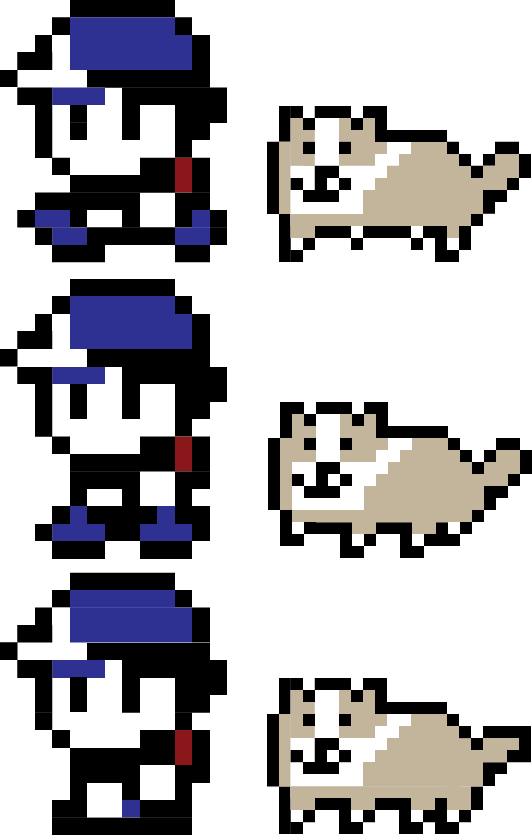

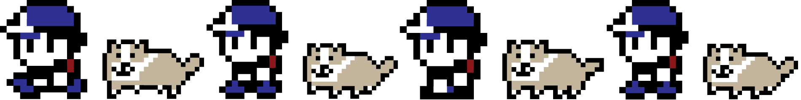

**Project Screenshots:**

(one for each page in the project – scaled to take the whole page width, not distorted/stretched) _ USE <http://www.awesomescreenshot.com/> to help get the best results

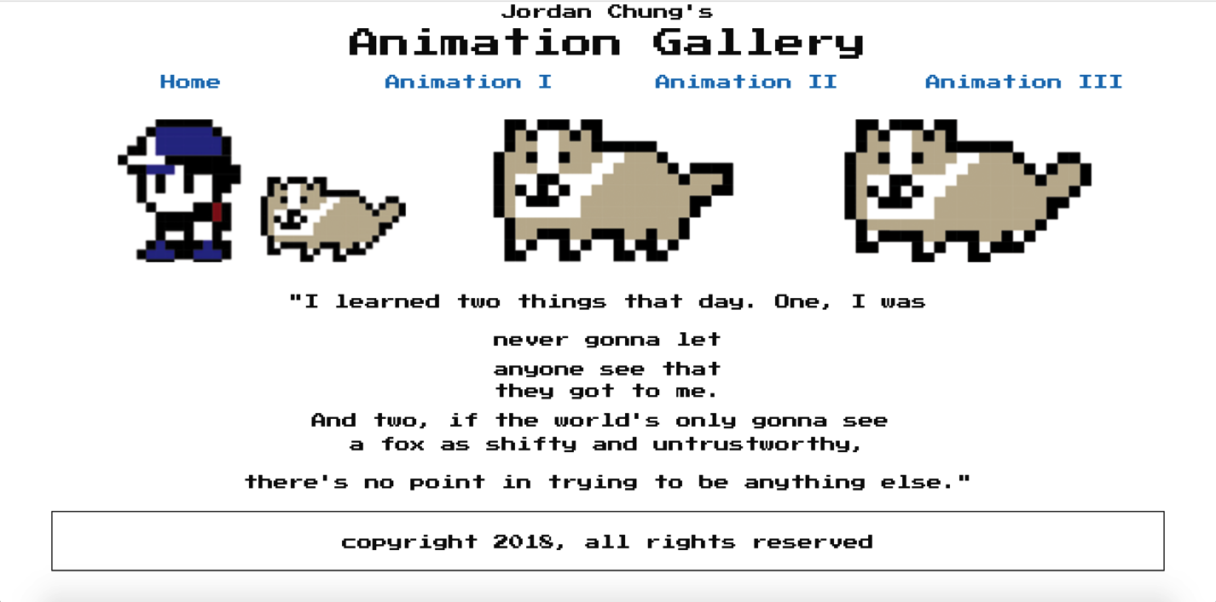

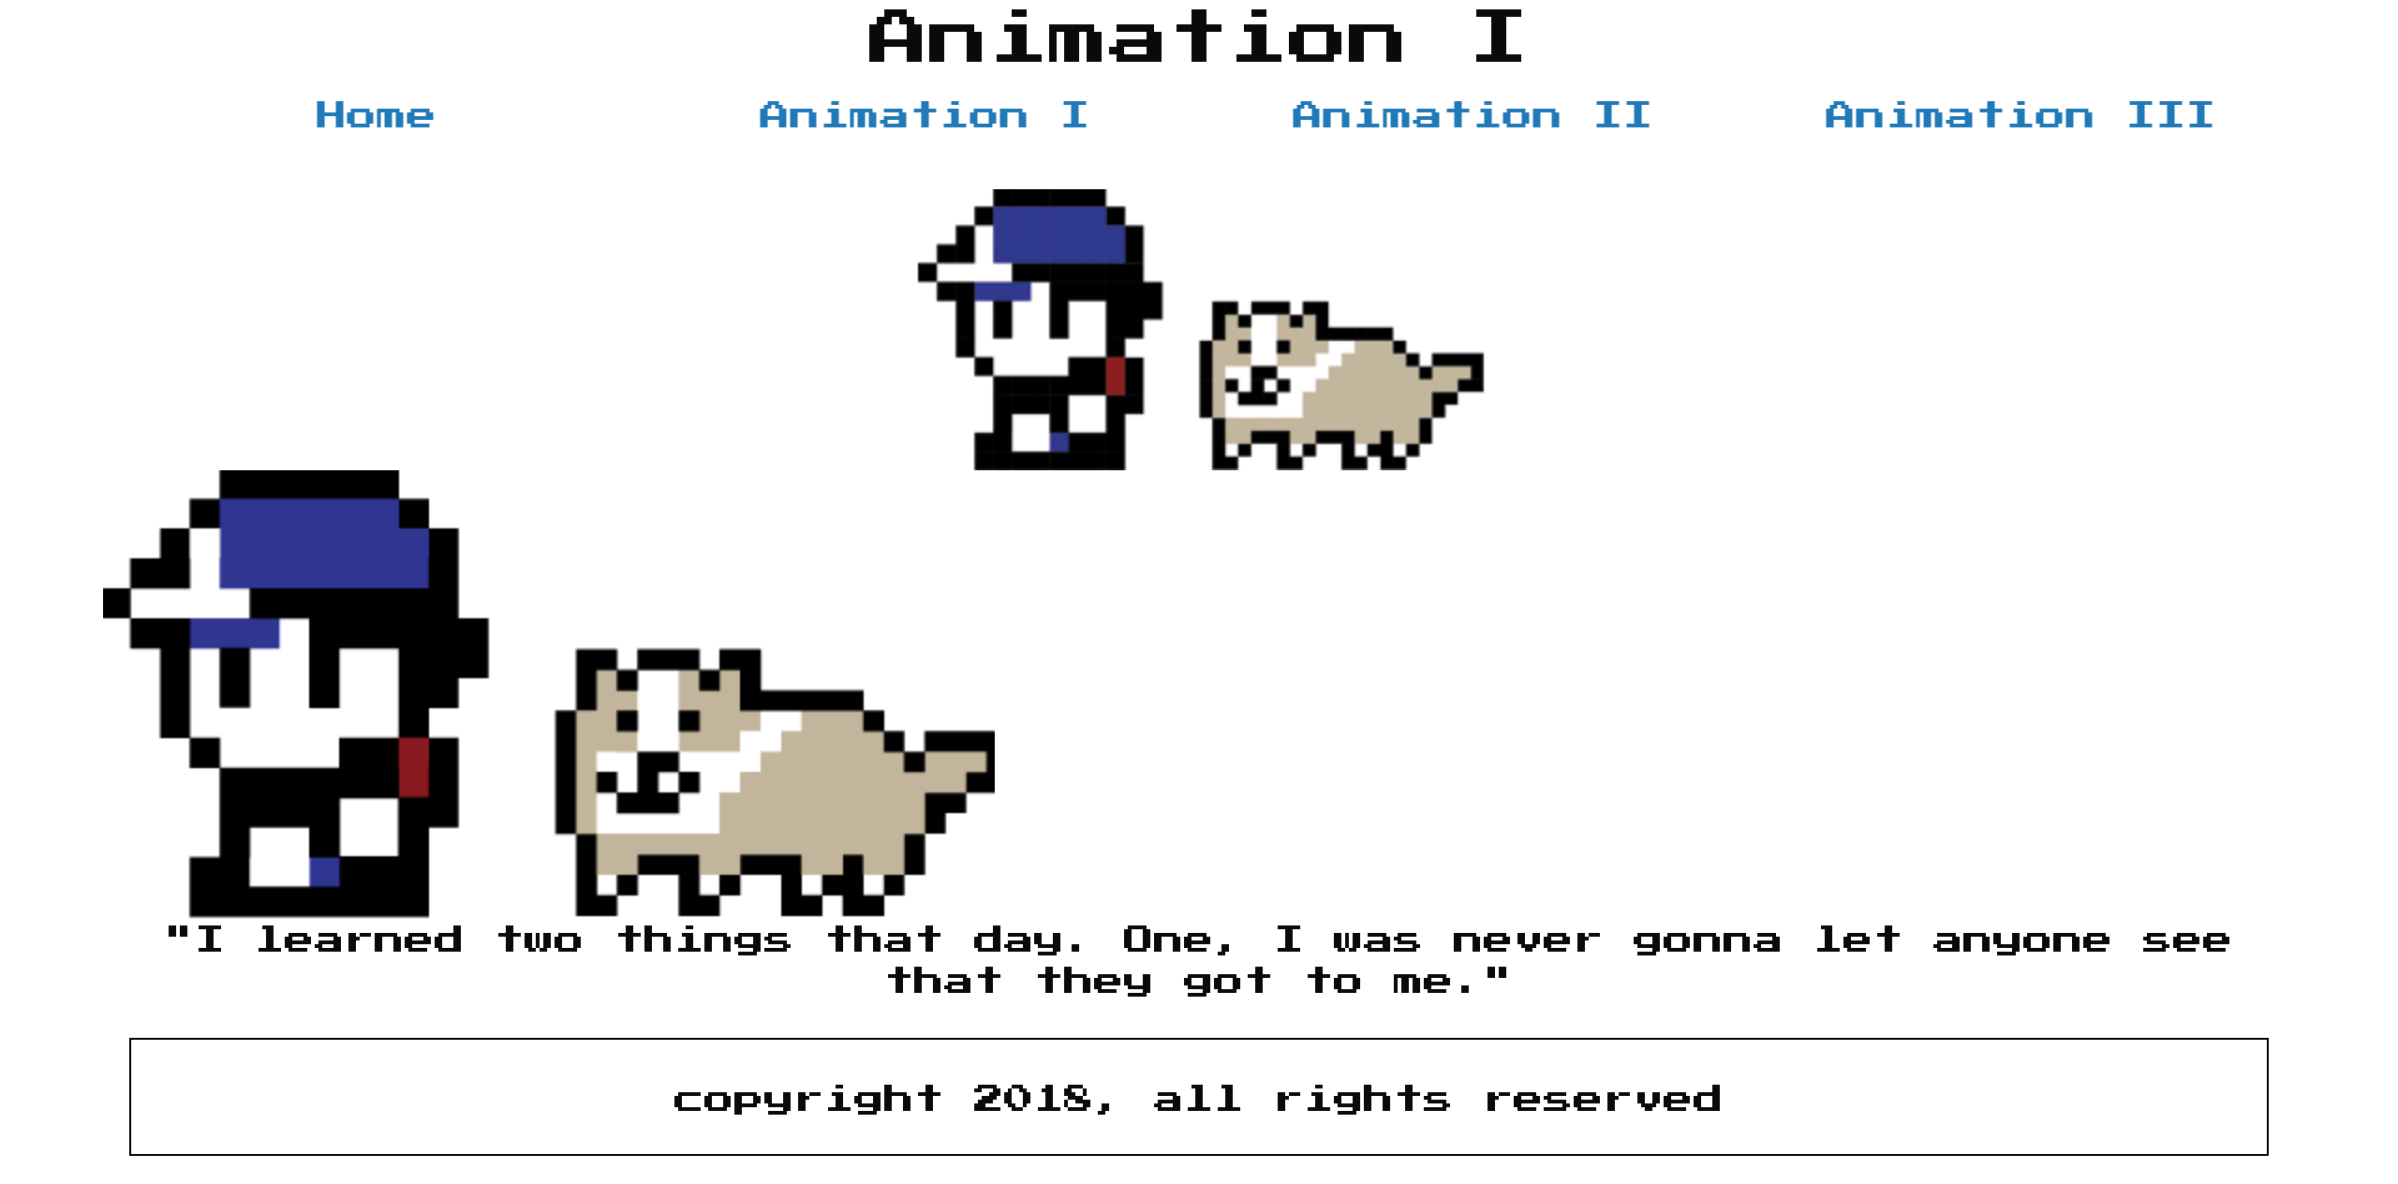

### Screen Shot 2018-02-13 at 6

### Screen Shot 2018-02-13 at 6

### Project Reflection:

(250 words – reflective writing –What was the most challenging part? What was the most exciting part now that the project is done? What did you learn in this assignment, what is your biggest takeaway?)

The most challenging part was to understand the new scripts, and sprite itself. I had to play around with it for a long time to finally get it right. Out of all it was a lot of fun, and I loved seeing my work move and interact. The most exciting part was figuring out the degrees on making my dog spin, and it was pretty hilarious. I learned about functions, commands, and a lot more about css. I am looking forward to the new project to have a long scrolling page because we are about to put our skills to the test. I hope I am able to make everything correct, and it definitely was a confidence booster seeing my work finally work. I thought the sprite, and transitions were going to be hard to figure out, but it was sooner than expected that I figured it all out.