Please answer the 4 following questions and provide unit test where necessary.

Practical Question 1: Set in Java

Sources: src/main/java/test/Cat.java
Sources: src/main/java/test/Test.java

Given the following Cat class we are creating 3 instances in Test, We are adding it to a Set. The Set should contains 2 element not 3.

Practical Question 2: Thread in Java

Sources: src/main/java/test/Test2.java

Write 2 Threads that lives for 15 seconds. Each threads should be independent and live for the full 15 seconds.

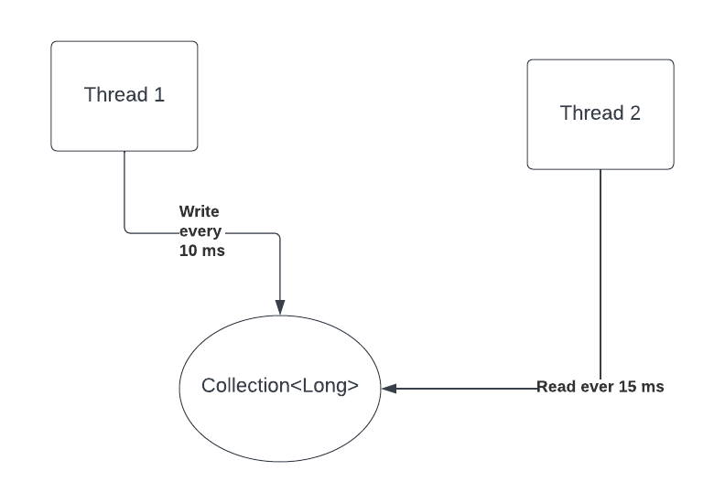

- 1 thread that write to the list a random long number every 10 ms second
- 1 thread that read from the list the first number every 15ms, output it to the console and delete it from the list.
The program runs for 15 seconds

Practical Question 3: Serialization

Sources: src/main/java/test/Test3.java

Serialize and de-serialize the Frame in Test3. The diagram below represent the serialization format of the object (the frame). Some bytes have the full 8 bit allocated, others have it partially

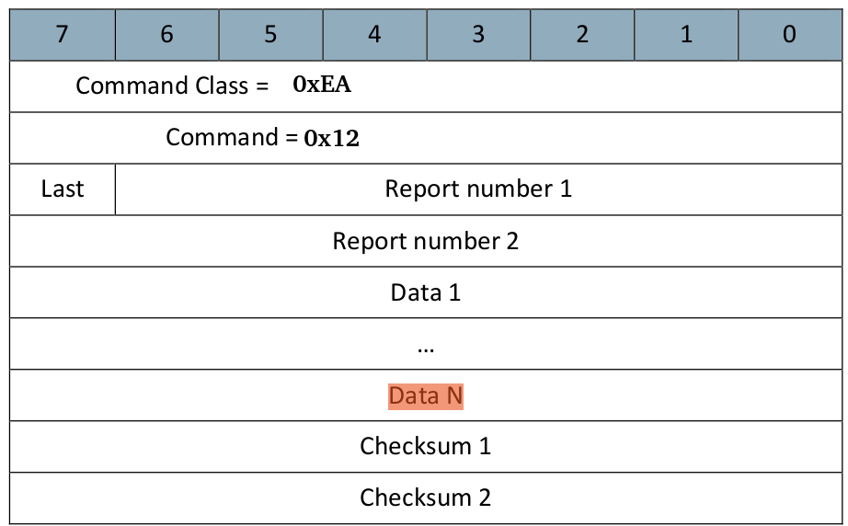

- Report Number 1 & 2 – is a short number
- Last – If the last field is set then the frame is the last one that will be sent, if the field is not set then other frames will be sent
- Data is a an arbitrary byte array
- Checksum – 2 bytes

Given the following byte array (in hex) 0xEA12810148454C4C4F20574F524C440001 write a class that will de-serialize (read) the frame by completing the read method (which read the byte array into an instance of the Frame class) and serialize the frame by completing the get method which write the instance of Frame into a byte array.

Practical Question 4: Algorithm

Sources: src/main/java/test/Test4.java

Given an array of integer, return the distance between the two closest numbers. For example if there is number 2, 4, 10, 6, ad 5, the shortest distance is one (between 5 and 6). Please implement the shortestDistance(int[]) method in Test4.

Practical Question 5: Debugging

There is a bug in test 5. Discover it and make the test succeed.

Practical Question 6: Protocol

Write a simple TCP Server application that echo the data sent to it. You can use telnet for the client application

Practical Question 7: AES-128

By completing the following methods, encrypt and decrypt the message using AES-128

