Jurassic Park
CS 345

Project Requirements

The following are important guidelines for programming the Jurassic Park assignment:

1) Use the arguments to the project3 command to optionally specify the number of park visitors. (The default is 45 visitors.)
2) Add a one second semaphore (tics10sec) in the scheduling loop (void pollInterrupts() in OS345p1.c).
3) Add a delta clock to your operating system. The delta clock ticks in tenth-of-a-second increments. (See Delta Clock.)
4) Create a task for each park visitor (NUM_VISITORS), driver (NUM_DRIVERS), and tour car (NUM_CARS). These tasks should all run at the same priority level.
5) Update the park data structure variables appropriately as visitor, driver, and car states change. The park is displayed using the park data struct every second by the jurassicTask task.
6) Each task (visitor, driver, and car) should create its own timing semaphore, which is used for timing functions (ie, arrival delay, standing in lines, time in gift shop or museum.) The delta clock should be used to signal these semaphores.
7) Park visitors should randomly arrive at the park over a 10 second period. In addition, visitors should stand in lines for a random time before requesting a ticket or entrance to the museum or gift shop (3 seconds maximum).
8) Use resource semaphores (counting) to control access to the park, the number of tickets available, and the number of people allowed in the gift shop and museum.
9) Use mutex semaphores (binary) to protect any critical sections of code within your implementation, such as when updating the delta clock, acquiring a driver to buy a ticket or drive a tour car, accessing global data, or sampling the state of a semaphore.
10) Use signal semaphores (binary) to synchronize and communicate events between tasks, such as to awaken a driver, signal data is valid, signal a mode change, etc.
11) The “SWAP” directive should be liberally inserted throughout your tasks. This is especially true for critical code (those areas protected by mutexes).
12) You are to implement a fair algorithm that prevents deadlock and starvation rather than detect them.

Delta Clock

Interfacing to “jurassicTask”

The “jurassicTask” task fills tour cars with passengers when a car is in the loading position, moves tour cars one position forward (if possible) around the park, randomly chooses a route at the route cross roads, and displays the status of Jurassic Park every second. The display is generated from the following C struct variables defined in the os345park.h file:

typedef struct
{
int numOutsidePark; // # outside of park
int numInPark; // # in park (P=#)
int numTicketsAvailable; // # left to sell (T=#)
int numRidesTaken; // # of tour rides taken (S=#)
int numExitedPark; // # who have exited the park
int numInTicketLine; // # in ticket line
int numInGiftLine; // # in gift shop line
int numInMuseumLine; // # in museum line
int numInCarLine; // # in tour car line
int numInGiftShop; // # in gift shop
int numInMuseum; // # in museum
int drivers[NUM_DRIVERS]; // driver state (-1=T, 0=z, 1=A,...)
CAR cars[NUM_CARS]; // cars in park
} JPARK;

Your visitor, driver, and tour car tasks need to update the appropriate variables at the appropriate times. The following global signal semaphores are defined in “os345park.c”:

Semaphore* fillSeat[NUM_CARS];
Semaphore* seatFilled[NUM_CARS];
Semaphore* rideOver[NUM_CARS];

All car tasks should

1) for each car (and seat in the car),
a. wait (fillSeat) to be filled, seat by seat, when the car is in loading position,
b. get a passenger from the tour car waiting line,
c. signal (seatFilled) that seat has been filled,
2) get a driver for the car,
3) wait for a signal (rideOver) that the ride is over,
4) and then allow driver to go back to sleep.

For example, to fill a seat in tour car carID, wait for available seat ready (fillSeat[carID]), then find a visitor from the tour car waiting line, and then signal (seatFilled[carID]) that you are ready for the next seat.

WAIT(fillSeat[carID]); // wait for available seat

SIGNAL(getPassenger); // signal for visitor
WAIT(seatTaken); // wait for visitor to reply
signalWhenRideDone(rider); // save ride done signal semaphore
SIGNAL(passengerSeated); // signal visitor in seat

// if last passenger, get driver
{ WAIT(needDriverMutex);

// wakeup attendant
SIGNAL(wakeupDriver);
...
// got driver (mutex)
SIGNAL(needDriverMutex);
}

SIGNAL(seatFilled[carID]); // signal ready for next seat

// if car full, wait until ride over
WAIT(rideOver[myID]);

Park variables correspond to the park display as follows:

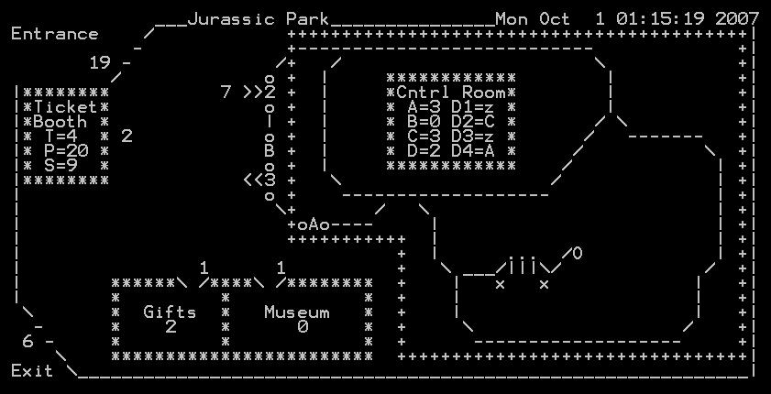
Driver Status
park.drivers[ ]
# of Passengers
park.cars[ ].passengers
# Exited Park
numExitedPark
# Waiting to Enter Park
numOutsidePark
# Tickets Available
numTicketsAvailable
# in Park
numInPark
# Rides Taken
numRidesTaken
Ticket Line
numInTicketLine
# in Gift Shop
numInGiftShop
# in Museum
numInMuseum
Tour Car Line
numInCarLine
Gift Shop Line
numInGiftLine
Museum Line
numInMuseumLine

Suggested Steps to Implementing the Jurassic Park Project

1. Implement delta clock.
a. Design data structure to hold delta times/events.
b. Add 1/10 second routine to pollinterrupts. Decrement top event and semSignal when time = 0.
c. Program an insert delta clock routine (insertDeltaClock(int time, Semaphore* sem)).
d. Thoroughly test the operation of your delta clock before proceeding.
2. Develop the car task.
a. Design car functionality and Jurassic Park interface. (Don’t worry about passengers yet.)
b. Implement design and integrate with os345 and Jurassic Park.
c. Observe correct car behavior.
3. Develop the visitor task.
a. Design visitor functionality and car task interface.
b. Implement design and integrate with os345 and car tasks. (Don’t worry about tickets yet.)
c. Use delta-clock to vary visitor time in all lines, museum, and gift shop.
d. Observe correct visitor behavior as a visitor moves through the park.
4. Develop the driver task.
a. Design driver functionality and interface with visitor and car tasks.
b. Implement design and integrate with os345, visitor, and car tasks. (Now is the time to worry about ticket sales and driver duties.)
c. Add ticket sales and driver responsibilities.

Grading and Pass-off
- 4 points – Implement a delta clock in the pollInterrupts routine (OS345.c) to signal semaphores after a certain time period, unblocking sleeping tasks. (The delta clock should tick down every 1/10 of a second.) Make the delta clock generic – able to signal any semaphore, binary or counting. The clock should handle mutual exclusion with insert/delete routines and not lose any time. Implement functions to insert and delete semaphores from the delta clock.
- 3 points – Create a single, re-entrant visitor task that
  - tries to enter the Jurassic Park at random times over a 10 second period. (Use a counting semaphore to restrict the number of visitors in the park to MAX_IN_PARK.)
  - upon being allowed in the park, a visitor must get in line to purchase a ticket. (Use a counting semaphore to restrict the number of available tickets to MAX_TICKETS.)
  - after successfully obtaining a ticket from a free driver, the visitor gets in the museum line. (Restrict museum and gift shop visitors to MAX_IN_MUSEUM and MAX_IN_GIFTSHOP.)
  - after visiting the museum, the visitor gets in the tour car line to wait until permitted to board a tour car. (Release visitor ticket after boarding tour car.)
  - when the touring car ride is over, the visitor moves to the gift shop line.
  - after visiting the gift shop, the visitor exits the park allowing another visitor into the park.
- 3 points – Create a single, re-entrant car task, which acquires (NUM_SEATS) visitors as it waits (fillSeat) and fills (seatFilled) requested car seats, acquires a driver, waits (rideOver) until the park ride is over, and then releases the seats/visitors.
- 2 points – Create a single, re-entrant driver task, which waits to be awakened and then either sells a visitor a ticket or else fills a driver seat in a car and waits until the ride is over. (The driver task controls ticket access using a resource semaphore.)
- 1 point – Use resource semaphores (counting) to control access to the park, the number of tickets available, and the number of people allowed in the gift shop and museum.
- 1 point – Use mutex semaphores (binary) to protect any critical sections of code within your implementation, such as when updating the delta clock, acquiring a driver to buy a ticket or drive a tour car, accessing global data, or sampling the state of a semaphore.
- 1 point – Use signal semaphores (binary) to synchronize and communicate events between tasks, such as to awaken a driver, signal data is valid, signal a mode change, etc.
- 5 points – Have the project3 command schedule the jurassicTask. Also schedule 4 driver tasks, 4 car tasks, and 45 (or a number passed as an argument in the task argc/argv variables) visitor tasks at the same priority level. Be prepared to insert SWAP directives anywhere in your task code.
# | Task Name | Priority | Blocking Semaphore
0 | CLI | 5 | inputCharReady
1 | jurassicPark | 20 | tics1sec
2-5 | driver(01-04) | 10 | wakeupDriver
6-9 | car(01-04) | 10 | fillxSeat
10-54 | visitor(01-45) | 10 | timeEventxx
- +2 points – bonus for early pass-off (at least one day before due date.)
- –2 points – penalty for not running visitor, car, and driver tasks at same priority level.
- –2 points – penalty for altering os345park.c.
- +2 points – bonus for approved improved interface to os345park.c.
- –2 points – penalty for each school day late.

