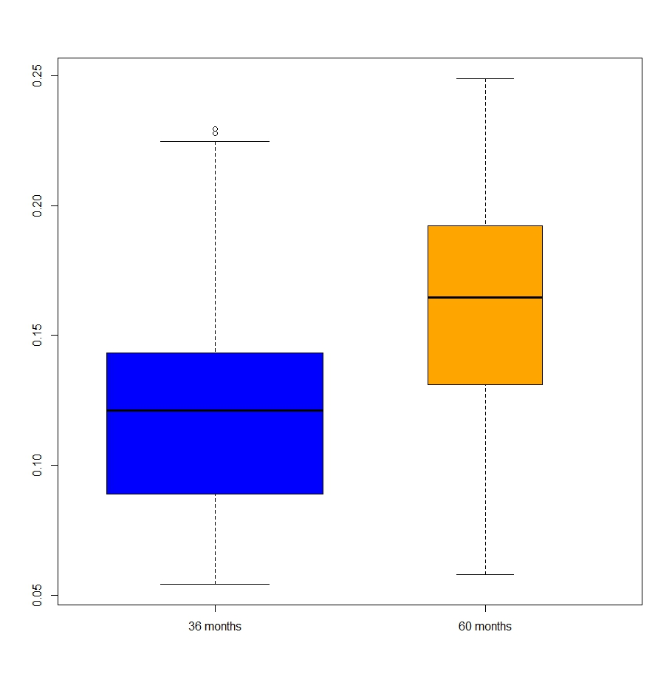

boxplot(Interest.Rate ~ as.factor(Loan.Length),col=c("blue","orange"),varwidth=TRUE)

Box and Whisker plot of Interest Rate using Loan Length as a factor variable. Save the two outliers with 36-month lengths and extremely high interest rates, 60-month length loans are almost all at a higher interest rate than 36-month loans.

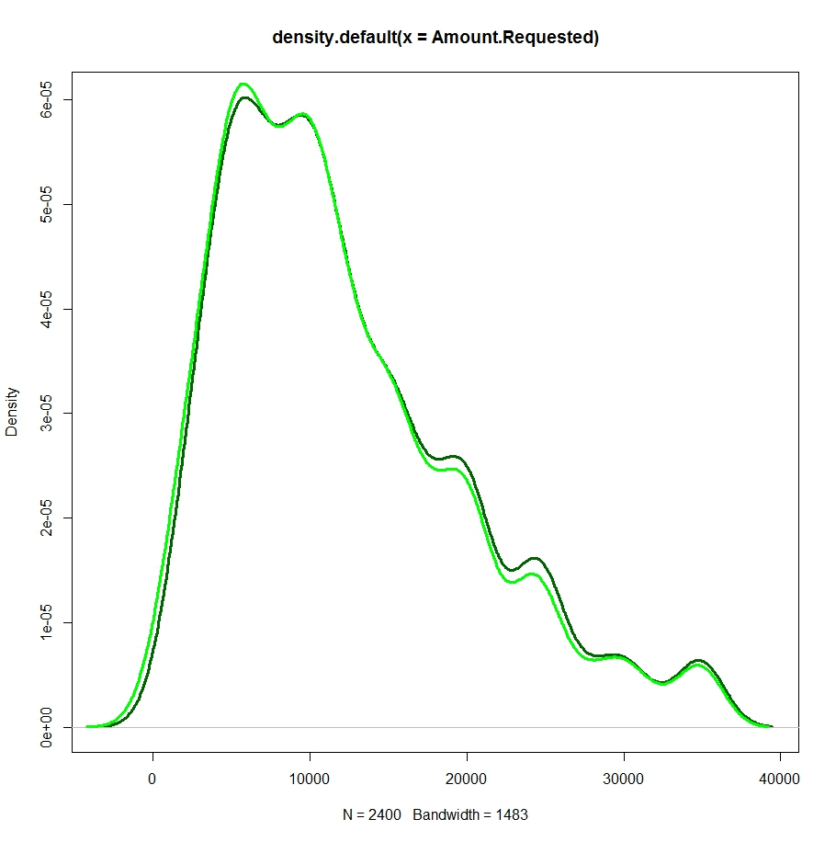

This was a density plot comparing Amount Requested (dark green) with Amount Funded By Investors (green). This graph does not suggest that investors ever funded more than what was requested (why would they do that?) – but it does show that as the amount requested increases, particularly in the 17000-28000 range, it was much more likely that the investors did not pay the full amount requested.

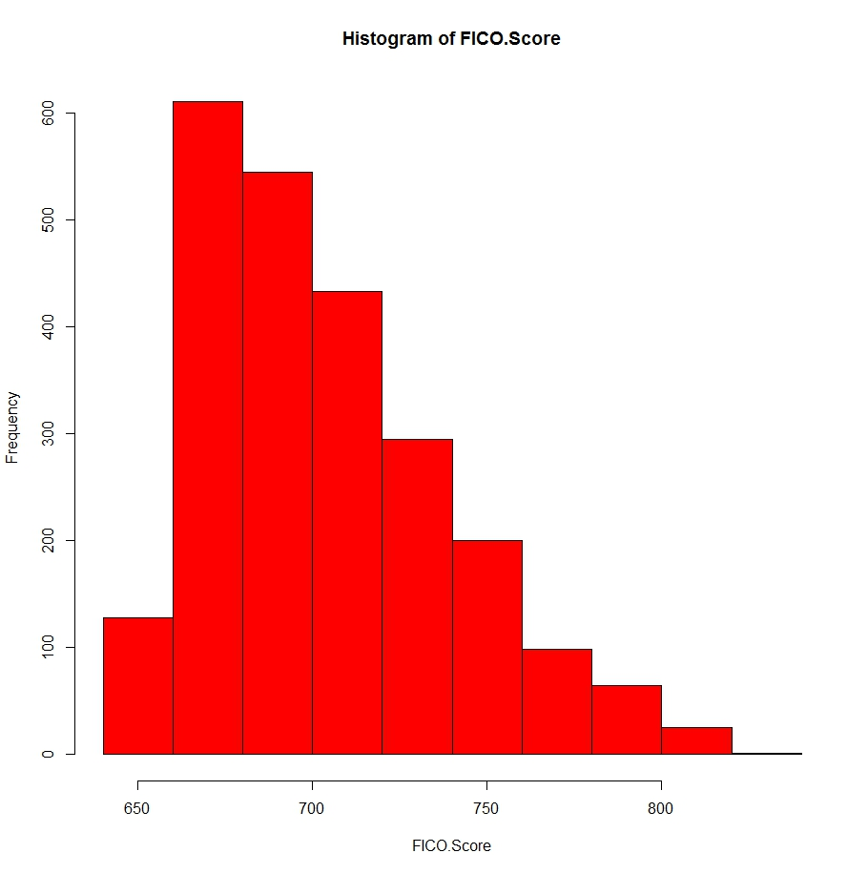

This is a histogram depicting FICO scores. It is a skewed distribution, and much more…immediately apparent that there is a measurable relationship here, perhaps, than the other graphs presented, suggesting that it might provide a good foundation, if you will, for comparisons with other variables.

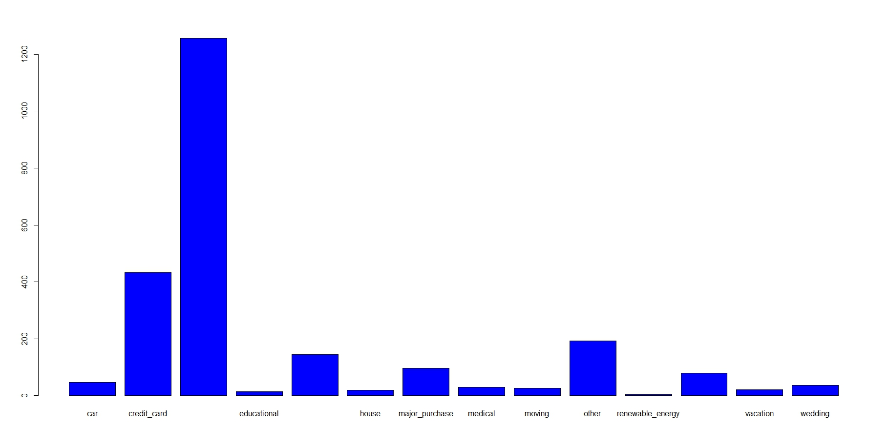

Unfortunately, not all the names could be displayed on this bar graph showing Loan Purposes. Between credit_card and educational is “debt_consolidation”. Between educational and house is “home_improvement”. Between renewable_energy and vacation is “small_business”. It’s easy to see that debt consolidation is the most popular reason – in fact, there are roughly as many loans taken out for debt consolidation as there are for all other reasons combined! This doesn’t say much about interrelations of the numbers in the data, but may prompt thought-provoking conclusions about human behavior.

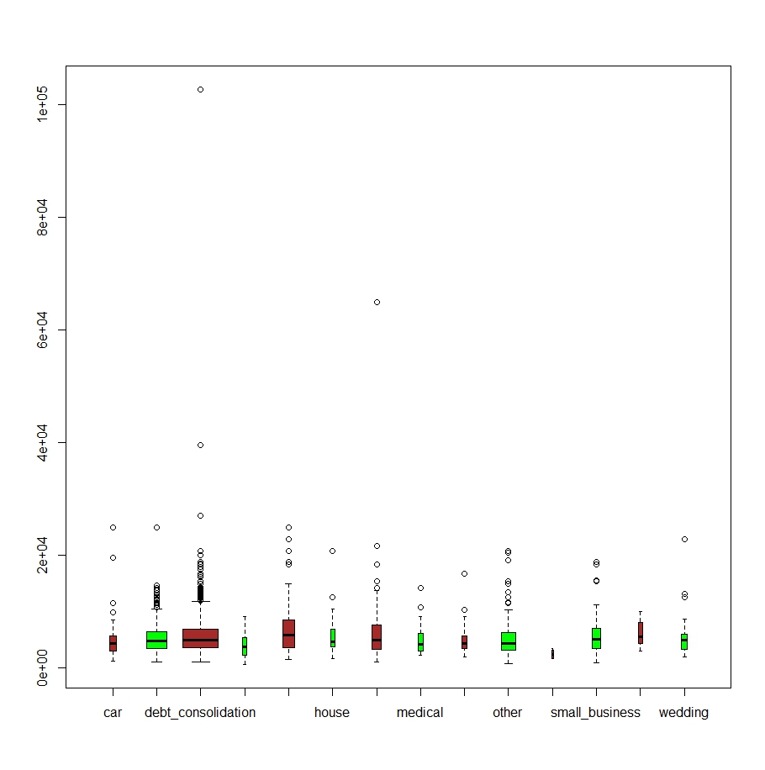

boxplot(Monthly.Income ~ as.factor(Loan.Purpose),col=c("brown","green"),varwidth=TRUE)

This is a boxplot of monthly income with loan purpose as a factor variable. It is included mostly for humorous effect; the sheer number of “outliers” is impressive, not to mention how extreme a few of them are. There seems to be no correlation at all between these variables…

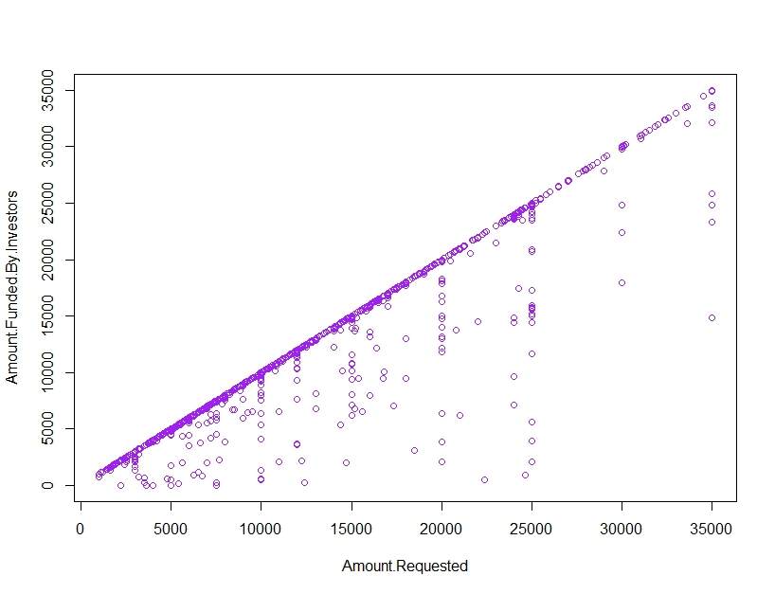

My favorite graph of the bunch. A beautiful, completely unsurprising linear relationship between Amount Requested and Amount Funded By Investors, showing that investors will not fund more than is requested. What is surprising is that investors seem to fund a higher percentage of the amount requested once it exceeds 25000…this motivates additional investigation, as the conclusion of “requesting more means you are more likely to be better funded” does not seem sensible.

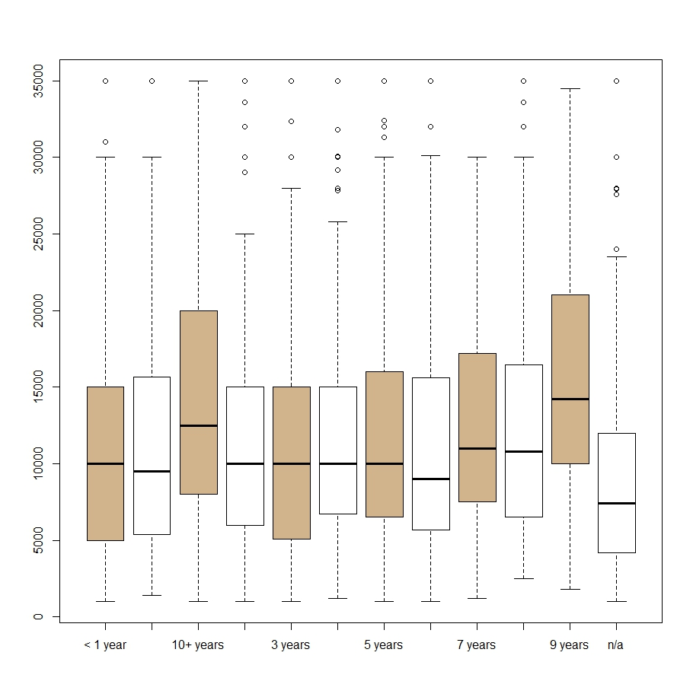 plot(Employment.Length,Amount.Requested,col=c("tan","white"))

A box and whisker plot of amount requested using employment length as a factor variable. The average amount requested is startlingly similar up until the 9th year of employment. After which, presumably, they enter a midlife crisis (which may or may not be supported by the fact that the vast majority of loans are made for debt consolidation).

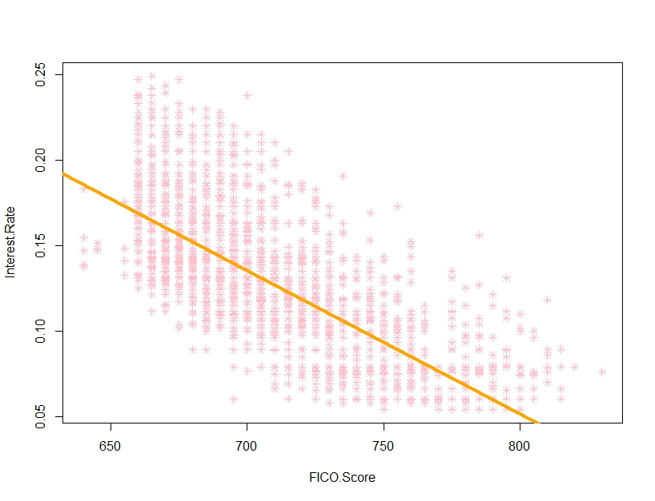

This graph plots interest rate against FICO score. Line added to show a clear relationship: interest rates are, across the board, lower for people with better FICO scores.