**/Use Case Diagram**

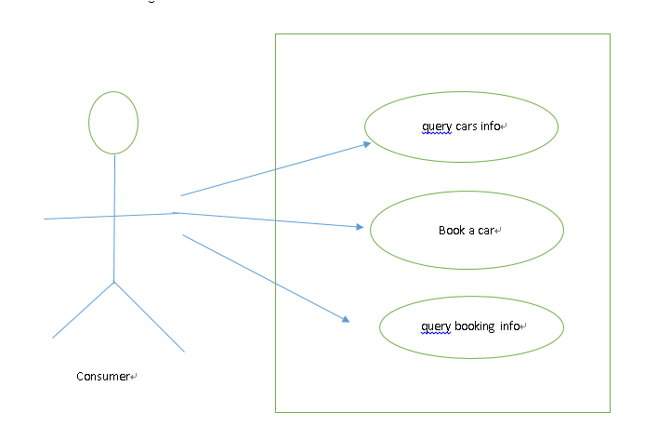

**/schema.sql**

DROP TABLE IF EXISTS car;

CREATE TABLE car (

carid varchar(50) NOT NULL,

model varchar(50) NOT NULL

);

INSERT INTO car VALUES ('888','BMW 650');

INSERT INTO car VALUES ('101','Toyota Camry');

INSERT INTO car VALUES ('102','Toyota Camry');

DROP TABLE IF EXISTS carbooking;

CREATE TABLE carbooking (

id int(10) unsigned NOT NULL AUTO_INCREMENT,

phonenum varchar(50) NOT NULL,

carid varchar(50) NOT NULL,

starttime DATE NOT NULL,

endtime DATE NOT NULL,

deleteflag varchar(2) NOT NULL DEFAULT 'N',

PRIMARY KEY (id)

);

/**assumptions**.

For this small assignment, REST services, web framework are necessary.

Sprintboot with embedded tomcat and database is one of the best choices.

**/API spec** <http://carbookinglixu.azurewebsites.net/swagger-ui.html#/>

**/URL**

https://carbookinglixu.azurewebsites.net/

POST /assignment/carbooking book a car

GET /assignment/carbooking/cars query car info

GET /assignment/carbooking/{phonenum} query car booking info