 | CSCI/ISAT B104  Computer Programming Techniques, Practices, and Tools  Fall 2025  Project Documentation  Team XX

Contents
Project Contributions by Team Member 2
Collaboration Tools 3
YRBS Questions Explored 4
YRBS Demographic Information Explored 5
YRBS Data Winnowing & Retrieval 6
Research Question and/or Hypothesis 7
Bibliography 8
Acknowledgements 8

Project Contributions by Team Member

Members and their Contact Information
Member | Email | Text
Jordan Maharaj | jmaharaj@email.uscb.edu | (518) 569-7554
Luis Lopez | igotchicken@uscb.edu | (843) -

Overall
Relative Contribution of each member over the course of the entire project

Member | Contribution | Total Hours
Jordan Maharaj | 63 % | 74.0
 | 37 % | 43.5

YRBS Question Identification & Documentation
Member | Contribution | Hours | Components
Jordan Maharaj | 59 % | 28.5
Leroy Jenkins | 41 % | 19.75

YRBS Data Winnowing & Retrieval
Member | Contribution | Hours | Components
James Doe | 70 % | 13.75
Leroy Jenkins | 30 % | 6.25

Data Analysis (via Python)
Member | Contribution | Hours | Components
James Doe | 80 % | 16.75
Leroy Jenkins | 20 % | 4.25

Data Visualization (via Python)
Member | Contribution | Hours | Components
James Doe | 50 % | 12.5
Leroy Jenkins | 50 % | 12.5

GUI Creation (via Python)
Member | Contribution | Hours | Components
James Doe | 50 % | 12.5
Leroy Jenkins | 50 % | 12.5

Python Script Creation
Member | Contribution | Hours | Components
James Doe | 50 % | 12.5
Leroy Jenkins | 50 % | 12.5

Presentation Preparation & Practice
Member | Contribution | Hours | Components
James Doe | 100 % | 2.5
Leroy Jenkins | 0 % | 0.25

Project Documentation & Administration
Member | Contribution | Hours | Components
James Doe | 100 % | 2.5
Leroy Jenkins | 0 % | 0.25

Collaboration Tools
Tools to assist with task management, version control, communication, etc.

- GitHub

YRBS Questions Explored
Questions & responses explored over the course of the project.

Place screenshots of the two questions below. Be sure to include their “response keys”.

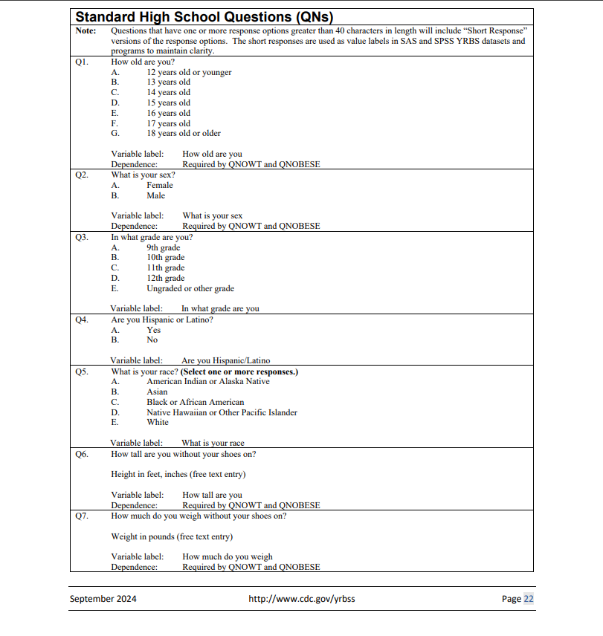
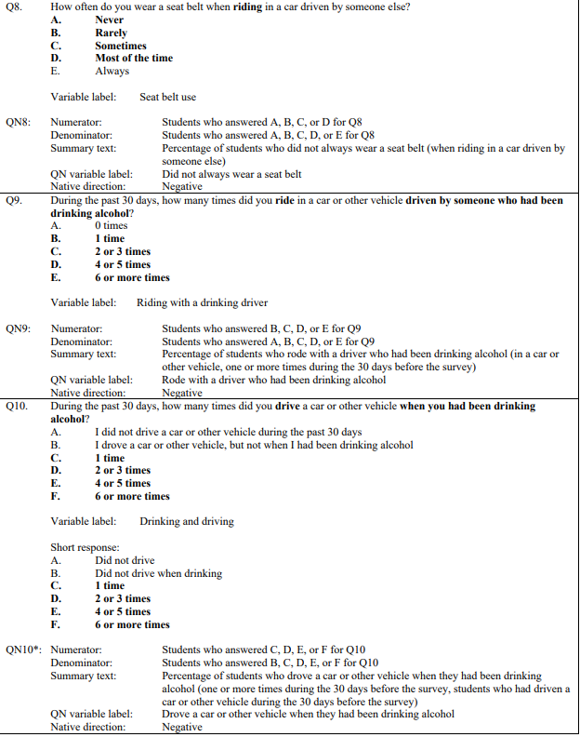
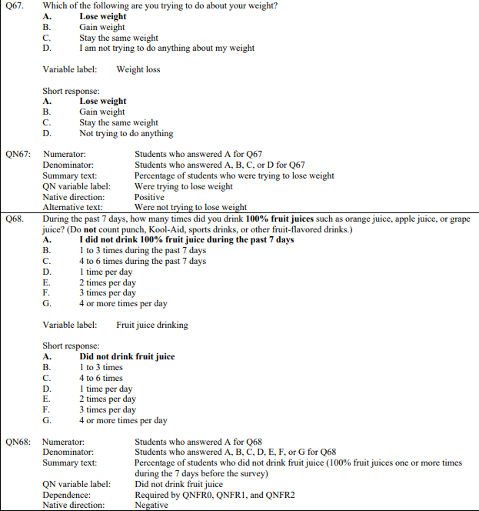

YRBS Demographic Information Explored
Demographic questions & responses explored over the course of the project

Place screenshots of the questions below. Be sure to include their “response keys”.

Demographic information includes gender, age, height, weight, ethnicity, etc.

YRBS Data Winnowing & Retrieval
How we winnowed & retrieved the data explored over the course of the project.

Write down a step-by-step guide explaining how you winnowed & retrieved the data from the YRBS site.

Place screenshots of the SQL code and other relevant details here
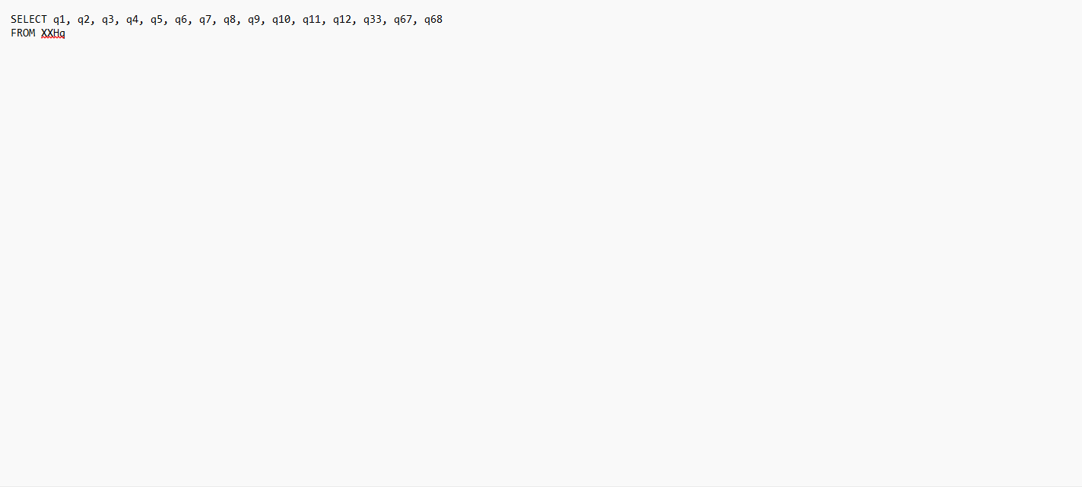

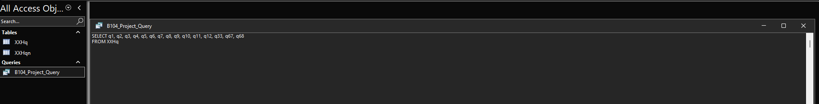
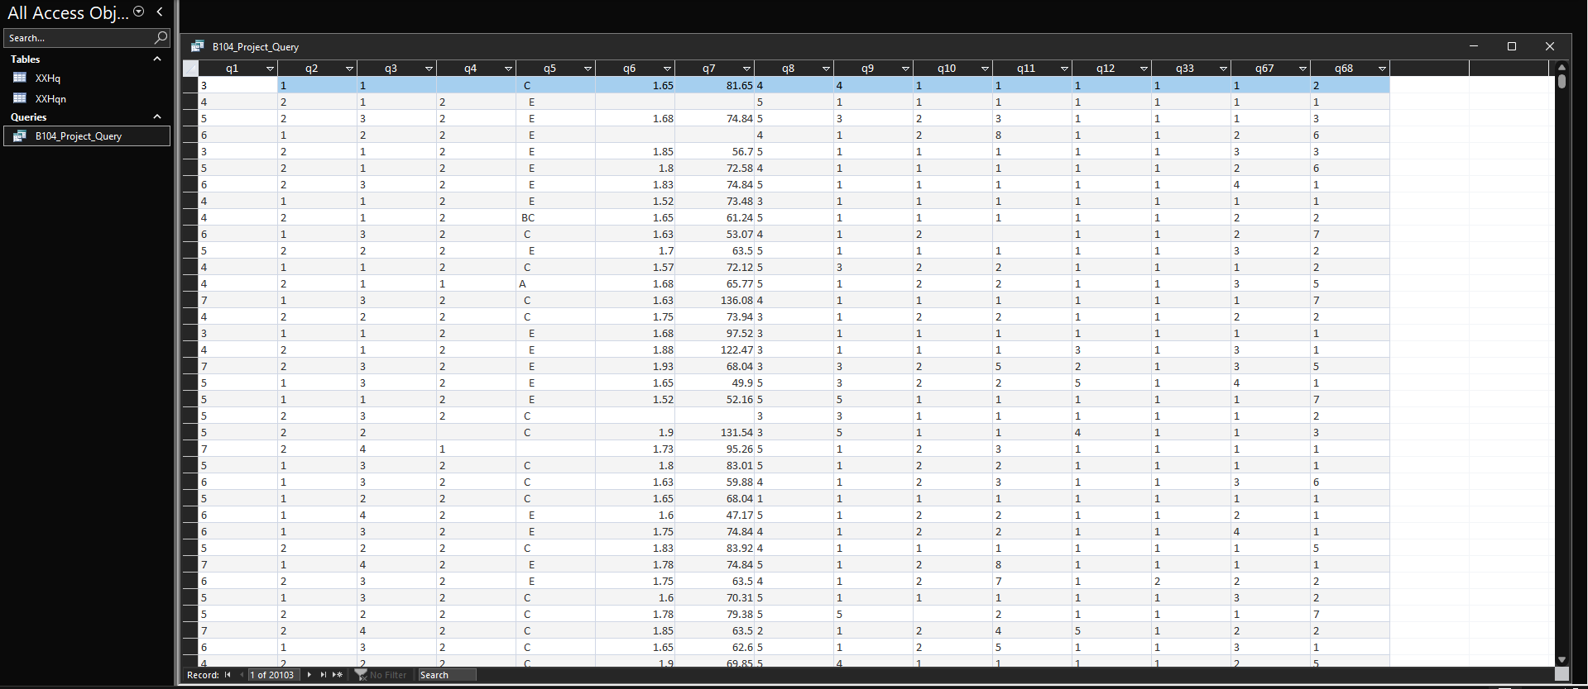
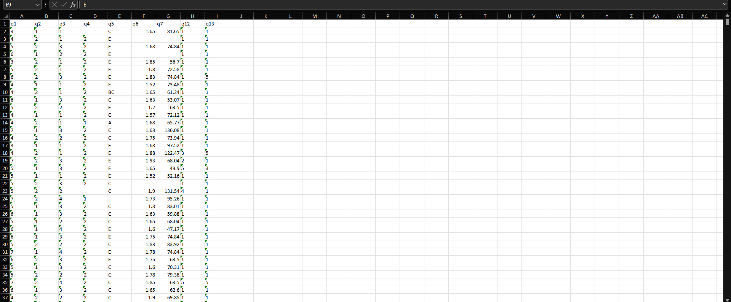

Research Question and/or Hypothesis
The specific research questions we sought to answer.

Write down your research question here.

Bibliography
Resources which we used over the course of the project.

Citations for:

Python Library Documentation
Python Tutorials
Best Practices
Poster Templates
Stack Overflow questions/answers
Etc.

Follow APA format

Acknowledgements

Specific peers who helped you debug
Upper class students, parents, siblings, friends, etc. who provided feedback and guidance
Etc.

