 | CSCI/ISAT B104  Computer Programming Techniques, Practices, and Tools  Fall 2025  Project Documentation  Team XX

Contents
Project Contributions by Team Member 2
Collaboration Tools 3
YRBS Questions Explored 4
YRBS Demographic Information Explored 5
YRBS Data Winnowing & Retrieval 6
Research Question and/or Hypothesis 7
Bibliography 8
Acknowledgements 8

Project Contributions by Team Member

Members and their Contact Information
Member | Email | Text
Jordan Maharaj | jmaharaj@email.uscb.edu | (518) 569-7554
Luis Lopez | Ls152@email.uscb.edu | (843) 298-0906

Overall
Relative Contribution of each member over the course of the entire project

Member | Contribution | Total Hours
Jordan Maharaj | 50 % | 22
Luiz Lopez | 50 % | 22

YRBS Question Identification & Documentation
Member | Contribution | Hours | Components
Jordan Maharaj | 50% | 3
Luis Lopez | 50% | 3 | Selected YRBS question, wrote each question, explained what each question measures, connected question to the project

YRBS Data Winnowing & Retrieval
Member | Contribution | Hours | Components
Jordan Maharaj | 50 % | 2
Luis Lopez | 50 % | 2 | Downloaded dataset, removed unnecessary columns, cleaned everything

Data Analysis (via Python)
Member | Contribution | Hours | Components
Jordan Maharaj | 50 % | 4
Luis Lopez | 50 % | 4 | Used pandas to analyze data, calculated the average. Worked on questions

Data Visualization (via Python)
Member | Contribution | Hours | Components
Jordan Maharaj | 50% | 3
Luis Lopez | 50 % | 3 | Created graphs, labeled axes and titles, chose color for the graphs

GUI Creation (via Python)
Member | Contribution | Hours | Components
Jordan Maharaj | 50 % | 2
Luis Lopez | 50 % | 2 | Created a simple working gui  Added buttons

Python Script Creation
Member | Contribution | Hours | Components
Jordan Maharaj | 50% | 15
Luis Lopez | 50 % | 15 | Wrote main python code  Connected the questions  Fixed errors  Tested final results

Presentation Preparation & Practice
Member | Contribution | Hours | Components
Jordan Maharaj | % | 2
Luis Lopez | 50 % | 2 | Created slides  Practiced explaining project

Project Documentation & Administration
Member | Contribution | Hours | Components
Jordan Maharaj | 75% | 1.5 | Took screenshots and place them,
Luis Lopez | 25% | 30 mins | Organized documents  Filled in tables  Formatted final report

Collaboration Tools
Tools to assist with task management, version control, communication, etc.

- GitHub
- IMessage

YRBS Questions Explored
Questions & responses explored over the course of the project.

Place screenshots of the two questions below. Be sure to include their “response keys”.

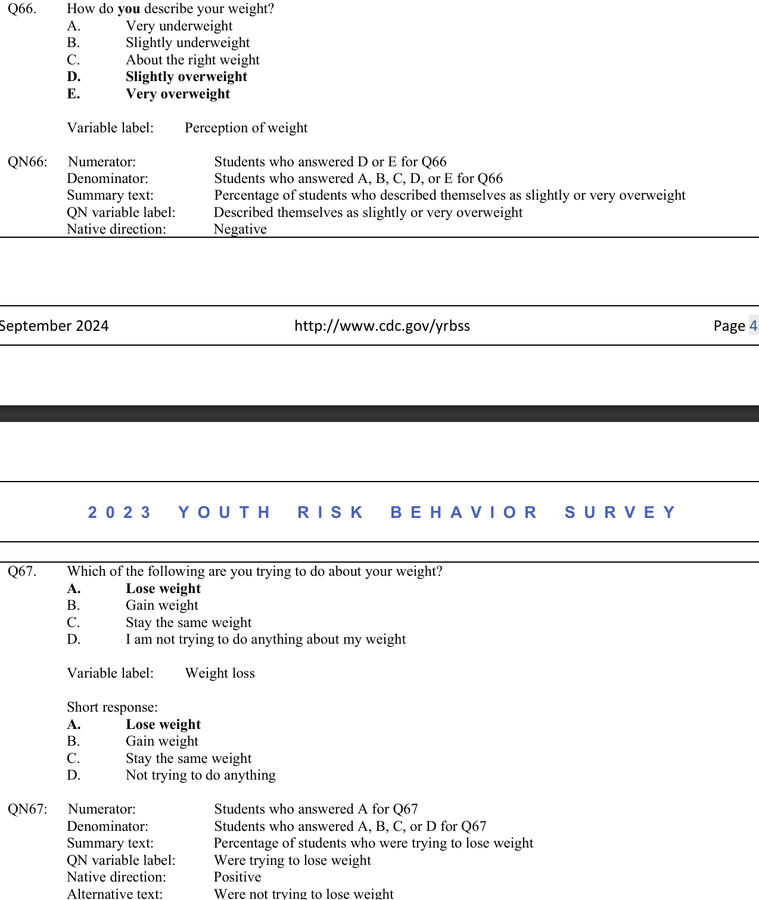
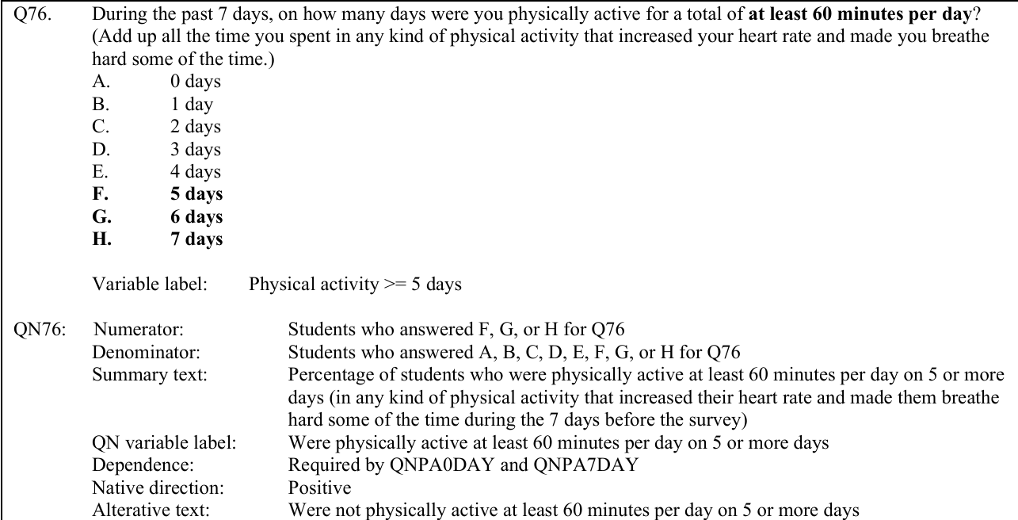

YRBS Demographic Information Explored
Demographic questions & responses explored over the course of the project

Place screenshots of the questions below. Be sure to include their “response keys”.

Demographic information includes gender, age, height, weight, ethnicity, etc.



YRBS Data Winnowing & Retrieval
How we winnowed & retrieved the data explored over the course of the project.

Write down a step-by-step guide explaining how you winnowed & retrieved the data from the YRBS site.

Place screenshots of the SQL code and other relevant details here
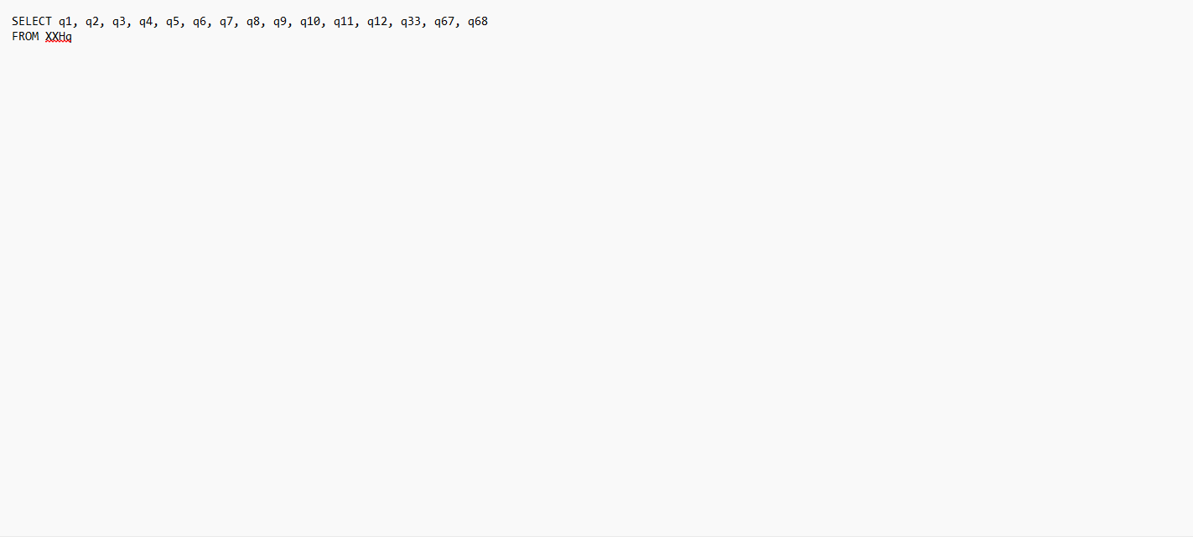

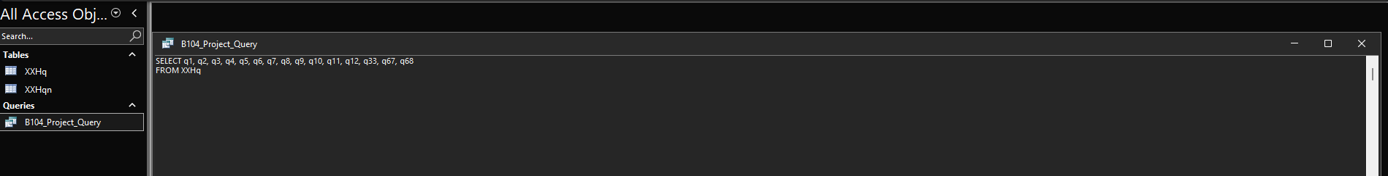
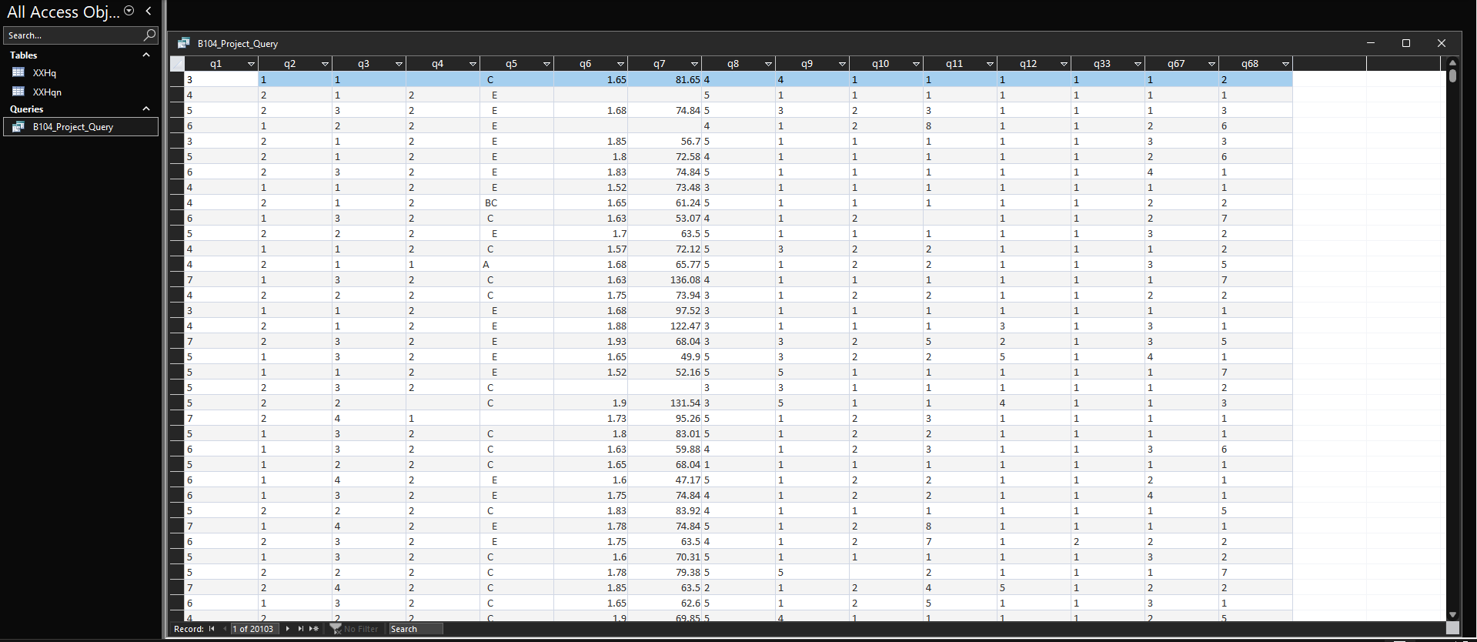
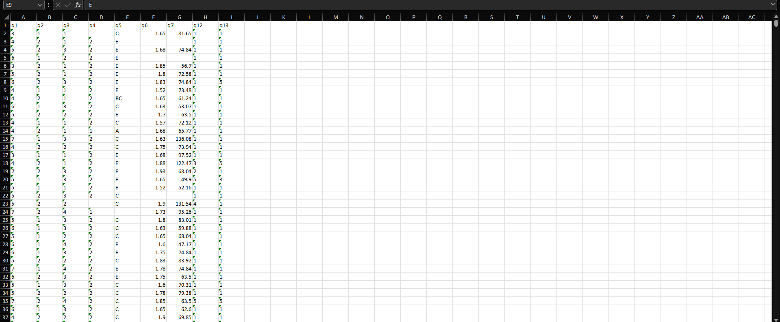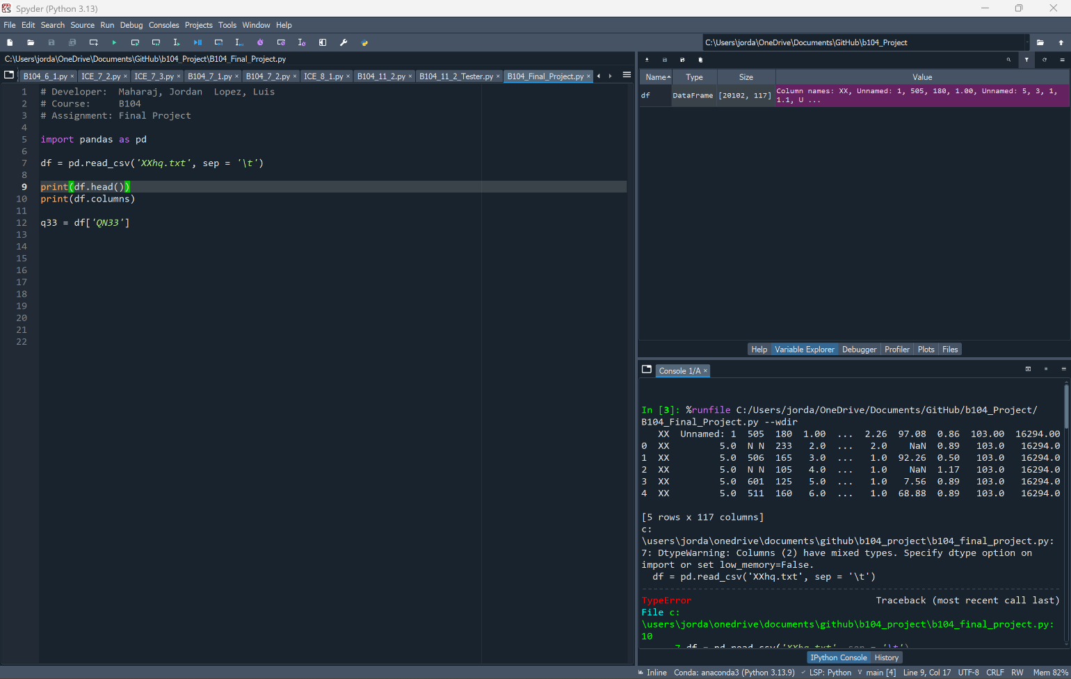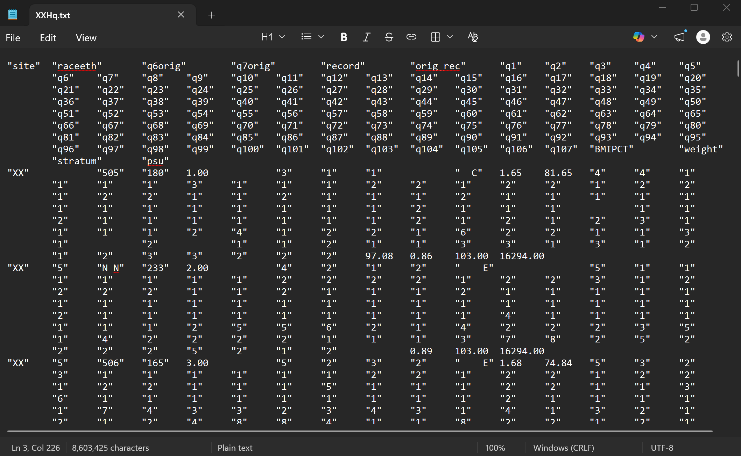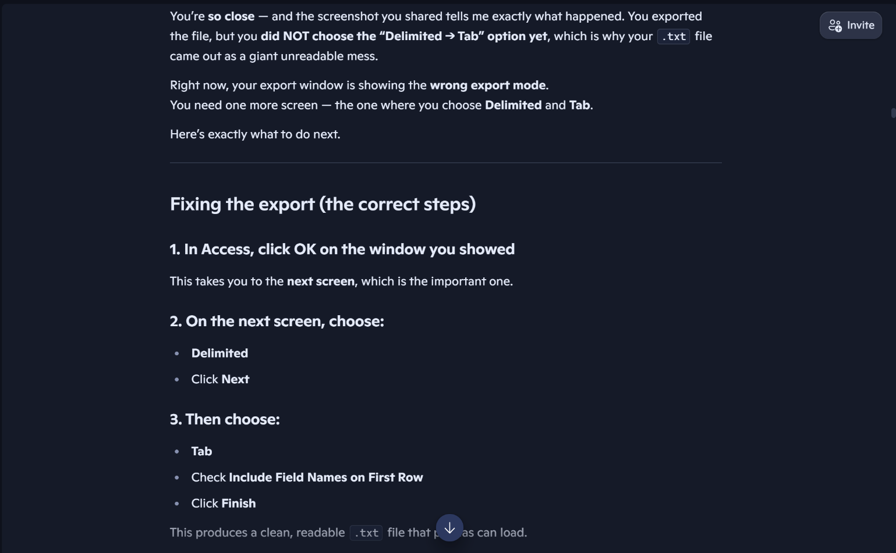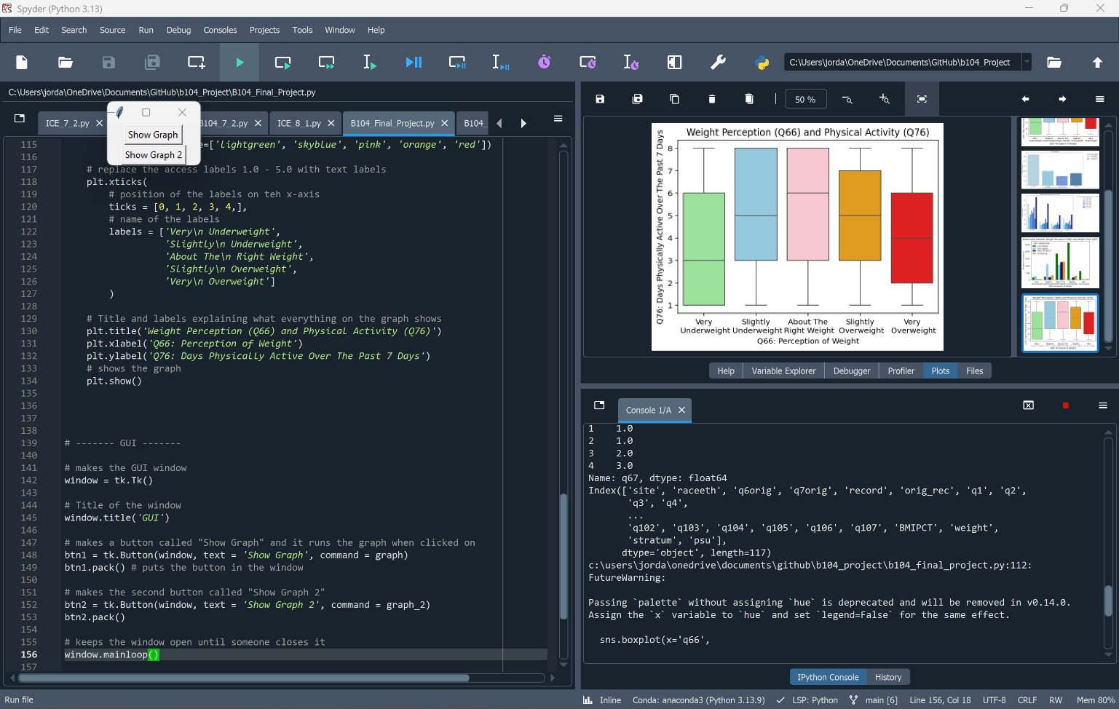

Research Question and/or Hypothesis
The specific research questions we sought to answer.
Q66. How do you describe your weight
Q67. Which of the following are you trying to do about your weight?
Q76. During the past 7 days, on how many days were you physically active for a total of at least 60 minutes per day? (Add up all the time you spent in any kind of physical activity that increased your heart rate and made you breathe hard some of the time.)

Write down your research question here.

Bibliography
Resources which we used over the course of the project.

Citations for:

Python Library Documentation
Python Tutorials
Best Practices
Poster Templates
Stack Overflow questions/answers
Etc.

Follow APA format

“YouTube Video.” YouTube, https://www.youtube.com/watch?v=gpQDZ5CNY5w. Accessed 25 Apr. 2026.

Example gallery — seaborn 0.11.2 documentation. (n.d.). Seaborn.pydata.org. https://seaborn.pydata.org/examples/index.html
‌Graphic User Interface FAQ. (2026). Python Documentation. https://docs.python.org/3/faq/gui.html#graphic-user-interface-faq
‌W3Schools. (2019). Python Tutorial. W3schools.com. https://www.w3schools.com/python/default.asp
‌
“Canva.” Canva, 2026, www.canva.com/design/DAHHlae7zIw/gQUsl3PFw8bdvyHXj4nrzQ/edit. Accessed 24 Apr. 2026.

Acknowledgements

Specific peers who helped you debug
Upper class students, parents, siblings, friends, etc. who provided feedback and guidance
Etc.

