Couple Rater

Kristofer Plunkett
Mathias Klous
James Peck
Matthew Gable
Richard Jordan
Nathan Sjoquist

System Design Specification and Planning Document

Draft 2
May 12th, 2008

CSE 403 - CSRocks Inc.
Revisions
Version | Primary Author(s) | Description of Version | Date Completed
1 | James Peck  Matthew Gable Kristofer Plunkett  Mathias Klous  Richard Jordan  Nathan Sjoquist | Initial draft. | 04/28/08
2 | James Peck  Matthew Gable Kristofer Plunkett  Mathias Klous  Richard Jordan  Nathan Sjoquist | Beta revision  Updated:  UML Sequence Diagram #1  UML Class Diagram  Risk Assessment  Team Member Responsibilities  Database Schema  Test Plan (minor change) | 05/12/2008
3 | James Peck  Matthew Gable Kristofer Plunkett  Mathias Klous  Richard Jordan  Nathan Sjoquist | Final Revsion  Updated:  Risk Assessment  Database Schema  Documentation Plan  Project Schedule | 06/04/2008

System Architecture

Introduction
Our system will be deployed on the Facebook platform, and we will adopt the Ruby on Rails framework for our software development environment. Users access our application through the Facebook website, and the Facebook web application forwards this request to our application. Our system responds to Facebook using Facebook Markup Language (FBML)--a variation of HTML with Facebook specific tags.

The Deployment View diagram shows, at a high-level, how our application interacts with the Facebook application and defines the known hardware and software. Our Design View provides a detailed overview of how our application will appear. Our two Process Views show in greater detail how users interact with our application, through the Facebook website. Finally, we provide a schema for our database and list some design assumptions and
alternatives.

Deployment view

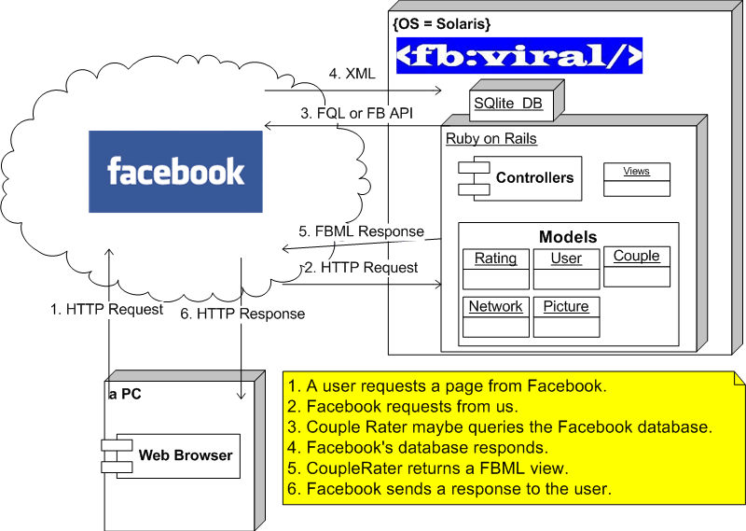

Design view - UML class diagram

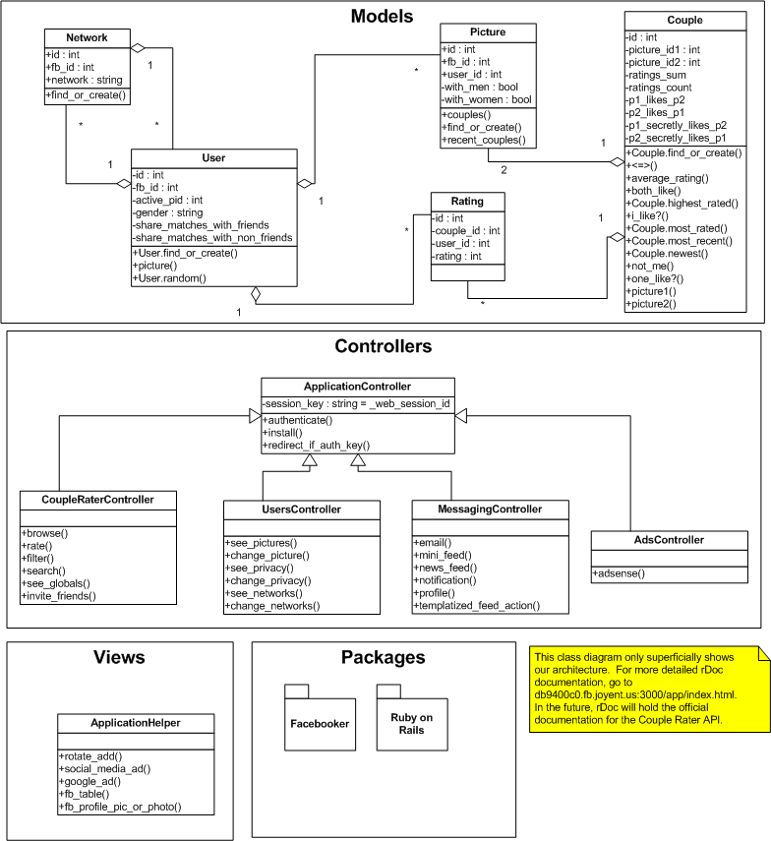

Process view – UML sequence diagrams

Sequence diagram 1: User rates a couple, based on Use Case 3. 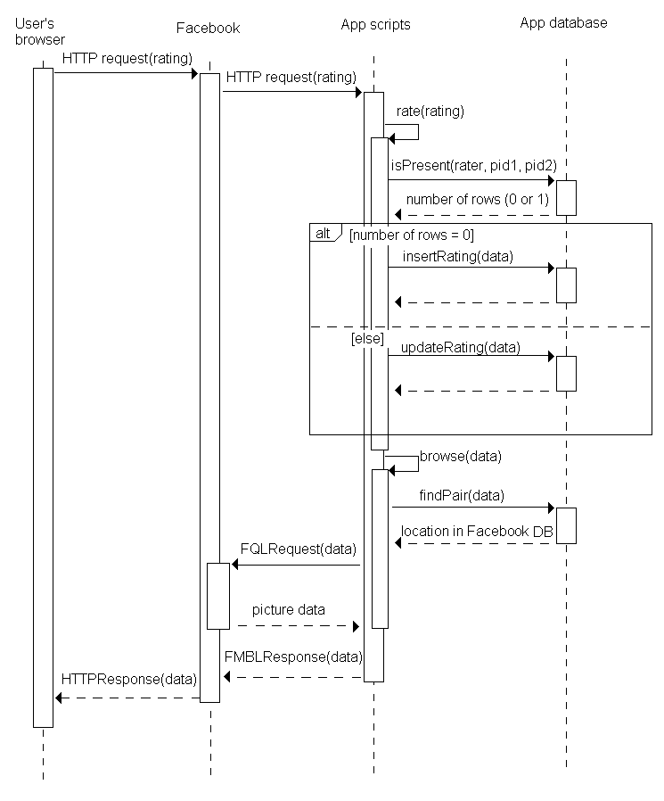

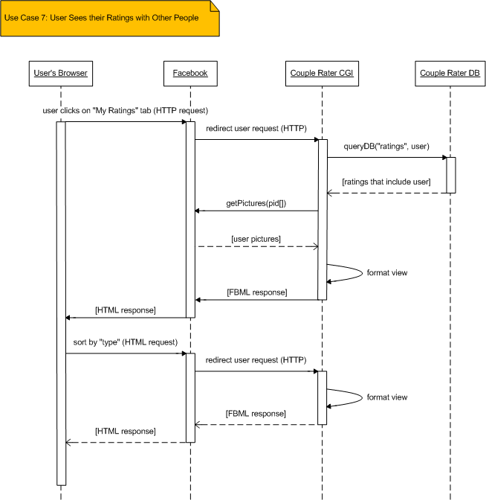

Database Schema

The following data is a snapshot of the current version of our database schema.
ActiveRecord::Schema.define(:version => 21) do  create_table "couples", :force => true do |t|  t.integer "picture_id1"  t.integer "picture_id2"  t.datetime "created_at"  t.datetime "updated_at"  t.boolean "picture1_likes_picture2"  t.boolean "picture2_likes_picture1"  t.integer "ratings_sum"  t.integer "ratings_count"  t.boolean "picture1_secretly_likes_picture2"  t.boolean "picture2_secretly_likes_picture1"  end  create_table "couples_networks", :id => false, :force => true do |t|  t.integer "couple_id"  t.integer "network_id"  end  create_table "networks", :force => true do |t|  t.integer "fb_id"  t.string "network"  t.datetime "created_at"  t.datetime "updated_at"  end  create_table "networks_users", :id => false, :force => true do |t|  t.integer "network_id"  t.integer "user_id"  end  create_table "pictures", :force => true do |t|  t.integer "fb_id"  t.integer "user_id"  t.datetime "created_at"  t.datetime "updated_at"  end | create_table "ratings", :force => true do |t|  t.integer "couple_id"  t.integer "rating"  t.integer "user_id"  t.datetime "created_at"  t.datetime "updated_at"  end  create_table "sessions", :force => true do |t|  t.string "session_id", :null => false  t.text "data"  t.datetime "created_at"  t.datetime "updated_at"  end  add_index "sessions", ["updated_at"], :name => "index_sessions_on_updated_at"  add_index "sessions", ["session_id"], :name => "index_sessions_on_session_id"  create_table "users", :force => true do |t|  t.integer "fb_id"  t.integer "picture_id"  t.datetime "created_at"  t.datetime "updated_at"  t.boolean "gender"  t.boolean "with_men"  t.boolean "with_women"  t.boolean "friends_can_see_my_matches"  t.boolean "non_friends_can_see_my_matches"  t.string "first_name"  t.string "last_name"  t.string "session_key"  t.boolean "see_question_marks"  end

The database supports four main operations:

- Choose two random pictures that fit pairing and network constraints
- Record a rating given two pictures
- Calculate a summary rating for two pictures
- Find all results for a user, grouped by user's picture and ordered by rating

Design Alternatives and/or Assumptions

Alternatives
If the Ruby on Rails framework is not sufficient to meet our requirements, we will be able to switch software development platforms (Java or PHP).

Assumptions
Because we will be deploying our application using the Facebook platform, we assume the supported Facebook API will provide access to user-specific information. We are also required to communicate to Facebook using FBML.

Development Plan

Team Structure

The following team member roles and responsibilities have been defined.

Project Manager – Kristofer Plunket
Development Lead – Richard Jordan
Databases and Back-end Development – James Peck, Matt Gable
UI and Front-end Development – Nathan Sjoquist
Testing and Documentation Lead – Mathias Klous

The proiect manager is responsible for overall team organization, coordinating with CSRocks Inc. and our clients, ensures projects and assignments are turned in on time, mitigates risks, and organizes and schedules meetings.

The Development Lead is responsible for the overall functionality of the system, must manage and test Ruby controllers, ensuring proper messaging and query handling between the front and back end, and working with other developers to ensure quality and completeness

The Back-end developers are responsible for managing the sqlite database, and for managing and testing the Ruby models.

The Front-end developer is responsible for constructing the user interface and managing and testing the Ruby views.

The Testing and Documentation lead is responsible for performing system and integration testing, supporting team members with unit testing, responsible for user and administrative documentation, and takes meeting minutes at each team meeting.

Coherence in the work effort is achieved through good communication, which is maintained by regular Thursday afternoon meetings backed up by Sunday evening meetings scheduled as needed; by daily two-minute stand-ups after class; a team mailing list; the team wiki, particularly the status page; and emails and meetings among subgroups working on specific tasks.

Project Schedule

To keep the project on schedule, control scope, and reduce risk, planning is organized around one-week iterations. Since the project has tight restrictions on the time and resources available, flexibility comes chiefly from adjusting features. Each week, in an iteration planning session, the remaining project requirements are evaluated, prioritized and allocated. Evaluation includes breaking a requirement into tasks and estimating the programming time needed to complete each task. Priorities for tasks are set by discussion within the team and with the customers when their input is available. Tasks are allocated by team members stepping forward to sign up for the work they’d like to do in the next week.

Only the tasks that fit within the total programming time available in the current week will be scheduled; the rest must wait for a later iteration. Iteration planning, as opposed to up-front scheduling, allows adjustment of estimates and priorities as experience is gained with the project, and it allows late changes in requirements to be incorporated smoothly into planning and scheduling. Since the highest-priority tasks are selected in each iteration, the feature set at each point in development, including in the final product, should include the most valuable features that can be implemented given the available time and resources.

The table below includes major tasks already completed and features remaining to be implemented.

Task/Milestone | Date due | Resource(s)
Set up bug tracking, Bugzilla | 4/8/08 | Plunkett
Set up team and individual Facebook accounts | 4/9/08 | All
Choose a specific Facebook app to develop | 4/10/08 | All
Get input from/provide input to customers and executives | 4/16/08 | Jordan, Gable; Sjoquist, Peck; Klous, Plunkett
Complete SRS | 4/17/08 | All
Choose a programming language and development framework, Ruby on Rails | 4/18/08 | All
Set up project space on a commercial server, Joyent | 4/18/08 | Jordan
Set up source control, Subversion | 4/19/08 | Jordan
Consider a Joint Venture Agreement | 4/24/08 | All
Build skeleton Couple Rater app | 4/26/08 | Jordan
Complete initial SDS | 4/28/08 | All
Browse couples | Beta† | Jordan, Plunkett, Peck*
Rate the currently viewed couple on a scale from 1 to 10 | Beta† | Sjoquist*
See the rating of the couple that you just rated | Beta† | Gable*
Change the picture of you that is seen by others when they are browsing couples | Final† | Klous*
See how people rated you with other couples (organized by rating, network, gender, etc...) | Beta† | Jordan, Klous, Sjoquist*
Narrow browsing by gender | Beta† | Gable, Peck*
Narrow browsing by network (college, city, friends only, etc...) | Final† | Plunkett*
Narrow browsing by age group | Deleted | Plunkett*
Set what genders you show up with when others browse | Final† | Gable*
Receive notifications when both you and another person think you two make a good couple (called "matches") | Stretch† | Jordan, Sjoquist, Peck, Klous*
See global statistics (such as couple with the most/highest ratings, best couples in your network, etc...) | Final† | Plunkett, Gable, Sjoquist*
Say that you like a person but not notify anyone. | Final† | Jordan, Peck, Klous*
Publish news stories to you about ratings on good couples you are part of | Stretch† | Jordan*
Be able to search for a particular couple by choosing one or both of the people in the couple | Final† | Peck, Sjoquist*
Change your text description that others see when they are browsing couples | Stretch† | Plunkett, Klous, Gable*
Be able to search for a couple based on keywords (that would appear in their description) | Stretch† | Peck, Gable*
Show in a box on your profile how well you rate couples compared to global ratings | Stretch† | Jordan, Sjoquist, Klous, Plunkett*
Rate the currently viewed couple based on keywords (bad, mediocre, good, etc...) | Stretch† | Peck, Jordan, Sjoquist, Klous*
Rate friends who are not users of Couple Rater. | Final† | Jordan
Maintain ratings of non-user friends. | Final† | Peck, Gable
Display list of friends who are users of Couple Rater. | Final† | Sjoquist
Provide ability to avoid seeing “?” pictures when rating. | Final† | Jordan

Beta = May 12; Final = June 6; Stretch = later. All features subject to adjustment
* Example. Final allocation to be determined in weekly iteration planning sessions

Risk Assessment

Risk | Chance of occurring (High, Med, Low) | Impact if it occurs (H,M,L) | Steps taking to increase chance it won’t occur | Mitigation plan should it occur
Dilution of Ratings:  n users equate to n² couples, which could cause ratings to be spread very thinly and result in a non-interesting user experience. | High | High | We are currently thinking of varying algorithms that could alleviate this problem, such as biasing the couples chosen to be rated towards couples that already have ratings (so fewer couples get more ratings), and also to limit users to rating only couples that are within at least one of their networks. | Should our plans to alleviate this issue not be sufficient, we will need to respond by implementing more aggressive algorithms and policies for making sure ratings aren’t too diluted.
Usability:  From researching other similar Facebook apps, it is clear that users are very sensitive to the usability of the interface. If our app is not easy and straight-forward to use, users will quickly move on. | High | High | Our approach to preventing this problem is not use other, similar Facebook apps As examples of what interfaces work and what ones do not. We can then adopt good practices and avoid pitfalls to ensure that our app has good usability. | If usability becomes a problem, some users will most like let us know through comments
Team Member Doesn’t Meet Deadline:  With chaotic college schedules, it is very possible that a team member is unable to complete a task because they are too busy. | Med | High | We currently make sure that at least two developers are allocated to a single feature. That way, if one member falls through, hopefully the other will at least have enough knowledge of the problem to complete the most critical parts of the feature on time. | If a team member cannot complete a task and is the only person allocated to that task, then they will communicate that to the team as soon as possible. The developer with the most experience with the software related to that feature will step in and do the best they can to complete the feature.
Performance:  Must provide users with real-time performance, because they will expect to be able to rate couples and navigate our app very quickly. Some of this is out of our hands, as our application runs through Facebook’s servers as well. | Med | High | Keeping this risk in mind, we will need to develop our application around the performance constraint. This will mean, among other things, using fast libraries and algorithms. Also, should our app become heavily used, our basic web hosting service subscription can be upgraded to accommodate for larger bandwidth and database storage needs. | If performance becomes an issue, depending on where the bottleneck is, we might need to develop faster algorithms, search for faster libraries, or upgrade our web hosting service.
Team Member Becomes Unavailable:  In a six-person team, if one member becomes unavailable (is sick, leaves on vacation, etc…), there could be significant consequences to the project’s progress. | Med | Med | Since most reasons for a team member becoming unavailable are unpredictable, the best thing we can do is agree to let the team know as soon as something comes up. That way the team has as much time as possible to respond and compensate for the loss of work-hours. | Should a team member become unavailable, the team will need to quickly come up with a plan to make sure that the work that was allocated to the lost person will get completed on time. This can be accomplished by allocating a point person who would be responsible for quickly responding to these situations by distributing the work to the remaining members.

Test and Documentation Plan

Test Plan
Unit Testing

Unit testing is an important aspect of our testing strategy. Several members of our team have not had much experience using the Ruby on Rails framework, so good unit tests will help catch common syntax and functional errors associated with learning a new language and framework. Unit tests will ensure that our code is behaving exactly as we intend. To this end, we will adopt a test-driven development strategy. For each new feature or improvement, we will begin by writing several unit tests that will initially fail and then write code that will make the unit tests pass. The following six steps outline this strategy.

For each feature or improvement:
1. Compose a test case describing the expected behavior of our new feature.
2. Add the new test case to our collective test suite.
3. Run the test suite and observe failure for the new test case.
4. Write code for new feature with the goal of passing the new test case.
5. Run the test suite and observe success for the new test case.
6. Refactor code as needed.

We will use Ruby's built-in unit testing framework to compose the test cases. The test suite will be a single script containing instructions to run all test cases. This allows us to automate our testing process, and easily perform regression tests and ensure code quality.

Usability Testing

Our team expects that many people with very limited technical knowledge will use our Facebook application. It is therefore important for our application to have good usability. To ensure that our application has good usability, our team will implement usability testing throughout the development process. We will primarily be testing for ease of use, ease of navigation, and stability. Our team feels that the best test for usability is having people use the application to provide early feedback. We will not develop a set of tests but instead have as many people use our product as possible. We will primarily have two groups of people testing the usability of our application. First, our team will download the Facebook application to try and gauge how well our application does in respect to the above mentioned three levels of usability. Secondly, we will have our customers download and try the application. They will be asked to use all of the features in the application. They will then provide feedback on the usability of our application. This will provide an important measure of our application’s usability from a more realistic audience: Facebook users who are not necessarily very technically savvy. We will be continuously testing the usability of our application throughout our entire development process.

System Testing

Our team will perform system testing on our Facebook application through a suite of automated tests. These tests will be used to test the system as a whole to make sure that each part of the program works correctly with the other parts. Separate integration tests will also be developed during the development of the application as needed. The integration tests will be added to our test suite, so that each time that our software has a major update, all tests can be run to ensure that our software works correctly. Our team will use system testing throughout the entire development process and will especially use system testing before each major release.

Bug Tracking

Bugzilla will be used to define and track bugs in our software. Group members will post and define their bugs in Bugzilla. Group members will also be assigned to fix certain bugs through the use of this software. After a member has fixed a bug, that bug will be marked as resolved so other members will be up to date with the state of bugs in our software. Bugzilla will help organize our bugs so two people will never unknowingly be working on the same bug.

Documentation Plan
One of our goals is to create a simple and intuitive user interface which will not require extensive documentation. Users will not need extensive support, so a separate user guide or manual is not appropriate. A Frequently Asked Questions page will be used to briefly outline the application features and provide simple explanations, which will be written in a light and friendly manner to engage the user.

We plan to include an administrative guide as part of the deployable package, providing instructions on how to unpack, set-up, and manage our software system. The scope of this guide will be limited to instructions on how to manipulate the system, and thus the guide will not contain a description of the functional behavior of our system. Functional behavior will be explained by our test cases, which will serve as "living" documentation of our system.

