Couple Rater

Kristofer Plunkett
Mathias Klous
James Peck
Matthew Gable
Richard Jordan
Nathan Sjoquist

Software Requirements
Specification

Draft 2
May 12th, 2008

CSE 403 - CSRocks Inc.
Table of Contents

Revisions -------------------------------------------------------------------------- 3

Overall Description ----------------------------------------------------------- 4
- Description ----------------------------------------------------------- 4
- Scope ------------------------------------------------------------------- 5
- Risks ------------------------------------------------------------------- 5

Use Cases ------------------------------------------------------------------- 6
- Use Case 3 ----------------------------------------------------------- 6
- Use Case 7 ----------------------------------------------------------- 8
- Diagram ------------------------------------------------------------------- 10

Feature List ------------------------------------------------------------------- 11

UI Prototype ------------------------------------------------------------------- 12
Revisions
Version | Primary Author(s) | Description of Version | Date Completed
1 | Kristofer Plunkett  Mathias Klous  James Peck  Matthew Gable  Richard Jordan  Nathan Sjoquist | First draft, which was collaboratively assembled by the entire Couple Rater project team. | 04/17/2008
2 | Kristofer Plunkett  Mathias Klous  James Peck  Matthew Gable  Richard Jordan  Nathan Sjoquist | Beta Revision  Scope and Risks reflect move from Cubist to Joyent web server  Updates to Feature List | 05/12/2008
3 | Kristofer Plunkett  Mathias Klous  James Peck  Matthew Gable  Richard Jordan  Nathan Sjoquist | Final Feature List | 06/04/2008

Overall Description

Description

Couple Rater is a Facebook app, a component Web application optionally installed by users of the social networking website Facebook.com. Users are the general Facebook population, who use the website for many reasons but chiefly for entertainment and socializing. There are just over 20,000 Facebook apps as of April 2008, and they receive a very wide range of usage measured by number of users installing the app and frequency of use, from almost none to double-digit millions.
Couple Rater displays photos of two people and asks the user to rate them as a couple on a scale of 1 to 10. Users may submit their own photos, view lists of couples in which they have been included, and get their ratings.
Couples are formed at random from the pool of available users, subject to constraints imposed by 1) raters, who may select subgroups among whom they want to see couples (e.g., users from a particular college), and 2) users submitting photos, who may limit the people they are paired with (e.g., men may choose to be paired only with women).
Couple Rater produces a summary rating for each couple based on user input. After rating a couple, the user will see in a sidebar that couple and their summary rating, along with a reminder of the rating the user gave them. A new couple will be displayed at the same time in the main frame, so that the user may quickly and easily rate many couples.
The goal of this project is wide use of the app. The popularity of a new Facebook app is difficult to predict, but analysis by a Stanford group suggests ease of use is important. Ease of use is therefore a key objective.
Couple Rater will provide entertainment and may enable socializing in a new way. While Facebook, as a social networking site, provides many ways for people to meet (including traditional ad-and-message Internet dating services), Couple Rater brings group opinion into individual decisions in a new way by providing suggestions, from an anonymous and possibly large group, that are easily organized via a quantitative rating.
We will not be providing extensive user documentation, as the primary goal in developing this application will be interface simplicity and ease-of-use. If we meet this goal, user documentation will simply become unnecessary. We may, however, at some time provide a FAQ page if we foresee certain questions becoming common or if we begin receiving similar questions in large quantities from the users themselves.

Scope

As a Facebook app, Couple Rater relies on the Facebook database and API for user data, including photos, network or other group membership, and gender. Couple Rater could be deployed as a separate website, eliminating the dependence but giving up Facebook’s large and accessible user base. This would also require the development of independent profile and account management systems, which in itself would be a daunting task.

Couple Rater relies on Web browser, server and database hardware and software. We expect to support, at minimum, Mozilla Firefox, and to use the Joyent web server and MySQL database software. There are no specific performance or reliability parameters.

Risks

Couple Rater has an inherent problem with scaling. The number of possible couples increases as the square of the number of users. This leads to a problem with sparse ratings. While each user will receive a number of ratings that keeps pace with the total ratings submitted to the site, the number of ratings for each couple the user is a part of will fall. 10 people can form a maximum of choose(10, 2) = 45 unique couples; if each user submits 50 ratings, each couple will receive about 10. 100 people form a maximum of choose(100, 2) = 4950 couples, which at 50 ratings per user is only 1 rating per couple. The ratings:couples ratio improves when the number of couples falls due to user-imposed pairing limits and when users rate without submitting their own photos, but the fundamental n-squared problem remains.

Use Cases
USE CASE 3

- Goal
Rate the currently viewed couple.

- Level
User goal

- Primary Actor
A facebook user

- Precondition
The user has installed our application onto their Facebook profile and is currently logged into their account.

- Success end condition
The rating for the given couple has been successfully received and processed.

- Failure end condition
The user's rating is not recorded.

- Trigger
The user first clicks on our application link on their profile, clicks on the "Browse" tab within our application, or is already in the Browse view. In any case, the user is in the Browse view and has decided that they would like to rate couples.

- Main success scenario
1. If the user is not already in our application within their Facebook account, they will first find our applications link (usually in the application nav bar on the left side of the Facebook page) and click it to enter our application.
2. User clicks on a number to rate the couple (clicking on the radio button associated with the rating automatically causes that rating to be submitted).
3. The rating is sent to our application to be processed and recorded (no user action required for this step).
4. The new rating and the images the user just rated will appear in a thumbnail off to one side, and a new couple will appear on the screen.

- Extensions
1a. The user is disconnected from the internet
1a1. The database is not updated and the user must start over.
2a. The user is disconnected from the internet
2a1. The database is updated, but the user must start over and view the last rated couple to see the updated rating
3a. The user is disconnected from the internet
3a1. The database is updated, but the user must start over and view the last rated couple to see the updated rating

- Variations
3’. This user has already rated the couple; the new rating replaces the old one and a new overall rating is devised

USE CASE 7

- Goal
To view the ratings of couples that the user is part of. This use case includes the cases where the user will want to view this information sorted by either rating, gender combination, or networks.

- Level
Our Facebook application, as it is viewed by a user logged onto their Facebook account.

- Primary Actor
The user currently logged into their Facebook account via some browser.

- Precondition
The user has successfully logged into their Facebook account, has installed our application, and is viewing their home page.

- Success End Condition
The user is viewing the page that contains the rated couples that they are part of, optionally sorted by the category of their choice.
(Note: The user does not have to vote on other couples before being able to see their own ratings.)

- Failure End Condition
The user was unable to reach the page containing information about the ratings of couples that they are part of, or that information was unsuccessfully sorted by the category that they chose to sort by.

- Trigger
The user has logged into their Facebook account and has decided that they would like to see their couple ratings.

- Main Success Scenario
1. The user locates and clicks on our application name in their application nav bar on the left side of their home page.
2. The user clicks on the tab near the top of the application start page labeled "My Matches".
3. The user will now see their couple ratings, sorted by rating by default. If they wish to sort by another category, then they will continue this use case, else they have successfully finished this use case.
4. The user now clicks on the "Sort By" list box and selects the category (rating, gender, or by network) that they would like to sort their ratings by.
5. The user may repeat step 4 as many times as they like, sorting their couple ratings by any other categories they choose.
(Note: The rating is used as the second level of sorting. So if a user sorts by networks, all their couples in a particular network will be sorted by their rating.)
(Note: If a user wishes to sort their couple ratings by network, and the other person in a couple is in multiple of the user's own networks, then that couple will be sorted with the most specific network that they are both part of. So if both the user and the other person in a couple are in the Washington (college) and Seattle (city) networks, that couple will be sorted with the Washington network. Furthermore, if the user and the other person in a couple do not share a common network, that couple will get sorted into the "No Shared Network" category, which will be considered the least specific.)

- Extensions
1a. The user has lost Internet connectivity with Facebook.
1a1. The user will need to re-establish Internet connectivity, return to their Facebook home page, and restart this use case.
1b. The user has lost log-on credentials with Facebook.
1b1. The user will be prompted by Facebook to log in again, after which the user's browser will be redirected to our applications start site. The user can then resume this use case at step 2.
2a. see 1a and 1a1
3a. see 1a and 1a1
4a. see 1a and 1a1
5a. see 1a and 1a1

- Variations
1'. The user does not have our application listed in their nav bar on the left side of their Facebook home page.
1'1. The user will need to click on "Profile" at the top of their home page.
1'2. The user then finds and clicks on the icon corresponding to our application in the group of application icons listed below their profile picture in the top left corner of their profile.
1'3. The user will then be viewing the start page of our application and can resume this use case at step 2.

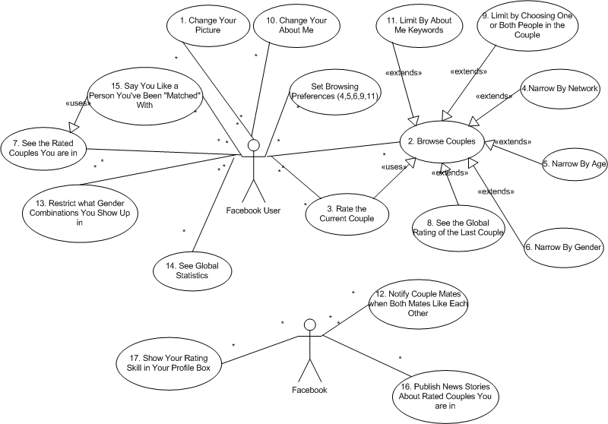
Use Case Diagram:

Feature List
Feature | Target
Browse couples. | Beta
Rate the currently viewed couple on a scale from 1 to 10. | Beta
See the rating of the couple that you just rated. | Beta
Change the picture of you that is seen by others when they are browsing couples. | Final
See how people rated you with other couples (organized by rating, network, gender, etc...). | Beta
Set what genders you show up with when others browse (so you can say that you only want to appear with other guys, girls, or both). | Final
Narrow browsing by network (college, city, friends only, etc...). | Final
Narrow browsing by age group. | Deleted
Narrow browsing by gender. | Beta
Receive notifications when both you and another person think you two make a good couple (called "matches"). | Stretch
See global statistics (such as couple with the most/highest ratings, best couples in your network, etc...). | Stretch
 | Beta
 | Final
Say that you like a person but not notify anyone. | Final
Publish news stories to you about ratings on good couples you are part of. | Final
 | Stretch
Be able to search for a particular couple by choosing one or both of the people in the couple. | Stretch
 | Final
 | Stretch
Change your text description that others see when they are browsing couples. | Stretch
 | Stretch
Be able to search for a couple based on keywords (that would appear in their description). | Stretch
Show in a box on your profile how well you rate couples compared to global ratings. | Stretch
 | Stretch
Rate the currently viewed couple based on keywords (bad, mediocre, good, etc...). | Stretch
 | Stretch
Rate friends who are not users of Couple Rater. | Final
Maintain ratings of non-user friends. | Final
Display list of friends who are users of Couple Rater. | Final
Provide ability to avoid seeing “?” pictures when rating. | Final

UI Prototype

