**Summary of Major Findings**

Is there a correlation between population density and fatal car crashes?

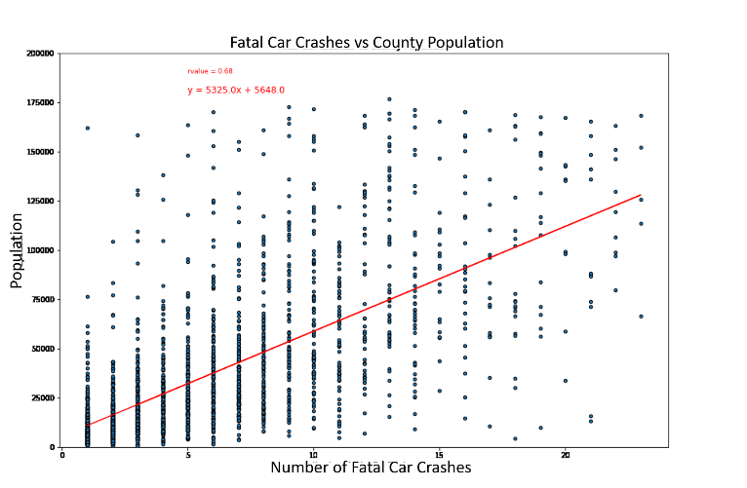Presumably, there would be a linear relationship between the number of people in an area and the number of fatal accidents occurring in that area. As we expected, there is a positive correlation between population density and fatal accidents Fig 1. However, there are several instances where counties have either relatively high or low fatal accidents per capita. It may be useful to examine these cases to better understand why some areas are safer than others to drive and so that more effective plans can be implemented in the high fatality areas. One important point worth noting is that these data do not include a way to measure vehicle miles traveled which is a standard metric used when comparing the frequency of accidents between two regions. You could imagine that in a rural area a person might have to drive much further than a person in an urban area which would increase the likelihood that they get into an accident in the first place.

**Figure 1: Fatal Car Crashes and County Population are Positively Correlated.**

When do most fatal accidents happen in the U.S.?

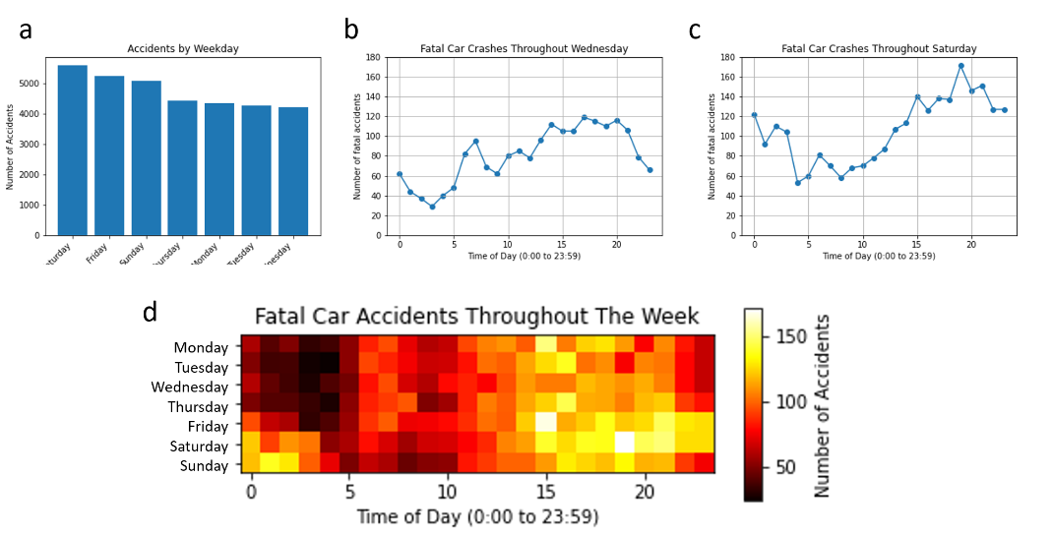We next examined when fatal accidents are occurring during the week. The most fatal accidents occurred on Saturdays while the fewest occurred on Wednesdays (Fig 2a). Taking a closer look at these two days we find that for almost any given time of day there are more fatal accidents on Saturday than Wednesday except from 6 to 8 am – when people are likely on their way to work – and from 10 am to 12 pm (Fig 2b & 2c). Wednesday did not have more than 120 accidents for any time of day, while Saturday peaked at ~170 from 7 to 8 pm. Comparing times for every day of the week, we noticed that the highest incidence of fatal accidents occurs in the afternoon beginning around 3 pm and dropping off around 10 pm, except on Friday and Saturday evenings when high levels of fatal accidents continue into the following morning (Fig 2d). These results make sense considering that people will often stay out later socializing and engaging in recreational activities on the weekends. This highlights the importance of being extra cautious when driving around these times.

**Figure 2: Fatal Car Crash probability fluctuates throughout the week.**

Do urban or rural roads have higher fatal accidents?

The last question we had was whether it is safer to take country roads or city roads. While more data would certainly be useful for drawing any conclusions about this, we were curious to see if the fatal car accident data could provide some useful insights. Surprisingly, the dataset provided whether the fatal accident occurred on rural or urban roads. 44.3% of all fatal accidents occurred on rural roads yet only 17.3% of people live in rural areas according to the U.S. census. If we adjust the number of crashes based on the population, rural areas are having fatal accidents 4.6 times more often per capita than urban areas. This, of course, does not consider the distance that your average person is driving in a day. In rural areas, drivers might have to travel much further, often with less traffic than urban areas. As we previously stated, more data would be useful for drawing conclusions, but we can clearly see that more accidents per capita are occurring on rural roads.