Predicting Iris Species
Jordan Schupbach

Introduction
The famous (Fisher 1936) (or (Anderson 1936)) iris data set gives the measurements (in centimeters) of the sepal length and width, and petal length and width for 50 flowers, each from one of three species of iris. The species are I. setosa, I versicolor, and I. virginica. We provide images for each of the three species in Figure . Researchers are interested in whether they can identify the species from the set of the four measurements taken on the plants. For this study, the focus is only on predicting I. Setosa versus I. Versicolor.

Description of Data
This dataset has 1 categorical variable (species) and 4 quantitative variables (sepal length and width, and petal length and width; all measured in centimeters). Again, the researchers are interested in predicting species from the four measurements. We provide the first six lines of the dataset in Table and a five-number summary of the data in Table . We also may want to subset our data by species and look at summary statistics. Means for the two species of interest are given in Table .
These data were gathered by Dr. Edgar Anderson. The Iris setosa and Iris versicolor were found growing together in the same colony. The third species, Iris virginica, was from a different colony, as it would be a ``circumstance which might considerably disturb both the mean values and their variabilities.''

Statistical Methods Used
To classify the two species of interest, I. setosa and I. versicolor, we use the method of linear discriminant analysis following (Fisher 1936). One assumption of the method is that the covariates be independently normally distributed. We check the assumption of normality by plotting histograms of four variables grouped by species type in Figure . Further, we provide beanplots from the R package (Kampstra 2008), which assume a normal kernel density. The two figures would suggest the assumption of normality is reasonably met.
Linear discriminant analysis allows us to write an objective function of the form
for which we classify an observation as either I. Setosa or I. Versicolor depending on its value.

Summary of Statistical Findings
We provide means for the two groups in Table . The LDA was conducted in R (R Core Team 2017) using the function from the package (Venables and Ripley 2002). Coefficients of discrimination are given in Table . We see that we can write equation as
Following (Fisher 1936), we can take the coefficient for sepal width to be unity (see Table ) and rewrite equation as
These equations can be used to score each observation on this new scale, and classify the observation as either I. setosa or I. virginica. Figure shows the values of the scores for the two species according to equation . We can see from the plot that the scores do an impressive job in separating I. setosa and I. virginica. A confusion matrix is given in Table . We see that the equation can perfectly separate I. setosa plants from I. virginica.

Scope of Inference
Since we did not randomly assign any treatment to treatment groups, no causal inference can be inferred in this study. Further, since observations did not come from a random sample, we cannot infer to a larger population than that of the sample.

Appendix

Tables
Sepal.Length | Sepal.Width | Petal.Length | Petal.Width | Species
5.1 | 3.5 | 1.4 | 0.2 | setosa
4.9 | 3 | 1.4 | 0.2 | setosa
4.7 | 3.2 | 1.3 | 0.2 | setosa
4.6 | 3.1 | 1.5 | 0.2 | setosa
5 | 3.6 | 1.4 | 0.2 | setosa
5.4 | 3.9 | 1.7 | 0.4 | setosa
Sepal.Length | Sepal.Width | Petal.Length | Petal.Width | Species
Min. :4.300 | Min. :2.000 | Min. :1.000 | Min. :0.100 | setosa :50
1st Qu.:5.100 | 1st Qu.:2.800 | 1st Qu.:1.600 | 1st Qu.:0.300 | versicolor:50
Median :5.800 | Median :3.000 | Median :4.350 | Median :1.300 | virginica :50
Mean :5.843 | Mean :3.057 | Mean :3.758 | Mean :1.199 | NA
3rd Qu.:6.400 | 3rd Qu.:3.300 | 3rd Qu.:5.100 | 3rd Qu.:1.800 | NA
Max. :7.900 | Max. :4.400 | Max. :6.900 | Max. :2.500 | NA
 | Sepal.Width | Sepal.Length | Petal.Width | Petal.Length
setosa | 3.428 | 5.006 | 0.246 | 1.462
versicolor | 2.77 | 5.936 | 1.326 | 4.26
 | LD1
Sepal.Width | -1.774
Sepal.Length | -0.3005
Petal.Width | 3.036
Petal.Length | 2.142
 | LD1
Sepal.Width | 1
Sepal.Length | 0.1694
Petal.Width | -1.711
Petal.Length | -1.208
 | setosa | versicolor
setosa | 50 | 0
versicolor | 0 | 50

Figures
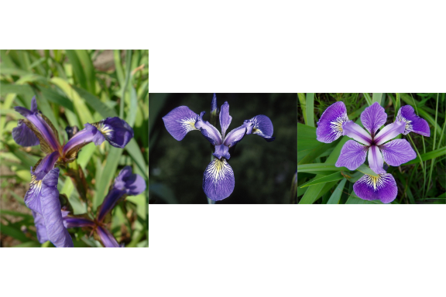
Three species of iris: I. Setosa, I. Virginica, I. Versicolor
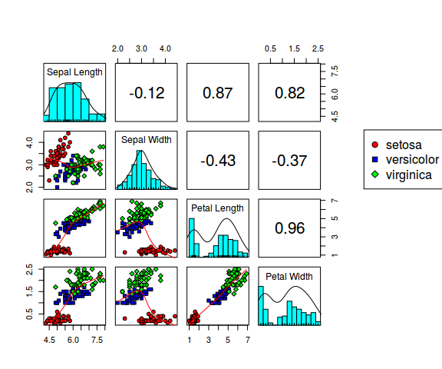
A matrix of scatterplots of the quantitative variables
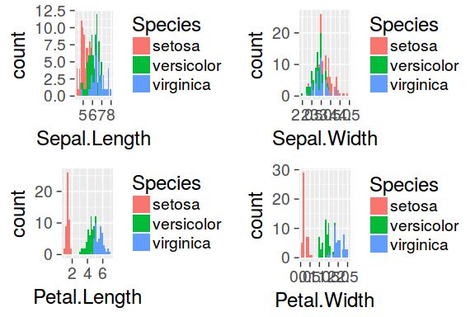
Histograms of covariates separated by species
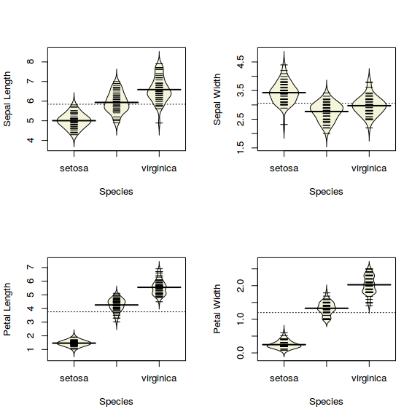
Beanplots of the four quantitative variables by species
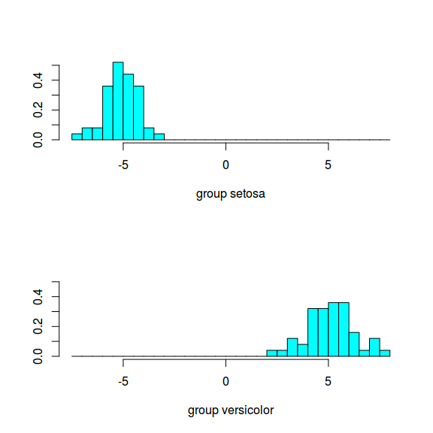
Linear discriminant scores for setosa and versicolor

R-code
# Subset the data
iris_sub <- subset(iris, iris$Species == "setosa" |
iris$Species == "versicolor")
iris_sub$Species <- factor(iris_sub$Species)
head(iris_sub)

# LDA
z <- lda(Species ~ Sepal.Width + Sepal.Length + Petal.Width +
Petal.Length, iris_sub, prior = c(1,1)/2)
preds <- predict(z)$class

## Tables:
# Table 1
head(iris)
print(xtable(head(iris), caption = "First 6 lines of the dataset",
label = "data-head"),
comment = FALSE)

# Table 2
summary(iris)
stargazer(iris, iqr = TRUE,
type = "latex", header = FALSE, label = "summary",
title = "Summary table of the four quantitative variables")

# Table 3
z$mean
print(xtable(z$mean, label = "means-tbl", caption = "Group means"),
comment = FALSE)

# Table 4
z$scaling
print(xtable(z$scaling, label = "scaling-tbl",
caption = "Coefficients of linear discriminants"),
comment = FALSE)

# Table 5
(1/z$scaling[1]) * z$scaling
print(xtable((1/z$scaling[1]) * z$scaling, label = "scaling-unity-tbl",
caption = "Coefficients of linear discriminants with first scaled to unity"),
comment = FALSE)

# Table 6: Confusion Matrix
table(preds, iris_sub$Species)
print(xtable(table(preds, iris_sub$Species), label = "confusion",
caption = "Confusion matrix"),
comment = FALSE)

## Figures
# Figure 1:
fig1 <- rasterGrob(readPNG("images/iris_setosa.png"), interpolate=TRUE)
fig2 <- rasterGrob(readPNG("images/iris_virginica.png"), interpolate=TRUE)
fig3 <- rasterGrob(readPNG("images/iris_versicolor.png"), interpolate=TRUE)
grid.arrange(fig1, fig2, fig3, ncol=3)

# Figure 2:
par(mar = c(5,4,4,3))
pairs.panels(iris[,1:4],
labels = c("Sepal Length",
"Sepal Width",
"Petal Length",
"Petal Width"),
bg=c("red",
"blue",
"green")[iris$Species],
pch=20+as.numeric(iris$Species),
ellipses = FALSE,
oma=c(4,4,6,12))
par(xpd=TRUE)
legend(.9*par("usr")[2], ## 1.05 times x1 limit
.7*par("usr")[4], ## .8 times y2 limit
levels(iris$Species),
pch = c(21,22,23),
pt.bg = c("red", "blue", "green"))

# Figure 3:
plot1 <- ggplot(iris, aes(x=Sepal.Length))
plot1<- plot1 + geom_histogram(aes(fill = Species))
plot2 <- ggplot(iris, aes(x=Sepal.Width))
plot2<- plot2 + geom_histogram(aes(fill = Species))
plot3 <- ggplot(iris, aes(x=Petal.Length))
plot3<- plot3 + geom_histogram(aes(fill = Species))
plot4 <- ggplot(iris, aes(x=Petal.Width))
plot4<- plot4 + geom_histogram(aes(fill = Species))
theme_set(theme_gray(base_size = 18))
m<-grid.arrange(plot1,plot2, plot3,plot4, ncol=2)
print(m)

# Figure 4:
par(mfrow = c(2,2))
beanplot(Sepal.Length ~ Species, data = iris, ylab = "Sepal Length",
xlab = "Species", col = "beige", method = "jitter")
beanplot(Sepal.Width ~ Species, data = iris, ylab = "Sepal Width",
xlab = "Species", col = "beige", method = "jitter")
beanplot(Petal.Length ~ Species, data = iris, ylab = "Petal Length",
xlab = "Species", col = "beige", method = "jitter")
beanplot(Petal.Width ~ Species, data = iris, ylab = "Petal Width",
xlab = "Species", col = "beige", method = "jitter")

# Figure 5:
plot(z)

Document Creation Info
- platform:
  - version: R version 3.4.3 (2017-11-30)
  - system: x86_64, linux-gnu
  - ui: X11
  - language: en_US
  - collate: en_US.UTF-8
  - tz: Navajo
  - date: 2018-02-23
- packages:

References
Anderson, Edgar. 1936. “The Species Problem in Iris.” Annals of the Missouri Botanical Garden 23 (3). Missouri Botanical Garden Press: 457–509. http://www.jstor.org/stable/2394164.
Fisher, R. A. 1936. “The Use of Multiple Measurements in Taxonomic Problems.” Annals of Eugenics 7 (2). Blackwell Publishing Ltd: 179–88. doi:10.1111/j.1469-1809.1936.tb02137.x.
Kampstra, Peter. 2008. “Beanplot: A Boxplot Alternative for Visual Comparison of Distributions.” Journal of Statistical Software, Code Snippets 28 (1): 1–9. http://www.jstatsoft.org/v28/c01/.
R Core Team. 2017. R: A Language and Environment for Statistical Computing. Vienna, Austria: R Foundation for Statistical Computing. https://www.R-project.org/.
Venables, W. N., and B. D. Ripley. 2002. Modern Applied Statistics with S. Fourth. New York: Springer. http://www.stats.ox.ac.uk/pub/MASS4.

