**Milestone One**

For my project, I chose a real photograph of a modern workspace with a dark and minimal design. The scene features a desk setup with a laptop, a desk lamp, a potted plant, and a chair, all arranged from a side view instead of a flat top-down angle. I liked this image because the objects are clearly defined and not too overwhelming to model. Each part of the scene feels practical to build using basic 3D shapes, and the clean layout makes it easy to understand the proportions and spacing. The balance between man-made items and something more natural like the plant adds a nice bit of variety to the modeling process.

The laptop will be modeled using a few box shapes to represent the screen and keyboard base, with a thin plane for the open screen. The lamp is the most complex object in the image and will need multiple shapes. I’ll use a cylinder for the lamp stand, a cone for the lampshade, and a small sphere or rounded joint where the arm bends. This lamp fits the requirement to include at least one object made from two or more shapes.

For the plant, I’ll use a cylinder for the pot and create simple spheres or cone shapes to stand in for the leaves or bushy top. I want it to feel organic without making the shapes too detailed. The chair will likely be made with cylinders for the legs and supports, and the seat and backrest can be modeled using boxes or a slightly angled form depending on what fits best. Even though the desk is mostly hidden, I’ll still model a basic flat surface using a plane or a low box to support the other objects.

I think this scene works well for the assignment because it includes a mix of different objects, but each one is clear and manageable to build. There’s enough variation to keep it interesting, but not so much detail that it becomes too difficult. The image’s side perspective helps give a strong sense of depth, which will be useful when setting up the virtual camera and building the layout in OpenGL. I plan to start by placing the desk surface, then add the other objects one at a time, making sure they are scaled and positioned properly.

For my project, I chose a real photograph of a modern workspace with a dark and minimal design. The scene features a desk setup with a laptop, a desk lamp, a potted plant, and a chair, all arranged from a side view instead of a flat top-down angle. I liked this image because the objects are clearly defined and not too overwhelming to model. Each part of the scene feels practical to build using basic 3D shapes, and the clean layout makes it easy to understand the proportions and spacing. The balance between man-made items and something more natural like the plant adds a nice bit of variety to the modeling process.

The laptop will be modeled using a few box shapes to represent the screen and keyboard base, with a thin plane for the open screen. The lamp is the most complex object in the image and will need multiple shapes. I’ll use a cylinder for the lamp stand, a cone for the lampshade, and a small sphere or rounded joint where the arm bends. This lamp fits the requirement to include at least one object made from two or more shapes.

For the plant, I’ll use a cylinder for the pot and create simple spheres or cone shapes to stand in for the leaves or bushy top. I want it to feel organic without making the shapes too detailed. The chair will likely be made with cylinders for the legs and supports, and the seat and backrest can be modeled using boxes or a slightly angled form depending on what fits best. Even though the desk is mostly hidden, I’ll still model a basic flat surface using a plane or a low box to support the other objects.

I think this scene works well for the assignment because it includes a mix of different objects, but each one is clear and manageable to build. There’s enough variation to keep it interesting, but not so much detail that it becomes too difficult. The image’s side perspective helps give a strong sense of depth, which will be useful when setting up the virtual camera and building the layout in OpenGL. I plan to start by placing the desk surface, then add the other objects one at a time, making sure they are scaled and positioned properly.

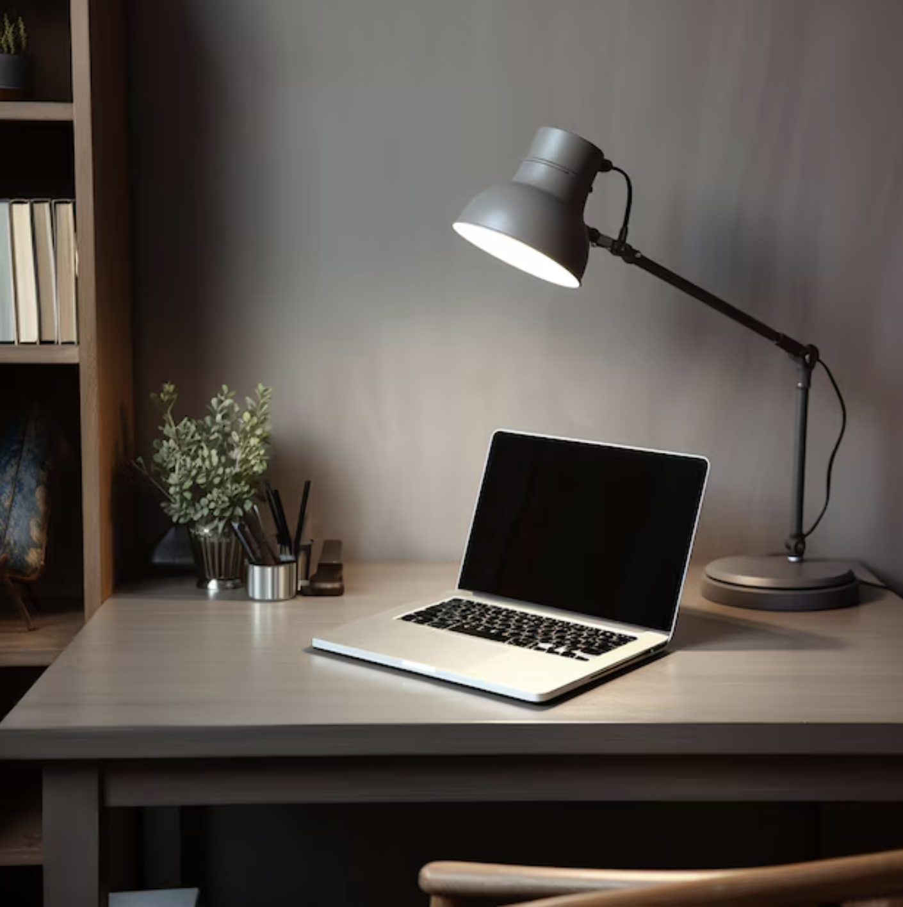

Unknown. (n.d.). Sleek workspace desk with gray laptop and lamp [Photograph]. Bing. <https://tse2.mm.bing.net/th/id/OIP.Qg-fp6vfYuzKpJau7AoYXgHaHa?pid=Api>