EGH490

Servo Test Rig Operating Manual
  - Servo control and EVK4 event acquisition
Draft 0.3
15 October 2026
Delta ASDA-B3 | LabJack U3-HV | LattePanda | EVK4
Installation and configuration, startup, application operation, controlled experiments, results processing and shutdown.
Status: Draft for review.

Contents
1 Introduction 1
1.1 Background 1
1.2 Purpose of the platform 1
1.3 Scope of this manual 1
2 System architecture 2
2.1 Equipment 2
3 Software installation and configuration 4
3.1 Motor PC interface 4
3.2 Drive communication 7
3.3 Draw-string encoder to LabJack AIN0 9
3.4 Motor power and encoder feedback 11
3.5 Computer Wi-Fi network 11
3.6 EVK4 camera USB connection 13
3.7 Trigger In cable 15
4 Startup procedure 16
4.1 Isolate the rig and start the LattePanda 16
4.2 Prepare the rotating platform 16
4.3 Connect and check the application 16
5 Servo Test Rig Control GUI Application 17
5.1 Application overview 17
5.2 How the application controls the drive 17
5.3 Dashboard 19
5.4 Motion 23
5.5 Tests 27
5.6 Trends 32
5.7 Parameters 35
5.8 Logs 37
5.9 Settings 38
6 Processing results and creating videos 40
6.1 Collect and back up the run files 40
6.2 Open the processing environment 40
6.3 Prepare Experiment 40
6.4 Enter the timing details and prepare again 41
6.5 Create a complete run video 42
6.6 Compare runs at matching platform angles 44
6.7 Extract images or short clips at a chosen angle 45
6.8 Retain and check the outputs 46
7 Shutdown procedure 47
7.1 Stop motion and isolate the Control Box 47
7.2 Shut down the LattePanda 47
7.3 Leave the rig secure 47

1 Introduction

1.1 Background
Visual place recognition (VPR) allows a robotic system to recognise a previously observed scene and relocalise within a known environment. Reliable recognition is important for high speed navigation, loop closure and long term localisation. Rapid motion can reduce the usefulness of conventional frame based images through motion blur, latency and loss of trackable features.
Event cameras record pixel level brightness changes asynchronously, with microsecond level temporal resolution. The resulting event stream depends on the relative motion between the camera and scene. Angular velocity, scene complexity and viewpoint therefore influence the density and timing of events used for recognition.
Many existing datasets are recorded along trajectories using handheld devices, vehicles or robotic platforms. These datasets provide useful benchmarks, but their motion and viewpoint variables are not always independently controlled. A controlled, repeatable test platform helps isolate the effects of rotational speed and scene position on event stream behaviour and VPR performance.

1.2 Purpose of the platform
The platform was developed to support controlled benchmarking of event based VPR. It generates angular motion while recording event camera data and encoder derived measurements of angular position and speed. These measurements provide a motion reference for comparing recordings collected under different rotational and viewpoint conditions.

1.3 Scope of this manual
Use this manual to install and configure the software, start the rig, operate the Servo Test Rig application, record controlled experiments, process the results and shut down the system. Complete installation and connection checks in Section 3 before routine operation. Use Section 4 for startup, Section 5 for application controls, Section 6 for processing and Section 7 for shutdown.
The Motor PC runs the servo application and communicates with the drive over Modbus RTU through an RS485 to USB converter. The LattePanda runs the EVK4 camera and trigger service. Both computers connect to the same Wi-Fi network for clock synchronization and run coordination. The LabJack U3-HV records the draw-wire sensor voltage used to determine scene height.

2 System architecture
The system hardware is divided into four sections: Control Box, Rotating Platform, Enclosure Frame and Scene Frame. The Control Box supplies and controls the servo drive. The Enclosure Frame supports the motor and rotary mechanism. The Rotating Platform carries the camera and onboard acquisition computer, while the Scene Frame supports the visual patterns and their vertical adjustment mechanism.

2.1 Equipment

2.1.1 Control Box
The Control Box contains the electrical power and control equipment used to operate the motor. The Motor PC is the external operator station associated with this section.
- Servo drive - Delta ASD-B3A-0721-L. Receives speed commands from the Motor PC, controls electrical power to the servo motor and reads its encoder feedback. The application retrieves speed and position measurements through the drive registers.
Reference: Delta ASDA-B3 series product information
- 24 V DC supply - Mean Well HDR-30-24. Provides low voltage power for the installed control circuit. Refer to the installed electrical schematic for circuit connections.
Reference: Mean Well HDR-30 series datasheet
- Power distribution and protection. The circuit breaker, contactor, terminals and protective earth connections form the supply and control assembly. Refer to the as-wired schematic for their connections and switching behavior.
- Operator controls. The panel provides start, stop, reset and emergency-stop controls. Their functions depend on the installed wiring and drive input assignments.
- Motor PC and serial interface. The PC runs the servo GUI, records motor and displacement measurements and processes experiments. An RS485 to USB converter and RJ45 terminal adapter connect it to the drive CN3 RJ45 serial port.
- LabJack U3-HV. Mounted inside the Control Box, this unit converts the draw-wire sensor voltage at AIN0 into digital measurements and transfers them by USB to the Motor PC. The application records voltage and calculates displacement using the configured calibration.
Reference: LabJack U3 datasheet covering U3-HV

2.1.2 Rotating Platform
The Rotating Platform carries the equipment required to record the scene while the camera turns. Local camera acquisition keeps the camera USB and trigger connections within the rotating assembly.
- Platform plate and equipment cradle. Support and secure the camera, LattePanda and local power source. Counterweights compensate for uneven mass distribution about the rotary axis.
- EVK4 event camera and 8 mm C-mount lens. Observe the surrounding scene and produce timestamped brightness-change events. The camera connects by USB to the LattePanda and receives timing markers through its Trigger In cable.
Reference: Prophesee EVK4 HD camera manual
- LattePanda Mu with Lite Carrier Board. Runs the camera and trigger service, saves camera RAW data and provides the scheduled run origin to the Motor PC over Wi-Fi. Its SIO UART generates the timing markers received by the camera via the Trigger In cable.
Reference: LattePanda Mu Lite Carrier documentation
- Onboard power source - MB3824. The 20,000 mAh USB-C PD 45 W laptop power bank supplies the rotating acquisition equipment. It is carried on the platform so an external power lead does not wind around the rotary axis.
Reference: MB3824 power bank manual

2.1.3 Enclosure Frame
The Enclosure Frame provides the stationary structure, mechanical support and guarding around the rotary assembly. It maintains the relative positions of the motor, rotary shaft and scene.
- 40 x 40 mm T-slot aluminium extrusion structure and base. Support the motor mounting, rotary mechanism and guarding. The modular joints allow assembly alignment and equipment mounting.
- Servo motor - Delta ECMA-C20807RS. Drives the platform through the timing-belt transmission. Its internal encoder provides the motor position and speed reference used by the drive and application.
Reference: Delta ASDA-B3 drive and motor user manual
- Timing-belt transmission and pulleys. Transfer motor rotation to the platform with a 2:1 motor-to-platform reduction. The application divides motor speed and angular displacement by two to obtain platform values.
- Rotary shaft and bearing supports. Support the rotating assembly and maintain its axis. Their alignment, attachment and clearance affect mechanical operation and stability.
- Transparent Perspex guarding panels. Provide a physical barrier around moving components while allowing visual inspection.

2.1.4 Scene Frame
The Scene Frame carries the visual targets around the camera and allows their height to change between trials. Its displacement measurement chain connects to the Motor PC.
- Scene panels and printed targets. Four MDF panels carry twelve A3 pattern sheets, with three sheets on each panel. These provide a repeatable visual scene observed by the rotating camera and allow the scene to be easily swapped between experiments.
- Vertical adjustment mechanism. The hand winch, wire rope, guide pulleys and sliding supports raise or lower the scene. Secure the frame at the selected height before recording.
- RS PRO draw-string encoder - 0100398. Measures vertical scene movement as an analogue voltage. Its wire follows scene displacement so the acquisition software can associate scene height with each trial.
Reference: RS PRO 100-398 draw-wire encoder datasheet

3 Software installation and configuration
The procedures below describe the physical connection, its purpose, the software used to configure it and a check of successful operation. Work through the relevant connection test before attempting a coordinated experiment. Keep the motor stopped and Servo Off while checking communication and changing drive parameters.

3.1 Motor PC interface
Follow the numbered steps in order. At each step, use only the instructions labelled for your operating system. Windows commands use Command Prompt; Linux commands use Terminal with Bash. Enter one command at a time, press Enter and wait for it to finish. An internet connection is required for installation. The drive can remain disconnected until the application passes the simulation check.
This example uses Windows 10 Home 22H2 with Python 3.11.9, and Ubuntu 22.04.5 LTS with Python 3.10.12. The application requires Python 3.10 or newer.

3.1.1 Copy the project folder
Copy or extract the complete servo_controller folder to a writable location on the Motor PC. This is the project folder for the following setup steps. Open servo_controller and confirm that it contains app.py, requirements.txt and the servo_control folder. Extract any ZIP archive before continuing.

3.1.2 Open a command window in the project folder
Windows
Open servo_controller in File Explorer. Click the address bar, type cmd and press Enter. Command Prompt opens in that folder. Check the location:
dir app.py requirements.txt
Linux
Open servo_controller in the file manager. Right-click a blank area and select Open in Terminal.
ls app.py requirements.txt
Expected result on either system: both filenames are listed. If a file is missing, return to the folder containing app.py before continuing. Keep this command window open for the following Motor PC setup steps.

3.1.3 Check or install Python
Windows
python --version
python -m tkinter
Required result: Python 3.10 or newer and a small Tk window. Close the window and continue to Section 3.1.4.
If either check fails, install or repair the full 64-bit Python installation. In the installer, select Add python.exe to PATH and keep pip and Tcl/Tk and IDLE selected. For an existing installation, use Modify to add missing components. Reopen Command Prompt and repeat the two checks.
Reference: Python 3.12 full Windows installer release page
Reference: Python Windows installer components and repair instructions
Linux
python3 --version
python3 -m tkinter
Required result: Python 3.10 or newer and a small Tk window. Close the window and continue to Section 3.1.4. If Python or Tk is missing, run:
sudo apt update
sudo apt install python3 python3-venv python3-pip python3-tk
Repeat the two checks after installation.

3.1.4 Check for an existing environment before creating one
The hidden .venv folder contains this application's Python environment. Check for it first. Do not run the creation command until you have chosen the applicable case below.
Windows check
dir /a
Linux check
ls -a
Look for a folder named .venv, then choose one of these cases:
- No .venv folder: continue to Create a new environment below.
- A working .venv created on this same computer: keep it, run the version check below and continue to Section 3.1.5. Skip the creation command.
- A .venv copied from another computer or operating system: rename it before continuing. In the file manager, rename .venv to .venv_copied. On Windows, enable View > Show > Hidden items; on Ubuntu press Ctrl+H to show hidden folders. If .venv_copied already exists, choose another unused name. Then return to the command window.
A Windows environment normally contains Scripts; a Linux environment contains bin. Folder layout alone does not prove that an environment copied from another computer is usable. Create a fresh environment for a copied project.
Create a new environment only when no .venv remains
Windows:
python -m venv .venv
Linux:
python3 -m venv .venv
Expected result: the command returns to the prompt and a new .venv folder exists. No success message is normally printed.
Check the selected environment
Windows:
.\.venv\Scripts\python.exe --version
Linux:
./.venv/bin/python --version
Expected result: the chosen Python version is printed. If a copied environment reports a missing interpreter or another computer's path, rename that .venv and repeat creation. The remaining commands select .venv directly, so no activation command is required.

3.1.5 Install the project packages
Windows
.\.venv\Scripts\python.exe -m pip install --upgrade pip
.\.venv\Scripts\python.exe -m pip install -r requirements.txt
.\.venv\Scripts\python.exe -m pip check
Linux
./.venv/bin/python -m pip install --upgrade pip
./.venv/bin/python -m pip install -r requirements.txt
./.venv/bin/python -m pip check
Expected result: installation finishes without errors and pip check reports No broken requirements found. If requirements.txt is not found, repeat Section 3.1.2. If a download fails, check the internet connection and retain the package error for troubleshooting. Complete the device installation in the Drive communication and Draw-string encoder to LabJack AIN0 subsections below.

3.1.6 Check the graphical interface
Windows
.\.venv\Scripts\python.exe -m tkinter
Linux
./.venv/bin/python -m tkinter
Expected result: a small Tk demonstration window opens. Close it before continuing. If an error mentions Tcl, Tk or init.tcl, repair the selected Python/Tk installation and recreate .venv. On Linux, confirm python3-tk is installed and use a local graphical desktop if a display error appears.

3.1.7 Start in simulation
Windows
.\.venv\Scripts\python.exe app.py --simulate
Linux
./.venv/bin/python app.py --simulate
Expected result: the GUI opens in Simulation and connects automatically. Confirm the displayed mode, then use the Motion and Tests controls described in Section 5. Close the application before installing and testing device drivers.

3.1.8 Starting the application on later visits
Open a command window in servo_controller using Section 3.1.2, then use the command for your operating system:
Windows
.\.venv\Scripts\python.exe app.py
Linux
./.venv/bin/python app.py
Keep the existing working .venv for normal use. Recreating the environment and installing packages are setup tasks, not daily startup steps. Use the explicit Linux command because the current launcher automatically locates only the Windows environment executable.

3.1.9 Saved settings
The application automatically saves its settings in settings.json inside the servo_controller folder. Copy the entire folder to transfer the application and its settings to another PC. Check the serial port and LattePanda IP address on the new PC.

3.1.10 Check the software installation
Run the software tests from servo_controller:
Windows
.\.venv\Scripts\python.exe -m unittest discover -s tests -v
Linux
./.venv/bin/python -m unittest discover -s tests -v
Review failures and skipped tests. Before live experiments, complete drive communication, LabJack voltage/displacement, clock and supervised motion checks described in Sections 3 to 5.

3.2 Drive communication
Purpose and required equipment
The Motor PC sends Modbus RTU commands and reads drive registers through CN3. Use an RJ45 Ethernet patch cable, an RJ45 screw-terminal adaptor, an RS485 to USB converter and the converter USB cable. The patch cable carries the serial signals on the pins listed below; it is not an Ethernet connection to the drive.
Cable assembly
1. Isolate the rig before assembling or changing terminal wiring. Identify CN3 on the drive and the numbered terminals on the RJ45 adaptor. Use the adaptor pin labels rather than assuming a wire colour or a connector viewing direction.
2. Connect RJ45 pin 4 to the converter T/R- terminal.
3. Connect RJ45 pin 5 to the converter T/R+ terminal.
4. Connect RJ45 pin 7 to converter GND. Leave the other adaptor pins unconnected for this link.
5. Connect the Ethernet patch cable between drive CN3 and the RJ45 terminal adaptor. Connect the converter to the Motor PC by USB. Do not bridge terminals or use the drive RJ45 connector as a network port.

3.2.1 Identify the COM port
Windows
Open Device Manager on the Motor PC and expand Ports (COM & LPT). Identify the RS485 to USB converter entry and record its COM number. If necessary, disconnect and reconnect only the USB converter to identify which entry changes. Enter that COM number in the application Settings.
Linux
Connect the RS485 to USB converter, then list available devices from the project folder:
./.venv/bin/python -m serial.tools.list_ports -v
Identify the converter by its USB description and identity. Enter its actual device path, such as /dev/ttyUSB0, in application Settings. Continue with the application connection check below.

3.2.2 Application serial settings
The drive connection uses slave address 1, 115200 baud, 8 data bits, no parity and 2 stop bits when configured as described in Section 3. Select the actual adapter port: a Windows COM name or a Linux /dev path. Confirm that saved application settings match the drive.
Installation record: retain the verified adapter port, drive address and serial format for each Motor PC.
Application connection and acceptance check
1. In the application Settings, select Live Drive and the port identified above: the COM number on Windows or the /dev device path on Linux. Set slave 1, 115200 baud if that is the verified drive setting, parity N and 2 stop bits.
2. Power on the servo drive, keeping motion disabled, then click Connect. Confirm live drive status, alarm readback and encoder/speed readings update without timeout or CRC errors.
On Linux, if clicking Connect produces an error in the Logs such as [Errno 13] Permission denied or could not open port, close the application and run this command in Terminal:
sudo adduser "$USER" dialout
Log out of Ubuntu and log back in. Reopen Terminal in servo_controller, launch the application and retry the connection with motion disabled.
Reference: pySerial serial-access permissions
3. If the check fails, compare the selected port, pin 4/5 polarity and pin 7 reference. Confirm the serial format and drive address in ASDA-Soft or via the drive panel, and match these values in the application. Confirm ASDA-Soft has released the port.
Check the drive using ASDA-Soft
Download ASDA-Soft for the ASDA-B3 from Delta's Download Center by searching for ASDA-Soft, and install it on the Motor PC. Connect a USB data cable from the Motor PC to the drive CN4 Mini USB connector. In ASDA-Soft select the USB connection and connect to the drive. Read the parameters and save a backup before making changes. This commissioning connection is separate from CN3: use CN4 for ASDA-Soft and CN3 RJ45 through the RS485 to USB converter for the servo application.
Reference: Delta Download Center for ASDA-Soft
Reference: Delta ASDA-B3 user manual
In the Delta Download Center, search for ASDA-B3 and select the English servo drive user manual. Check the following communication parameters in ASDA-Soft against that manual:
- P3.000 (P3-00), communication address: use slave address 1 for the project connection.
- P3.001 (P3-01), transmission speed: set the RS485 speed field X to 5 for 115200 baud, preserving unrelated fields. The selected value must match the application.
- P3.002 (P3-02), communication protocol: project value 6 selects Modbus RTU, 8 data bits, no parity and 2 stop bits.
- P3.005 (P3-05), word order and role: confirm low-word-first 32-bit transfers, as assumed by the application. The project catalog uses value 0.
- P3.003 and P3.004, communication error handling and timeout: record the installed values and their stop/alarm behavior. These are part of the drive configuration; do not choose new timeout settings solely to make a communication test pass.
Use ASDA-Soft over CN4 to read and configure the CN3 communication parameters listed above. The P3.001 baud and P3.002 protocol settings apply to the RS485 connection; they do not set the CN4 USB link speed. After applying changes, cycle power to the drive and verify the stored values. Enter the matching serial settings in the Motor PC application before connecting through CN3. Finish commissioning and leave the drive in its required operating state before running a profile.

3.3 Draw-string encoder to LabJack AIN0
Purpose and wiring
The RS PRO 0100398 draw-string encoder produces the analogue scene-height signal. The LabJack U3-HV is mounted inside the Control Box and connects by USB to the Motor PC. Use the installed sensor wire colours as follows:
- Brown: connect to the local +24 V DC supply in the Control Box.
- Blue: connect to the local 0 V DC supply and LabJack GND, establishing the measurement reference.
- Yellow: connect the analogue signal to LabJack AIN0.
- Shield: connect to the Control Box Earth terminal.
Make terminal changes with the supply isolated. Check the brown/blue supply wiring and yellow signal path before energizing. The sensor excitation goes to the sensor supply lead, not AIN0. The LabJack receives its own data/power connection over USB.
Reference: RS PRO 0100398 draw-wire encoder datasheet
Install and test with LJControlPanel
Install the following on the Motor PC before testing the U3-HV:
1. Open the linked LabJack UD Software Installer Downloads page and download the release Windows installer for U3, U6 and UE9.
2. Run the downloaded installer and follow the setup wizard. This installs the Windows USB device driver, UD library and LJControlPanel application used to connect to and test the U3-HV. Complete installation before connecting the LabJack USB cable.
3. For acquisition in the servo application, install the LabJackPython package into the project virtual environment. From the servo_controller directory on the Motor PC, run:
.\.venv\Scripts\python.exe -m pip install "LabJackPython>=2.1,<3"
4. Confirm the Python package can be imported using the command below, then follow the LJControlPanel connection test. The expected result is U3 Python interface available.
.\.venv\Scripts\python.exe -c "import u3; print('U3 Python interface available')"
Reference: LabJack UD Windows installer including USB driver and LJControlPanel
Reference: LJControlPanel configuration and test instructions
1. Connect the U3-HV to the Motor PC by USB. Open LJControlPanel from the LabJack Start menu group.
2. Select Find Devices, choose the connected U3 USB entry and open Test.
3. Observe AIN0 voltage. Move the scene through a small controlled height change and confirm the voltage changes smoothly. If no device is listed, check the USB connection and Device Manager. If voltage does not respond, check sensor supply, blue common reference and yellow AIN0 connection.
4. Close the test panel before acquiring with the servo application. In application Settings, enter the LabJack rate and calibration, then select CONNECT LABJACK. Confirm the application voltage agrees with the connection test and that displacement changes in the expected direction.
The report calibration gives 3.62 V at zero height and 1.671 V at 125 mm, giving a signed scale of about -64.1355 mm/V in displacement = (V - zero) x scale. Confirm these points on the rig before using the converted height as a measurement. The LabJack samples independently from the drive; USB readings and Modbus samples do not share a hardware latch.

3.3.1 Linux LabJack commissioning
Close the servo application and other LabJack programs. Keep the motor stopped throughout these checks. Complete each stage before continuing to the next.
1 Confirm USB detection
Connect the U3-HV to the Ubuntu Motor PC by USB. Open Terminal and run:
lsusb
Expected result: a LabJack entry or USB vendor ID 0cd5 is listed. If absent, check the USB cable and port before attempting the driver installation.
2 Install the native USB driver
sudo apt update
sudo apt install build-essential libusb-1.0-0-dev git
mkdir -p ~/labjack-drivers
cd ~/labjack-drivers
ls
If exodriver is already listed, skip the download command and continue with cd exodriver. Otherwise download it:
git clone https://github.com/labjack/exodriver.git
cd exodriver
sudo ./install.sh
Wait for successful completion. Exodriver builds the native USB library and configures device access. Unplug and reconnect the LabJack USB cable after installation. If installation reports an error, resolve that error before continuing.
Reference: Official Exodriver Linux installation instructions
3 Install and test the Python interface
Open a command window in servo_controller as described in Section 3.1.2. Run these commands using the project environment:
./.venv/bin/python -m pip install "LabJackPython>=2.1,<3"
./.venv/bin/python -c "import u3; d=u3.U3(); print(d.configU3()); d.close()"
Expected result: device configuration information, including serial number and firmware details, is printed without an error. If the device cannot open, confirm lsusb detection, Exodriver installation and device-access rules, then reconnect the U3-HV. Run the test as the normal desktop user.
Reference: LabJackPython and Exodriver documentation
4 Read the sensor voltage
Check the sensor wiring in Section 3 and turn on its Control Box 24 V supply, keeping motor motion disabled. Read AIN0:
./.venv/bin/python -c "import u3; d=u3.U3(); print('AIN0 voltage:', d.getAIN(0)); d.close()"
Expected result: AIN0 voltage followed by a numeric value in volts. The observed commissioning reading was approximately 0.847 V at the scene position used for that check. This is an example reading, not the zero-height calibration or a fixed acceptance value.
5 Check movement and application readback
Note the scene height, adjust it by a small controlled amount, secure it and repeat the voltage command. Confirm the voltage responds to height; the configured negative calibration slope means increasing height corresponds to decreasing voltage. Establish the zero-height voltage and a known-height reference before accepting the converted displacement.
Start the servo application, enter the verified LabJack calibration in Settings and select CONNECT LABJACK. Confirm the application voltage agrees with the independent AIN0 check and the displacement responds in the expected direction. LJControlPanel is used for the Windows procedure; these Python tests check the Linux connection and measurement chain.

3.4 Motor power and encoder feedback
Use the 5 m Delta ACS3-CAPF2105 motor power cable between the drive motor output and motor power connector. Use the separate 5 m ACS3-CAEB0105 encoder/feedback cable between the motor encoder connector and drive CN2. Match the cable and connector identification to the motor/drive manuals and installed electrical diagram before connection. The drive uses the encoder feedback for motor control.
With power isolated, fully seat and secure the keyed connectors without forcing them. Restore power using the approved rig startup procedure and check that the drive reports no motor or encoder connection alarm. Confirm encoder position is available before a motion test.

3.5 Computer Wi-Fi network
Purpose
Wi-Fi carries two timing services between the Motor PC and LattePanda: clock exchanges estimate the offset between their high-resolution clocks, and run coordination supplies the future T0 used for a recorded motor profile. The camera RAW stream stays on the LattePanda during acquisition. A shared Wi-Fi name alone does not prove that clients can exchange packets; guest or managed networks may isolate devices.
Set up and identify the LattePanda
1. Check the MB3824 power bank battery percentage and confirm the LattePanda is powered on. Charge the power bank before use if needed; it cannot power the LattePanda while charging.
2. Confirm the LattePanda and Motor PC are connected to the same Wi-Fi network with client-to-client communication permitted. If the LattePanda is not connected, attach a display and mouse to select the network. Once connected, disconnect the display and mouse. Use AnyDesk address 1629729399 to view its desktop wirelessly and transfer files.
3. On the LattePanda, open Command Prompt and run ipconfig. Record the IPv4 address of the active wireless adapter, excluding disconnected Ethernet, VPN and virtual adapters. To test network communication without the camera or UART trigger, run:
python C:\Users\LattePanda\Desktop\lattepanda_clock_responder.py --no-camera-recording --no-trigger
Confirm the responder prints its UDP service ports and leave it running during the clock synchronization test. This command disables camera recording and UART triggers. Press Ctrl+C to stop it before starting the normal acquisition service.
4. In Windows Defender Firewall with Advanced Security on the LattePanda, allow the service Python executable or create an inbound UDP rule for local ports 49152, 49153 and 49154. Apply it to the actual network profile. Do not disable the firewall. Replies must also be permitted through Motor PC firewall policy.
5. On the Motor PC, open application Settings and locate LATTEPANDA UDP CLOCK ALIGNMENT. Enter the recorded IPv4 address in LattePanda IP, port 49152 and exchange rate 2 Hz. Select START CLOCK SYNC.
6. Confirm that valid replies and timing metrics appear and stay fresh. Check that the address displayed or configured in the Motor PC application is the current LattePanda wireless IPv4 address. Recheck it after network changes or DHCP lease changes.
ipconfig
Run ipconfig on the LattePanda. From the Motor PC, ping followed by the LattePanda IPv4 address can provide an initial reachability check, but ICMP may be blocked and a ping reply does not test the UDP timing service. The application's valid clock exchanges are the service acceptance check.
Network fault isolation
If no valid reply appears, confirm the script is running, check the selected wireless IPv4 address, network profile, firewall rule, ports and client isolation. A VPN can change routing. Clock replies establish the clock service only; verify coordinator ARM/STATUS operation during the normal supervised experiment checks.
How the network timing services work
The Motor PC and LattePanda have independent clocks. The responder provides two services over Wi-Fi: one estimates the difference between those clocks, and the other agrees when an experiment will start. The IPv4 address identifies the LattePanda; a UDP port identifies the service on that computer. UDP sends individual messages, so the application must check replies and handle missing messages.
Clock alignment on UDP port 49152
The Motor PC records when it sends a request. The LattePanda records when it receives the request and sends its reply. The Motor PC then records when the reply arrives. These four timestamps estimate the clock offset and network round-trip time. The application uses the offset to express timestamps from both computers on a common timeline; it does not change either computer’s system clock.
For example, if the LattePanda counter is estimated to be 2 seconds ahead, a LattePanda timestamp of 12 seconds corresponds to about 10 seconds on the Motor PC. Network delay makes this an estimate. Unequal delays in each direction can bias it, and a small round-trip time does not prove exact synchronization.
Run coordination on UDP port 49154
ARM asks the LattePanda to prepare a run and return a future start time called T0. The Motor PC converts T0 into its own clock using the estimated offset. STATUS checks the run state; COMPLETE and CANCEL finish or cancel the coordinated run. Each run has a run_id, while request_id identifies an individual request and reply. Repeating ARM for the same active run retains the original T0.
Using the services in another application
Start with servo_control/clock_sync.py and servo_control/run_coordinator.py, which implement the Motor PC clients. The matching server is lattepanda_clock_responder.py, stored on the LattePanda desktop. These files define the project message formats; the links below explain the Python features used to implement them.
Clock messages use a fixed binary layout. The request format is !4sBQQQ and the reply is !4sBQQQQQQQ: ! means network byte order, 4s is the four-byte STRG identifier, B is the version byte and each Q is an unsigned 64-bit integer. Requests contain a sequence number and monotonic/UTC send timestamps. Replies echo those fields and add LattePanda receive/send timestamps. Timestamps are in nanoseconds. Use the source definitions to preserve the exact field order.
Coordinator messages use UTF-8 JSON with protocol STRG_RUN_V1. ARM includes the run identifier, profile name, expected duration, pre-roll and preparation margin. Check the returned request_id and ok result before using a response. The perf_counter_ns clock measures elapsed time from an arbitrary origin, so its raw readings cannot be compared between computers without the offset.
Python socket documentation — sending and receiving network messages
Python time documentation — perf_counter_ns timing counter
Python struct documentation — binary field formats and byte order
Python JSON documentation — encoding and decoding coordinator messages

3.6 EVK4 camera USB connection
Cable and port
Use a USB 3.0 SuperSpeed data cable with USB-C at the EVK4 and USB-A at a SuperSpeed host port on the LattePanda. A charge-only or USB 2.0 cable is unsuitable. USB-C shape alone does not establish data speed. The EVK4 receives power and event data through this USB link. On the Mu Lite Carrier, use a USB 3 data port, not its USB-C power-input connector.
Reference: EVK4 HD manual covering USB requirements and interfaces
Reference: LattePanda Mu Lite Carrier interface documentation
Install and check Metavision
The LattePanda uses Metavision SDK 4.0. Metavision Studio displays and records camera events; the SDK Python modules let lattepanda_clock_responder.py control acquisition. The project installation used SDK 4.0 under student/research access. For a replacement installation, request the same version through Prophesee’s Knowledge Center or support.
1. Install Python 3.9, 64-bit, on the LattePanda. Use the full Windows installer and select Add Python to PATH and pip. Prophesee lists Python 3.8 and 3.9 for SDK 4.x on Windows. Open a new Command Prompt and check that the interpreter selected below is Python 3.9:
python --version
If another version is shown, use the full path to the Python 3.9 executable instead of python in the environment creation command below.
2. Obtain the Metavision SDK 4.0 Windows installer from Prophesee. Run it and complete the setup, including Studio, Python support and the EVK4 camera driver/plugin. Accept the camera driver installation prompts. Reopen Command Prompt after installation.
3. Connect the EVK4 using the USB 3.0 cable described above. Open Metavision Studio and select the camera. Check the live display and record/replay a short RAW file using the next procedure. Close Studio before running the Python responder.
4. Create a separate camera Python environment on the LattePanda desktop. If a working camera environment already exists, use it instead. Run these commands in Command Prompt:
cd /d C:\Users\LattePanda\Desktop
python -m venv .venv-camera --system-site-packages
.venv-camera\Scripts\python.exe -m pip install pyserial
The --system-site-packages option allows the environment to access SDK Python modules installed for Python 3.9. Install the Python dependencies supplied with the SDK 4.0 installer, using its included instructions and requirement files. Use the requirement files supplied with the SDK 4.0 installer and retain them with the installation record.
5. Check the SDK and serial imports with the camera environment:
.venv-camera\Scripts\python.exe -c "import metavision_hal, metavision_core.event_io, serial; print('SDK and serial imports OK')"
If an import fails, check that the SDK Python bindings were installed for Python 3.9 and that its supplied dependencies are installed. Use this same environment for the responder commands below by replacing python with .venv-camera\Scripts\python.exe when running from the desktop.
Prophesee SDK and Python compatibility table
Prophesee Knowledge Center — request SDK 4.0 installer and its installation guide
Metavision Windows installation guide — current release, not SDK 4.0 dependencies
Open record replay and save biases in Studio
1. Connect the EVK4 using the SuperSpeed cable and host port. Start Metavision Studio on the LattePanda and select the connected live camera from its opening device selection.
2. Confirm a live event display appears and responds when the scene or camera moves. Adjust viewing settings as needed to see the pattern.
3. In Studio’s Biases settings, save the current sensor bias values to a .bias file, for example C:/EVK4/Settings1.bias. Keep a copy with the experiment files and use this same file for the responder’s --bias-file argument. The project responder expects a .bias file; a camera-settings JSON file is a different format.
4. Use Studio's recording control to save a short RAW acquisition to a writable directory. Stop recording before closing the camera.
5. Open the saved RAW in Studio and confirm that recorded events replay. Record the actual filename and save directory. Close Studio fully before opening the camera with the project Python service.
Reference: Metavision Studio user guide for the current release
Studio control labels may differ with the installed version; the linked guide describes its recording and replay controls. A successful test requires both a responsive live view and a replayable saved RAW.
Open and save with the project service
On the LattePanda, use the SDK-compatible Python and run this camera-only check. The C:\EVK4 paths below are examples; replace them with the actual bias file and writable recording directory. This test opens the camera, applies the bias file, streams and logs for five seconds, stops the RAW log and writes session metadata. It exits with PASS only after finalization.
python lattepanda_clock_responder.py --camera-test-seconds 5 --bias-file "C:/EVK4/Settings1.bias" --recordings-dir "C:/EVK4/recordings"
Open the new RAW in Studio to check readability, then close Studio. For coordinated experiments start the same script as a persistent service:
python lattepanda_clock_responder.py --camera-recording --trigger --serial COM1 --bias-file "C:/EVK4/Settings1.bias" --recordings-dir "C:/EVK4/recordings"
READY means the camera is open and streaming while waiting for a run. ARM begins RAW logging and schedules T0 after pre-roll. COMPLETE or CANCEL stops and finalizes acquisition. The script names RAW and sidecars from run_id and a timestamp; they are saved in --recordings-dir. Trigger In markers do not start RAW recording; logging is controlled by the service.

3.6.1 LattePanda service configuration
Run lattepanda_clock_responder.py in the Python environment configured for the Metavision SDK. Configure the bias file, camera recording directory and UART COM port. Allow the required inbound UDP ports: 49152 for clock synchronization, 49153 for discovery and 49154 for run coordination.
Installation record: retain the SDK 4.0 installer and its dependency instructions, and record the deployed camera Python executable path.

3.7 Trigger In cable
Purpose and connector
The trigger cable places timing markers into the camera event stream so camera time can be related to LattePanda run time. The EVK4 manual identifies its camera receptacle as Hirose IX80G-B-10P, with mating plug options IX30G-B-10S-CV(7.0) and IX31G-B-10S-CV(7.0). Pins 5 and 6 are the Trigger In pair. Use the manufacturer connector drawing for the pin-number viewing direction.
Wire the trigger pair
1. With power disconnected, identify the LattePanda SIO UART TX, RX and GND pins using the carrier drawing. Use the 3.3 V logic UART.
2. Connect LattePanda TX to Hirose pin 5, TRIG_IN_P.
3. Connect LattePanda GND to Hirose pin 6, TRIG_IN_N.
4. Leave LattePanda RX unconnected. Secure the cable and confirm continuity to pins 5 and 6 before powering the assembly.
Why the service sends 0x00
lattepanda_clock_responder.py opens COM1 at 115200 baud. A UART normally idles high. Sending 0x00 produces a start-bit transition to low, eight zero data bits and a return high for the stop bit. With 8-N-1 framing, the low interval is approximately 9/115200 seconds, or 78 microseconds. One byte therefore supplies a repeatable pulse using the existing UART, without requiring the camera to interpret serial bytes.
The script schedules sequence 0 at T0 and later bytes at absolute one-second deadlines. Its local write CSV records requested/completed API timestamps. The decoded camera trigger events provide observations on the camera clock. Neither the byte value nor API completion proves the camera received a pulse.
The project fitter selects channel 0 and decoded polarity 0. Prophesee documents a polarity inversion in EVK4 Trigger In circuitry, so do not assume a decoded polarity label directly names the physical TX edge. Verify the pulse/event pairing during the isolated trigger test before making timing claims.
Reference: Prophesee Trigger In configuration and EVK4 polarity notes
Isolated trigger test
python lattepanda_clock_responder.py --trigger-test-seconds 5 --serial COM1 --bias-file "C:/EVK4/Settings1.bias" --recordings-dir "C:/EVK4/recordings"
Run on the LattePanda with Studio closed. Confirm completed write rows in the new _0x00_writes.csv and inspect decoded external-trigger events in the RAW. A regular pair of transitions should accompany each pulse. If writes complete but no camera trigger events appear, check pin 5/6 continuity, UART output, MAIN Trigger In enabling and the camera input connection. This test requires no motor motion. Use the offline extraction command in Section 6.4.1 to decode the saved RAW for this check.

4 Startup procedure

4.1 Isolate the rig and start the LattePanda
1. Ensure the Control Box is disconnected from the wall supply, completely isolated and safe before checking or handling the rig.
2. Check the battery percentage of the MB3824 onboard power supply. Charge it before use if required. Disconnect the charger before powering the LattePanda; the power supply cannot power the LattePanda while charging.
3. Connect the USB-C PD power supply to the LattePanda. Turn the LattePanda on using the button at the top left of the board relative to the device ports. A red light should turn on and the fan should start immediately.
4. Wait approximately one minute, then connect through AnyDesk using address 1629729399. If AnyDesk times out or cannot connect, attach a display and mouse. Confirm the LattePanda has started and is connected to the same Wi-Fi network as the Motor PC. Disconnect the display and mouse once remote access is working.

4.2 Prepare the rotating platform
5. Ensure the EVK4 camera is connected to the LattePanda using the SuperSpeed USB cable. Check that every component on the rotating platform is securely fastened.
6. Close Metavision Studio if it is open. Start lattepanda_clock_responder.py from the LattePanda desktop using the camera and trigger configuration in Section 3. Confirm the script reports READY, with healthy camera and UART trigger status.
7. Check that all cables are routed cleanly and secured so they cannot catch on the frame, belt, scene or other components during rotation.
8. With the Control Box still isolated, position the platform at its home position. Replace all covers and guards.

4.3 Connect and check the application
9. Connect the Control Box to the wall supply and power it on. Connect the Motor PC to the LabJack and to the servo drive through the RS485 to USB converter.
10. Start the servo controller application on the Motor PC.
11. Before connecting to the drive, confirm the motor and platform are safe to operate. Ensure the Servo ON switch is OFF, the emergency stop is pressed and the red OFF button is pressed.
12. On the GUI Dashboard, select Live Drive and click Connect. Confirm the connected status, alarms and drive status are displayed.
13. Connect the LabJack from the Dashboard and confirm its voltage and displacement readings are displayed.
14. Open Settings and locate LattePanda UDP Clock Alignment. Verify the LattePanda IPv4 address and UDP port 49152, then start clock synchronization. Confirm the connected status and fresh clock replies. If the status remains Waiting, check that lattepanda_clock_responder.py is running and that the IPv4 address and UDP port are correct.

5 Servo Test Rig Control GUI Application

5.1 Application overview
The Servo Test Rig GUI runs on the Motor PC. It connects to the Delta drive, displays motor encoder feedback, reads scene displacement through the LabJack and coordinates experiment timing with the LattePanda. The drive performs its own speed and positioning PID control; the GUI sends commands and reads results over Modbus RTU through the RS485 to USB connection.
Simulation uses a software model in place of the drive. Use it to learn the controls before working with the rig. The screenshots in this section show Simulation connected, with no LabJack connected. Connecting a LabJack or starting network synchronization remains a separate action.

5.1.1 Navigation and page guide
Select a page from the dark blue sidebar on the left. The selected page is highlighted in blue. The title changes at the top of the window, and the badge at the top right identifies the connection mode and state. Use the page scrollbar to reach controls below the visible area; the Dashboard occupies more than one screen height at the illustrated window size.
Grey controls are unavailable in the current state; a disabled control does not necessarily indicate a fault.
Page | Purpose
Dashboard | Connect the drive and LabJack, start LattePanda clock synchronization, inspect status, issue manual speed or position commands, and view recent feedback and events.
Motion | Set manual speed, drive ramps and operating limits; inspect digital I/O and readiness checks.
Tests | Import a motion profile, prepare or write and verify it, then start, monitor or abort a coordinated run.
Trends | Inspect speed tracking and angular position, select plotted channels and export telemetry.
Parameters | Read project drive parameters, compare values and perform permitted parameter writes.
Logs | Inspect and filter events, warnings and errors, and export the event record.
Settings | Configure serial communication, LabJack acquisition, clock alignment and simulation; import or export application settings.

5.2 How the application controls the drive
A button or entry invokes the GUI action, which calls DriveController. The controller checks connection and motion permission, then MinimalModbusTransport exchanges Modbus RTU requests through pyserial. Reads use function 03; single-word writes use 06 and multiple-word writes use 16. A controller lock prevents interleaving a multi-step command with competing serial operations. Motor PID control and the configured ramps run inside the Delta drive.
Confirm these register addresses and configuration values against the installed drive and the ASDA-B3 user manual available through the Delta Download Center in Section 3.
Parameter | Use in the application
P1.001 | Configured PR/S mode, with low nibble X = 8 required by the readiness check. Current operation uses Speed commands; live PR commands are disabled.
P1.009 / 0x0112 | Signed 32-bit internal speed command, 0.1 rpm per unit. +100 rpm writes +1000; −100 rpm writes −1000.
P3.005 | Sets the order of the two 16-bit register words used for a 32-bit value, such as speed or encoder position. Value 0 selects the lower word first, matching the application. An incorrect order produces incorrectly decoded values.
P3.006 | Selects Hardware or Software as the source for each digital input. Setting bit 5 selects software control for DI6/SPD0. Project source mask: 0x0020.
P2.015 | Assigns the function and contact polarity of DI6. The project value 0x0114 assigns SPD0 with normally open polarity, allowing DI6 to select the internal speed command.
P4.007 / 0x040E | Combined software and hardware digital-input state. The application reads the hardware-controlled inputs here and writes the DI6 bit to control software-sourced SPD0.
P1.034 and P1.035 | Drive acceleration and deceleration constants, in ms on a 0-to-3000-rpm basis. Motion converts operator ramp times to this basis.
P1.055 and P1.111 | Drive maximum speed and overspeed level checked against the requested live speed cap.
P0.017 = 9; P0.009 | Set P0.017 to 9 to assign integrated speed command to Monitor 1. Read P0.009 to obtain that command in 0.1 rpm units.
P0.018 = 7; P0.010 | Set P0.018 to 7 to assign filtered encoder speed to Monitor 2. Read P0.010 to obtain that speed in 0.1 rpm units.
P0.019 = 3; P0.011 | Set P0.019 to 3 to assign encoder position to Monitor 3. Read P0.011 to obtain encoder counts, which the application converts to motor and platform angle.
P0.046 and P0.001 | Drive status and alarm code used for readiness, indicators and automatic disarming.

For manual speed, the controller writes P1.009 and sets DI6/SPD0 through P4.007. A write acknowledgement confirms command receipt; encoder feedback confirms the motion.
For example, P1.035 = 60000 ms sets a 60 s ramp from 3000 rpm to zero, equivalent to about 2 s for a 100 rpm change on that linear basis. Actual stopping depends on drive configuration and load. Confirm standstill from feedback; zero-command and Speed-mode readback alone do not establish it.

5.2.1 Python modules
- servo_control/ui.py: constructs pages and handles operator actions.
- servo_control/controller.py: checks permissions and performs drive command sequences.
- servo_control/registers.py: defines addresses, data widths, scaling and reference values.
- servo_control/transport.py: provides Modbus communication and the drive simulator.
- servo_control/models.py: decodes status and represents drive feedback.
- servo_control/telemetry.py: converts, buffers and exports measurements.

5.3 Dashboard
Use the Dashboard to establish the connections and monitor the rig during manual operation. Read the status cards before entering a command. The page has three main groups: drive and speed controls at the top, position, displacement and clock-sync controls in the middle, and the trend and event log below.
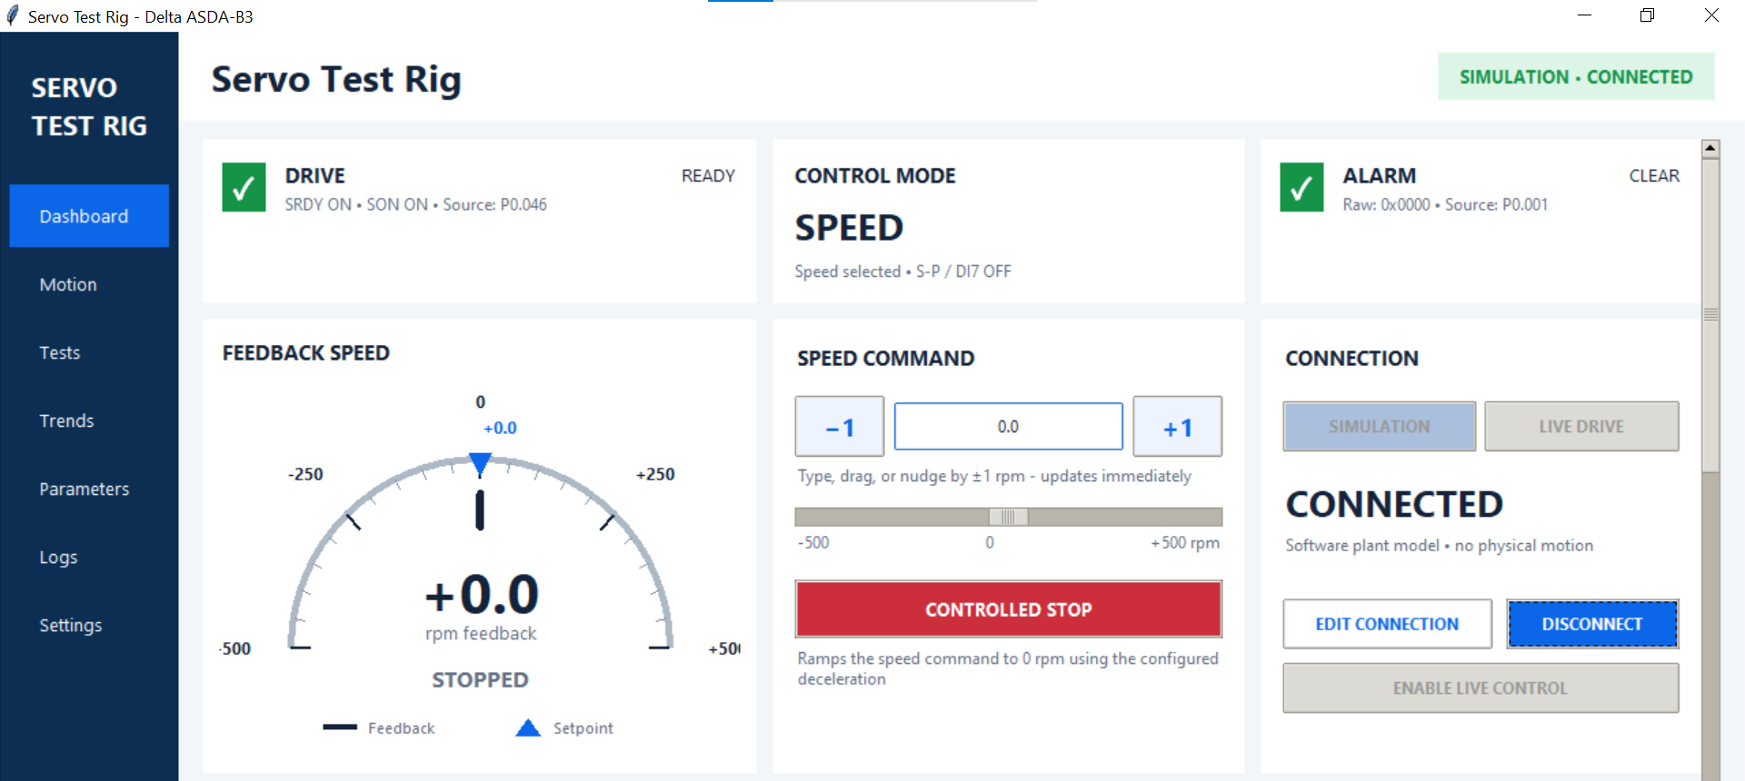
Figure 5.1 Dashboard upper view in Simulation: drive, control-mode and alarm status, manual speed controls and drive connection. The displayed +/-500 rpm range is the applied screenshot setting.

5.3.1 Drive status and alarm cards
DRIVE shows READY only when both SRDY (servo ready) and SON (servo on) are reported in P0.046. NOT READY may simply mean the physical Servo ON selector is OFF. CONNECTED means serial communication is established; READY means the drive reports those two conditions. Neither status by itself grants software motion permission.
ALARM shows CLEAR or ACTIVE and the raw alarm code from P0.001. The application also checks the alarm indication in P0.046. Use the Logs page to investigate an active alarm. Live alarm reset is performed using the blue reset button; the GUI does not provide a general live alarm-reset command.

5.3.2 Connection and mode selection
Select SIMULATION for the software model or LIVE DRIVE for the physical drive. Disconnect before changing modes. EDIT CONNECTION opens the serial settings. Click CONNECT; once connected, the button changes to DISCONNECT.
Before connecting, switch the Servo ON selector to OFF and press the red OFF button. If the motor does not respond, immediately press the emergency-stop button. Wait for the platform to stop before investigating the problem. The application verifies communication through P3.002 and requires ZSPD (zero speed) in P0.046; otherwise, connection fails and Logs shows the error.
During connection, the application configures P3.006 for software control of DI6/SPD0. This lets the GUI select internal speed commands using P4.007. SON and EMGS must remain hardware controlled; connection is refused if either is assigned to DI6. Manual motion stays locked until live control is enabled.

5.3.3 Enable Live Control
ENABLE LIVE CONTROL unlocks manual speed and GO TO POSITION controls on a connected live drive. It is disabled in Simulation. Set the operator speed limit on Motion before enabling it.
With the rig safe and the travel path clear, release the emergency stop, press the blue reset button and press the green Start button. Turn the Servo ON selector to ON, then confirm READY, no alarm and zero speed. You should hear a high-pitched noise from the servo. Click ENABLE LIVE CONTROL and accept the confirmation only after checking the motor/encoder, EMGS, STO, direction and stopping behavior.
The application checks drive readiness, zero command/speed, safety inputs, configuration and speed limits. If a check fails, motion remains locked and the reason is reported. On success, the button becomes DISABLE LIVE CONTROL. Enabling does not start motion, but subsequent speed edits can act immediately.
DISABLE LIVE CONTROL requests zero speed and removes permission. Permission is also removed by an alarm, unhealthy EMGS, loss of SON/SRDY, disconnect or restart. A zero-speed request remains available while connected. Software stopping depends on communication; use the physical emergency stop when required and verify standstill before handling the rig.

5.3.4 Feedback speed and speed command
FEEDBACK SPEED shows motor speed in rpm from the encoder monitor. The dark pointer and large numeric value show feedback; the blue marker shows the entered or pending setpoint. STOPPED, FORWARD and REVERSE describe the feedback direction. A changed setpoint marker alone is not evidence that a command has reached the drive.
Enter a signed motor speed and press Enter, or leave the entry field, to send it. The −1 and +1 buttons change it by 1 rpm; dragging the slider also schedules a command after a short delay. There is no separate Apply button for speed. Entry is checked against the applied operator limits, and nudges and slider travel are constrained to that range. Start with a low commissioned speed and watch the encoder response.
The command is motor rpm. With the configured 2:1 motor-to-platform reduction, 100 motor rpm corresponds to 50 platform rpm. Negative speed reverses the motor command.
CONTROLLED STOP cancels the active test through the common stop path and requests zero speed using the configured drive deceleration. It does not remove electrical power or turn the physical Servo ON selector OFF. If using the position-command panel, use that panel’s STOP to cancel its position loop, then verify zero feedback.
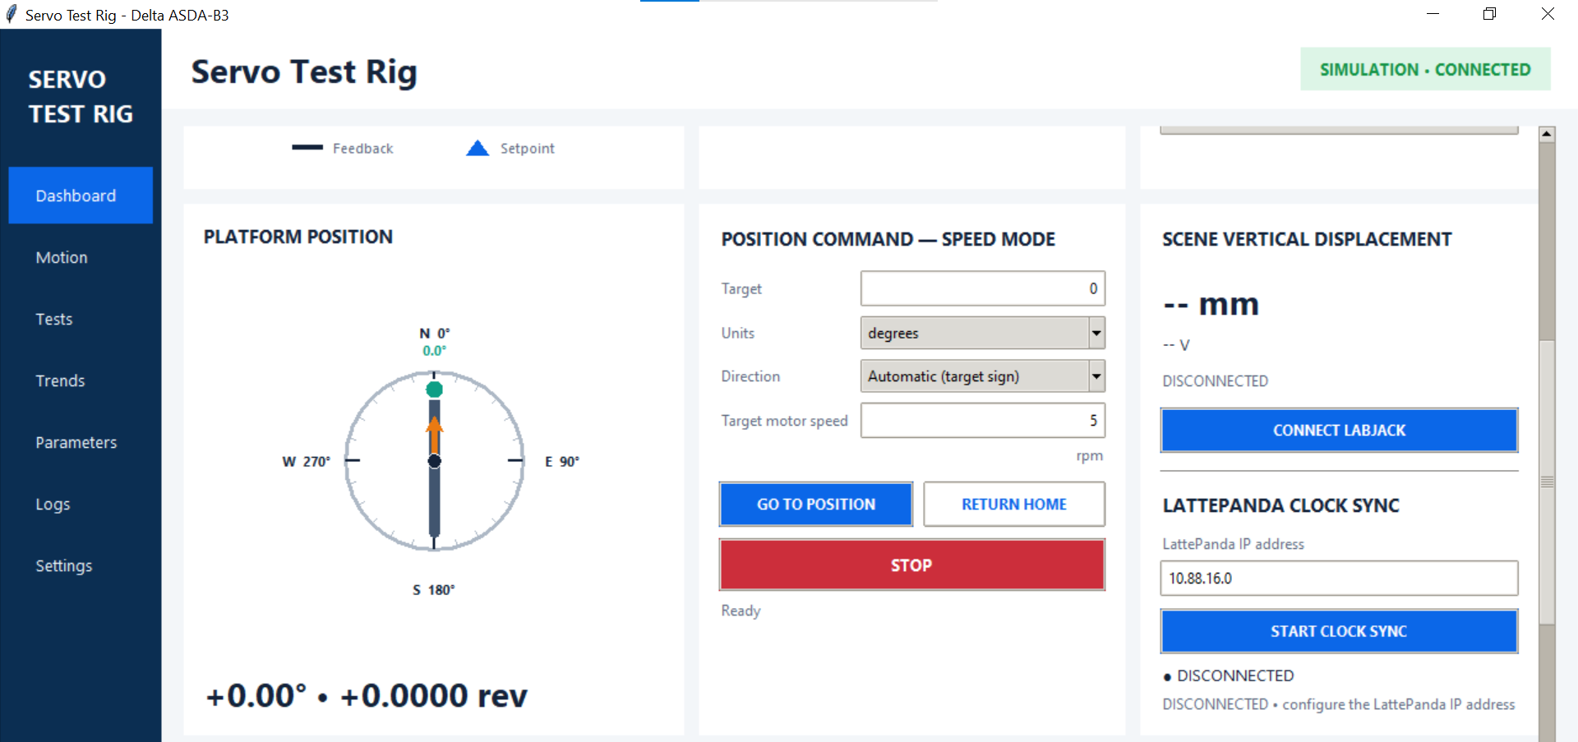
Figure 5.2 Dashboard middle view: platform position, Speed-mode position commands, LabJack connection and LattePanda clock synchronization.

5.3.5 Platform position display
The compass shows platform orientation modulo 360°. Its green marker identifies the front of the platform; the orange arrow shows motor angle. The number beneath the compass shows continuous platform position in degrees and revolutions, so it can distinguish more than one complete turn.
The session reference is captured from the first available encoder position after connection. Position is calculated from motor encoder counts using 2²⁴ counts per motor revolution and the configured motor-to-platform ratio, with the selected platform direction convention. The display assumes the belt ratio remains correct and does not measure the platform independently. Reconnecting establishes a new session zero; place the platform at the intended physical home before connecting.

5.3.6 Position command in Speed mode
Target and Units define the requested movement. With degrees selected, the target is an orientation within one revolution. Automatic selects the shortest angular path; Positive / anticlockwise and Negative / clockwise force a direction. For example, from 350° to 10°, Automatic selects approximately +20° travel. With revolutions selected, the target is relative travel: +2 means two additional turns, with direction overrides taking precedence over the sign.
Target motor speed is the maximum motor rpm for the movement and must be positive and within the applied limit. GO TO POSITION requires encoder data, zero command/speed, healthy readiness checks, no competing test and live control permission. A live move also presents a confirmation with the resolved target and travel.
The application selects Speed mode and follows encoder position, updating speed commands approximately every 50 ms when data is available. It estimates braking distance from the drive deceleration, requests zero before the target and can finish with a slower approach. It stops the operation on missing encoder data, timeout, command failure or excessive overshoot. This is a software position movement over the serial link, not a drive-resident PR trajectory.
A Dashboard position started event marks the movement start, target and maximum motor speed in Logs. STOP cancels this position operation and requests zero speed. The status line reports preparation, movement, braking, final approach, completion or failure.

5.3.7 Return home
RETURN HOME moves to the connection-time zero orientation by the shortest path. It does not search for a home switch. Its motor speed is capped at 5 rpm; this routine does not use the applied operator speed limit. The home workflow checks readiness and, on a live drive, asks for confirmation and separately arms the limited movement. It can therefore be available when ordinary manual controls are locked; do not treat its availability as permission to move without checking the path.

5.3.8 Scene vertical displacement
This card shows calibrated displacement in mm, AIN0 voltage and LabJack connection status. CONNECT LABJACK starts the independently configured voltage acquisition; the button becomes a disconnect control after connection. Sampling rate, 0 mm voltage and mm-per-volt calibration come from Settings. Displacement is calculated as (measured voltage − 0 mm voltage) × mm per volt.
The dashes in Figure 5.2 mean no reading is available. Zero is a measured value, whereas dashes do not confirm the scene is at zero height. The LabJack is independent of the servo connection.

5.3.9 LattePanda clock synchronization
The clock controls are below CONNECT LABJACK on the same card. Enter the current LattePanda IPv4 address, then click START CLOCK SYNC. Run lattepanda_clock_responder.py on the LattePanda and connect both computers to the same Wi-Fi network first. Use the address reported by ipconfig; the address in Figure 5.2 is an example, not a fixed rig address.
The status changes from DISCONNECTED to WAITING and then CONNECTED when valid replies arrive. The button changes to STOP CLOCK SYNC while the client is running. If it remains WAITING, check the responder, IP address, UDP port and network/firewall configuration. Clock synchronization does not start camera recording or motor motion.
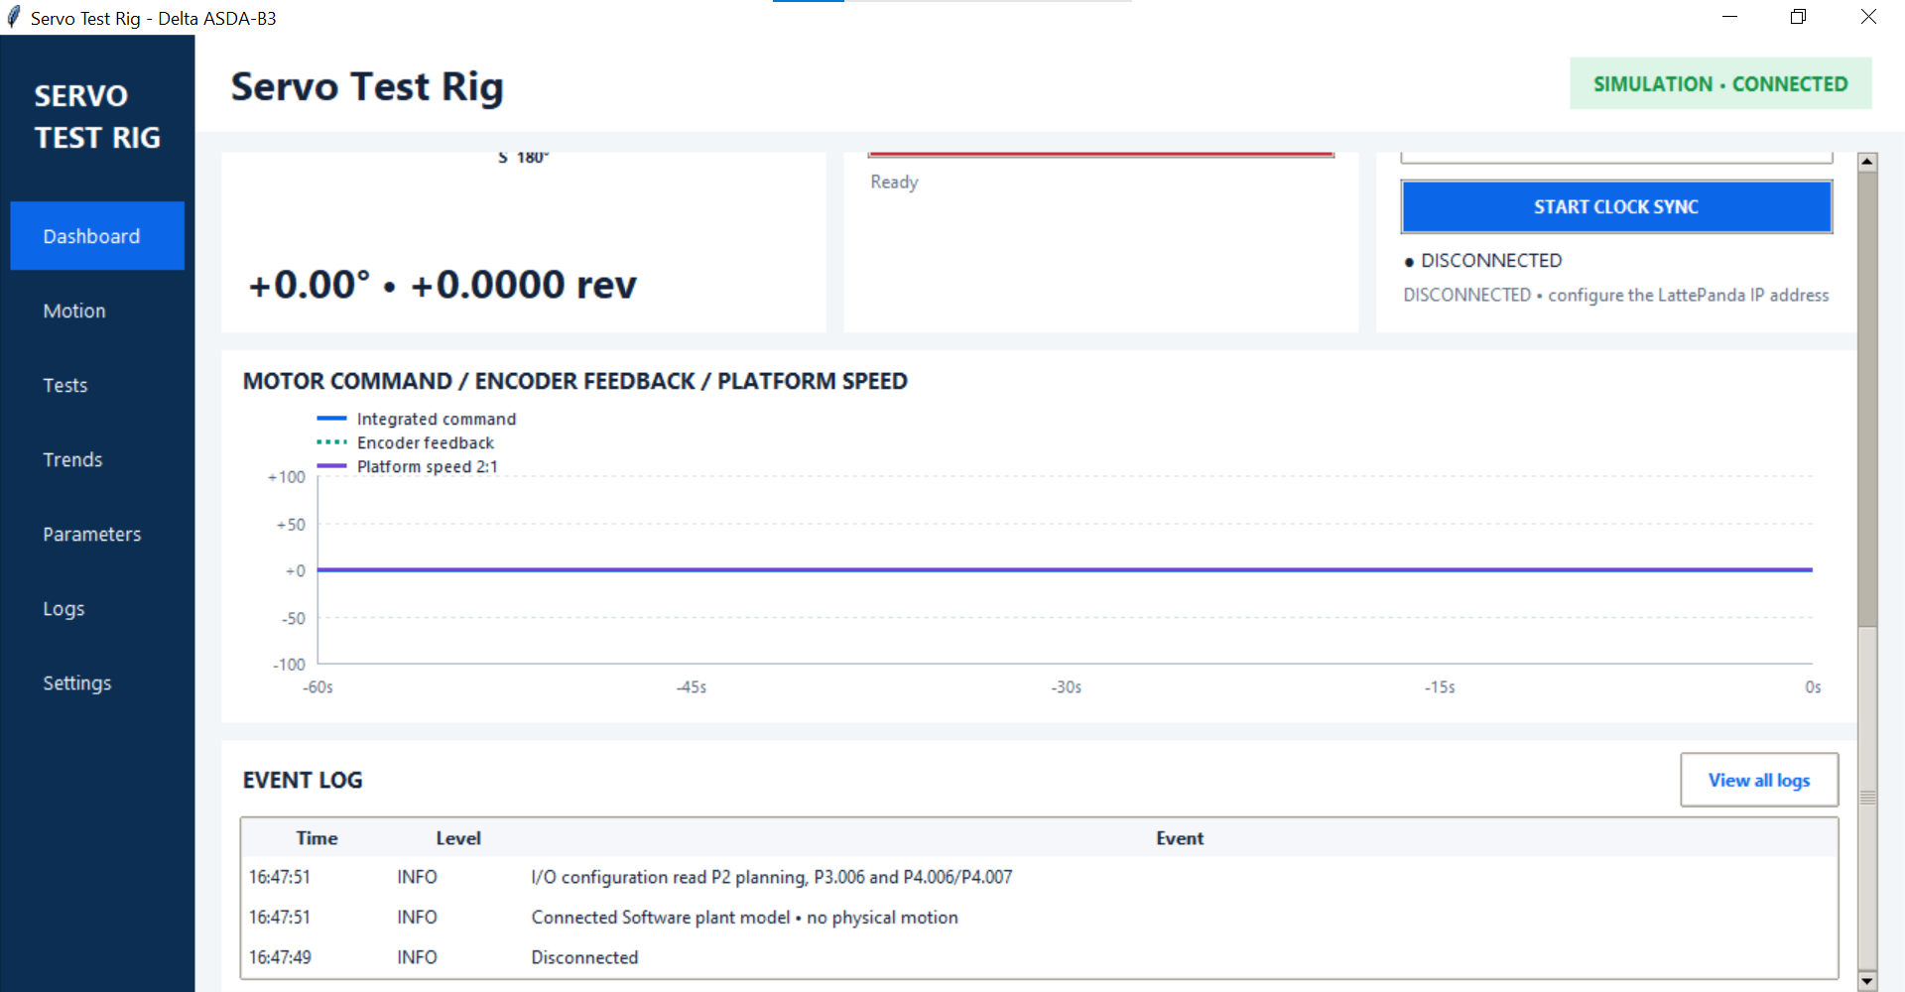
Figure 5.3 Dashboard lower view: rolling speed trend and recent event log.

5.3.10 Speed trend and event log
The compact trend shows the recent 60 seconds of command, motor encoder feedback and calculated platform speed. Use it to see acceleration, deceleration, direction changes and whether feedback follows the command. Platform speed is encoder speed divided by the configured ratio; it is not a separate platform measurement.
The blue Requested motor speed trace shows the application setpoint. Encoder feedback shows the measured response. Encoder speed and position are read together in a contiguous Modbus transaction; their timestamp is the midpoint of the software read interval.
EVENT LOG shows recent event time, level and description. INFO records normal actions; WARN and ERROR provide details for rejected commands, readiness problems and communication failures. View all logs opens Logs for the full session record, filtering and CSV export. Use this page when a connection or Enable Live Control fails.

5.4 Motion
The Motion page groups manual speed commands, ramp settings, operating limits and digital I/O. Select Motion in the sidebar. The upper cards configure movement; scroll down to inspect inputs, outputs and recent commands. The screenshots below show Simulation connected.
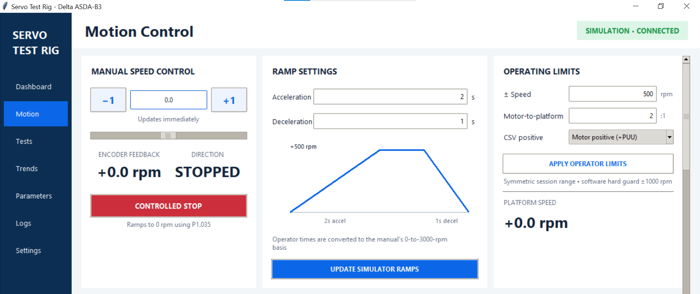
Figure 5.4 Motion upper view: manual motor speed, ramp settings and operator limits. The displayed values are example settings.

5.4.1 Manual speed control
Use manual speed control to test the configured acceleration and deceleration times. This card shares the Dashboard speed command. Enter signed motor rpm and press Enter or leave the field to send it. The -1 and +1 buttons nudge the command by 1 rpm; the slider also sends speed changes. There is no separate Apply action for speed. In Live Drive mode, first enable live control on the Dashboard.
ENCODER FEEDBACK shows measured motor speed, and DIRECTION shows FORWARD, REVERSE or STOPPED. The command changes P1.009 in 0.1 rpm units. Watch feedback to confirm the response. CONTROLLED STOP requests zero using the configured P1.035 deceleration; it does not switch off the drive supply. See the Dashboard section for position-move stopping and physical stop controls.

5.4.2 Operating limits
Set these values before applying ramps or preparing a profile, then click APPLY OPERATOR LIMITS:
- +/- Speed: the symmetric motor command range. Entering 100 allows commands from -100 to +100 motor rpm. The 1000 rpm software ceiling is not the rig's approved operating limit. Use only commissioned speeds, loads and ramp settings.
- Motor-to-platform: motor revolutions per platform revolution. Use 2 for the installed 2:1 reduction. PLATFORM SPEED is calculated from encoder motor rpm divided by this ratio; 100 motor rpm gives 50 platform rpm.
- CSV positive: the motor direction used as positive for CSV and platform-position commands. Motor positive (+PUU) selects the positive motor direction; the alternative reverses that convention. Manual speed entry retains its entered sign.
APPLY OPERATOR LIMITS updates the manual command range, gauge/slider range and platform conversion, saves the settings and reloads an imported profile for validation. The drive maximum-speed limit (P1.055) and overspeed protection threshold (P1.111) are not changed. A narrower range is rejected if the current speed entry lies outside the proposed range; stop and set zero before reducing the limit. Changing the reference speed changes the ramp conversion, so apply the ramps again after changing the speed limit.

5.4.3 Ramp settings
Acceleration is the time from zero to the applied positive speed limit; Deceleration is the time from that limit to zero. Enter positive times in seconds. The diagram previews these settings. The note below shows the maximum acceleration and deceleration times for the applied speed limit. Typing values does not itself write the drive.
Click UPDATE SIMULATOR RAMPS in Simulation, or APPLY LIVE DRIVE RAMPS with the physical drive connected. Live changes require a zero command, zero-speed indication and Servo ON OFF. Review the confirmation showing the register values, then apply. The application writes and reads back both ramp parameters. When disconnected, the values can be staged but cannot be applied to a drive.
The drive stores P1.034 and P1.035 as milliseconds for a 3000 rpm change. The application converts each operator time using:
Parameter value (ms) = time (s) x 3000 / applied speed limit (rpm) x 1000
In Figure 5.4, the limit is 500 rpm, acceleration is 2 s and deceleration is 1 s. These convert to P1.034 = 12000 ms and P1.035 = 6000 ms. On that ramp basis, a 0-to-100-rpm change takes approximately 0.4 s. The converted values must be within 1 to 65500 ms; an invalid combination is rejected.
Applying ramps invalidates the prepared profile and recalculates an imported profile. Complete its preparation again before starting a test. Actual motion should be checked against encoder feedback.

5.4.4 Example in Simulation
1. Connect Simulation on the Dashboard, then open Motion.
2. Set +/- Speed to 100, Motor-to-platform to 2 and click APPLY OPERATOR LIMITS.
3. Set Acceleration to 2 s and Deceleration to 2 s. Click UPDATE SIMULATOR RAMPS. Both register values should be 60000 ms for the applied 100 rpm limit.
4. Enter 100 rpm and press Enter. Use a stopwatch to measure the time until encoder feedback reaches approximately +100 motor rpm (+50 platform rpm). The configured acceleration time is 2 s; allow for feedback settling and manual timing uncertainty.
5. Click CONTROLLED STOP and use a stopwatch to check that feedback returns to approximately zero within about 2 s, allowing for feedback settling and manual timing uncertainty. Repeat with a negative command to observe reverse motion.
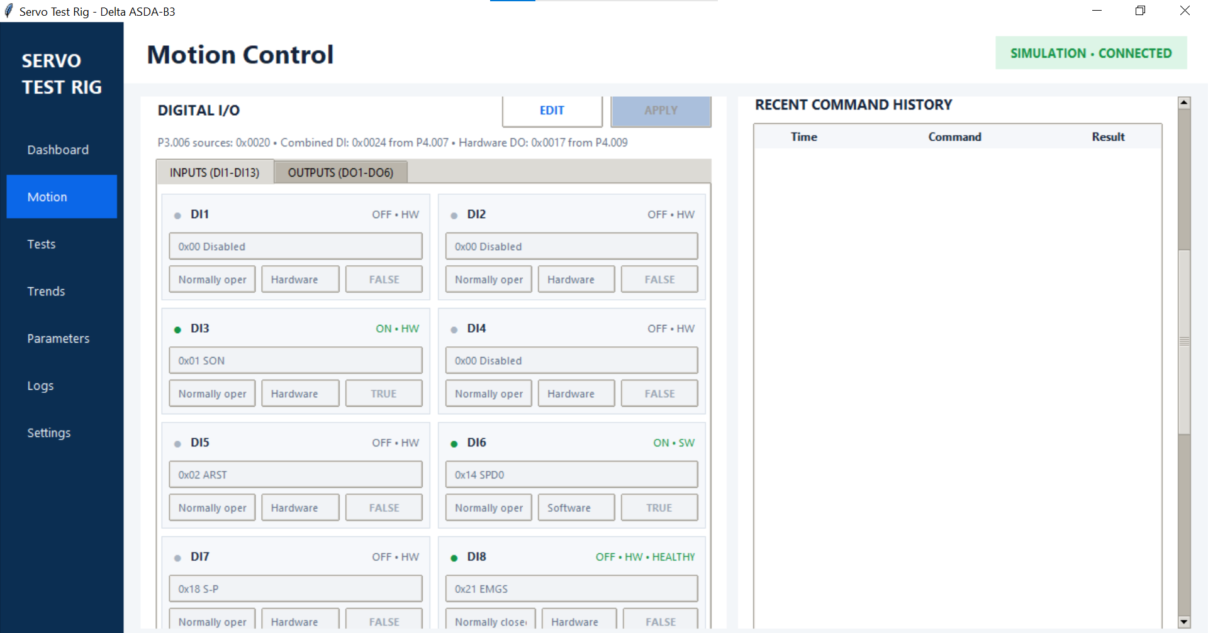
Figure 5.5 Motion lower view: digital-input states and configuration, with recent command history alongside. Scroll to reach the remaining inputs or select OUTPUTS.

5.4.5 Reading digital inputs
INPUTS lists DI1-DI13. Each card shows the assigned function, contact polarity, Hardware or Software source, and logical TRUE/FALSE state. The lamp and ON/OFF text show the current readback. HW means the physical input supplies the signal; SW means the corresponding P4.007 software bit supplies it. The TRUE/FALSE control is editable only for a software-sourced input while Edit is active.
The summary above the cards shows P3.006 source selection, combined DI state from P4.007 and hardware DO state from P4.009. In Figure 5.5, source mask 0x0020 means DI6 is software controlled. Combined DI 0x0024 means DI3 and DI6 are logically ON.
The installed input assignments shown include DI3/SON (Servo ON), DI5/ARST (alarm reset), DI6/SPD0 (internal speed selection), DI8/EMGS (emergency-stop function). SON and EMGS must remain hardware controlled.
Normally open and Normally closed describe how the physical signal is interpreted. For the normally closed EMGS circuit on this rig, OFF / HW / HEALTHY means the emergency-stop function is not active and the input voltage is HIGH. ON means EMGS is active and the input voltage is LOW, indicating an unhealthy circuit. Read the function name and HEALTHY indication together.

5.4.6 Reading digital outputs
Select OUTPUTS (DO1-DO6) to view output functions, contact polarity and hardware readback. The project assigns DO1/SRDY (servo ready), DO2/ZSPD (zero speed), DO3/TSPD (target speed reached), DO4/TPOS (target position reached) and DO5/ALRM (alarm output); DO6 is disabled. Interpret each output using its assigned function and contact polarity.
- P4.009 is the hardware output status. Software output control uses P4.006 only for functions assigned to the supported software-output range. A normal drive-status output is not a general-purpose software switch.

5.4.7 Editing digital I/O
Routine operation uses the commissioned I/O assignments. To make a deliberate configuration change, connect the drive and wait for its I/O configuration to load, then click EDIT. Select the function, contact polarity and input source, and set software TRUE/FALSE values where enabled. Changes are staged until APPLY is clicked. CANCEL discards staged edits and reloads the recorded configuration.
For live changes, set the command to zero and confirm zero speed. Turn Servo ON OFF before changing function or contact assignments. The application requires exactly one normally closed, hardware-sourced EMGS input. It refuses incompatible settings. Confirm the live-write prompt, then inspect the readback and Logs. Follow the drive parameter restart requirements for function/contact changes and recheck the affected signals before movement.

5.4.8 Recent command history
The table lists the most recent 20 manual speed requests with time, command and result. Sent means the request was dispatched by the GUI; it is not proof of motor movement or successful completion. Use encoder feedback and the Logs page to confirm the outcome and investigate rejected or failed commands.

5.5 Tests
Use Tests, titled Motion Profiles at the top of the page, to run a repeatable CSV motion profile and record motor feedback alongside EVK4 event acquisition. The operating sequence is: prepare the rig, import the CSV, review the compiled plan, stage and verify, start, monitor, then collect the saved files. Speed and position sequences both operate through Speed mode.
The screenshots show Simulation. Use this mode to practise profile preparation and stopping. For an event-capture experiment, connect Live Drive and run the camera-and-trigger responder on the LattePanda before pressing START.
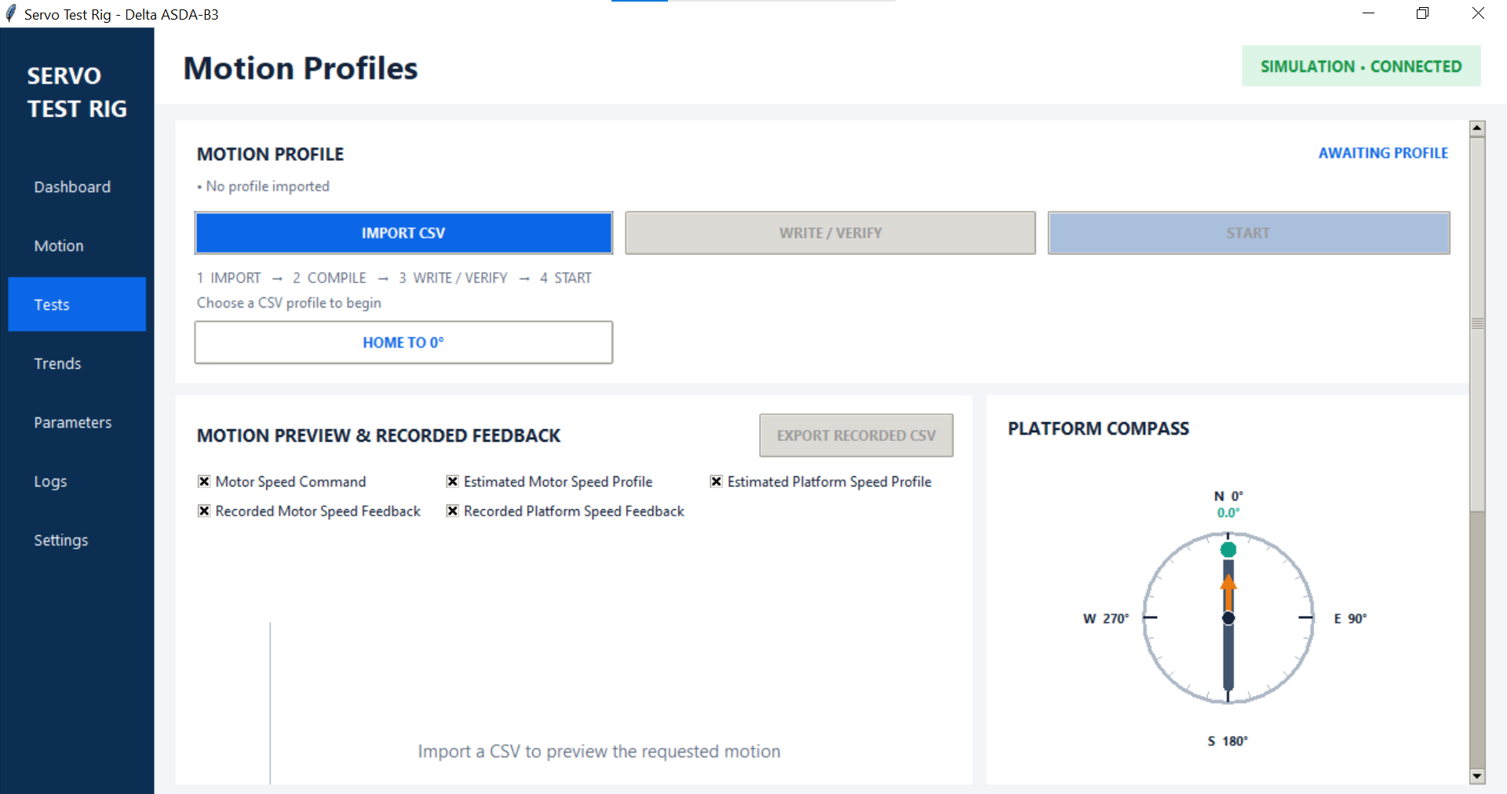
Figure 5.6 Tests before importing a profile. The workflow controls are at the top; preview channels and the platform compass are below.

5.5.1 Prepare for an event-capture run
- Complete the startup procedure in Section 4. Check the rig, guards and cable clearance, and confirm the drive and encoder are communicating.
- On Motion, apply the commissioned motor-speed limit, motor-to-platform ratio, direction convention and drive ramps. Finish these settings before importing or staging the profile.
- Connect the LabJack and check voltage and displacement if scene height is being measured. The run-readiness strip does not include a separate LabJack connection check.
- Ensure the LattePanda is powered on and has at least 5 GB of free space on the drive used for the recording directory. Close Metavision Studio and start lattepanda_clock_responder.py with camera recording and UART trigger enabled, using the required bias file and recording directory. Confirm camera and UART READY. The network-only command with --no-camera-recording --no-trigger cannot run a physical event-capture profile.
- Start clock synchronization from the Dashboard using the current LattePanda IP address. Confirm fresh replies. Camera health and trigger health are checked again when START arms the run.
- Confirm the intended starting orientation. HOME TO 0 degrees returns to the connection-time reference using encoder feedback; it does not search for a home switch. Use it before the run if that reference is required. Allow the home movement to finish before START.
To prepare for physical motion, release the emergency stop, press the blue reset button and the green Start button, and ensure the Servo ON selector is in the OFF position. Confirm the motor is stationary and the path is clear.

5.5.2 Choose the CSV format
The column names and order identify the profile type. Save a comma-separated CSV with the exact headers shown below, numeric values and no extra columns. Keep the original CSV with the experiment records.
Speed sequence CSV
Use time_s,motor_rpm for a speed-versus-time experiment. Times are seconds from T0 and must start at zero and increase strictly. Speeds are signed motor rpm, not platform rpm. At least two data rows are required. A physical speed profile must end with a zero-speed row; its first command may be nonzero.
The following short example waits at zero for 2 s, commands 100 motor rpm until 6 s, then requests zero:
time_s,motor_rpm
0,0
2,100
6,0
Each speed is sent at its CSV time and held until the next row. The drive ramps determine the actual acceleration and deceleration. The last row starts the terminal stop; recording continues while the motor slows. With a 2:1 reduction, 100 motor rpm corresponds to 50 platform rpm.
The supplied screenshot uses 450-rpm.csv, with a 450 motor rpm command and a nominal 20 s timeline. With the displayed 2:1 ratio, its platform-speed estimate is 225 rpm. Those are example values; use the commissioned operating limits for the physical rig.
Position sequence CSV
For a physical position sequence, use platform_position_deg,motor_speed_rpm,hold_s. Each row specifies a continuous platform-angle target relative to the run origin, a positive motor-speed limit and a hold after reaching the target. Start with position 0 and speed 0. For example:
platform_position_deg,motor_speed_rpm,hold_s
0,0,1
90,5,1
180,5,1
This requests 0, 90 and 180 degrees, with a 5 motor rpm limit for each move and a 1 s hold at each target. A target of 720 degrees represents two complete platform turns. The application follows encoder feedback and slows for holds, reversals and the final target. Consecutive targets in the same direction with no hold may be passed without stopping. Position-run duration is an estimate; it depends on measured motion and settling.

5.5.3 Import and review the plan
1. Click IMPORT CSV and select the profile. The application reads the headers, validates the values and compiles the plan automatically; there is no separate Compile button.
2. Check the filename, sequence type, nominal duration, peak motor speed, ratio and acceleration/deceleration values. Check the preview direction and the final stop. If the peak exceeds the applied limit or the CSV is invalid, resolve IMPORT FAILED or COMPILE FAILED before continuing.
3. Export any previous run that still needs saving before importing another CSV. Importing a profile clears the previous profile-recording view.
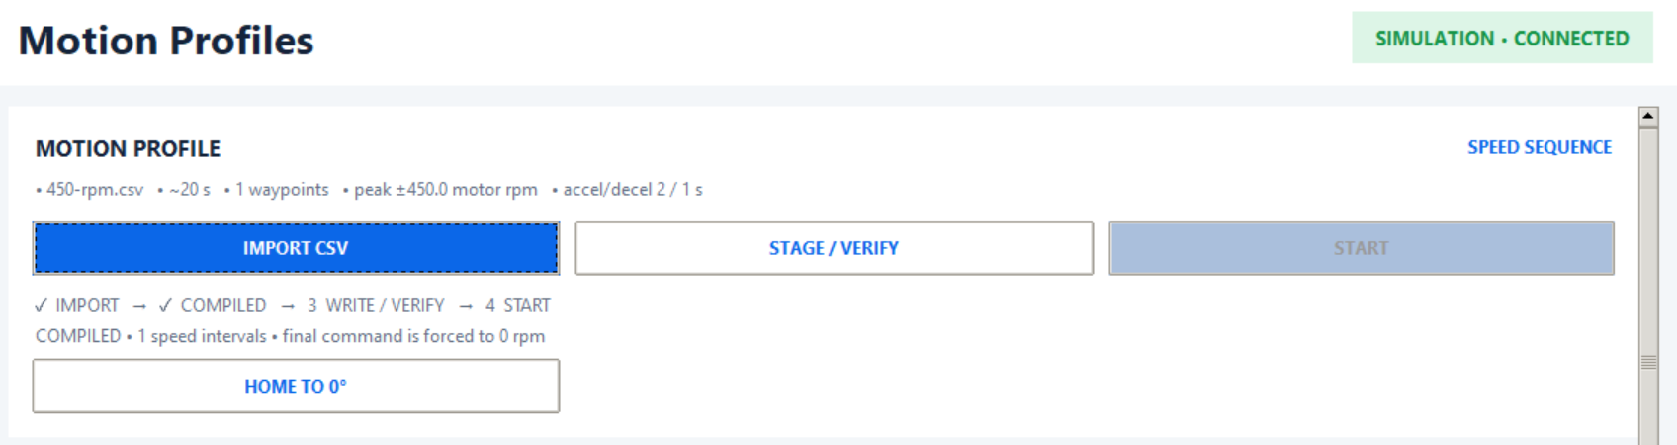
Figure 5.7 An imported and compiled speed sequence in Simulation, awaiting STAGE / VERIFY. START is disabled until staging and readiness checks pass.

5.5.4 Stage and verify
Click STAGE / VERIFY. For current Speed-mode operation, staging prepares the execution plan in the Motor PC application. It does not download a motion program to the drive or start camera recording.
Confirm STAGED + VERIFIED for a live profile, or WRITTEN + VERIFIED for the simulator plan. The workflow ticks show completed stages.
If the operator limit, ratio, ramps or profile change, review and stage the plan again. An enabled START button indicates the current motion checks pass; the camera and timing checks still take place during arming.

5.5.5 Read the preview and readiness checks
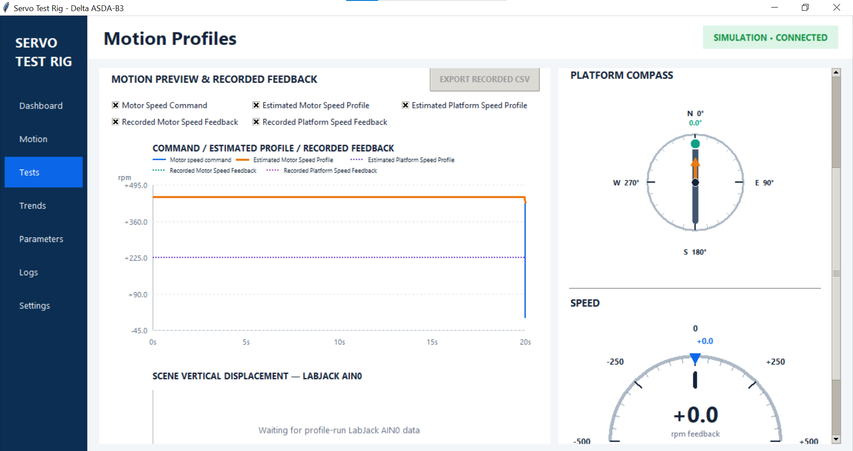
Figure 5.8 The imported 450 motor rpm sequence. Command and estimated traces are visible; recorded feedback appears when the run acquires data.
- Motor Speed Command: requested motor-speed setpoints from the CSV.
- Estimated Motor Speed Profile: a preview based on the configured ramps.
- Estimated Platform Speed Profile: the motor estimate divided by the configured ratio.
- Recorded Motor Speed Feedback: measured encoder motor speed during the run.
- Recorded Platform Speed Feedback: encoder motor speed divided by the configured ratio.
Use the checkboxes to show or hide traces. Estimated curves are preparation aids; recorded feedback shows the acquired response. For a position sequence, the channel labels change to active platform target, nominal motor/platform trajectories and recorded motor/platform position.
The compass shows orientation relative to the connection-time reference, while position-run targets and exports use a run origin captured when execution starts. The speed gauge shows motor feedback and setpoint. The scene-displacement chart plots profile-run LabJack AIN0 data; a waiting message means that no profile-run samples are available yet.
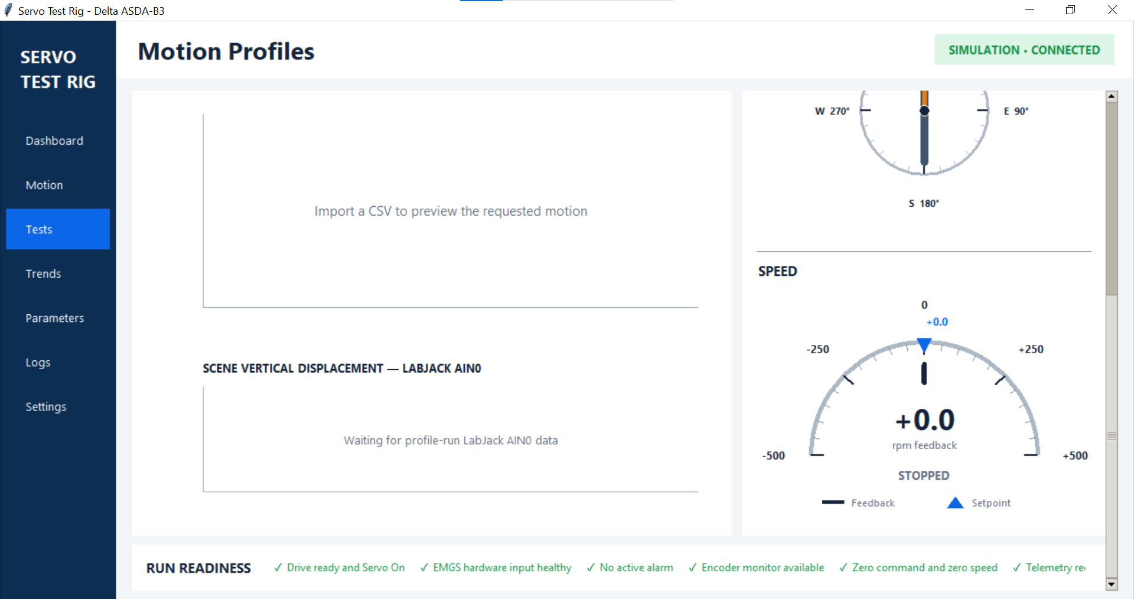
Figure 5.9 Lower Tests view before acquisition: displacement chart, feedback speed and the run-readiness strip. Maximize the window to read the readiness strip; use Logs for failure details.
Before START, all RUN READINESS checks must pass: drive ready and Servo On, healthy hardware EMGS, no active alarm, encoder monitor available, zero command and zero speed, and telemetry recording ready. If START is disabled, check the workflow status, this strip and Logs. Camera/trigger readiness and fresh clock alignment are additional checks during live arming.

5.5.6 Start the coordinated experiment
1. Set the Servo ON selector switch to ON, then click START LIVE SPEED CSV or START SPEED-CONTROLLED POSITION on a live connection. In Simulation the button reads START. Read and accept the physical-motion confirmation only when the rig is ready.
2. The Motor PC checks the drive and obtains a fresh clock exchange, then sends ARM to the LattePanda. The responder starts RAW recording and schedules a future T0. The current request uses 3 s pre-roll plus a 1 s preparation margin, giving approximately 4 s between arming and T0. The GUI shows ARMED and the countdown.
3. At T0, the LattePanda schedules its first UART timing marker and the Motor PC releases the CSV motion timeline. RAW recording has already begun. T0 is the agreed timing reference, not proof that the motor physically moved at that exact instant; encoder feedback records the actual response.
4. Monitor RUNNING, recorded speed/position, displacement and the responder. The run uses a shared run_id to link the motor data, timing records and camera acquisition. The application monitors the remote run and aborts on camera, trigger or coordinator health failures.
A stale or missing clock reply, camera disabled, unhealthy EVK4 stream or missing trigger prevents a physical run from arming. Check Logs and the responder console, correct the cause and stage/retry as appropriate. Simulation exercises the software motion workflow without the physical event-capture handshake.

5.5.7 Completion and abort
At the last speed-CSV deadline, the application requests zero and shows STOPPING. It continues recording until fresh encoder feedback is stably near zero, then shows COMPLETE / ZERO SPEED. Do not stop the responder or close the GUI at the last CSV time: the deceleration and recording finalization still need to finish. Position sequences similarly finish after the final target and stop checks.
On completion, the Motor PC sends COMPLETE to the LattePanda, which stops the UART schedule and finalizes RAW logging and metadata. Confirm the responder reports that recording was saved and the Motor PC reports export success.
START changes to ABORT during preparation or execution. ABORT cancels the timeline, requests zero speed and asks the LattePanda to cancel/finalize the run. Retain partial data and its abort reason for diagnosis. If the rig does not respond safely, use the physical emergency stop. Verify standstill before approaching it.

5.5.8 Save and collect the run
The application automatically exports acquired motion data beside the imported CSV, using a name such as 450-rpm_YYYYMMDD_HHMMSS_recorded.csv. EXPORT RECORDED CSV also lets you choose a destination after samples exist. Check Logs for the actual path and any sidecar or remote-finalization errors before importing another profile or starting another run.
- Motor PC recorded CSV: motor command, encoder feedback, calculated platform motion, timing fields and available LabJack voltage/displacement.
- Motor PC _clock_sync.csv: clock exchanges around the recording window, when valid synchronization samples are available.
- Motor PC _events.csv and _metadata.json: run events, run_id, timing and available remote completion information.
- LattePanda .raw: EVK4 event data, saved in the responder recording directory.
- LattePanda _0x00_writes.csv and _metadata.json: UART timing-write log and camera/session metadata, including the run_id and bias settings.
Copy the matching LattePanda files into the experiment folder on the Motor PC, keeping the original filenames and metadata. Identify the matching acquisition by run_id. Trigger-event extraction is deferred to experiment preparation on the Motor PC; an extracted _trigger_events.csv may therefore not exist immediately after capture. Follow the processing procedure in Section 6 after all run files have been collected. For optional extraction before transfer, use Section 6.4.1.
Before repeating a trial, confirm the previous recording was finalized and saved, the motor is stopped, the battery and storage are adequate, and the intended orientation and scene height are restored. Use the same profile and settings for comparable runs. Each START creates a new run_id and recording.

5.6 Trends
Select Trends in the sidebar to open Trends & Tracking. Use SPEED TRACKING to compare commands with encoder speed, and ANGULAR POSITION to inspect rotation. These pages display acquired telemetry; motion is commanded from Dashboard, Motion or Tests. The screenshots show Simulation at rest.
Both charts show a rolling 60-second window. The right edge, 0 s, is the newest displayed sample; negative times show earlier samples. Select channels in the right-hand panel to show or hide traces. Hiding a trace does not stop acquisition or remove that channel from export.

5.6.1 Speed Tracking
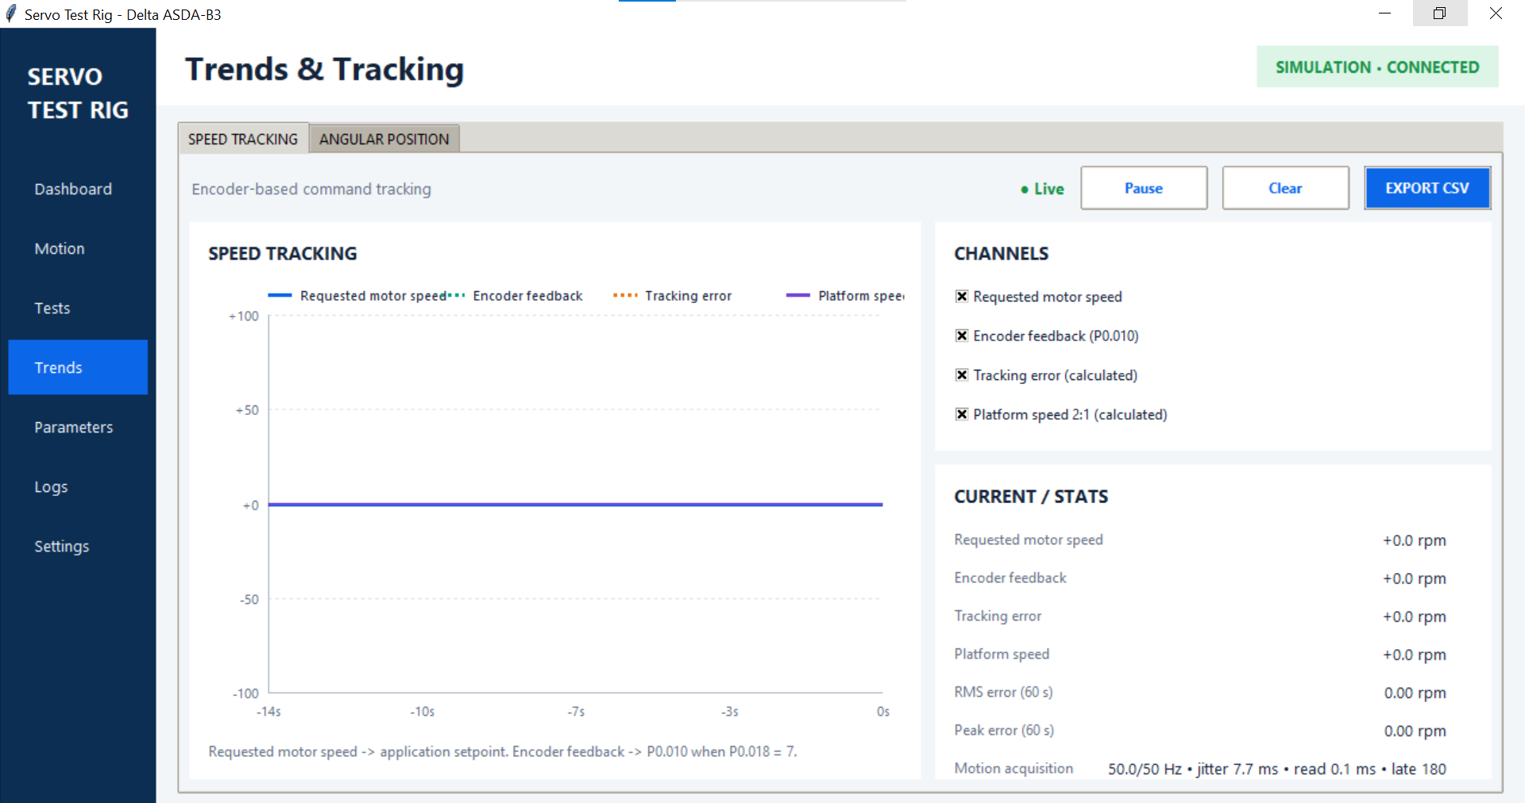
Figure 5.10 Speed Tracking: rolling speed traces, channel selection, current values, error statistics and acquisition timing.
- Requested motor speed: the blue trace shows the speed setpoint sent by the application. The motor accelerates or decelerates toward this value using its configured ramps.
- Encoder feedback: measured motor speed from P0.010, with P0.018 set to 7.
- Tracking error: command minus encoder feedback, in motor rpm. For example, a 100 rpm command and 98 rpm feedback give +2 rpm error.
- Platform speed: encoder motor speed divided by the motor-to-platform ratio. At 2:1, 100 motor rpm gives 50 platform rpm.
Use the graph to inspect acceleration, settling, steady speed and deceleration. A difference during a ramp is expected because feedback cannot change instantly.

5.6.2 Current values and error statistics
CURRENT / STATS shows the latest command, encoder feedback, calculated tracking error and platform speed. RMS error (60 s) is the square root of the mean squared tracking error over the latest 60 seconds of available samples. Peak error (60 s) is the largest absolute tracking error in that window. Both are in motor rpm.
These statistics include any acceleration, steady-speed and stopping samples in the window. Compare the same part of each test when assessing repeatability; a window containing a start or stop is different from one containing only steady rotation.

5.6.3 Motion acquisition timing
The acquisition line appears on both tabs. Use it to check whether sampling is keeping up:
- Rate: achieved samples per second followed by the target, such as 49.9/50 Hz. If acquisition is configured for the bus maximum, the label says so instead of showing a fixed target.
- Jitter: variation in the interval between samples, reported as the standard deviation in milliseconds.
- Read: duration of the latest motion-data read in milliseconds.
- Late: accumulated count of intervals longer than 1.5 times the target sampling period. This does not directly count missing samples.
Use the exported timestamps and acquisition durations for timing analysis rather than assuming every sample is exactly one target period apart. The values in the screenshots describe that simulation session.

5.6.4 Angular Position
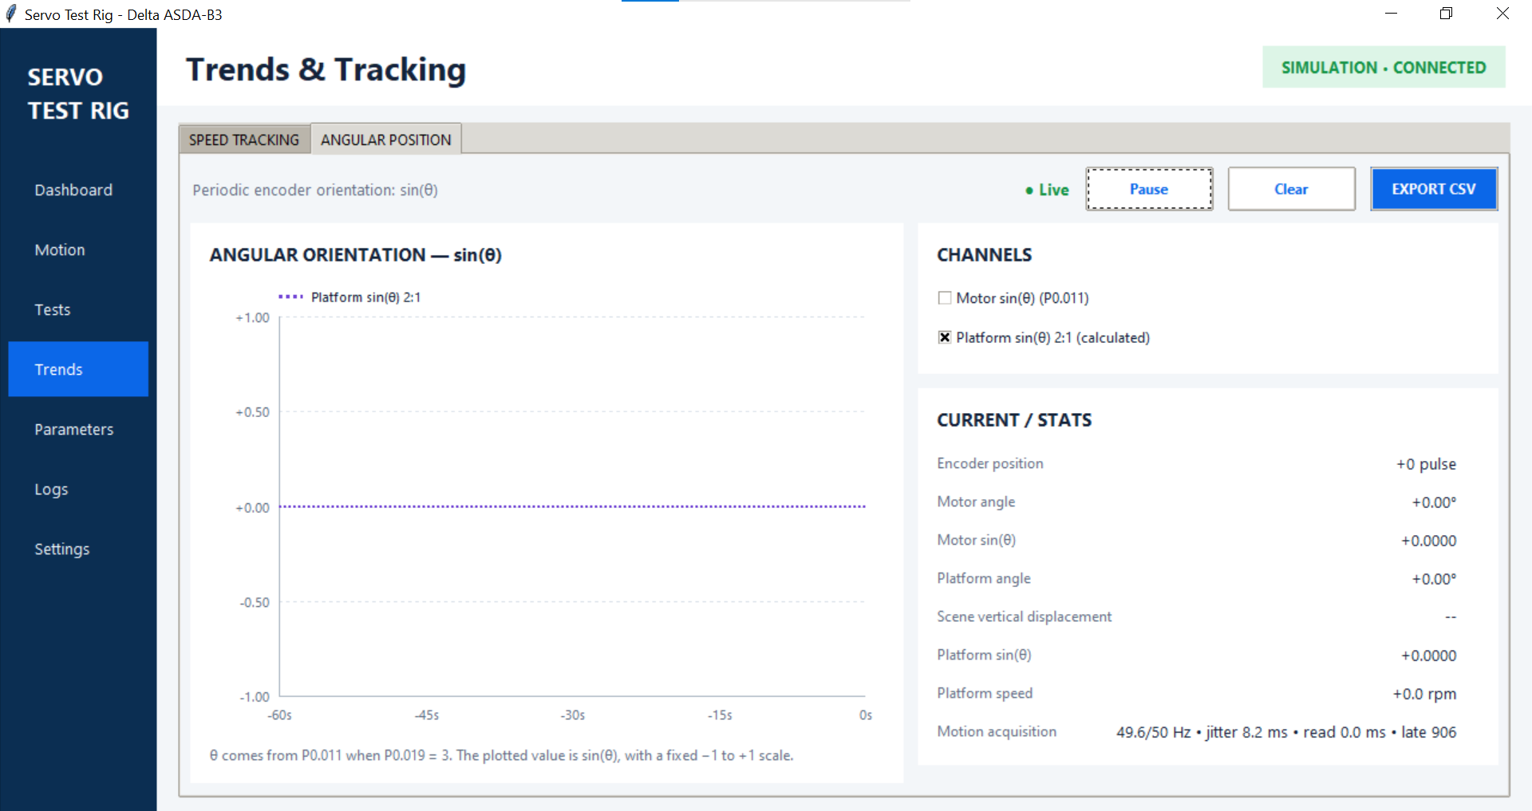
Figure 5.11 Angular Position: periodic orientation plotted as sin(theta), with encoder counts, angles, displacement and acquisition timing on the right.
This tab plots the sine of encoder-derived angle on a fixed -1 to +1 scale. Select Motor sin(theta), Platform sin(theta), or both. One complete waveform represents one revolution of that component. With a 2:1 reduction, the motor completes two revolutions for every platform revolution.
The sine plot makes repeated rotations easy to compare without a continually increasing angle axis. It does not identify a unique angle: 0 and 180 degrees both have a sine of zero. Use the numeric Motor angle and Platform angle when the actual angle or number of turns is required.
CURRENT / STATS shows raw encoder position in pulses, continuous motor and platform angles, their sine values, scene displacement and platform speed. P0.011 supplies encoder counts when P0.019 is set to 3. The application converts counts using 2^24 counts per motor revolution and divides by the configured ratio for platform angle. These telemetry angles use the encoder count reference, which differs from the Dashboard connection-time compass reference and a Tests run origin.
Scene vertical displacement shows the available LabJack reading. It displays calibrated millimetres with voltage when calibration is available, voltage alone otherwise, and dashes when no reading is available.

5.6.5 Pause and Clear
Pause freezes the selected tab’s chart and changes its indicator to Paused. Acquisition, numeric values and statistics continue updating, and the other tab has its own pause state. Click Pause again to resume the chart. Pausing is not a motor stop or a recording stop.
Clear removes the shared rolling telemetry history, resets its elapsed-time and encoder-unwrapping history, and resets acquisition timing counters and error statistics. It affects both Trends tabs and the Dashboard trend. New samples begin filling the history immediately. Export any history you need before clearing, and use Clear between checks rather than during an experiment. It does not delete files already saved.

5.6.6 Export telemetry
Click EXPORT CSV on the required tab, choose a destination and save. The suggested filenames are servo_telemetry_speed_YYYYMMDD_HHMMSS.csv and servo_telemetry_position_YYYYMMDD_HHMMSS.csv.
- Speed CSV: elapsed and acquisition timestamps, read duration, requested command, command trace, encoder feedback, tracking error, calculated platform speed and available LabJack voltage/displacement.
- Position CSV: elapsed and acquisition timestamps, read duration, motor/platform angles and sine values, and available LabJack voltage/displacement.
Export includes the retained telemetry buffer, not only the visible 60 seconds or the selected channels. The buffer is finite, so older samples are discarded as it fills. A paused chart does not freeze the export data: newer acquired samples remain eligible for export.
Use Trends exports for general checks and analysis. For event-camera experiment processing, collect the Tests recorded CSV and its timing/metadata sidecars as described in the Tests section; the Trends CSV has a different schema and does not replace that run export.

5.6.7 Example tracking check
1. In Simulation, apply a low motor-speed limit and the required ramps on Motion. With the motor stopped, clear previous telemetry if it is no longer needed.
2. Send a low speed command from Motion, then open Trends and select SPEED TRACKING. Compare command, feedback and platform speed during acceleration and settling.
3. Select ANGULAR POSITION and enable both sine channels. Observe the motor/platform rotation ratio.
4. Return to Dashboard or Motion and request CONTROLLED STOP. Use feedback to confirm zero speed, then return to Trends and export the required tab data.

5.7 Parameters
Select Parameters to inspect the project drive-parameter catalog, compare readback with reference values and edit writable parameters. This page covers the project-relevant subset of ASDA-B3 parameters. The screenshots show Simulation.
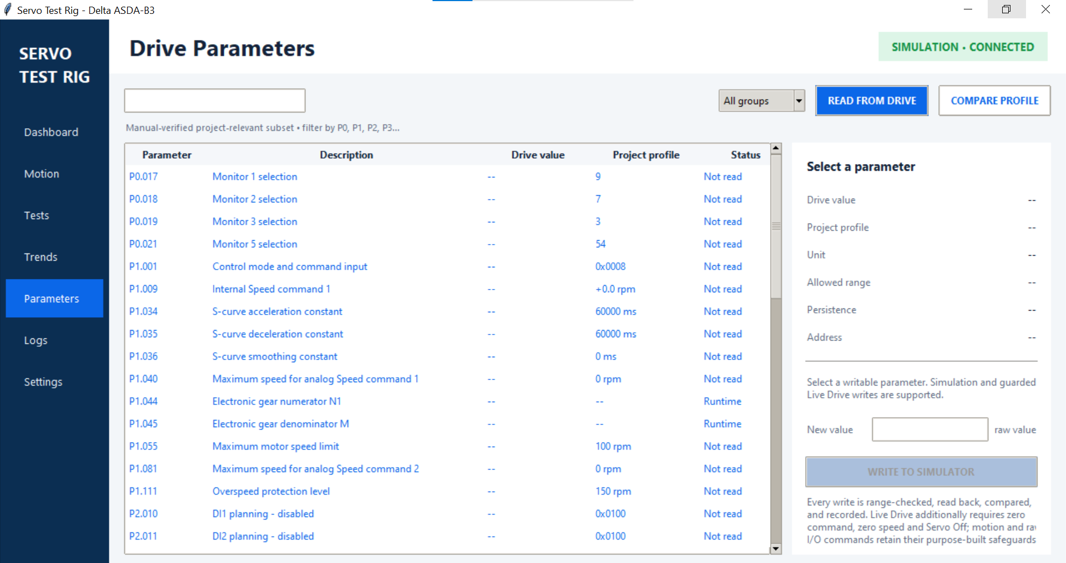
Figure 5.12 Drive Parameters before readback. Project profile contains reference values; dashes in Drive value mean no value has been read.

5.7.1 Read and compare
1. Connect Simulation or Live Drive, then open Parameters.
2. Click READ FROM DRIVE to refresh the catalog values. In Simulation, these values come from the simulator.
3. Review Drive value, Project profile and Status. COMPARE PROFILE performs the same fresh read and comparison; it does not write the reference values to the drive.
Match means the read value agrees with the project comparison. Mismatch means it differs. Not read means no readback is available. Runtime means the catalog has no fixed reference value for that parameter. Project profile is a code-defined reference, not a measurement or a motion CSV. Review a mismatch against the commissioned rig configuration before deciding to change it.

5.7.2 Find a parameter
Type a parameter number or description in the search field, or select a group such as P0 or P1. Choose All groups to remove the group filter. Select a row to display its current value, reference value, unit, allowed range, persistence and Modbus address in the right-hand panel.
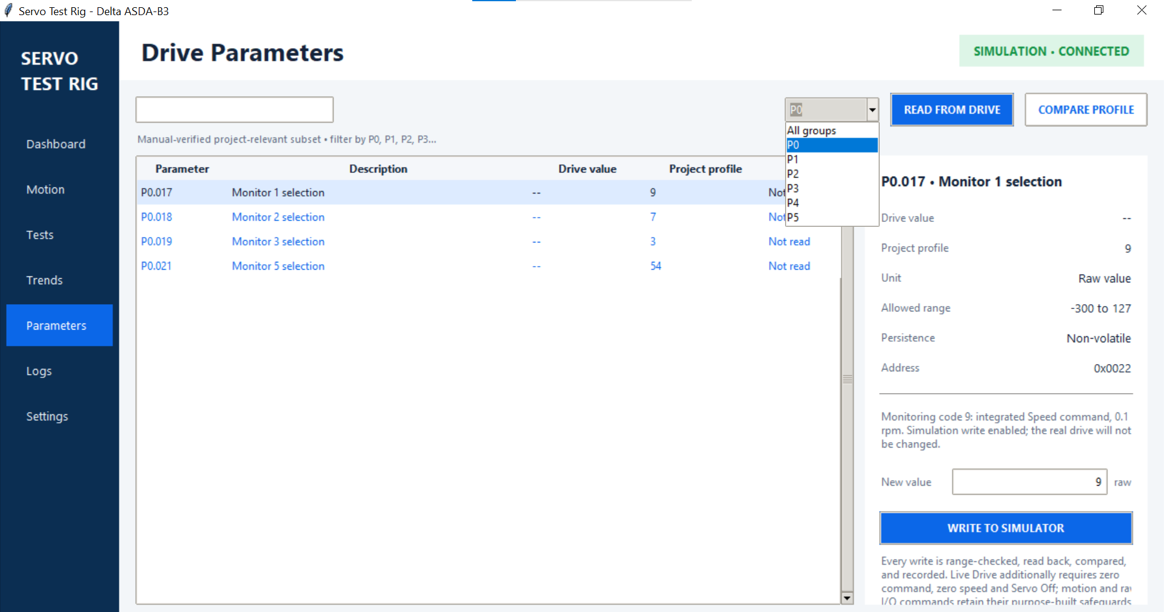
Figure 5.13 Filtering by group and selecting P0.017. The details panel explains the selected parameter and enables writing when permitted.

5.7.3 Write a parameter
1. Read the current values and select the required parameter. Check its description, unit, range and persistence.
2. Enter New value in the displayed unit. For hexadecimal values, use the 0x prefix, for example 0x0020. Where the field displays rpm, enter rpm rather than the internal scaled integer.
3. Click WRITE TO SIMULATOR or WRITE TO LIVE DRIVE. Live writes display a confirmation with the current value, proposed value and persistence.
4. Confirm the write result in Logs and read back the parameter. The controller checks the range, reads the written value back and rejects a mismatch.
Generic live configuration writes require zero command, zero speed and the Servo ON selector OFF. Read-only parameters cannot be written. Motion commands and raw I/O have separate restrictions; use the Dashboard or Motion controls for those operations. A visible Write button does not bypass the controller checks.
Persistence describes whether the value is retained and when it takes effect. If it says Power-cycle to apply, cycle power to the drive before checking operation. Communication-parameter changes can interrupt the connection; reconnect using the matching settings.

5.7.4 Example in Simulation
Filter to P0 and select P0.017, Monitor 1 selection. Enter 9 and click WRITE TO SIMULATOR. Read again and confirm Drive value is 9 and Status is Match. This assigns the integrated-speed-command monitor inside the simulator; it does not change the physical drive.

5.8 Logs
Open Logs to review connection, command, configuration and error events. Entries appear newest first. Use this page when a command is rejected or a connection or experiment does not complete as expected.
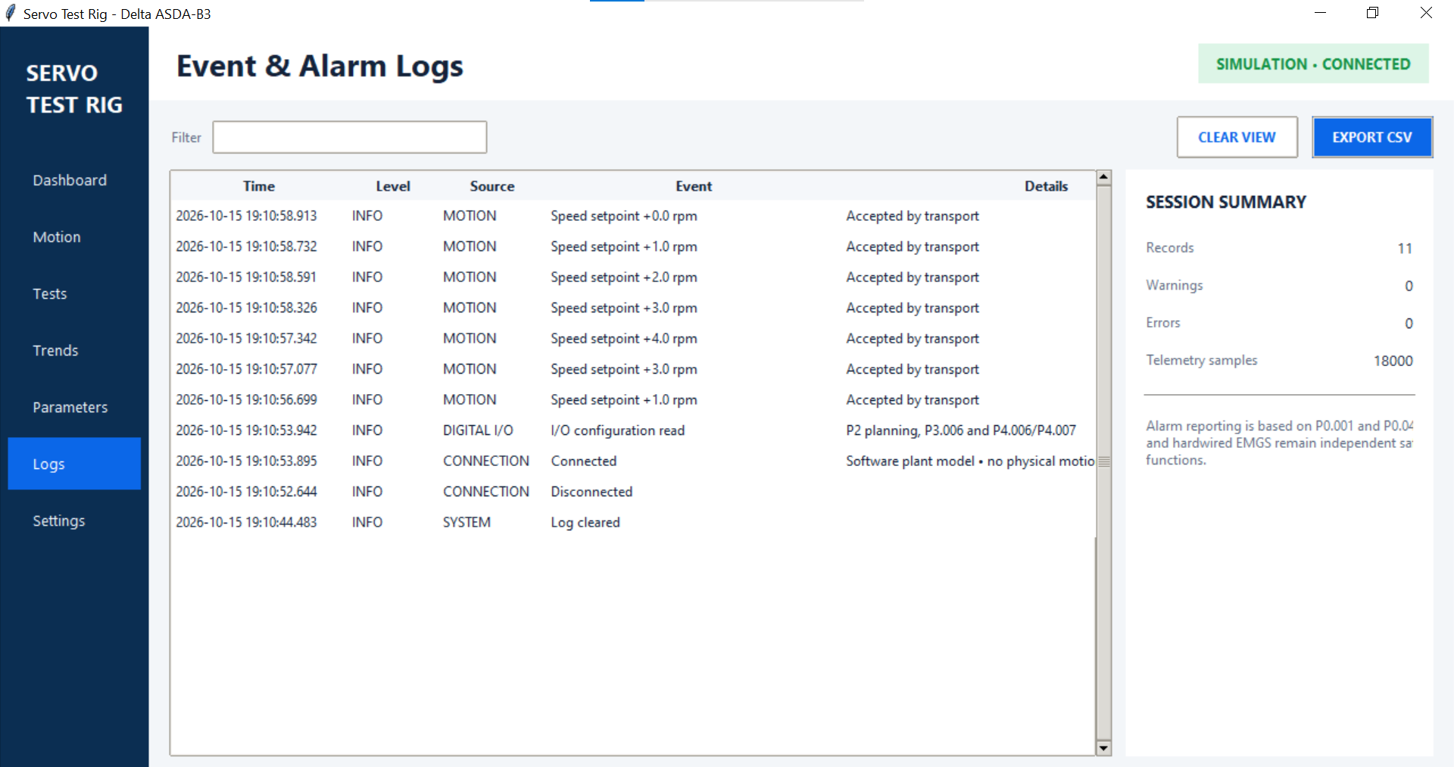
Figure 5.14 Event & Alarm Logs, showing event details and the session summary.
- Time identifies when the event was logged. Source identifies the part of the application involved; Event and Details describe the action or result.
- INFO records routine activity. WARN flags a condition needing attention. ERROR records a failure. Read Details to identify the cause.
- Filter searches the event text, source, level and details. Clear the field to show all retained entries.
- SESSION SUMMARY shows retained records, warnings, errors and telemetry-sample count. These totals are not limited by the filter.
EXPORT CSV saves all retained log entries, including those hidden by the filter. CLEAR VIEW removes the session log history and adds a Log cleared entry; it does not delete exported files. Export before clearing if the record is needed.
Accepted by transport confirms that the command transaction was accepted, not that the motor reached the requested speed. Use encoder feedback to confirm the response.

5.9 Settings
Open Settings to configure the drive connection, simulator, LabJack and LattePanda clock alignment. Scroll down for saved settings and clock controls.
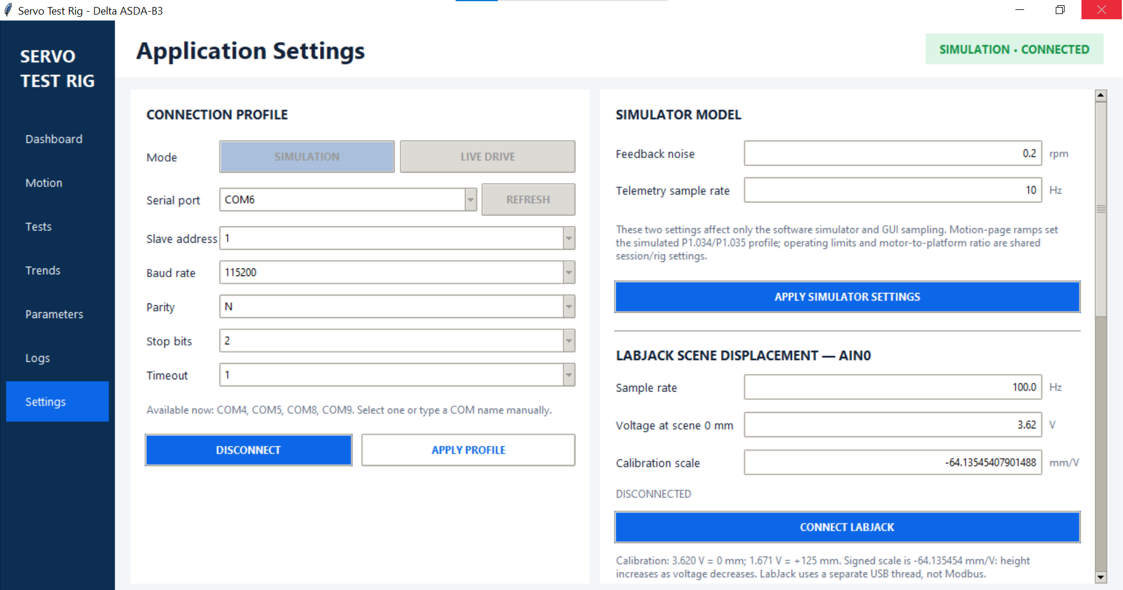
Figure 5.15 Settings upper view: connection profile, simulator settings and LabJack acquisition/calibration.

5.9.1 Connection profile
Disconnect before changing the mode or serial fields. Select SIMULATION or LIVE DRIVE, then choose or enter the serial port. Use REFRESH to update the port list. For the configured rig, use slave 1, 115200 baud, parity N and 2 stop bits; these values must match the drive. Timeout is the serial reply timeout in seconds.
APPLY PROFILE validates and saves the connection fields; it does not change drive parameters. CONNECT opens the selected connection and changes to DISCONNECT while connected. See Section 3 for Windows and Linux port identification.

5.9.2 Simulator model
Feedback noise sets the simulated speed variation in rpm. Telemetry sample rate sets simulator acquisition in Hz. Click APPLY SIMULATOR SETTINGS to apply the values. Configure acceleration, deceleration and operating limits on Motion.

5.9.3 LabJack scene displacement
With the LabJack disconnected, set Sample rate, Voltage at scene 0 mm and Calibration scale in mm/V, then click CONNECT LABJACK. Reconnect after changing these values. Displacement is calculated as (AIN0 voltage - 0 mm voltage) x calibration scale. A negative scale means displacement increases as voltage falls. Use the measured rig calibration; Section 3 covers commissioning.
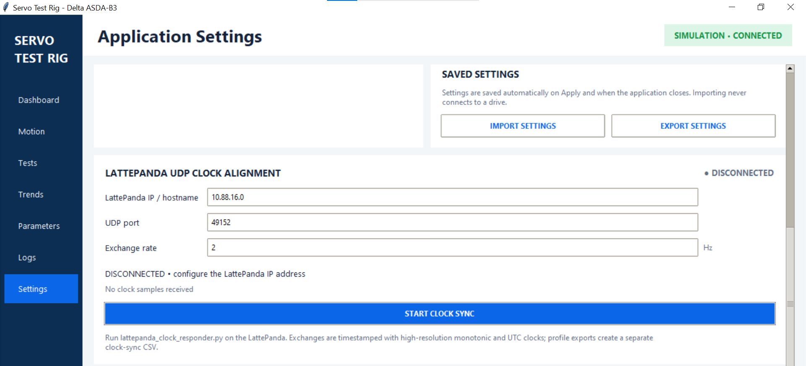
Figure 5.16 Settings lower view: settings import/export and LattePanda UDP clock alignment.

5.9.4 Saved settings
The application saves settings on Apply and when it closes, using settings.json inside servo_controller. EXPORT SETTINGS saves a separate JSON copy. Disconnect the drive before IMPORT SETTINGS; importing validates and applies the configuration without connecting the drive. Check the serial port and LattePanda address when moving the configuration to another PC.

5.9.5 LattePanda UDP clock alignment
Enter the current LattePanda IPv4 address, UDP port 49152 and exchange rate 2 Hz, then click START CLOCK SYNC. The responder must be running on the LattePanda. Confirm CONNECTED and fresh replies; if the status remains WAITING, check the responder, address and network configuration. STOP CLOCK SYNC stops the exchanges.
These controls share the same clock client and IP address as the Dashboard. Section 3 explains the network connection and responder setup.

6 Processing results and creating videos
Use this procedure after a Tests run to combine the motor feedback with the EVK4 recording and create labelled videos or angle comparisons. Processing can be performed on Windows or Linux without connecting the rig. The example experiment is 450rpm-0mm; substitute your own experiment folder and run labels.

6.1 Collect and back up the run files
Create one experiment folder under Experiments, beside the project’s existing experiment folders. Copy the following into it, retaining the original filenames:
- From the Motor PC: the source profile CSV, each *_recorded.csv, and its matching _metadata.json, _events.csv and _clock_sync.csv sidecars where available. A Trends export does not replace the Tests recorded CSV.
- From the LattePanda recording directory: each .raw file, its _metadata.json and _0x00_writes.csv. Include _trigger_events.csv if it already exists; preparation can extract it from RAW when needed. Optional offline extraction is described in Section 6.4.1.
Match each recorded CSV to its camera files using run_id. The RAW and camera metadata filenames must retain their run_id prefix. Each recorded run needs exactly one matching RAW and one camera metadata file. Keep an untouched backup before preparation: the tool moves files into folders and regenerates derived outputs.

6.2 Open the processing environment
Open a terminal in servo_controller. Processing uses OpenCV (the cv2 module), eventcv and Pillow. These packages must be installed in the same Python environment used to run vpr_media.py. Complete the steps below even on a processing-only computer that is not connected to the rig.
Windows — Command Prompt
If no .venv exists, create it once. Otherwise skip creation and activate the existing environment.
python -m venv .venv
.venv\Scripts\activate.bat
Linux — terminal
Use python3 to create the environment on Linux. If .venv already exists on this computer, skip creation and activate it. Do not reuse a virtual environment copied from another operating system or computer.
python3 -m venv .venv
If Ubuntu reports that venv is unavailable, run sudo apt install python3-venv, then repeat the creation command.
source .venv/bin/activate
After activation, the python command below refers to the virtual environment on both operating systems. Keep this terminal open and remain in servo_controller for the remaining commands.
Both operating systems — install and check processing packages
python -m pip install opencv-python eventcv Pillow
python -c "import sys, cv2, eventcv, PIL; print(sys.executable); print('Processing packages ready')"
Expected result: the interpreter path points inside .venv and the check prints Processing packages ready without an import error. Do not proceed to Section 6.3 until this check succeeds. These packages are also included in the full requirements installation in Section 3; the command above explicitly installs the packages required for offline processing.
Troubleshooting: No module named cv2 means opencv-python is missing from the selected environment; No module named eventcv means eventcv is missing. Activate .venv and repeat the installation and import check using the same interpreter. If Linux reports python: command not found, use python3 for environment creation and activate .venv before continuing. An externally managed environment error indicates that installation is being attempted outside the project virtual environment; create or activate .venv and retry.

6.3 Prepare Experiment
Each displayed command is one complete line. Output locations described below are relative to the experiment folder. Adjustable path inputs are:
- EXPERIMENT_FOLDER: your experiment folder, using an absolute path or a path relative to servo_controller. Keep quotation marks around paths.
- --folder: the experiment folder to prepare.
- --catalog: the prepared outputs/vpr_runs.csv for the experiment being processed.
- --output-root: where derived media are saved; the examples use outputs/vpr within the experiment folder.
python vpr_media.py prepare-experiment --folder "EXPERIMENT_FOLDER"
For example, if Experiments is in the parent directory of servo_controller:
python vpr_media.py prepare-experiment --folder "../Experiments/450rpm-0mm"
Preparation creates or organizes the following outputs:
- experiment_setup.csv: editable run list containing file paths, timing inputs and experimental conditions.
- raw/: the original EVK4 RAW recordings, moved into one shared folder.
- runs/<run_label>/: motor feedback CSVs and matching motor and camera sidecars, grouped by run.
- outputs/vpr_runs.csv: catalogue of included runs with complete inputs, used by the video and image commands.
- outputs/time_bins/: camera-time intervals labelled with motor and platform feedback, generated once the required timing inputs are supplied.
On the first pass, messages requesting timing values are expected. Open experiment_setup.csv in a spreadsheet or text editor, keeping its CSV format.

6.4 Enter the timing details and prepare again
Complete these fields for every run you want to process. Leave run_id and generated file paths unchanged.
- include: true to process the run, or false to omit it from the output catalogue. Use a unique, simple run_label such as run1, run2 or run3.
- studio_duration_s: open that run’s RAW in Metavision Studio and enter its full recording duration in seconds, including the stationary pre-roll. For example, enter 22.428085 for a duration of 22.428085 s. Do not enter only the motor profile duration. The processing tool subtracts this duration from the last RAW event timestamp to estimate recording time zero. Including the pre-roll keeps the camera and encoder timelines aligned; entering only the motor profile duration shifts that alignment.
- sync_mode: choose trigger when the recording contains valid camera Trigger In pulses and the matching UART write log. Choose manual when aligning using visible motion onset. New rows initially default to manual; select the intended method explicitly.
- manual_evk4_motion_s: for manual mode, replay the RAW slowly in Studio and enter the time when the platform first visibly starts moving, measured from the start of that recording. Leave this blank in trigger mode.
- nominal_speed_rpm, vertical_condition and notes: record the experimental conditions, such as motor speed and scene height.
Metavision Studio may be used on the LattePanda to read duration and motion-start times before processing on Linux. Use the values from each run’s own RAW file.
Save experiment_setup.csv, close the editor and repeat:
python vpr_media.py prepare-experiment --folder "EXPERIMENT_FOLDER"
Read every [RUN] message. Continue only when every included run reports ready and appears in outputs/vpr_runs.csv. A [DONE] catalogue message alone does not mean all runs were included. Correct any “needs” messages in experiment_setup.csv and rerun.
In trigger mode, preparation extracts missing Trigger In events, matches falling edges to UART writes and fits the camera timeline to the LattePanda timeline. Inspect outputs/trigger_sync/<run_label>_trigger_sync.csv and the reported match count, residuals and clock drift. A trigger fit failure requires investigation; it does not automatically switch to manual alignment. To extract a recording separately with the responder, see Section 6.4.1.
In manual mode, preparation aligns the visible camera motion onset to the first sustained encoder motion.
- --timing-uncertainty-ms: assumed manual alignment uncertainty in milliseconds; default 100. Append this option and a justified value to the preparation command to change it.

6.4.1 Extract trigger events offline
Use this optional command to decode Trigger In timestamps from a completed RAW recording on the LattePanda or another computer with the Metavision Python modules installed. No camera, UART connection or running responder service is required. Use the SDK-compatible Python environment from Section 3.6; the ordinary Motor PC environment in Section 6.2 is sufficient only if those SDK modules are also installed.
Open a terminal in the folder containing lattepanda_clock_responder.py. Replace RAW_FILE with the actual RAW path and retain the quotation marks. Each command below is one complete line. Replace python with the camera environment executable when required; on the LattePanda desktop this is .venv-camera\Scripts\python.exe.
python lattepanda_clock_responder.py --extract-trigger-events "RAW_FILE"
The command reads the RAW, saves <RAW filename stem>_trigger_events.csv beside it, reports the event count and output path, then exits. The CSV columns are trigger_index, raw_timestamp_us, polarity and channel_id. Raw camera timestamps are retained without SDK time shifting. The RAW is not modified.
To choose a different CSV path, add --trigger-events-output:
python lattepanda_clock_responder.py --extract-trigger-events "RAW_FILE" --trigger-events-output "OUTPUT_CSV"
The output directory must already exist. The extractor refuses to overwrite an existing CSV; choose another filename when repeating extraction. A zero event count means no Trigger In events were decoded. Successful extraction alone does not establish valid synchronization.
Copy the output with the matching camera files into the experiment folder before preparation. Keep one trigger CSV per run, retaining the run_id filename prefix and _trigger_events.csv suffix for automatic discovery. Keeping multiple matching trigger CSVs in the experiment folder causes an ambiguity error. A custom filename outside this convention is not discovered automatically.
This step is optional: prepare-experiment already extracts missing events in trigger mode using the Motor PC processing tools. The offline responder command only decodes events; continue with Section 6.4 to match them to UART writes and fit the camera timeline.

6.5 Create a complete run video
Start with one run to check the recording and alignment:
python vpr_media.py --catalog "EXPERIMENT_FOLDER/outputs/vpr_runs.csv" --output-root "EXPERIMENT_FOLDER/outputs/vpr" run-video --run run1 --source-fps 100 --accumulation-ms 2 --speed 0.3
Example with Experiments directly above servo_controller:
python vpr_media.py --catalog "../Experiments/450rpm-0mm/outputs/vpr_runs.csv" --output-root "../Experiments/450rpm-0mm/outputs/vpr" run-video --run run1 --source-fps 100 --accumulation-ms 2 --speed 0.3
The output is outputs/vpr/runs/run1/run1_angle_overlay.mp4, with camera time, platform angle, revolution, platform speed and scene displacement overlays. Adjustable inputs are:
- --run run1: prepared run label to render; change run1 to another label in the catalogue.
- --source-fps 100: reconstruct 100 event images per second of recording time.
- --accumulation-ms 2: accumulate 2 ms of events per image. Increasing this value makes more events visible but can blur motion.
- --speed 0.3: play at 0.3 times recording speed.
- --start-rev 3: optional first revolution label to include. Labels start at 0 relative to the first encoder angle. Omit to start at the beginning of the recording.
- --end-rev 6: optional last revolution label to include, inclusive. The recording must reach the start of revolution 7 to include all of revolution 6. Omit to continue to the end of the recording.
To render only revolutions 3 through 6, add the range options:
python vpr_media.py --catalog "EXPERIMENT_FOLDER/outputs/vpr_runs.csv" --output-root "EXPERIMENT_FOLDER/outputs/vpr" run-video --run run1 --start-rev 3 --end-rev 6 --source-fps 100 --accumulation-ms 2 --speed 0.3
Example with Experiments directly above servo_controller:
python vpr_media.py --catalog "../Experiments/450rpm-0mm/outputs/vpr_runs.csv" --output-root "../Experiments/450rpm-0mm/outputs/vpr" run-video --run run1 --start-rev 3 --end-rev 6 --source-fps 100 --accumulation-ms 2 --speed 0.3
This includes turns labelled 3, 4, 5 and 6 and saves outputs/vpr/runs/run1/run1_angle_overlay_rev3-6.mp4. Overlays retain the original recording times and revolution labels. With neither range option, the whole recording is rendered to the original filename. Range selection uses forward encoder rotation without reversals; unavailable or incomplete ranges are rejected.
Open the MP4 and inspect the stationary pre-roll, motion onset and stopping period. Check that the overlaid angle follows visible landmarks. Resolve any offset before comparing runs. Scene displacement requires recorded LabJack data; missing measurements cannot be recovered from the video.
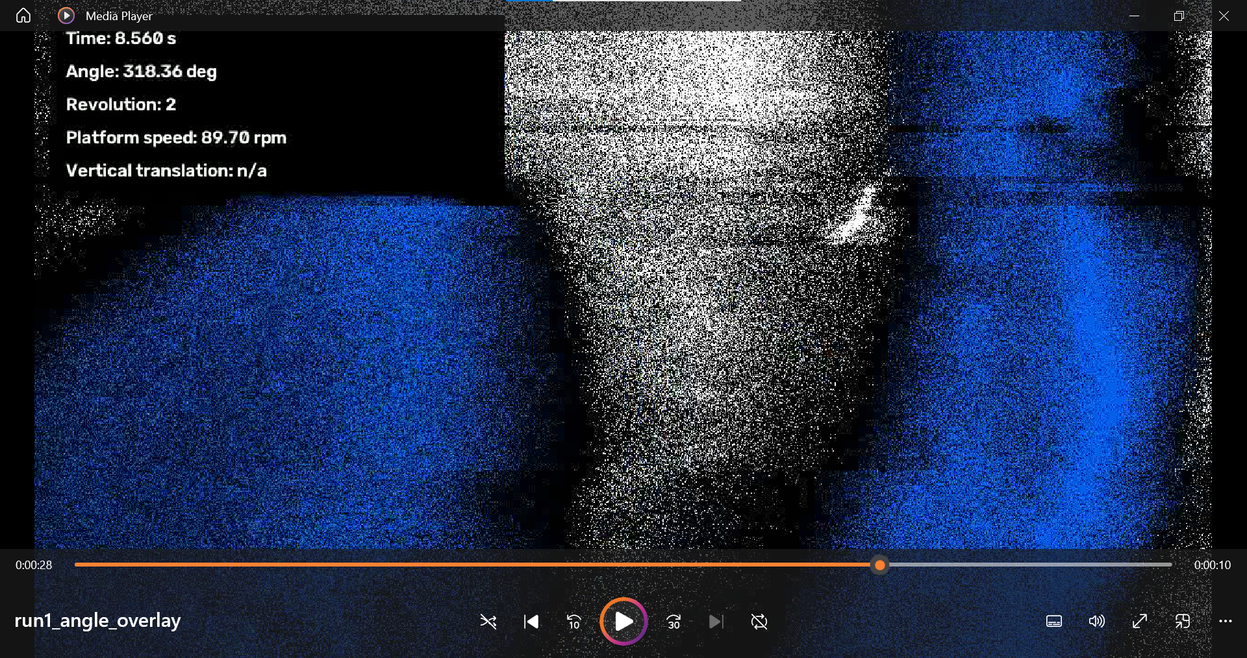
Figure 6.1 Example run-video output with recording time, platform angle, revolution and platform speed overlays. Vertical translation is n/a when a displacement measurement is unavailable.

6.6 Compare runs at matching platform angles
Select two or three run:revolution pairs. This example compares revolution 5 from three runs:
python vpr_media.py --catalog "EXPERIMENT_FOLDER/outputs/vpr_runs.csv" --output-root "EXPERIMENT_FOLDER/outputs/vpr" compare-runs-by-angle --instances run1:5 run2:5 run3:5 --angle-step 0.5 --accumulation-ms 2 --fps 30
Example with Experiments directly above servo_controller:
python vpr_media.py --catalog "../Experiments/450rpm-0mm/outputs/vpr_runs.csv" --output-root "../Experiments/450rpm-0mm/outputs/vpr" compare-runs-by-angle --instances run1:5 run2:5 run3:5 --angle-step 0.5 --accumulation-ms 2 --fps 30
Each panel shows the same target platform angle, using a different source time for each run. Select a complete turn within the recorded coverage. Adjustable inputs are:
- --instances run1:5 run2:5 run3:5: select two or three run:revolution pairs. Revolution numbering starts at 0 relative to the first encoder angle; :5 selects the turn labelled 5. Use run1:3 run1:5 to compare two turns within one run.
- --angle-step 0.5: advance the target angle by 0.5 degrees per output frame. Smaller steps produce more frames.
- --accumulation-ms 2: accumulate 2 ms of camera events per image.
- --fps 30: output playback rate of 30 frames per second.
The MP4 and matching CSV are saved in outputs/vpr/angle_synchronised/. The CSV records each panel’s source time and assigned angle. NO ANGLE MATCH means that the selected turn does not cover that angle; choose another turn or inspect the recorded coverage. Use this workflow for motion that turns consistently in one direction; reversing trajectories need separate checking.
With --angle-step 0.5 and --fps 30, one displayed revolution contains 720 frames and lasts 24 seconds. This playback aligns orientation across runs; use the complete run video and recorded timestamps to assess elapsed-time behaviour.
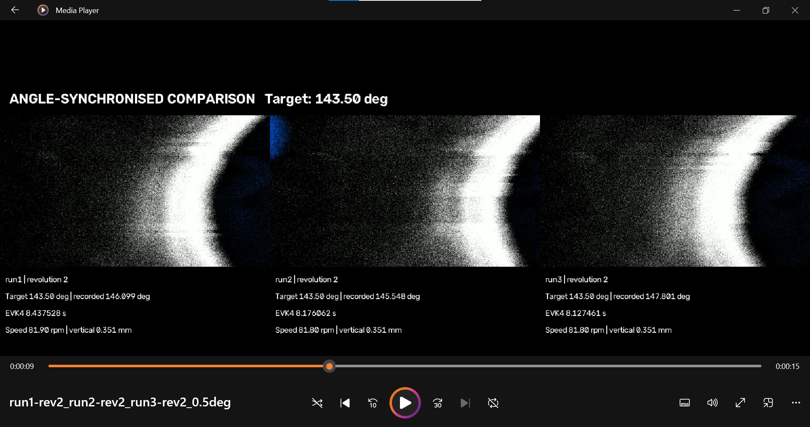
Figure 6.2 Angle-synchronised comparison of revolution 2 from run1, run2 and run3. Each panel is selected for the common target angle; its recorded angle, source time, speed and displacement are shown below.

6.7 Extract images or short clips at a chosen angle
First create the reference table and principal images for a target angle, here 120 degrees:
python vpr_media.py --catalog "EXPERIMENT_FOLDER/outputs/vpr_runs.csv" --output-root "EXPERIMENT_FOLDER/outputs/vpr" query-angle 120 --tolerance 0.5 --window-ms 30
Example with Experiments directly above servo_controller:
python vpr_media.py --catalog "../Experiments/450rpm-0mm/outputs/vpr_runs.csv" --output-root "../Experiments/450rpm-0mm/outputs/vpr" query-angle 120 --tolerance 0.5 --window-ms 30
Open outputs/vpr/angles/120deg/120deg_reference.csv to identify the available runs and revolution labels. The principal_frames subfolder contains the corresponding PNG images. Adjustable inputs are:
- 120: target platform angle in degrees, from 0 up to but excluding 360.
- --tolerance 0.5: angle-matching tolerance in degrees.
- --window-ms 30: total time window around each crossing, recorded in the reference table for comparisons.
- --runs run1: optional filter to query only the named run; omit it to query all prepared runs.
Then create a short comparison around selected crossings:
python vpr_media.py --catalog "EXPERIMENT_FOLDER/outputs/vpr_runs.csv" --output-root "EXPERIMENT_FOLDER/outputs/vpr" compare-angle 120 --format video --instances run1:5 run2:5 --window-ms 30 --speed 0.02
Example with Experiments directly above servo_controller:
python vpr_media.py --catalog "../Experiments/450rpm-0mm/outputs/vpr_runs.csv" --output-root "../Experiments/450rpm-0mm/outputs/vpr" compare-angle 120 --format video --instances run1:5 run2:5 --window-ms 30 --speed 0.02
The MP4 is saved in the same angle folder. Run query-angle again before comparing a different angle. This short clip aligns the crossing instant; angles away from that instant can differ between runs. Adjustable inputs are:
- 120: the queried target angle; use the same angle as the reference table.
- --format video: create an MP4; change video to gif for a GIF.
- --instances run1:5 run2:5: run:revolution pairs to compare, selected from the reference table.
- --window-ms 30: a 30 ms total clip window, centred on each angle crossing.
- --speed 0.02: play at 0.02 times recording speed.
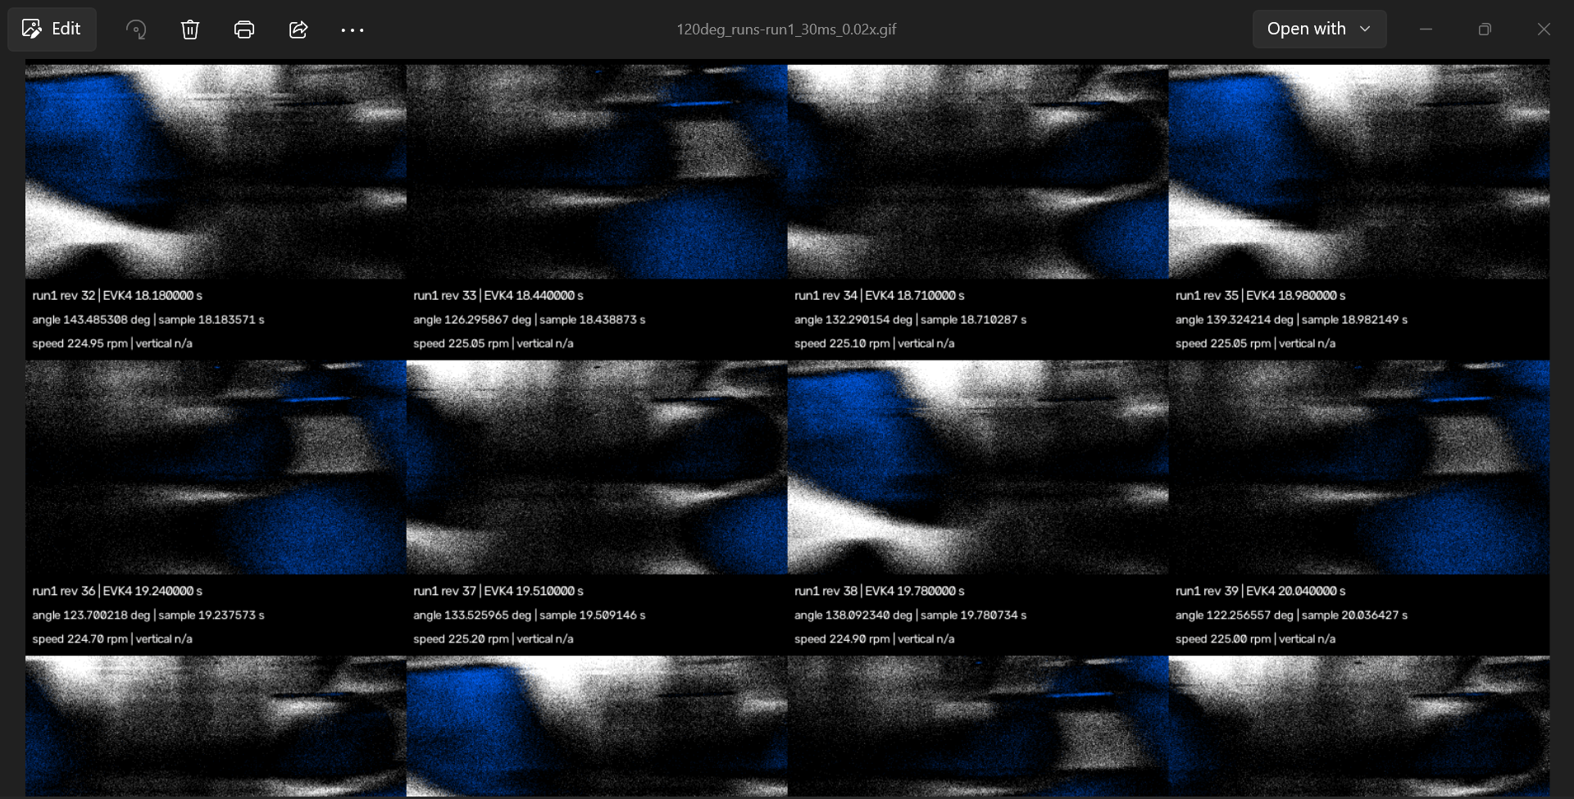
Figure 6.3 Example GIF comparing repeated crossings near 120 degrees within run1. Each panel represents a different revolution. The crossing instants are aligned; angles can differ elsewhere in the clip.

6.8 Retain and check the outputs
- experiment_setup.csv: the run labels, timing inputs and chosen synchronization method.
- outputs/vpr_runs.csv: the included runs and paths used by media commands.
- outputs/time_bins/: camera-time intervals labelled with recorded motor and platform feedback.
- outputs/trigger_sync/: trigger-fit diagnostics when trigger synchronization is used.
- outputs/vpr/: derived videos, comparison CSVs, angle references and PNG images.
Retain the original acquisitions, settings, setup file and processing commands with the results. Repeating preparation or media commands can overwrite matching derived outputs. If the experiment is moved to another computer, rerun preparation and angle queries: query reference tables contain absolute file paths.
For a missing run, inspect its [RUN] message and setup fields. For a missing file, check run_id, filenames and paths. If video creation fails, check the terminal error, available disk space and the OpenCV installation in the active environment. Use the following command to list further options:
python vpr_media.py --help

7 Shutdown procedure

7.1 Stop motion and isolate the Control Box
1. Select CONTROLLED STOP in the Servo Test Rig GUI and wait until all motion has stopped.
2. Turn the Servo ON selector to OFF, press the red Stop button, then press the emergency stop.
3. Disconnect the drive in the GUI, then close the application.
4. Turn off the Control Box power supply and unplug it from the wall outlet.

7.2 Shut down the LattePanda
5. On the LattePanda, stop the responder service, close all applications and shut down the PC. Wait until shutdown is complete.
6. Once all motion has stopped, the emergency stop is pressed, the Control Box is unplugged from the wall and the LattePanda has shut down, disconnect the LattePanda USB-C power supply. This prevents the onboard battery from draining if the PC enters sleep mode.

7.3 Leave the rig secure
7. Replace all guards and covers. Leave cables neatly routed and secured to prevent trip hazards.

