1. This is not ‘glitch’, this is called ‘ripple’. Caused by limitations of the function generator itself.

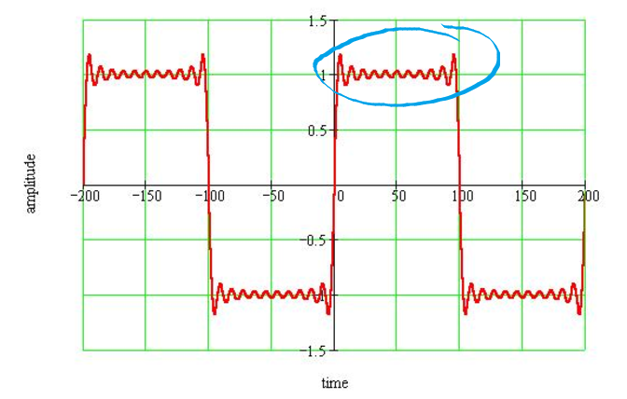

1. Glitch: A momentary incorrect output value.

Eg: Two inputs through a gate, gets an output.

“Propagation delay” in chips causes temporary faulty output.

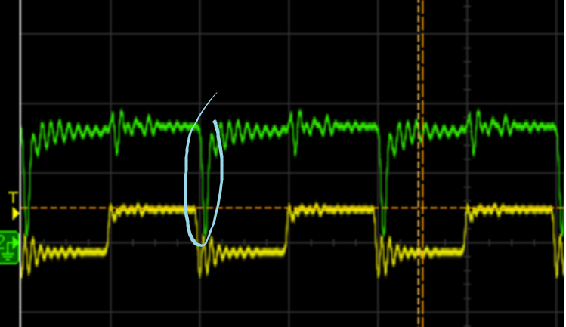

1. Use up to 8 inverter to see the glitch.
2. Debouncing circuit question in post lab:  
   “To do this question, draw a next state table and analyze what will happen if the connection is loose.”
3. Static-1 Hazard: the output is currently 1 and after the inputs change, the output momentarily changes to 0 before settling on 1

Static-0 Hazard: the output is currently 0 and after the inputs change, the output

momentarily changes to 1 before settling on 0

1. We add an additional minterm (redundant) to resolve a static-1 hazard, but static-9 hazard might still happen.

A static hazard is not guaranteed to happen even when you don’t add the additional term.