For detailed instructions about the required file format or upload process, see the attached user documentation. To upload your .csv formatted contribution:

1. Log into the application at the following URL: <https://apex.psmfc.org/akfin/f?p=140>.
2. Expand the **Data Management**menu on the left by selecting the caret symbol and choose the **ESP Data Sources**module.
3. Locate your associated **Data Source(s)** and select the **Edit**icon.
4. Find the **Source Target(s)** and select the **Edit**icon to complete any necessary indicator details (see attached document for the required detail definitions and examples, page 8).
5. Choose the **Upload**icon to open the upload page.
6. Hit **Upload File** to open the upload modal and proceed with selecting your file.
7. Select the **View Data**icon after the upload completes to preview the data in the report below.
8. Note the status of your uploaded file is Y**ellow-Warning** until approved by an AFSC administrator.

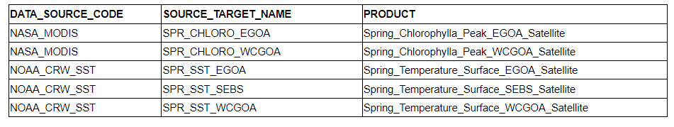

**Spring_Temperature_Surface_EGOA_Satellite**

Sablefish: May-June SST from 10 m to extent of EEZ in the EGOA (nmfs areas 640 and 650), no deep depth restriction

crwsst_goa_nmfs640_650_MayJune_Avg.RDS

**Spring_Temperature_Surface_SEBS_Satellite**

Sablefish: May-June SST from 10 m to extent of EEZ in the SEBS (south of 60), no deep depth restriction

crwsst_SEBS_19850401_through_2020_May_June_Avg

**Spring_Temperature_Surface_WCGOA_Satellite**

GOA pollock: April-May SST for 10 m to shelf break (200 m), in WCGOA (nmfs area 610, 620, 630)

crwsst_goa_nmfs610_620_630_AprMay_Avg

**Spring_Summer_Temperature_Surface_SEBS_Satellite**

EBS Pcod: April-June SST for 10 m to shelf break (200 m) in SEBS (south of 60)

Bering_Sea_Shelf_April_Through_June_Mean.RDS

EBS Pcod: April-June SST for 10 m to shelf break (200 m) in NBS (north of 60)

EBS Pcod: June-Oct SST for 10 m to shelf break (200 m) in SEBS (south of 60)

EBS Pcod: June-Oct SST for 10 m to shelf break (200 m) in NBS (north of 60)

GOA Pcod: June-Oct SST for 10 m to shelf break (200 m) in WCGOA (nmfs area 610, 620, 630)

GOA Pcod: April-June SST for 10 m to shelf break (200 m) in WCGOA (nmfs area 610, 620, 630)