**Title**: Sea Surface Temperature and Marine Heatwaves in the Gulf of Alaska Ecosystem Regions

**Contributed by**: Jordan T. Watson

**Contact author**: Jordan T. Watson

**Contact information**: Auke Bay Laboratories, Alaska Fisheries Science Center, NOAA Fisheries, Jordan.watson@noaa.gov

**Last updated**: September 2020

**Description of indicator**: Sea surface temperature is a foundational characteristic of the marine environment and temperature dynamics can impact many biological processes. Changes in temperatures can influence physiological processes of fish (e.g., metabolic rates and growth rates), fish distribution (e.g., Yang et al. 2019), trophic interactions, availability of spawning habitat (e.g., Laurel et al 2020), and energetic value of prey. Extended periods of increased SST can lead to marine heat waves (Bond et al. 2015; Hobday et al. 2016). We describe trends in sea surface temperature throughout the Gulf of Alaska (GOA) ecosystem regions.

In recent years, warm water events have become so frequent in the world’s oceans that a new method for describing them has been formalized. We consider marine heatwaves (MHWs) to occur when SST exceeds a particular threshold for five or more days. That threshold is the 90th percentile of temperatures for a particular day of the year based on a 30-year baseline (Hobday et al., 2016). The intensity of a MHW can be further characterized by examining the difference between the 90th percentile threshold for a given day and the baseline (“normal”) temperature for that day. If the threshold is exceeded, the event is considered *moderate*, *strong* (2 times the difference between then threshold and normal), *severe* (3 times the difference between the threshold and normal), or *extreme* (>=4 times the difference) (Hobday et al., 2018).

Satellite SST data from the NOAA Coral Reef Watch Program were accessed via the NOAA Coast Watch West Coast Node ERDDAP server (<https://coastwatch.pfeg.noaa.gov/erddap/griddap/NOAA_DHW.html>) for April 1985 - September 2020. Daily SST data were averaged within the western (144 ̊W - 163 ̊W) and eastern (133 ̊W – 144 ̊W) Gulf of Alaska (WGOA and EGOA, respectively) for depths from 10m – 200m (i.e., on the shelf). Detailed methods are online, including maps of the spatial strata and processing the data in R (github.com/jordanwatson/EcosystemStatusReports/tree/master/SST).

We use the earliest complete 30-year time series as the baseline period for mean and standard deviation comparisons although the guidance on such choice varies across studies (e.g., Hobday et al., 2018; Schlegel et al., 2020). Three notable differences exist between the current marine heatwave indicators and those previously presented to the North Pacific Fishery Management Council (detailed in Barbeaux et al., 2020). First, the current indicator uses a different NOAA SST dataset, with a slightly different time period (beginning mid-1985 instead of mid-1982) and spatial resolution (the current indicator has finer spatial resolution and thus, more data points within the same region). Given the shorter time series, the 30-year baseline period is necessarily different (1986-2015 instead of the previous 1983-2012). Finally, the previous indicator was bounded spatially to target management of Pacific cod in the GOA, whereas the current indicator is bounded spatially by the ESR regions for a broader comparison.

**Status and trends**: In the WGOA, cooler late winter and spring temperatures in 2020 were similar to the long term average SST, departing from the warm 2019 conditions (Figure 1). However, starting in May, temperatures warmed and remained above average throughout the summer (yet generally below the 2019 summer SST). At some points during the summer, the SST was among the warmest temperatures recorded for those dates. SST cooled to approximately average or slightly greater than average values in September. In the EGOA, temperatures were consistently more similar to the long term mean SST, departing from the warm temperatures of 2019 and suggesting more of a return to average conditions.

As a whole, 2020 has been closer to average than several recent years, though some of those recent years were among the warmest on record with MHWs standing out on a global scale (Bond et al., 2015; Holbrook et al., 2019). Despite appearing more ‘normal’ this year (Figure 2), the western GOA still experienced nearly 100 days of heatwave conditions in 2020 (Figure 3).

**Factors influencing observed trends**: The time period illustrated here includes the well-documented “warm blob” period (Bond et al., 2015; Hu et al., 2017) and recent marine heatwaves (2014-2016, 2019) (Barbeaux et al., 2020), which are characterized by anomalously warm winters. In 2020 northerly winds brought relatively warm and dry air off mainland Alaska, contributing to warmer summer SST (see Bond contribution). Westerly winds drove eastward and southward surface transport in EGOA, creating upwelling conditions and contributing to moderate sea surface temperatures in that region (see Bond and Stockhausen contributions).

Many factors can influence sea surface temperatures and subsequently, the formation of MHWs, including a suite of weather, climatic, and oceanographic factors (Holbrook et al., 2019). Meanwhile, defining or contextualizing heatwaves depends upon the selection baseline years (1986-2015). As long term climate change leads to warmer temperatures, the baseline used to define ‘normal’ will change as well, requiring consideration of how baseline selection affects our interpretation of deviations from normal and thus, events like MHWs (Jacox 2019; Schlegel et al., 2020). The warm years of 2014 and 2015 have a warming influence on the definition of the climate ‘normal’ used here for MHWs and thus, would raise the threshold for triggering a MHW. If the baseline period had included the most recent 30-year period, then each of the warm years since 2015 would be included in the baseline as well, leading to an even higher threshold for triggering a MHW.

**Implications**: Barbeaux et al. (2020) provide tangible evidence for the potential implications of warming conditions on groundfish, in particular Pacific cod. Holsman et al. (2020) further emphasize the risk of warming conditions on gadid populations but highlight the value of an ecosystem-based management approach for buffering the impacts of projected temperature increases and more frequent The approximately average 2020 winter and spring SST values across GOA, and summer SST in EGOA, provide improved conditions over 2019 for spawning, zooplankton quality and quantity, and fish metabolic demands. While the WGOA summer SST was oscillating around the heat wave threshold, the duration and intensity of warm temperatures does not equate to previous heatwave years and it is uncertain how and if the warmth will impact the marine environment.

**Literature Cited**

Barbeaux, S.J., Holsman, K. and Zador, S., 2020. Marine heatwave stress test of ecosystem-based fisheries management in the Gulf of Alaska Pacific cod fishery. *Frontiers in Marine Science*, 7:703 [doi.org/10.3389/fmars.2020.00703](https://doi.org/10.3389/fmars.2020.00703)

Bond, N.A., M.F. Cronin, H. Freeland, and N. Mantua. 2015. Causes and impacts of the 2014 anomaly in the NE Pacific. Geophysical Research Letters 42:3414–3420.

Hobday, A. J., Alexander, L. V., Perkins, S. E., Smale, D. A., Straub, S. C., Oliver, E. C. J., et al. 2016. A hierarchical approach to defining marine heatwaves. Progress in Oceanography, 141, 227–238. <https://doi.org/10.1016/j.pocean.2015.12.014>

Hobday, A. J., Oliver, E. C. J., Gupta, A. S., Benthuysen, J. A., Burrows, M. T., Donat, M. G., et al. 2018. Categorizing and naming marine heatwaves. *Oceanography* 31, 162–173. doi: 10.5670/oceanog.2018.5205

Holbrook, N. J., Scannell, H. A., Sen Gupta, A., Benthuysen, J. A., Feng, M., Oliver, E. C. J., et al.. 2019. A global assessment of marine heatwaves and their drivers. Nature Communications, 10(1), 1–13. <https://doi.org/10.1038/s41467-019-10206-z>

Holsman, K.K., Haynie, A.C., Hollowed, A.B. et al. 2020. Ecosystem-based fisheries management forestalls climate-driven collapse. Nat Commun 11, 4579 . <https://doi.org/10.1038/s41467-020-18300-3>

Hu, Z.Z., A. Kumar, B. Jha, J. Zhu, and B. Huang. 2017. Persistence and predictions of the remarkable warm anomaly in the northeastern Pacific Ocean during 2014–16. Journal of Climate 30(2):689-702.

Jacox M.G. 2019. Marine heatwaves in a changing climate. Nature. 571: 485-487.

Laurel, B. J., & Rogers, L. A. 2020. Loss of spawning habitat and prerecruits of Pacific cod during a Gulf of Alaska heatwave. Canadian Journal of Fisheries and Aquatic Sciences, 77(4), 644-650.

Schlegel, R.W., Oliver, E.C., Hobday, A.J. and Smit, A.J., 2019. Detecting marine heatwaves with sub-optimal data. *Frontiers in Marine Science*, *6*, p.737.

Yang, Q., Cokelet, E.D., Stabeno, P.J., et al. How “The Blob” affected groundfish distributions in the Gulf of Alaska. Fish Oceanogr. 2019; 28: 434– 453. https://doi.org/10.1111/fog.12422

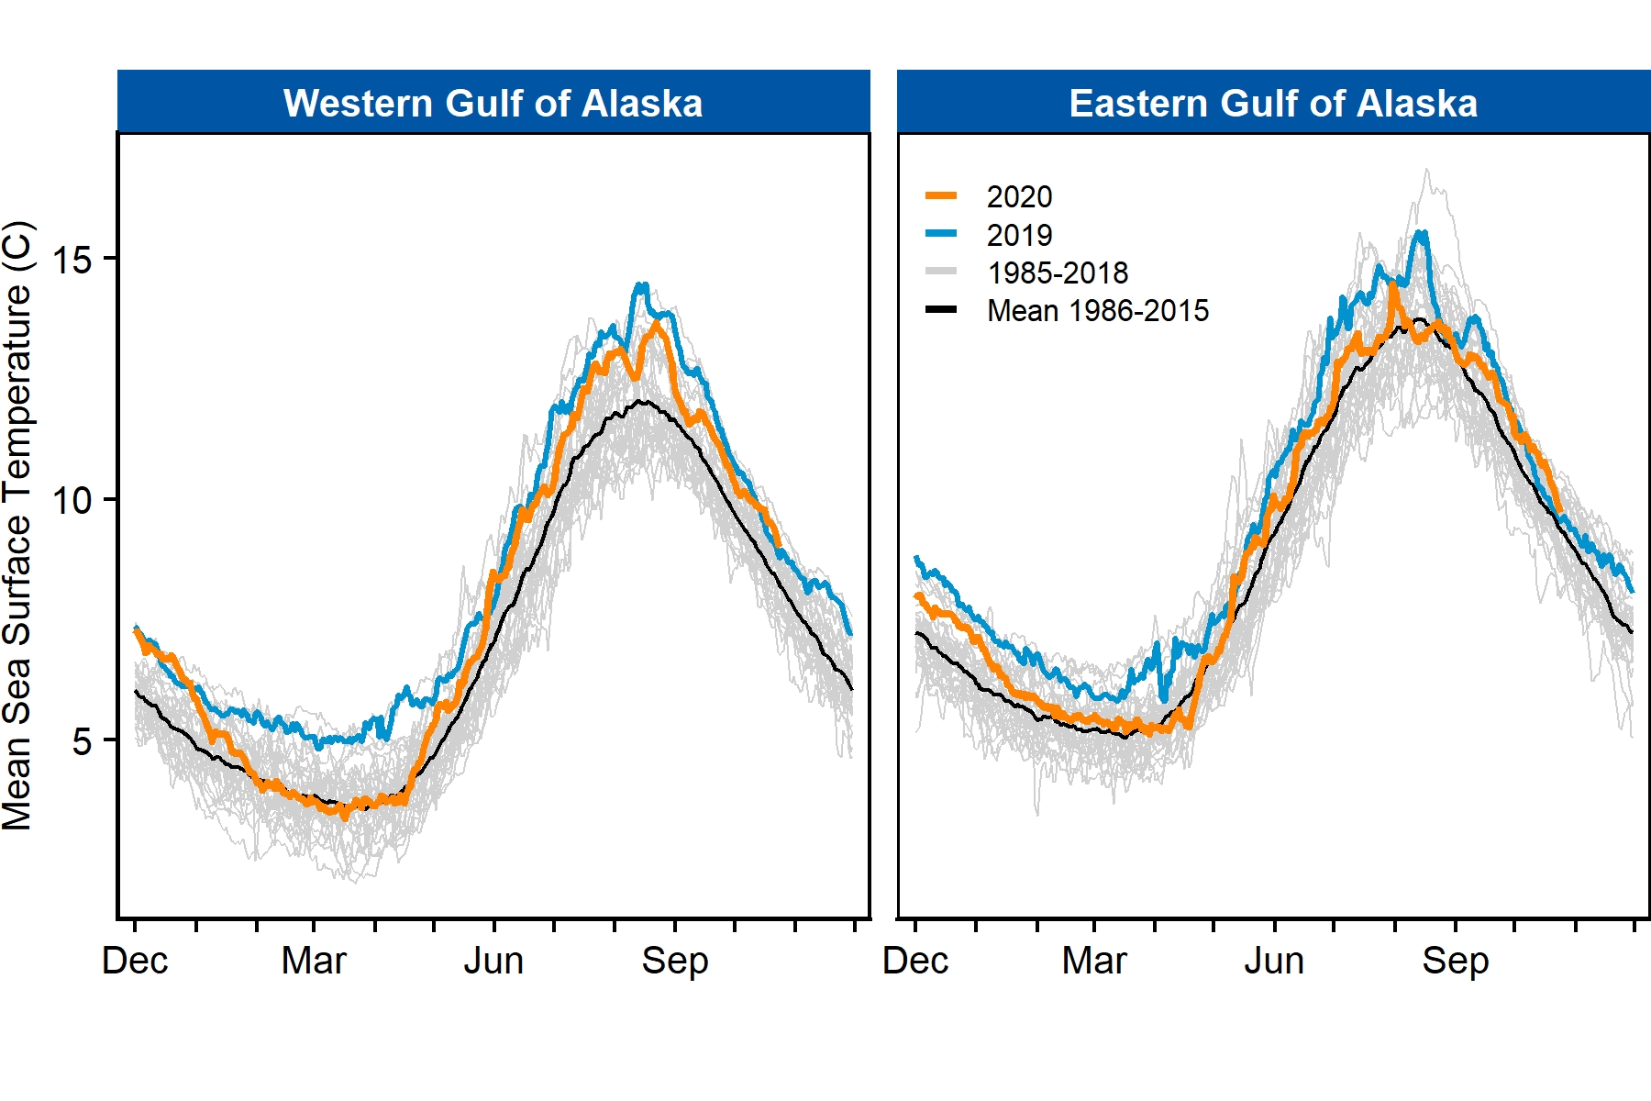

**Figure 1.** Seasonal sea surface temperatures (SST) for Gulf of Alaska ecosystem regions. Lines illustrate the 2020 SST (orange), 2019 SST (blue), 30-year mean SST (black), and each of the 1985-2018 SST (gray) time series.

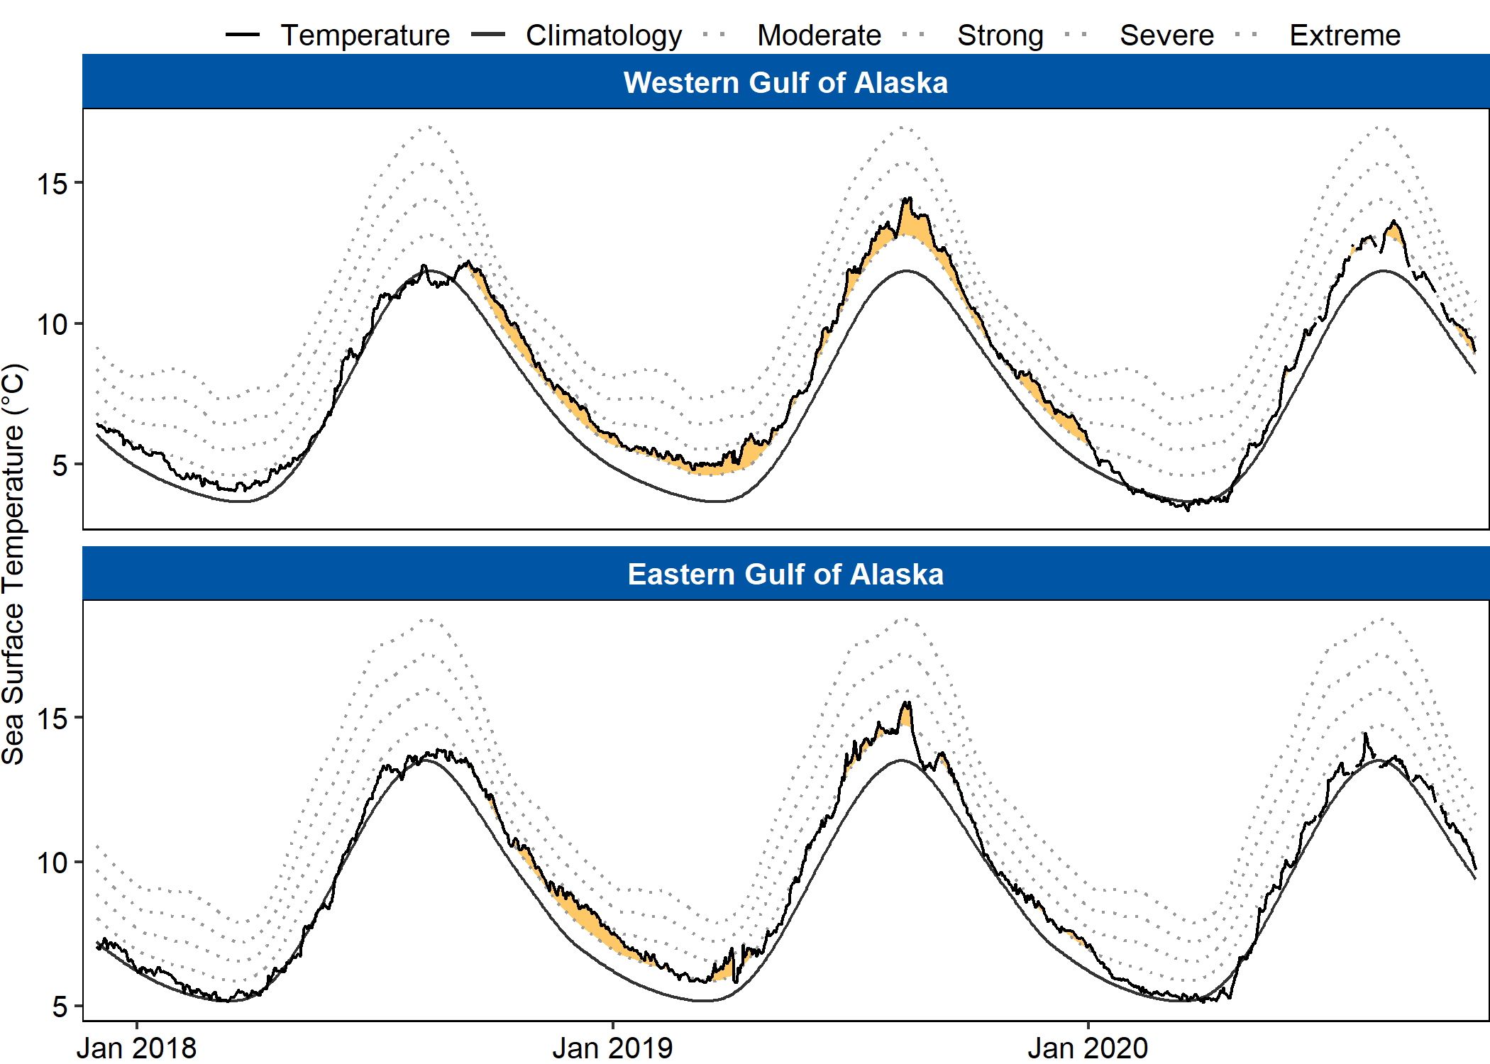

**Figure 2.** Marine heatwave (MHW) status during the last three years. Filled (yellow) areas depict MHW events. Black lines represent the 30-year baseline (smoothed line) and observed daily sea surface temperatures (jagged line). Faint grey dotted lines illustrate the MHW severity thresholds in increasing order (moderate, strong).

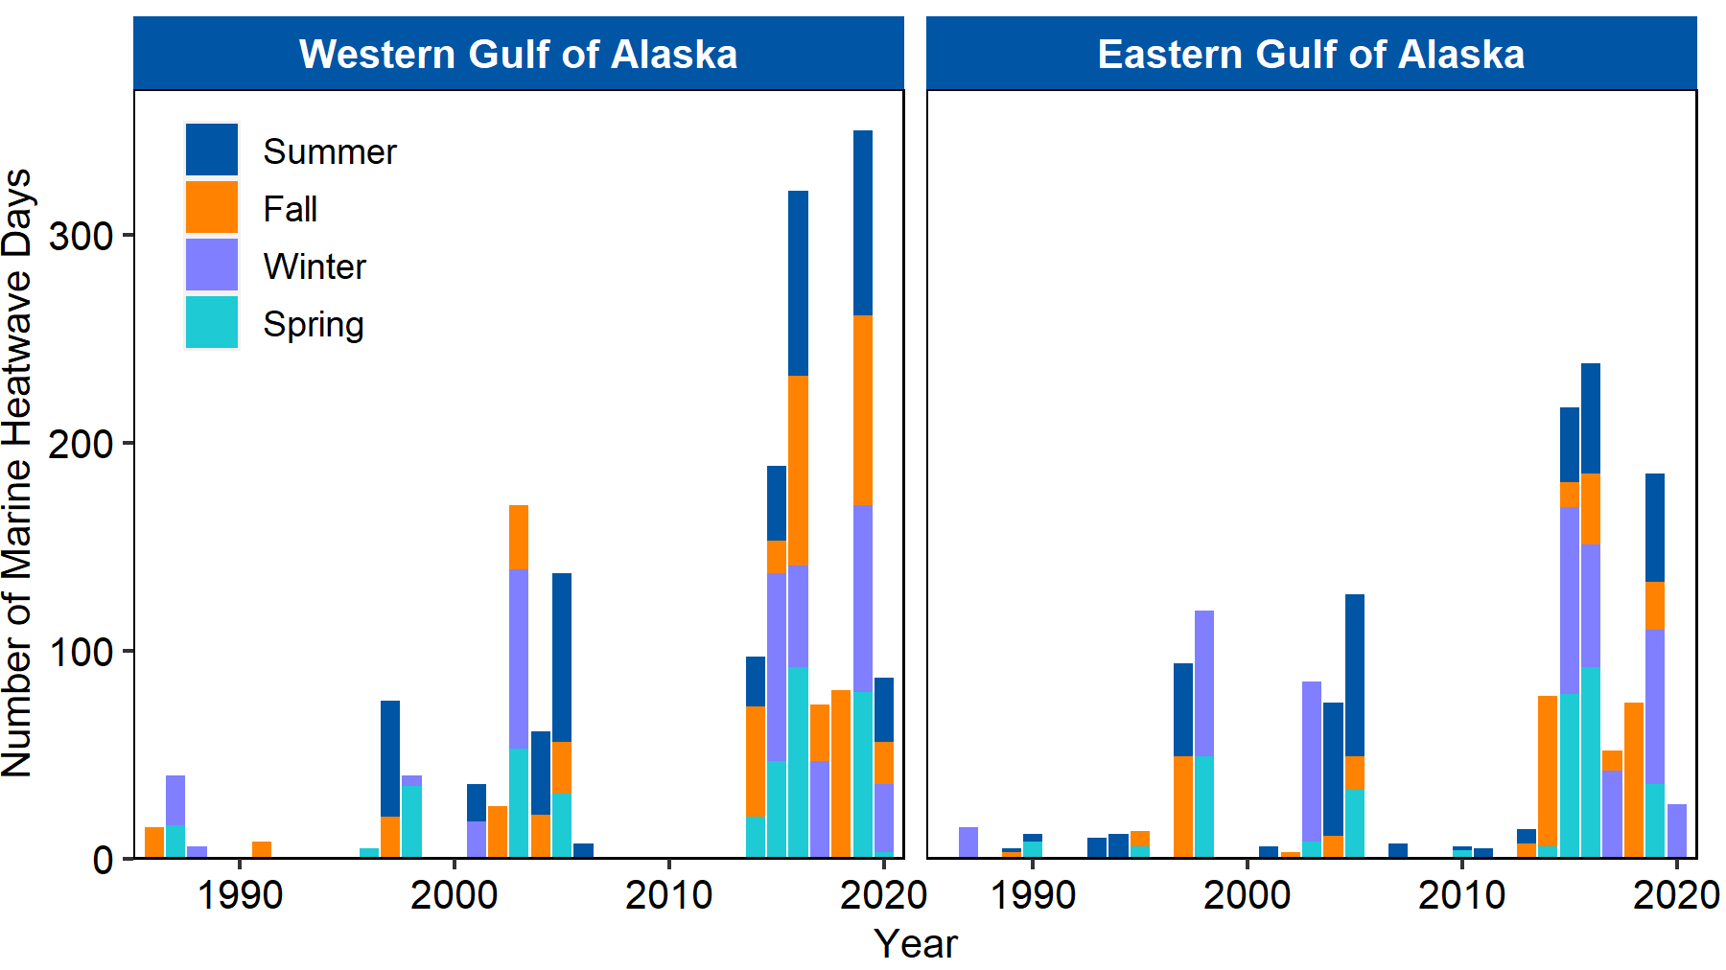

**Figure 3.** Number of days during which marine heatwave conditions persisted in a given year. Seasons are summer (Jun - Aug), fall (Sept – Nov), winter (Dec – Feb), spring (Mar – Jun). Years are shifted to include complete seasons so December of a calendar year is grouped with the following year to aggregate winter data (e.g., Dec 2019 occurs with winter of 2020).