Title: Sea Surface Temperature and Marine Heatwaves in the Aleutian Islands Ecosystem Regions
Contributed by: Jordan T. Watson
Contact author: Jordan T. Watson
Contact information: Auke Bay Laboratories, Alaska Fisheries Science Center, NOAA Fisheries
Last updated: September 2020
Description of indicator:
Sea surface temperature is a foundational characteristic of the marine environment and temperature dynamics can impact many biological processes. Changes in temperatures can influence physiological processes of fish (e.g., metabolic rates and growth rates), fish distribution (e.g., Yang et al. 2019), trophic interactions, availability of spawning habitat (e.g., Laurel et al 2020), and energetic value of prey. Extended periods of increased SST can lead to marine heat waves (MHWs) (Bond et al. 2015; Hobday et al. 2016). Trends in SST and MHWs are presented here throughout the Aleutian Islands ecosystem regions.
Satellite SST data from the NOAA Coral Reef Watch Program were accessed via the NOAA CoastWatch West Coast Node ERDDAP server (https://coastwatch.pfeg.noaa.gov/erddap/griddap/NOAA_DHW.html) for April 1985 - September 2020. Daily SST data were averaged within the western (west of 177 ̊W), central (170 ̊W - 177̊W), and eastern (163 ̊W - 170 ̊W) Aleutian Islands. The earliest complete 30-year time series (1986 – 2015) was used as the baseline period for mean and standard deviation comparisons (see Hobday et al., 2018; Schlegel et al., 2020 for discussions of baseline choices). Detailed methods are online, including maps of the spatial strata and querying satellite data with R (github.com/jordanwatson/EcosystemStatusReports/tree/master/SST). Annual SST time series are apportioned from December of the previous year through November so that the winter season (Dec-Feb) for each year can be consistently aggregated. A time series decomposition (i.e., seasonality and noise removed) is also provided to better illustrate the long term trends in SST data (Edulantes 2019).
Warm water events have become so frequent in the world’s oceans that a new method for describing them has been formalized. A marine heatwave occurs when SST exceeds a particular threshold for five or more days. That threshold is the 90th percentile of temperatures for a particular day of the year based on a 30-year baseline (Hobday et al., 2016). The intensity of a MHW can be further characterized by examining the difference between the 90th percentile threshold for a given day and the baseline (“normal”) temperature for that day. When the threshold is exceeded, the event is considered moderate, strong (2 times the difference between then threshold and normal), severe (3 times the difference between the threshold and normal), or extreme (>=4 times the difference) (Hobday et al., 2018). MHW indices were developed using the heatwaveR package (Schlegel and Smit 2018).

Status and trends:
During the winter (Dec – Feb) and spring (Mar – Jun) of 2020, SST in all three regions was generally more aligned with 2019 than with longer term average temperatures (Figure 1). Summer temperatures however, tended more towards or below average in the western and central Aleutians while the eastern Aleutians remained a bit warmer, though still cooler than 2019.
Generally, all three regions have trended towards anomalously warm (> 1 SD from the long term mean) conditions over the last few years, though the western Aleutians may be trending nearer to average conditions. Meanwhile, the central and eastern Aleutians both continue their anomalously warm conditions, especially in the eastern Aleutians where SST is generally warmer.
MHWs have occurred periodically throughout the SST time series but with greater frequency during the last few years. In each of the most recent 8 years, at least one MHW event has occurred in each of the three Aleutian Islands regions, with the greatest duration of events occurring in the eastern region. Notably though, the year with the most MHW days in both the western and central Aleutians was 1996. Strong El Nino conditions occurred in 1996-1997 and may have been a factor during this time but notably, the MHW did not persist appreciably into 1997 so this may suggest a weak relationship.
Factors influencing observed trends:
Conditions in the eastern Aleutians are slightly cooler than observed in the western Gulf of Alaska ecosystem region, but the SST patterns are quite similar between the two areas. Thus shelf dynamics and weather dynamics near the Alaska Peninsula may still have an effect in this region.
Implications:
Sea surface temperature is a foundational characteristic of the physical marine environment and temperature dynamics can impact many biological processes. Barbeaux et al (2020) demonstrated marine heatwave impacts on marine fish populations and during recent warm years, the Gulf of Alaska has seen record low returns for several salmon stocks. Meanwhile, growing evidence supports the notion of temperature driven northward range shifts. While we do not connect SST to fish populations here, continued warm periods are concerning for the predictability of fish populations and recruitment.
References

Barbeaux, S.J., Holsman, K. and Zador, S., 2020. Marine heatwave stress test of ecosystem-based fisheries management in the Gulf of Alaska Pacific cod fishery. Frontiers in Marine Science, 7:703 doi.org/10.3389/fmars.2020.00703
Bond, N.A., M.F. Cronin, H. Freeland, and N. Mantua. 2015. Causes and impacts of the 2014 anomaly in the NE Pacific. Geophysical Research Letters 42:3414–3420.
Edullantes, B. 2019. ggplottimeseries: Visualisation of Decomposed Time Series with ggplot2. R package version 0.1.0. Available from: github.com/brisneve/ggplottimeseries.

Hobday, A. J., Oliver, E. C. J., Gupta, A. S., Benthuysen, J. A., Burrows, M. T., Donat, M. G., et al. 2018. Categorizing and naming marine heatwaves. Oceanography 31, 162–173. doi: 10.5670/oceanog.2018.5205

Hu, Z.Z., A. Kumar, B. Jha, J. Zhu, and B. Huang. 2017. Persistence and predictions of the remarkable warm anomaly in the northeastern Pacific Ocean during 2014–16. Journal of Climate 30(2):689-702.

Schlegel, R.W., Oliver, E.C., Hobday, A.J. and Smit, A.J., 2019. Detecting marine heatwaves with sub-optimal data. Frontiers in Marine Science, 6, p.737.

Schlegel, R. W., and Smit, A. J. 2018. heatwaveR: Detect Heatwaves and ColdSpells. R package version 0.3. Available online at: doi: 10.21105/joss.00821 (accessed July 2020).

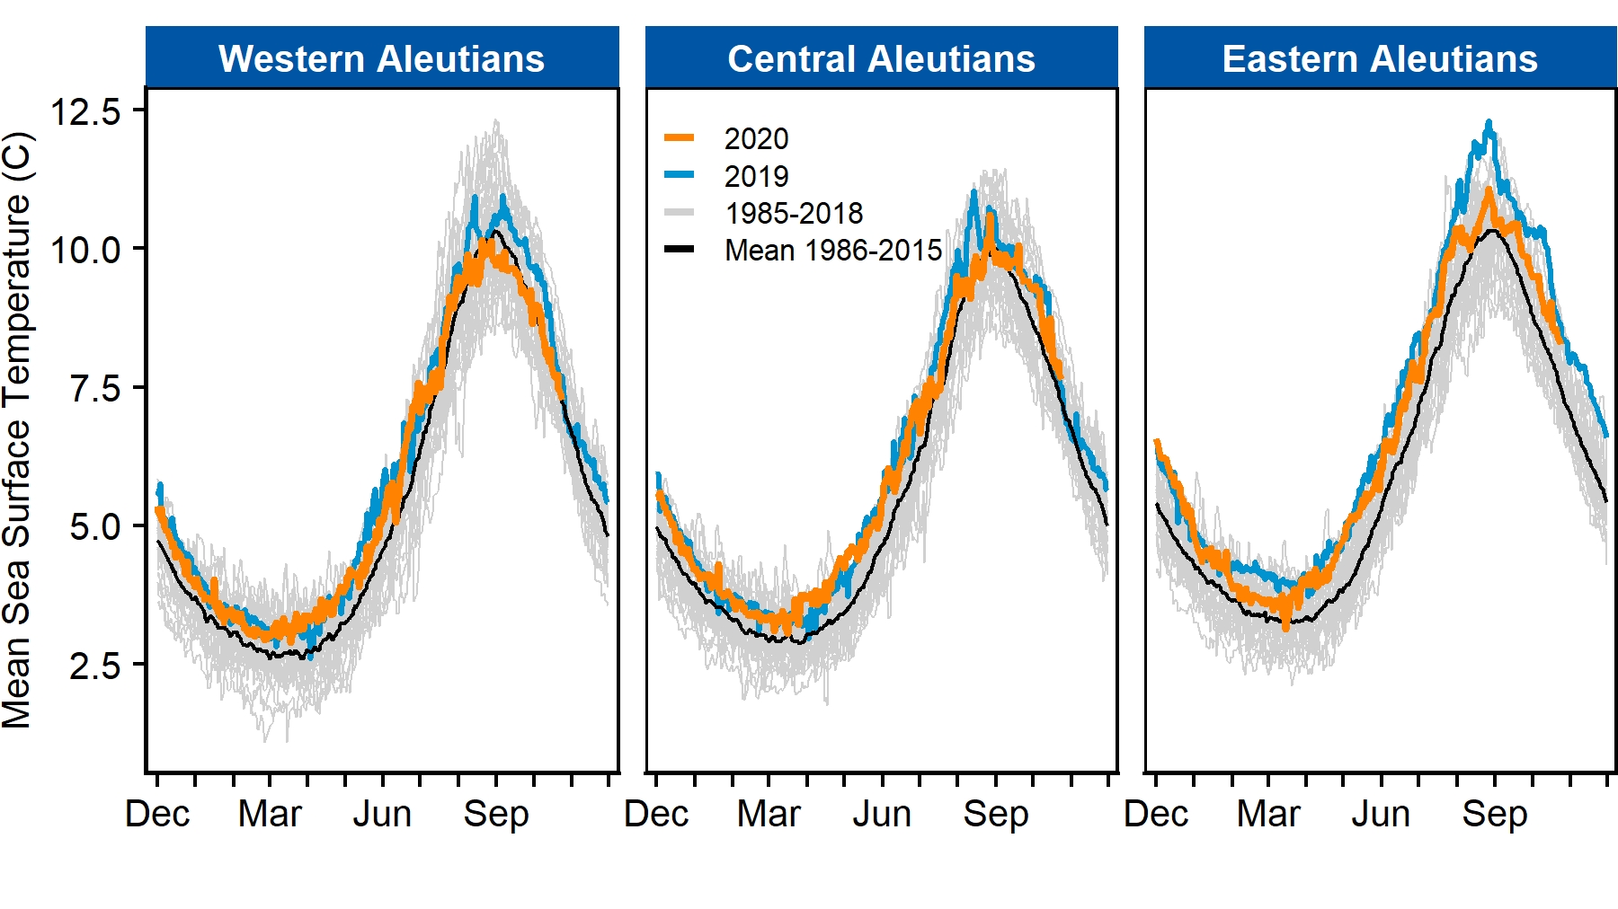
Figure 1. Seasonal sea surface temperatures for Aleutian Islands ecosystem regions.

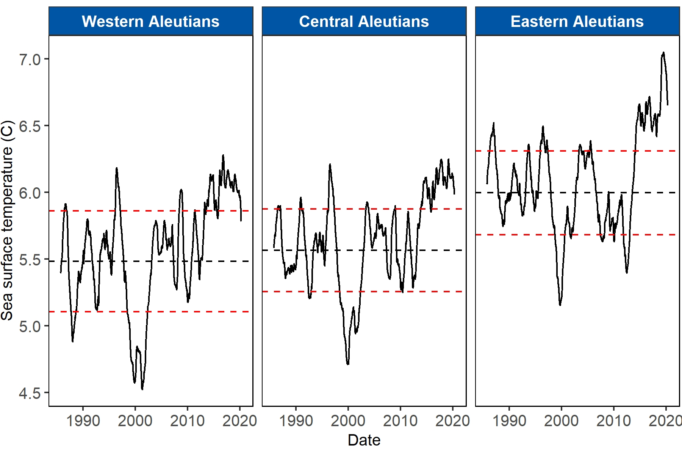
Figure 2. Time series trend (i.e., seasonality and noise removed) of sea surface temperatures. Horizontal dashed lines represent the mean (black) and standard deviation from the mean (red) during the earliest complete 30-yr baseline period (1986-2015).

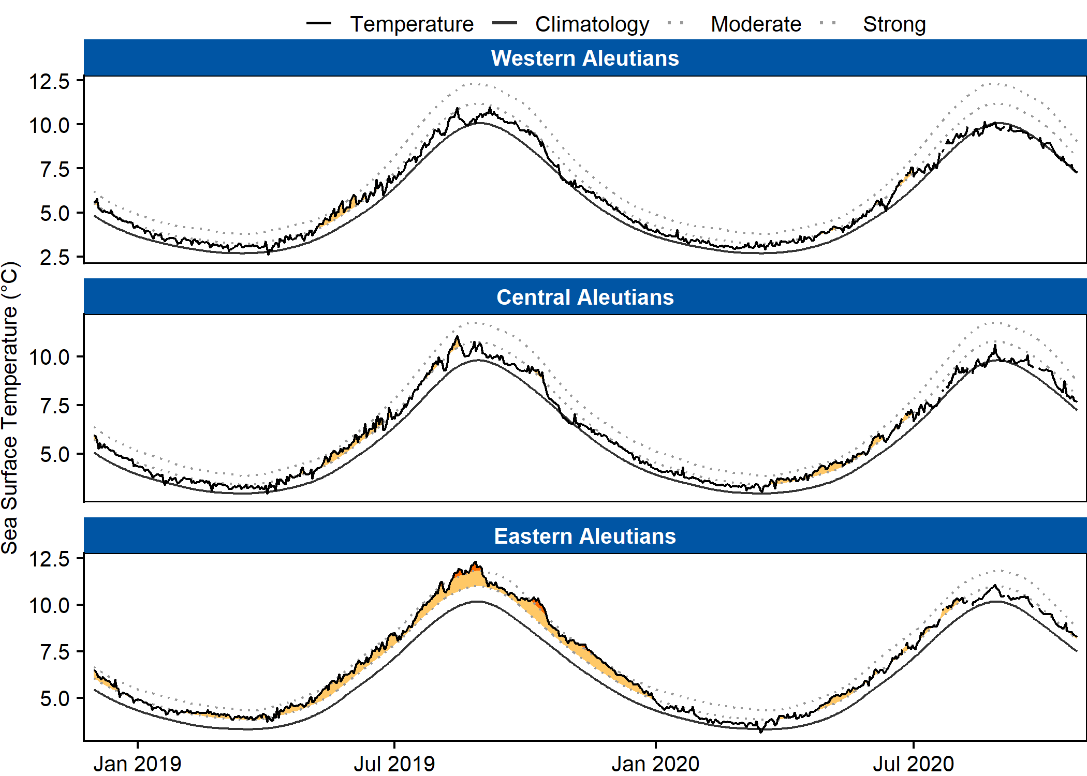
Figure 3. Marine heatwave (MHW) status during the last three years. Filled (yellow) areas depict MHW events. Black lines represent the 30-year baseline (smoothed line) and observed daily sea surface temperatures (jagged line). Faint grey dotted lines illustrate the MHW severity thresholds in increasing order (moderate, strong).

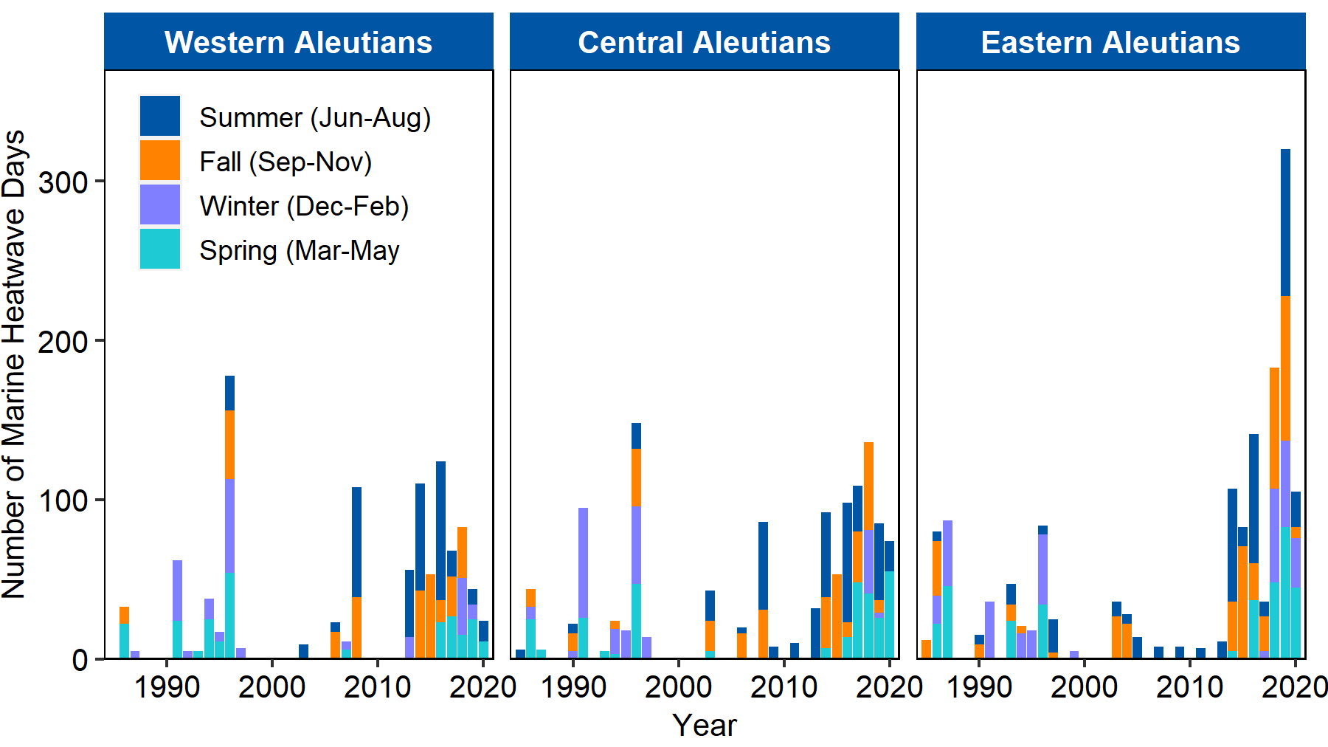
Figure 4. Number of days during which marine heatwave conditions persisted in a given year. Seasons are summer (Jun - Aug), fall (Sept – Nov), winter (Dec – Feb), spring (Mar – Jun). Years are shifted to include complete seasons so December of a calendar year is grouped with the following year to aggregate winter data (e.g., Dec 2019 occurs with winter of 2020).

