**File Validation for** [**https://lab8.jordanwentland.com**](https://lab8.jordanwentland.com)

**HTML Validation:**

* **Index.html**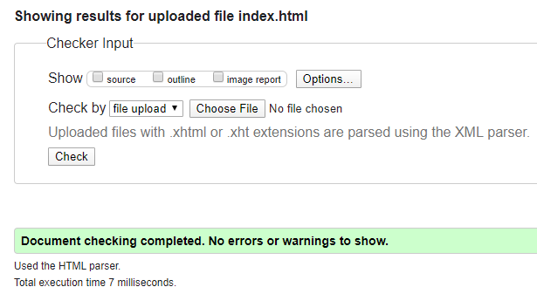
* **Training.html**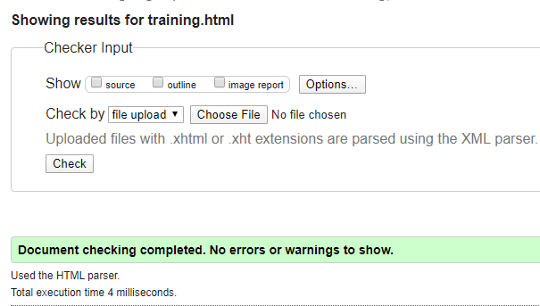
* **Board.html**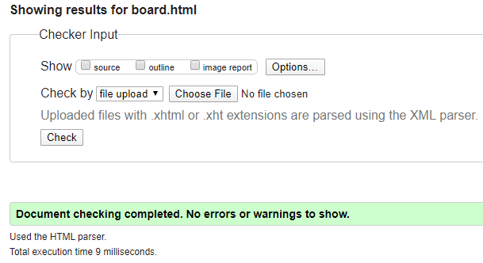
* **Contact.html**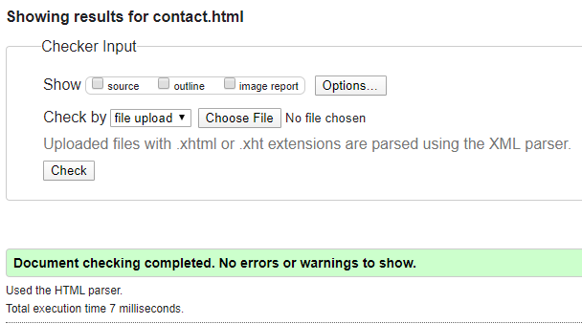

**CSS Validation:**

* **GPST.css**