**HTML and CSS Validation Check for** [**https://lab9.jordanwentland.com**](https://lab9.jordanwentland.com)

**HTML Validation:**

* Index.html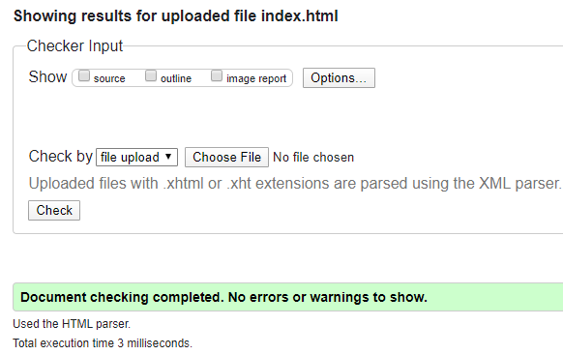
* Board.html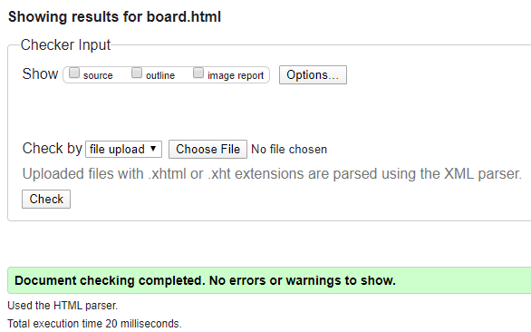
* Training.html

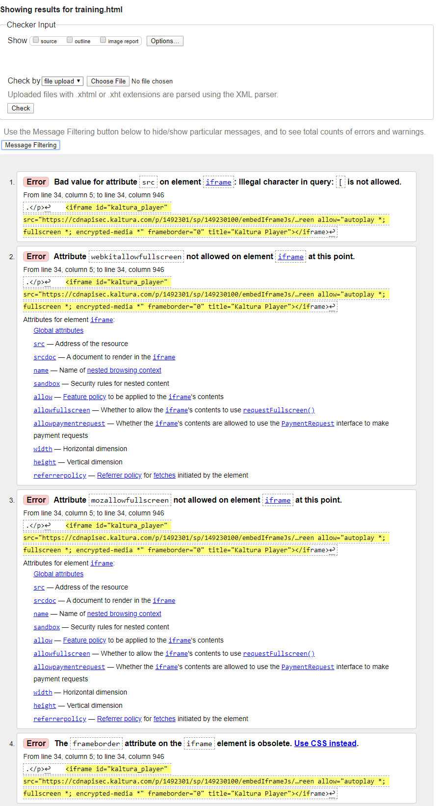

**ALL OF THE ERRORS IN TRAINING ARE RELATED TO THE COPY PASTE CODE AND I WILL NOT ACCEPT POINTS OFF FOR THAT.**

* Contact.html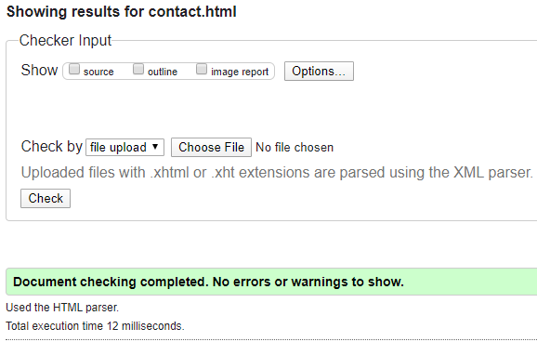

**CSS Validation:**

* GPST.css