Chunhoi Wong

Pics and Answer

Answer to:

1. Choose something that is relatively monochromatic with a color fairly different from your background surroundings (a water bottle, a piece of clothing). Try to create a video stream where you track this object with a bounding box surrounding it by thresholding HSV or RGB values. Is HSV or RGB typically better? How large is the threshold range that you need to track the object?

ANS: RGB is better, It is more clear and easier to tack an object with RGB. The object size will be in this range:260 132 108 240.

2. Now change the lighting condition (turn on or off the lights or turn on your phone flashlight on the object). Is there a major difference in the tracking ability of your object?

ANS: Yes, visibility does matter! If its too dark, the tracker might able to follow the object for a while but It will be so easy to lost tracking the object.

3. Now navigate to a Color Picker on your phone (Zoom into the color zone so that it covers a good portion of your phone screen). Since you can pick your color with the website, see if that is the color (with a small range) that you can pick up with your camera. Does changing your phone brightness help or hurt with how your code is able to track the color?

To me, No, both brightness hurt the tracking process. I think my code is not good enough to handle these situations. Maybe it is because the object is too big? My assumption is brighter will help.

4. Create a new piece of code that can determine the “dominant” color in a designated (central) rectangle in your video feed (Use K-Means, see a tutorial to find an image’s dominant colors). Use your non-phone object and change the brightness of its surroundings. Note the change of the color. Do the same with your phone. Is one or the other more robust to brightness?

Brighter is better. I have attached the image below to show my prove.

Simple test for Section 5: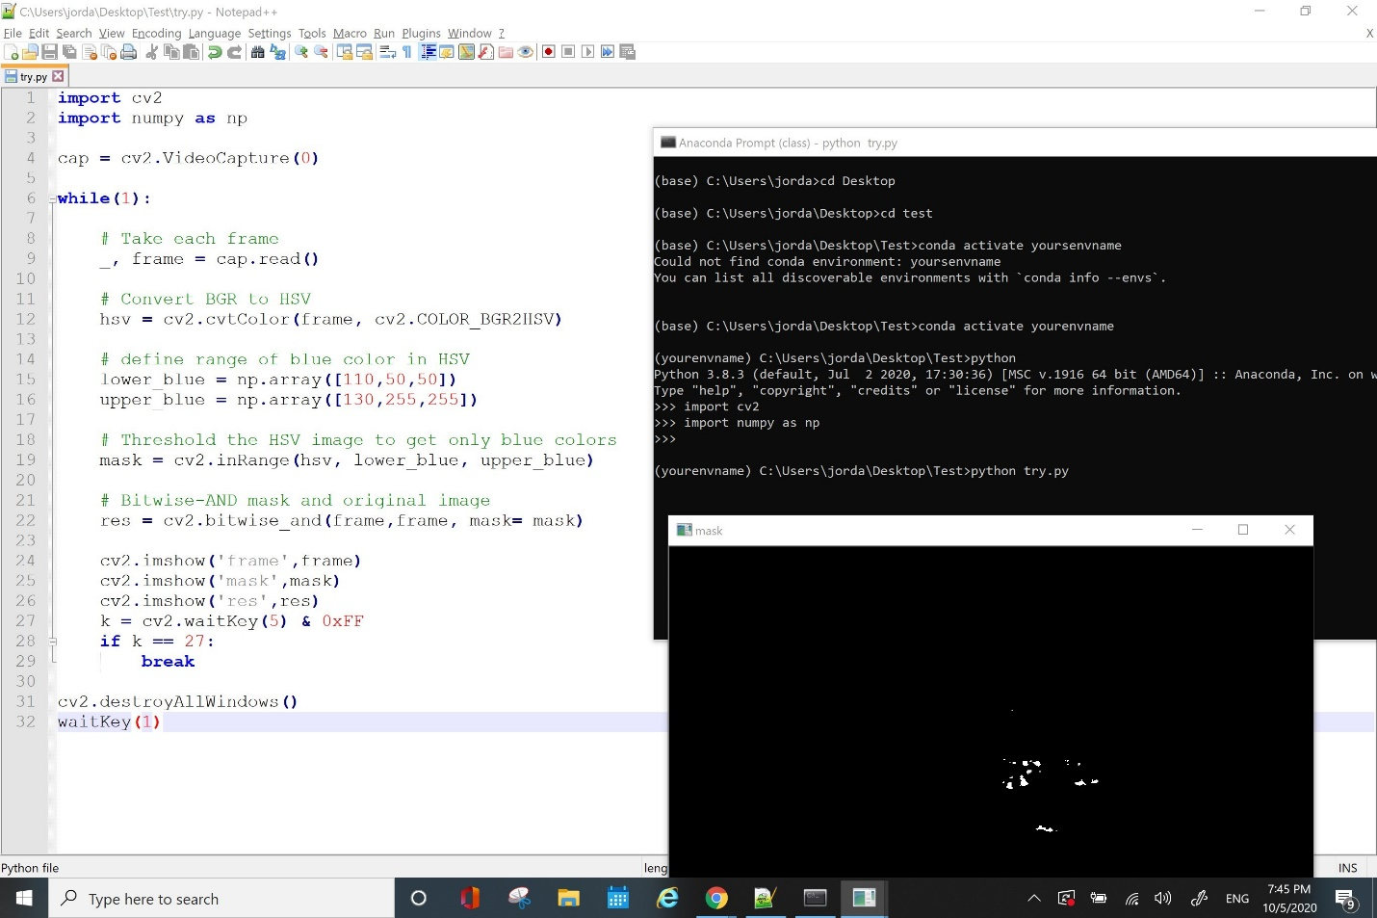



Section 6(Task 4)

Normal Tracking:

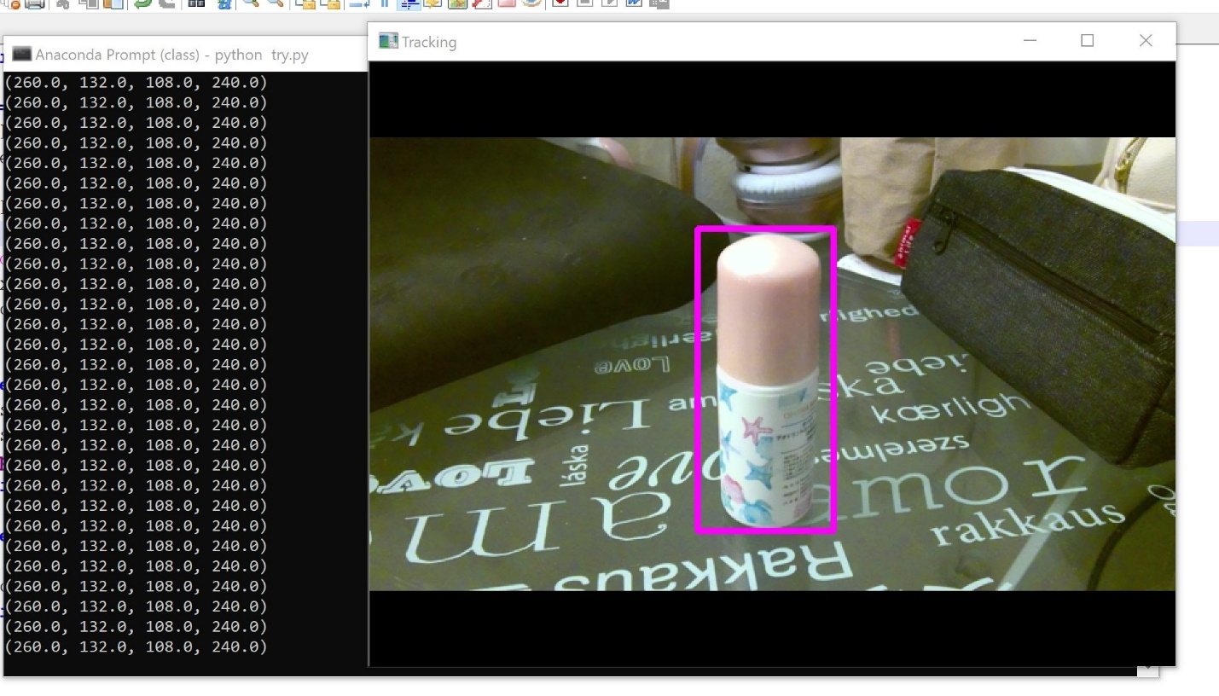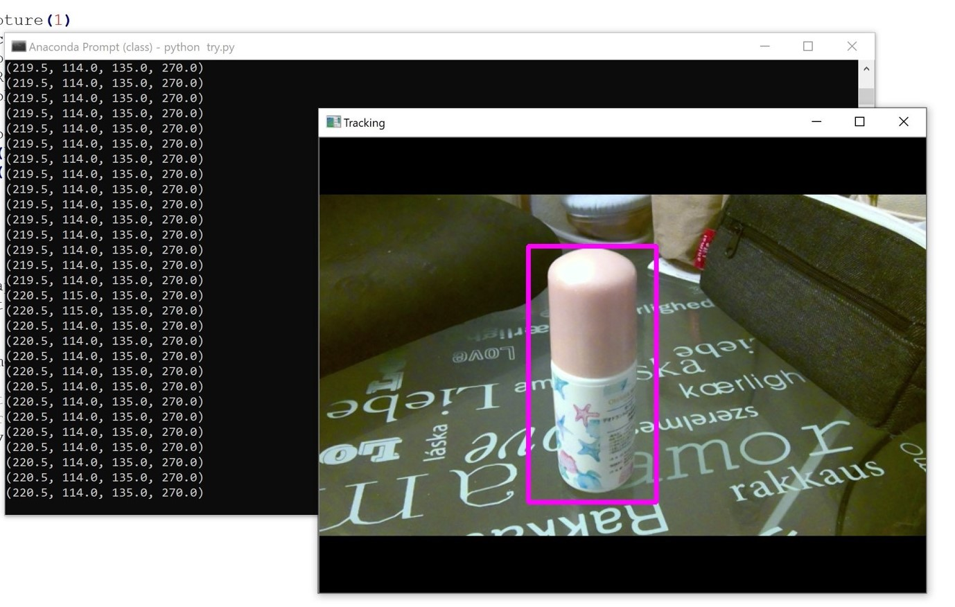

When it is a little bit darker:

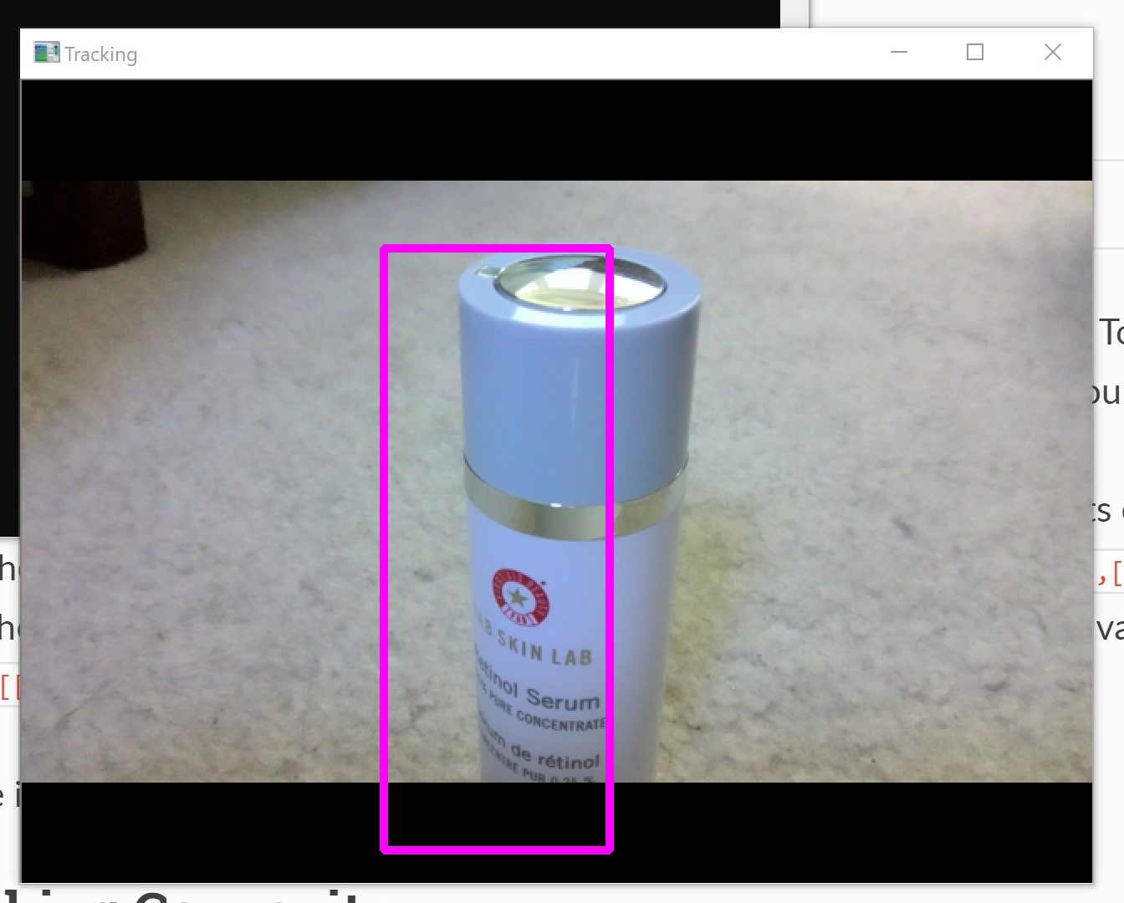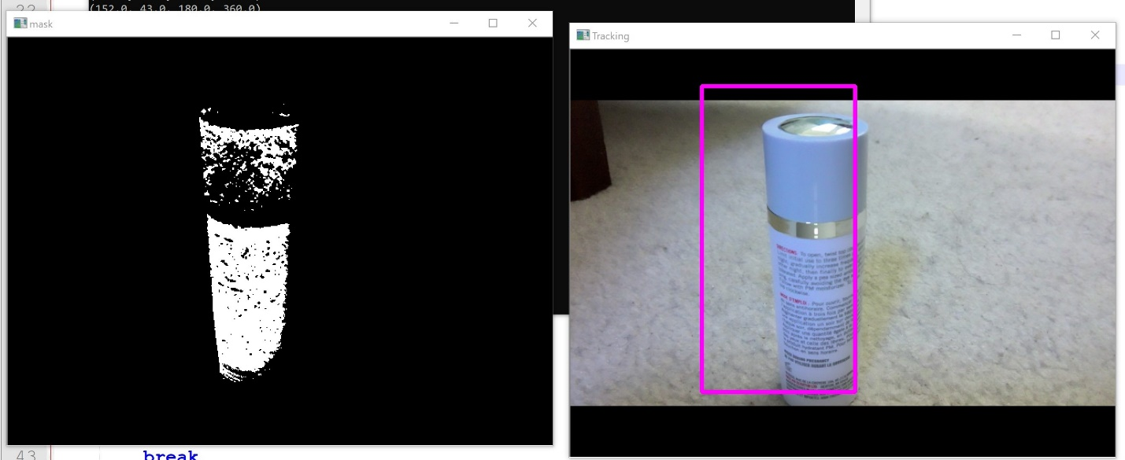

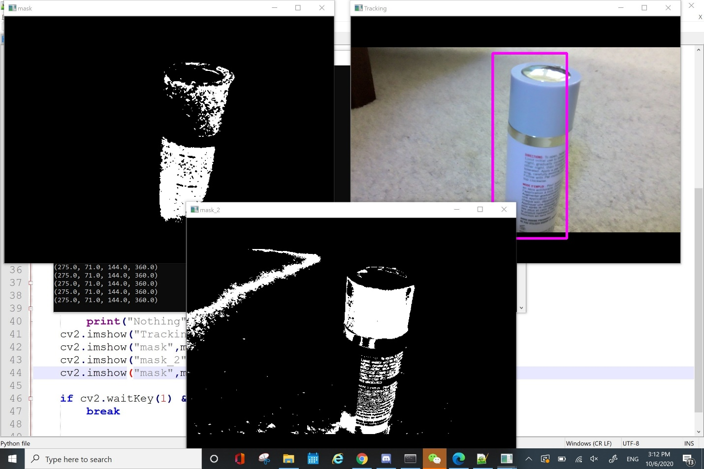

Picky Color:

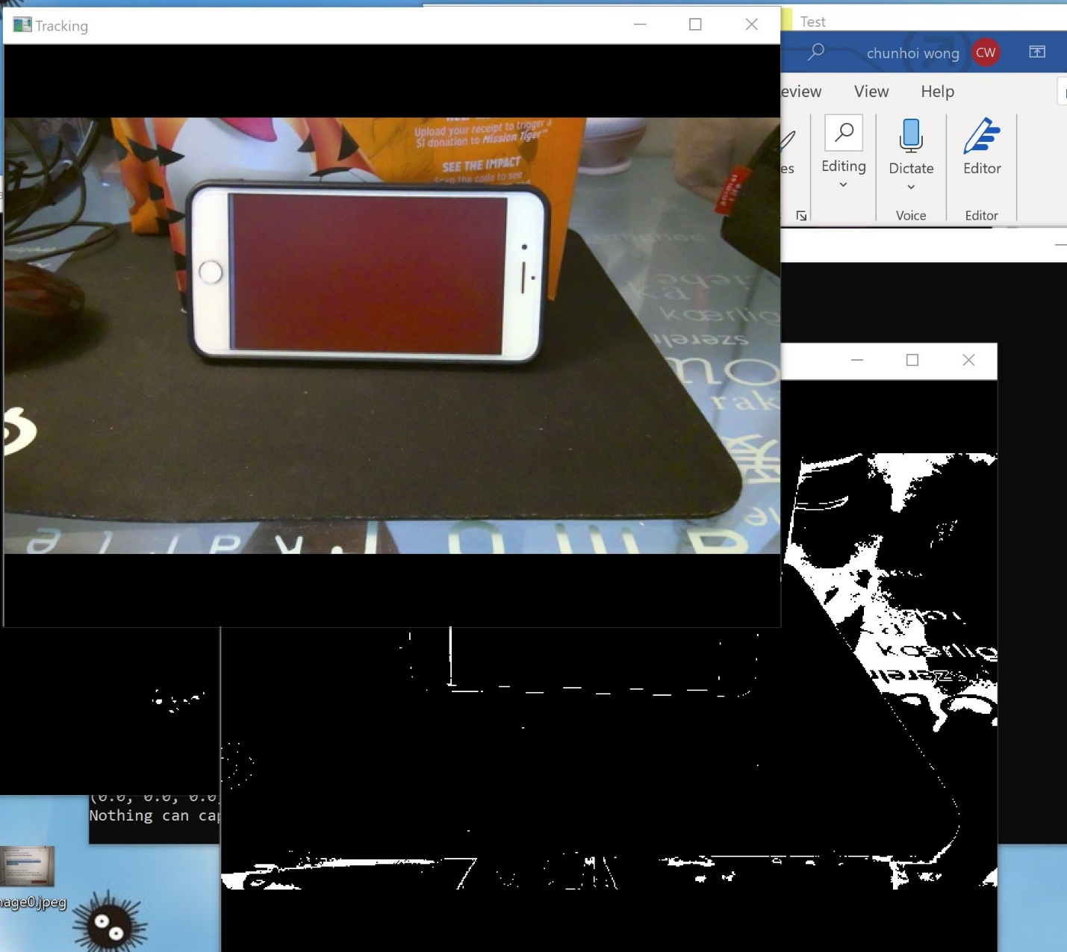

Low brightness result:

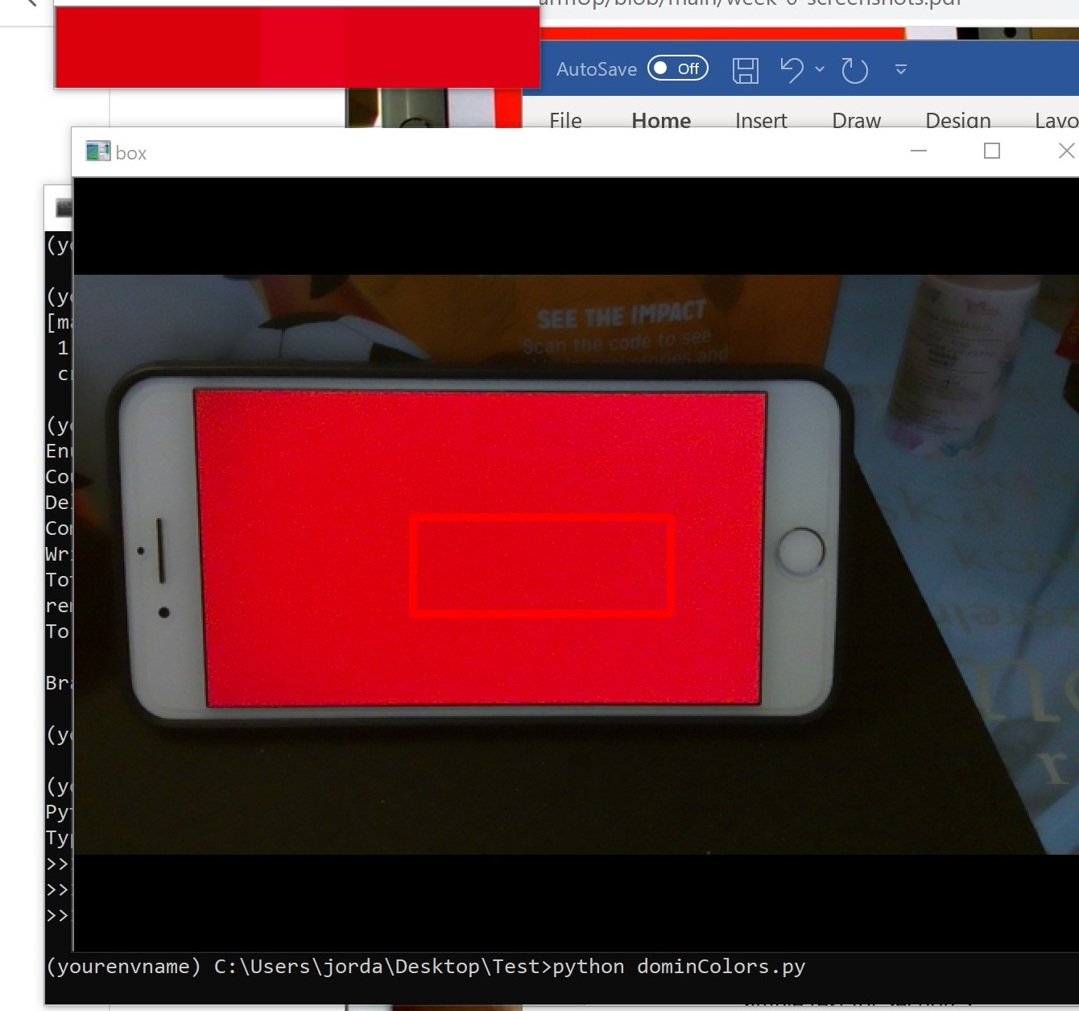

Really Bright:

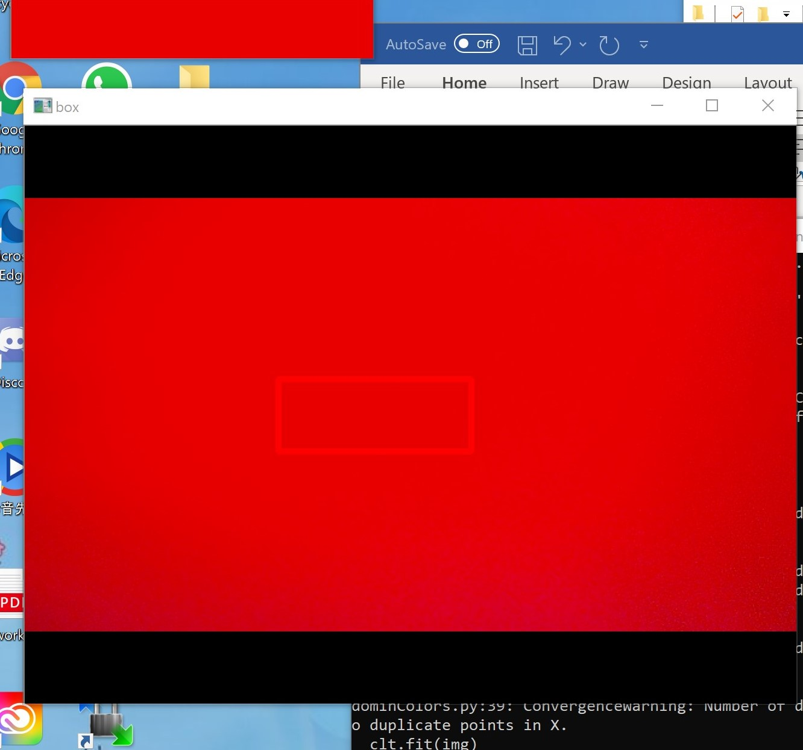

Dominate Color: