Artificial Neural Networks and Deep Architectures, DD2437

Short report on lab assignment 1

## Learning and generalisation in feed-forward networks — from perceptron learning to backprop

Jordan Wu, Daniel Janischowsky

#### September 17, 2019

1. **Main objectives and scope of the assignment**

* List here a concise list of your major intended goals, what you planned to do and what you wanted to learn/what problems you were set to address or investigate, e.g.

##### Our major goals in the assignment were

*•* to learn how to program a neural network

*•* to experience the differences between perceptron and sigmoid

*•* to see the learning rate of multi- vs. single layer networks

# Methods

* Python scripting with pycharm
* libraries: numpy, matplotlib

# Results and discussion - Part I

### Classification with a single-layer perceptron *(ca. 1 page)*

* With Separable Data Learning Rates (squared error per epoch):
* 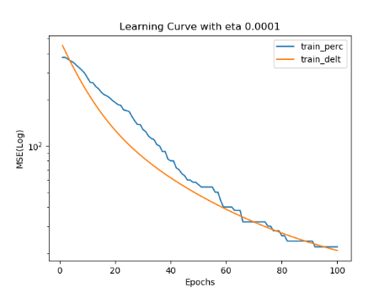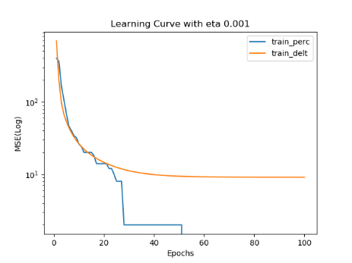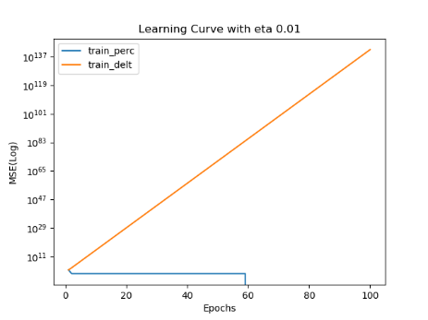
* If solution exits, perceptron will always find it, delta not at bigger learning rates (the boundary depends on the structure and the starting values)
* Perceptron stops learning when it has found any solution, error decreases to zero
* Delta always tries to improve and find the minimum error
* With small learning rates more epochs are needed
* Sequential learning is faster in terms of minimizing error per epoch, but needs more calculating
* There is an optimal learning rate for each data set

* Non separable data:
* 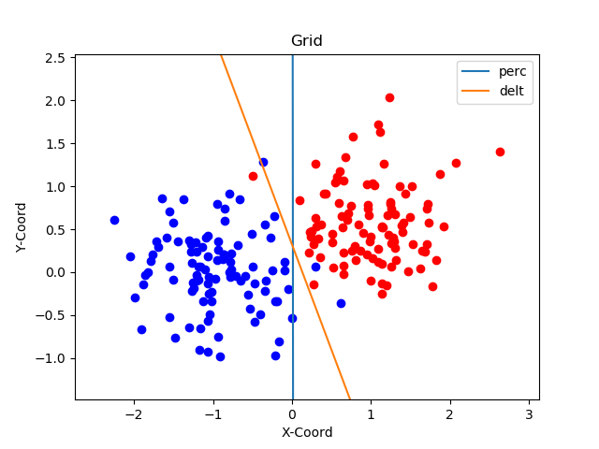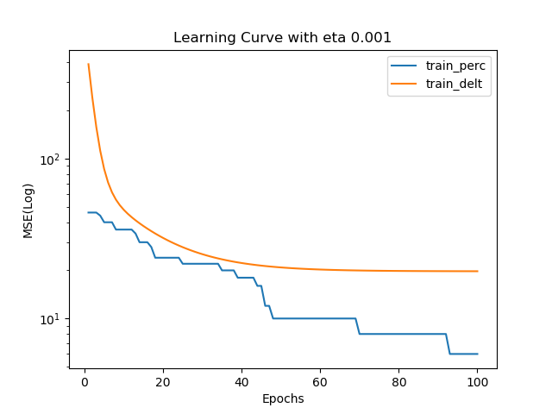

### Classification and regression with a two-layer perceptron*(ca. 2 pages)*

##### Classification of linearly non-separable data

* It seems that one (decision boundary) or two plots (including learning curves) should suffice. Build a story around the questions in the assignment. Include concise motivation for your findings and potential interpretations/speculations.

##### The encoder problem

* Here you do not really need any illustrations, this could be a very short section reporting on your experiments in line with the assignment questions.

##### Function approximation

* This subsection requires plots to reflect intuitive visual interpretation of the results. Make sure that you condense information and avoid any excessive plotting. Here you may need to incorporate some illustration of the network’s generalisation performance or use a table to systematically report the results requested in the assignment.

1. **Results and discussion - Part II *(ca.2 pages)***

* Here you do not have to introduce the problem or define Mackey-Glass time series, as you should focus on the results. You could divide them into two parts as the following two suggested subsections but you might as well keep your story under the main heading of Part II of the assignment. Importantly, always clearly state what network architecture you use, crucially with the number of hidden nodes, systematically report average results with various manipulations (regularisation etc.) and pay attention to differences between training, validation and test errors. Illustrating the outcome of your network predictions along with the original chaotic time series can also be very helpful. Finally, since you compare two- and three-layer architectures, make sure that you do not jump to any conclusions based on a small number of simulations unless you have statistically convincing evidence (when you compare the mean performance measures, their second moment is also relevant). In this part it may be particularly desirable to rely on tables.

### Two-layer perceptron for time series prediction - model selection, regularisation and validation

* 1. **Comparison of two- and three-layer perceptron for noisy time series prediction**

1. **Final remarks** *(max 0.5 page)*

*Please share your final reflections on the lab, its content and your own learning. Which parts of the lab assignment did you find confusing or not necessarily helping in understanding important concepts and which parts you have found interesting and relevant to your learning experience?*

*Here you can also formulate your opinion, interpretation or speculation about some of the simulation outcomes. Please add any follow-up questions that you might have regarding the lab tasks and the results you have produced.*