Jordan Gary

2/1/2021

CSC 4263 – Individual Game Report

Game Title: Don

Don is a basic 2d, sprite-based platformer

Goal: The goal of Don is to get Don (the player) from the start of the level all the way to the flag at the end. While avoiding ghosts along the way or shooting them to get rid of them for more points.

Don: 

Controls:

A – to move left

D- to move right

W- to point gun up

SPACE – to jump; when against a wall you can jump multiple times to scale the wall

LEFT MOUSE KEY – to shoot

Main Menu:

Game starts here, you can either press “Start” to start the game or “Quit” to exit.

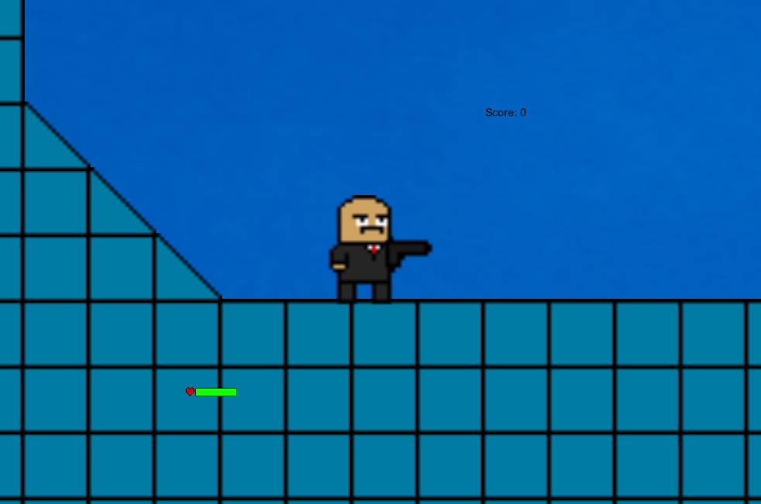When the game starts, you’ll notice a health bar at the bottom left and your score at the top right

Ghosts stand in the way of you, sometimes flying back and forth. You can shoot them to get rid of them. Hitting a ghost with a bullet awards you some points to up your score.

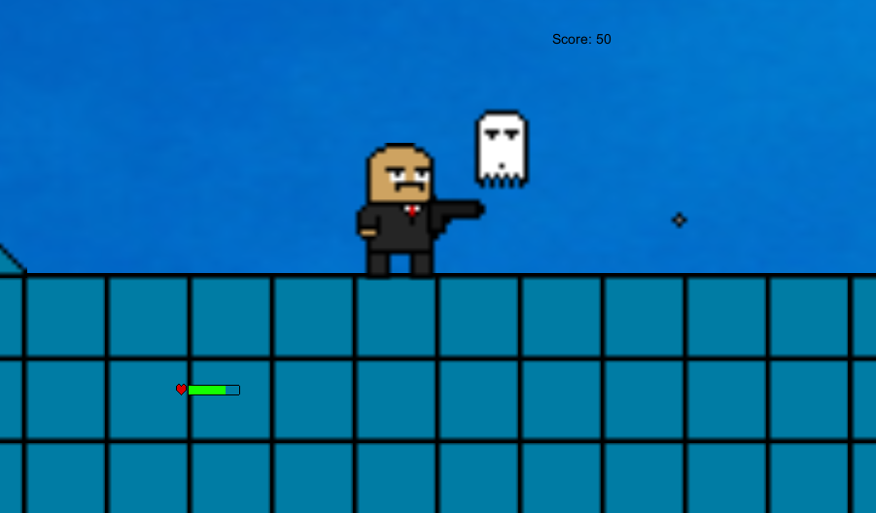

To avoid falling down holes, the player can wall jump by pressing the jump button while against a wall

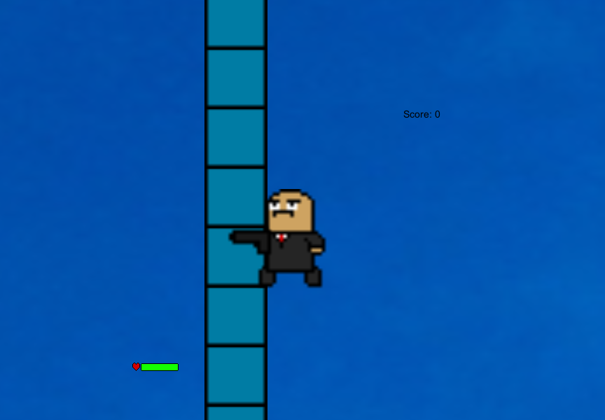

If you get hit, Don will blink red and your health and score will drop.

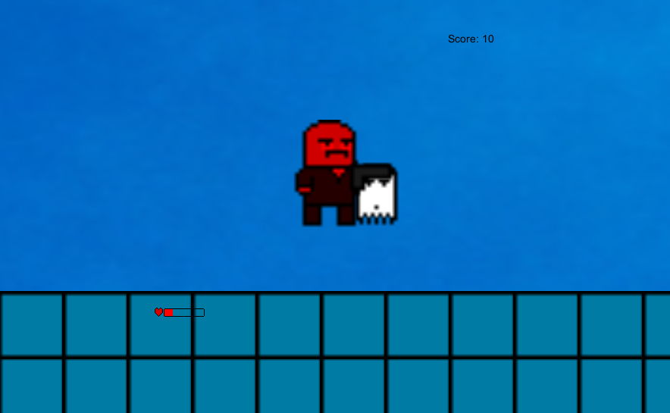

The player can defend themselves by either shooting straight or up (done by holding up when pressing the “shoot” button)



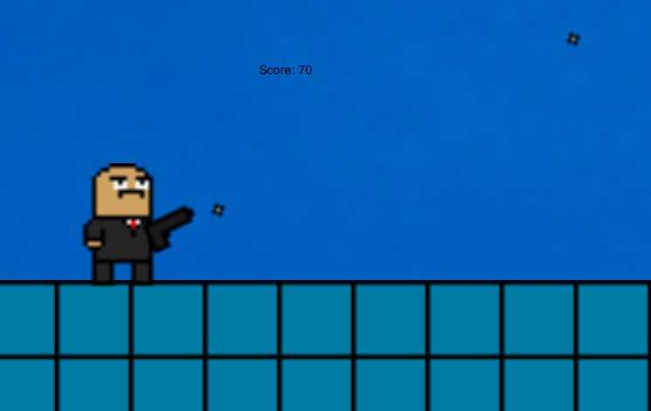

The game ends when Don hits the flag at the end of the level.

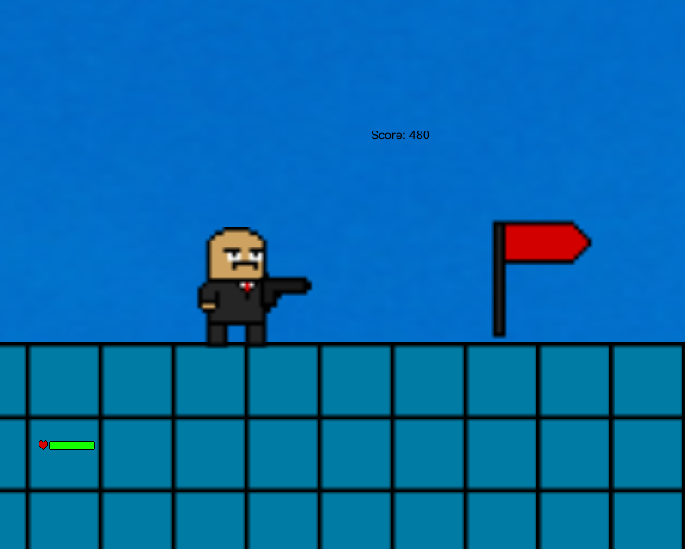

* Movement for the players is based on vector2 forces acting on the rigidbody and collisions between the player and the surrounding area.
* Enemy ghosts use collision detection to move back and forth and detect when they need to turn around. They only move when they are in the view of the “Main Camera”. They also activate a particle system of white pixels when shot, to give off the effect of them being shot.
* Gun object is attached to the player model and instantiates a bullet object each time the “shoot” button is pressed. Bullets are destroyed once they come in contact with another collider.
* All sprite-work was done by me, Jordan Gary
* Free assets:
  + Background was done by Elia Clerici on pexels.com
  + https://www.pexels.com/photo/photo-of-blue-sky-912110/?utm_content=attributionCopyText&utm_medium=referral&utm_source=pexels