SCRUMptious Finance
Software Configuration
Management Plan

SCRUMptious Six
SCRUMptious Finance
March 8th, 2018
V2.0.0

______________________________
SCM Lead Signature

______________________________
Scrum Master Signature

______________________________
Project Manager Signature

Table Of Contents

1. INTRODUCTION 1
1.1 Purpose 1
1.2 Scope 1
1.3 Acronyms 2
2. Software Configuration Management (SCM) 3
2.1 SCM Organization 3
2.2 SCM Responsibilities 3
2.3 SCM Resources 4
3. SCM ACTIVITIES 4
3.1 Configuration Identification 4
3.2 Project Baselines 5
3.3 Procedures for changing baseline 5
3.4 Procedures for processing change requests and approvals 5
3.5 Document revision and configuration status accounting……………..6
3.6 Release Process……………………………………………………………....6

4. CM Milestones…………………………………………………………..6

INTRODUCTION

This Software Configuration Management Plan (SCMP) document for SCRUMptious Finance (SF) is formed to expedite the definition of procedures and methods related to software configuration management activities.

Purpose

The purpose of this document is to establish the guidelines to which all project members should comply to. This includes requirements, plans, identification and detail to all documents that are created for this project. It’s intention is to act as a reference for project members and developers, to help coordinate the changes of the software throughtout development.

Scope

This documents defines Configuration Management (CM) activites for all software and documentation. The following configuration items (CI’s) will be produced during the development of SCRUMptious Finance (SF):

- Software Configuration Management Plan (SCMP);
- Software User Manual (SUM);
- Software Project Management Plan (SPMP);
- Software Design Document (SDD);
- Software Requirements Specification (SRS);
- Project Code (PC);
- User Stories (US);

The CI’s are to be configured and done within the following stages:

- Sprint 1 (SP1)
- Sprint 2 (SP2)
- Sprint 3 (SP3)

Acronyms

- CM – Configuration Management
- CI – Configuration Item
- CSA – Configuration Status Accounting
- DT – Development Team
- PC – Project Code
- PO – Product Owner
- PM – Project Manager
- SCM – Software Configuration Manager
- SCMP - Software Configuration Management Plan
- SDD – Software Design Document
- SE – Software Engineer
- SF – SCRUMptious Finance
- SM – Scrum Master
- SP1 – Sprint 1
- SP2 – Sprint 2
- SP3 – Sprint 3
- SPMP – Software Project Management Plan
- SRS – Software Requirement Specification
- SUM – Software User Manual
- US – User Stories

Software Configuration Management (SCM)

SCM Organization

Figure 2.1 provides an overview of SF’s SCM organization.

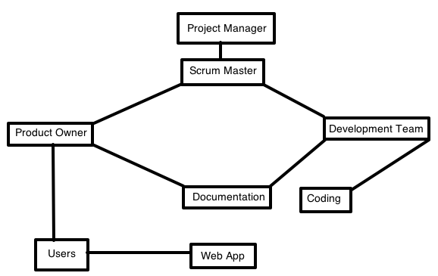
Figure 2.1

SCM Responsibilities

The Product Owner (PO) is responsible for being the “voice of the customer.” The PO’s purpose is to ensure that the team delivers value to the business. ensuring the SCM process is developed, maintained and implemented. The SB Product Owner and Development Team work together to develop, maintain, and implement effective software configuration management.

Development Team (DT), for SB is made up of 5 members. The DT is responsible for the design, documentation, and actual code of the project.

The Software Configuration Manager (SCM) ensures that the process is implemented once approved and that proposed changes to the process are reviewed by SF team members and approved by the CCB as required.

Scrum Master (SM), is accountable for guiding the team to deliver the sprint goals and deliverables. The SM will assign tasks and enforce rules. The main purpose of the SM is to ensure the Development Team (DT) stays focused on their assigned tasks. The SM develops and proposes a baseline version of the software configuration management product, ensuring that the SCM process is followed. The SM gives out a scope for when each activity should be completed

Project Manager (PM) is responsible for ensuring that project configuration management processes are followed. The PM also ensures all members of the project team are trained in SCM policies and procedures that apply to their function on the team.

SCM Resources

The minimum recommended resources are:
- Program(s) for html, css, php and javascript
- 30 days
- Scrum meetings
- Laptops
- Google Docs

SCM ACTIVITIES

Configuration Identification

SF is currently in development, product baseline to be approved upon delivery.

Product baselines are to be maintained by the SF SM. The Baseline will consist of the following:

- code files
- documentation
- executable files
- data files
- link files
- User's Manuals

Project Baselines

Figure 3.1 shows the progression of baselines

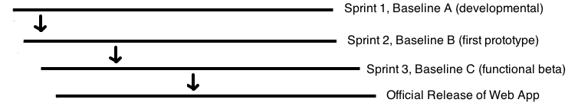
Figure 3.1

Procedures for changing baseline

All baseline CI’s are stored in a shared google docs library. To make any changes the following steps should be followed:
- DT member or PO identifies the CI they’d like to change
- Runs the request through the rest of the team
- Team rejects or accepts request
- Scrum Master approves or disapproves
- Changes are made and tracked
- Version is updated

Procedures for processing change requests and approvals

Figure 3.2 Shows procedure for processing change requests
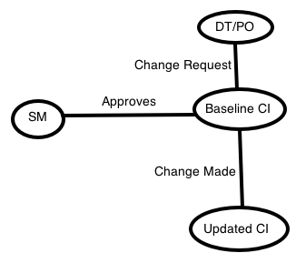
Figure 3.2

Document revisions and Configuration Status Accounting

One appointed member of the DT is in charge of updating the SCMP as the project progresses. Whenver they make changes they are to let every other member know which changes have been made and why. Configuration Status Accounting (CSA) is how the status and changes to CI’s will be tracked and handled. This will be maintained by the PO. The status will be kept in a separate document folder and revised every scrum meeting.

Release Process

The final product will be reviewed by the entire team and examined for any bugs or finishing touches. The project lead will then send all CI’s to the project manager. Who will then go about the process to release the product to users.

4.0 CM Milestones

Completed:
- Sprint 1 (10 user stories as HTML files, first versions of documentation)
- Sprint 2 (more HTML, presentation, css stying, second version documentation)
Needs Completion:
- Sprint 3 (final touch up stying and coding, bug fixes, final documentation)

