Java RMI session 2/3

Jorden Belis & Wouter Vandenputte  
november 2, 2018

# Introduction

An interface ICarRentalCompany is an abstract talking point for methods between client and server. The server (the physical machine for al rental companies) implements this methods with a class instance from this interface and registers this remote reference on a certain port to the RMI registry. A client then locates the registry and gets access to these interface methods. Every method is thus executed server side.

For the above to work, some classes have been made serializable so they can travel between the talking points. The Quote (and thus Reservation), CarType and ReservationConstraints classes implement this serializable interface. This is necessary for a client to make reservations. Certain parameters need to have been marshalled in order for the server to unmarshall them.

# Q&A

**Which classes are remotely accessible and why?**

* RemoteCarRentalCompany, RemoteManagerSession, ReservationSessionRemote
* Their methods will be called from different machines. Remote references will be passed along different distributed components.

**Which classes are serializable and why?**

* The Quote (and thus Reservation), Car, CarType and ReservationConstraints classes are serializable.
* The ReservationConstraints class is serializable in order to send certain constraints in Java classes (after being deserialized) to the server for it to process them. Thus every class composed by the client and sent to the server is serializable.

**Which remote objects are registered via the built-in RMI registry (or not) and why?**

* CarRentalCompany as well as SessionControl will be registered in Java RMI registry. When the CarRentalAgency server starts, companies can register through it and the SessionControl object is used for the management of sessions.
* Some classes are not registered. Obviously the simple domain classes and also the sessions. The latter is managed by the SessionControl class.

**Briefly explain the approach you applied to achieve life cycle management of sessions.**

* The system stores sessions in the SessionControl class. The client is able to start a new sesssion through the means of getNewReservationSession in the Client class wich calls the **createNewReservationSession** method in the **SessionControl** class. Here, the session will be stored in a List. Deletion is not implemented in this assignment.

**At which places is synchronization necessary to achieve thread-safety? Will those places become a bottleneck by applying synchronization?**

* Synchronization is necessary whenever multiple clients or entities use the distributed system. In this case, synchronization problems may occur at concurrent requests. To tackle this problem. The methods CreateQuote and confirmQuote (both in ReservationSessionRemote) have been marked synchronized. This prevents the method from being called more than once at the same time.
* Of course this creates the bottleneck issue. However, the frequency of the use of this method is rather negligible.

# Diagrams

* Class Diagram

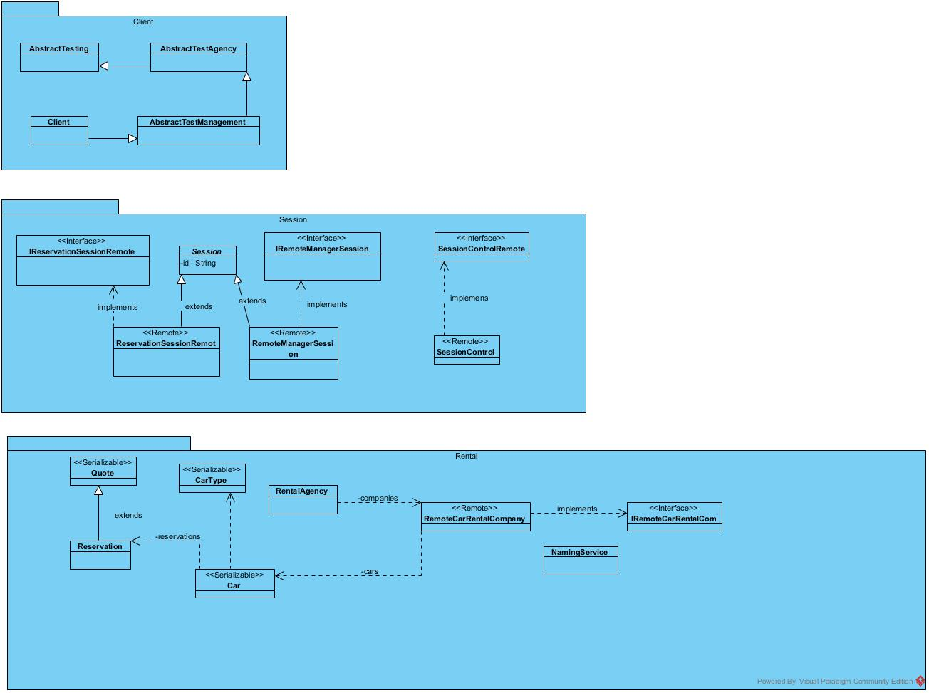

* Deployment diagram

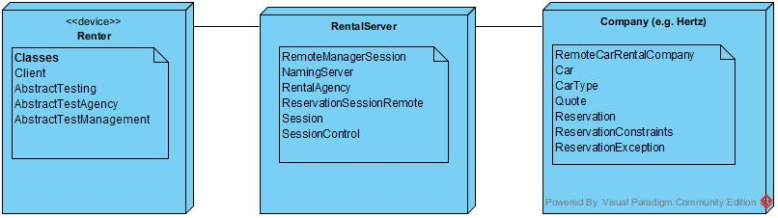

* Sequence diagrams

