|  |  |
| --- | --- |
| Device Manager App  Implementation of web application | Hemos diseñado e implementado una aplicación que gestionará el personal, las entregas y lo dispositivos informáticos de una empresa.  Jordi Gómez Daniel Fernández Perona  ASIX |

ÍNDICE

INTRODUCTION 2

GITHUB 3

DEVICEMANAGER 4

SOCIAL NETWORKS 14

TEST ENVIRONMENT 15

LOGO 16

DISTRIBUTION OF TASK 17

PERSONAL OPINION 18

INTRODUCTION

Device Manager is an application that manages the computer deliveries of a company, in this case a school that is where one of the members of the group works. This application, apart from computer deliveries, will register all devices, or hardware, and personnel.

GITHUB

Here you can see and download all the code of the application:<https://github.com/jordiPE/ProyectoPHP>

DEVICEMANAGER

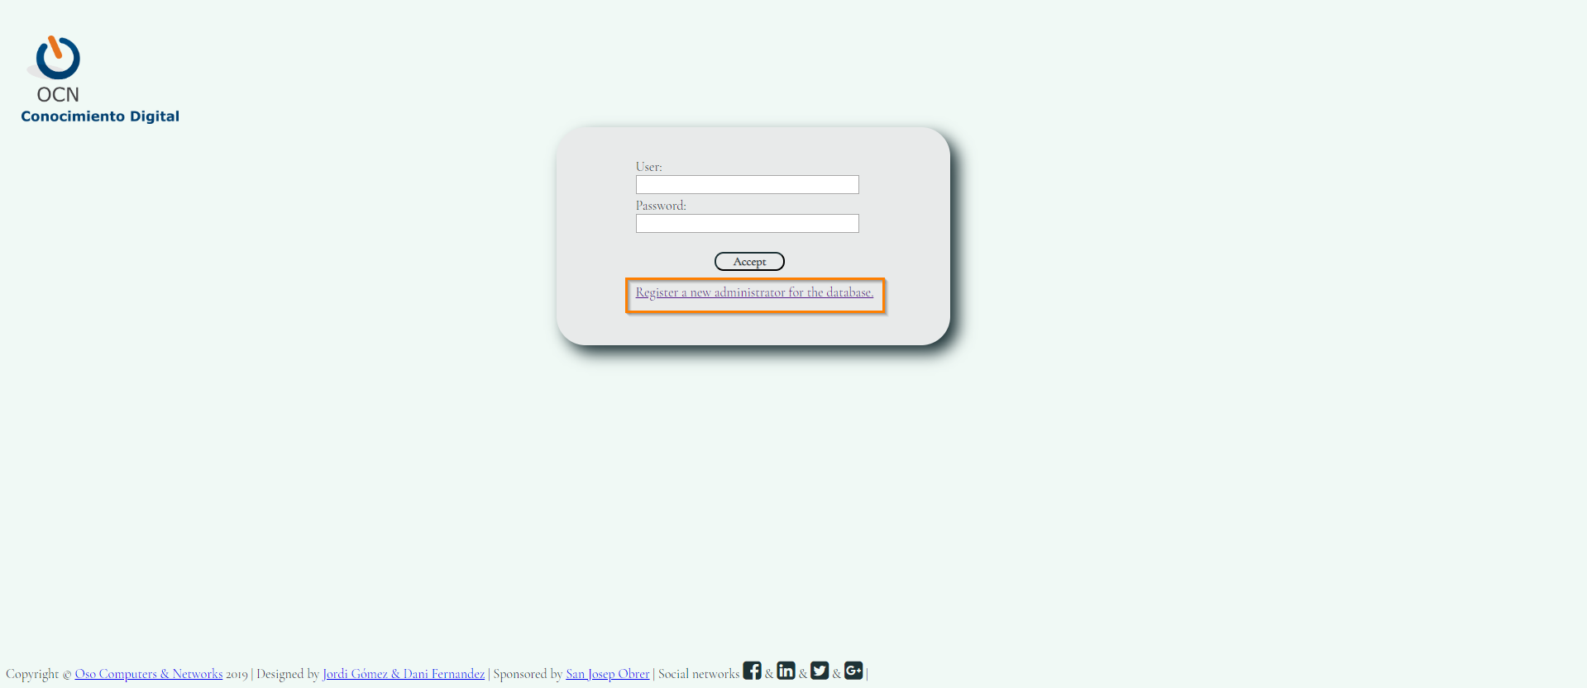

We have the main screen, where we will login to access the application, this application is initially designed only for administrators of the center's system. We can see that we have added a link to register users, it may not make much sense, but in the future if we want the administration staff to be able to manage the application, some permissions can be programmed to create users. It is also a way to implement what is seen in class.Para entrar puede entrar con las siguientes credenciales:

User: Admin.

Password: Seg123

You can also create a new user.



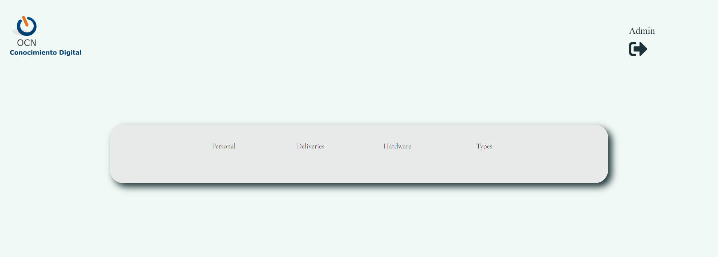

Once inside the application we can move around the 4 pages it has. In the first, we will manage the center's staff. In the second we will manage the delivery of the equipment, in the third we manage the computer equipment of the center and finally, in the last screen we manage the types of devices that the center has.

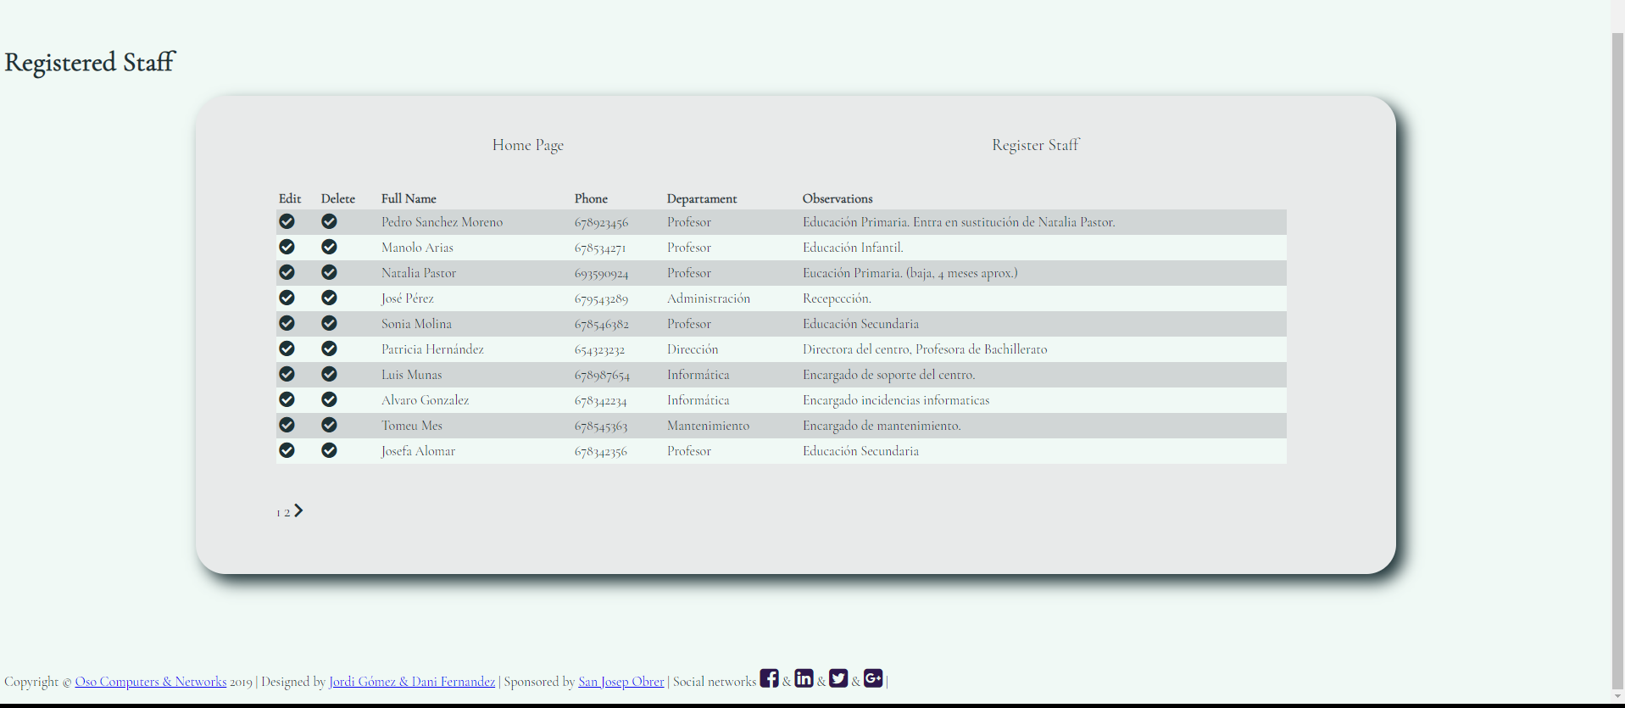

In the main page of the personnel, all the personnel of the center will be listed with a series of information of each one of them.

We have two tabs for registered personnel where you can edit a record of an employee or delete it, the users will be shown ten by ten, with an option below where we can go through the pages.

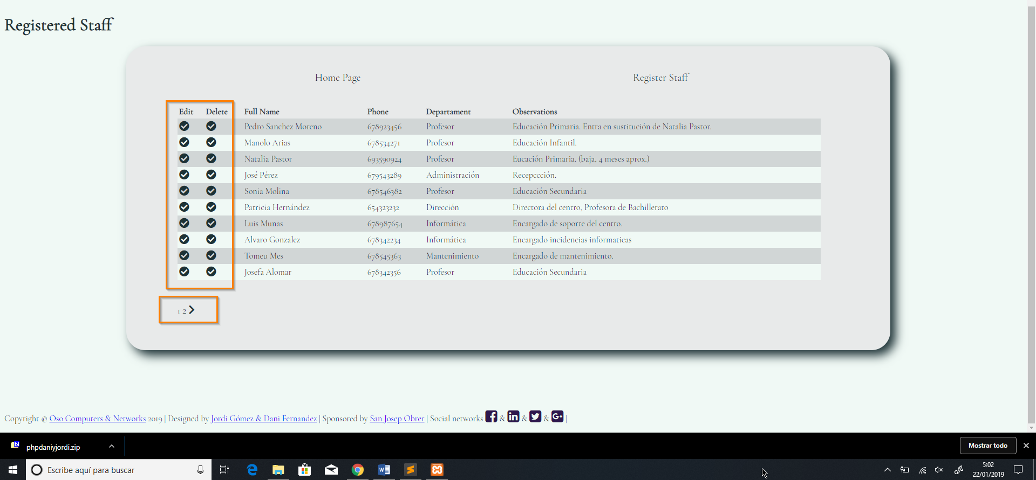

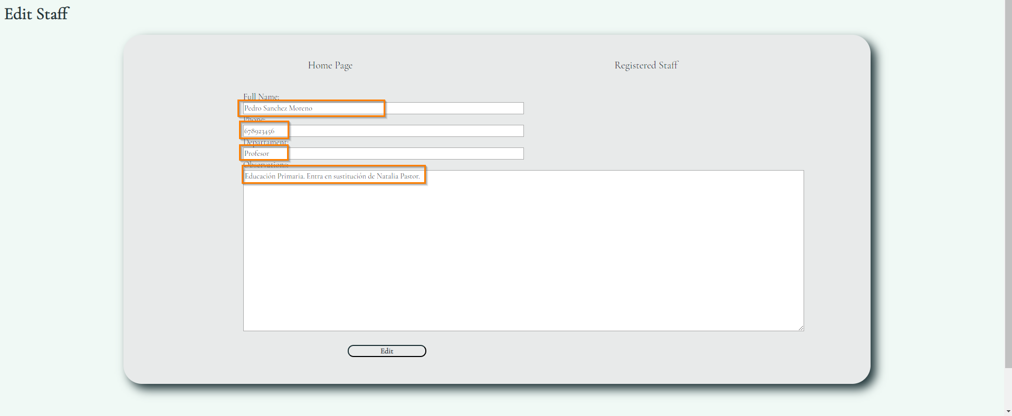

If we choose the edit option, the registration form will appear, but with the difference that we will have the fields initially filled out.

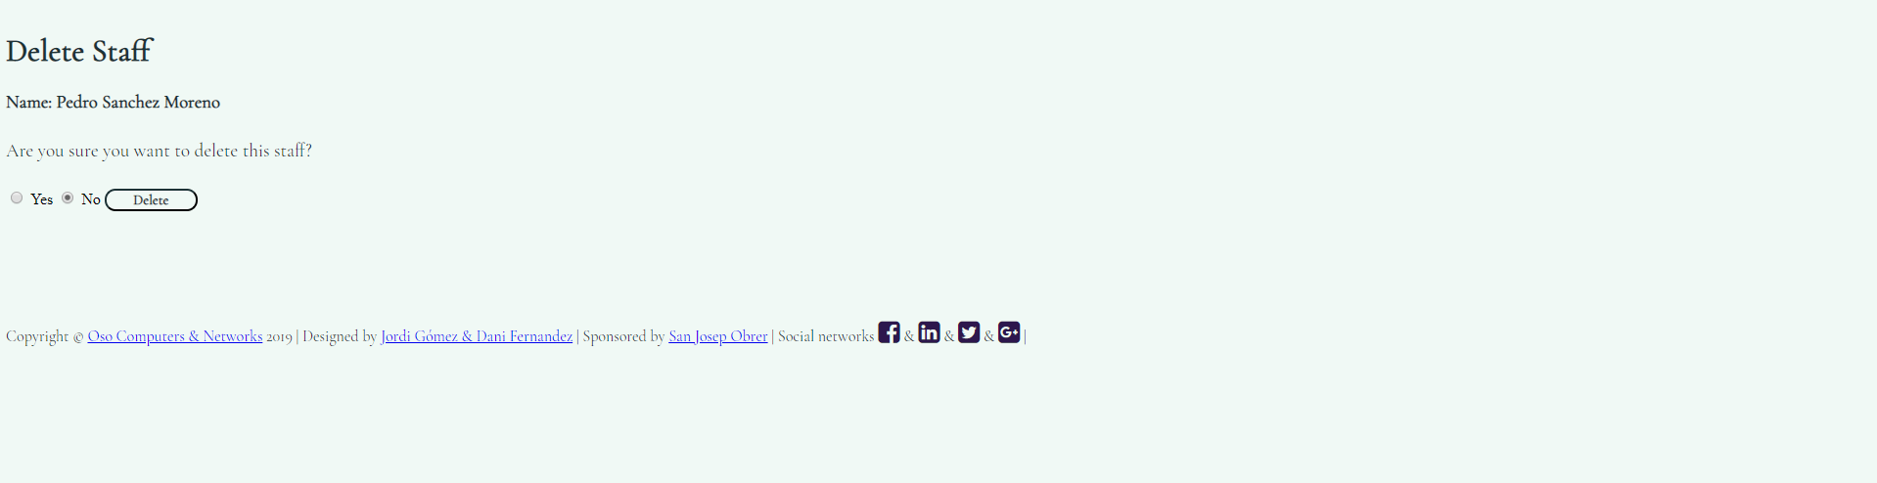

On the other hand, if we choose the option to delete, the application will ask us if we are safe if we want to execute that action, we will have to check whether or not to continue.

This format will have the entire application.

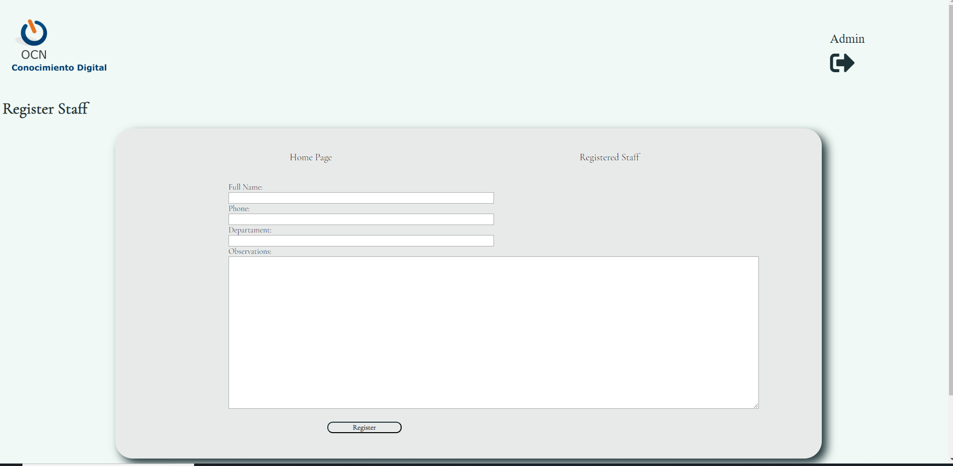

In the register tab we find a form to add new personnel, the format is as follows:Full Name: varChar(40)



The input format to be entered in the fields should be as similar to the one presented in the example, since all the inputs with regular expressions have been protected for information that we enter is the most accurate to the type of data that we have selected in the database.

The latter may be unnecessary since the application will be used by administrators, but if, as we have said in the future, other users are given access, we will have the most protected application.

The rest of the pages are designed in the same way.

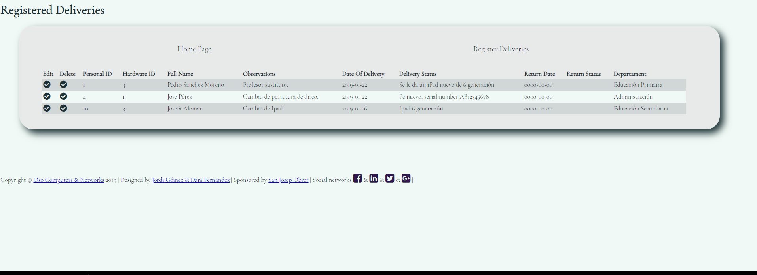

In the main page of the deliveries, all the deliveries that will be made by the IT department of the center in relation to the available hardware will be listed.

We have two tabs for registered deliveries where you can edit a record of an employee or delete it.

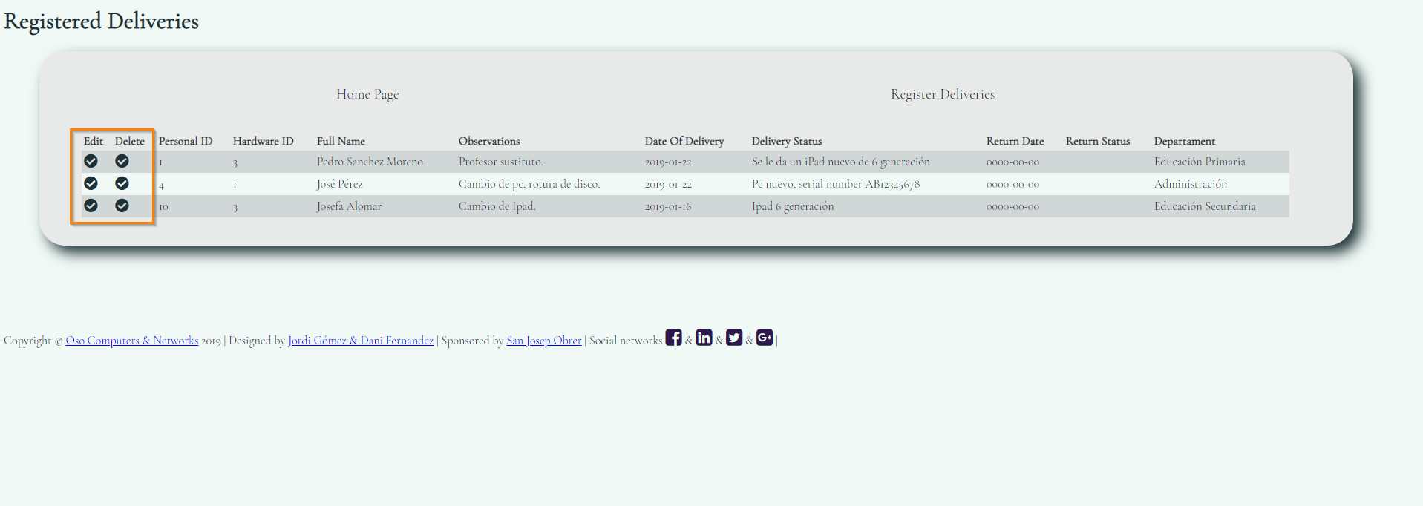

We can see that in this capture does not appear the option of turning the page, that is because it is programmed to appear when there are more than ten records.

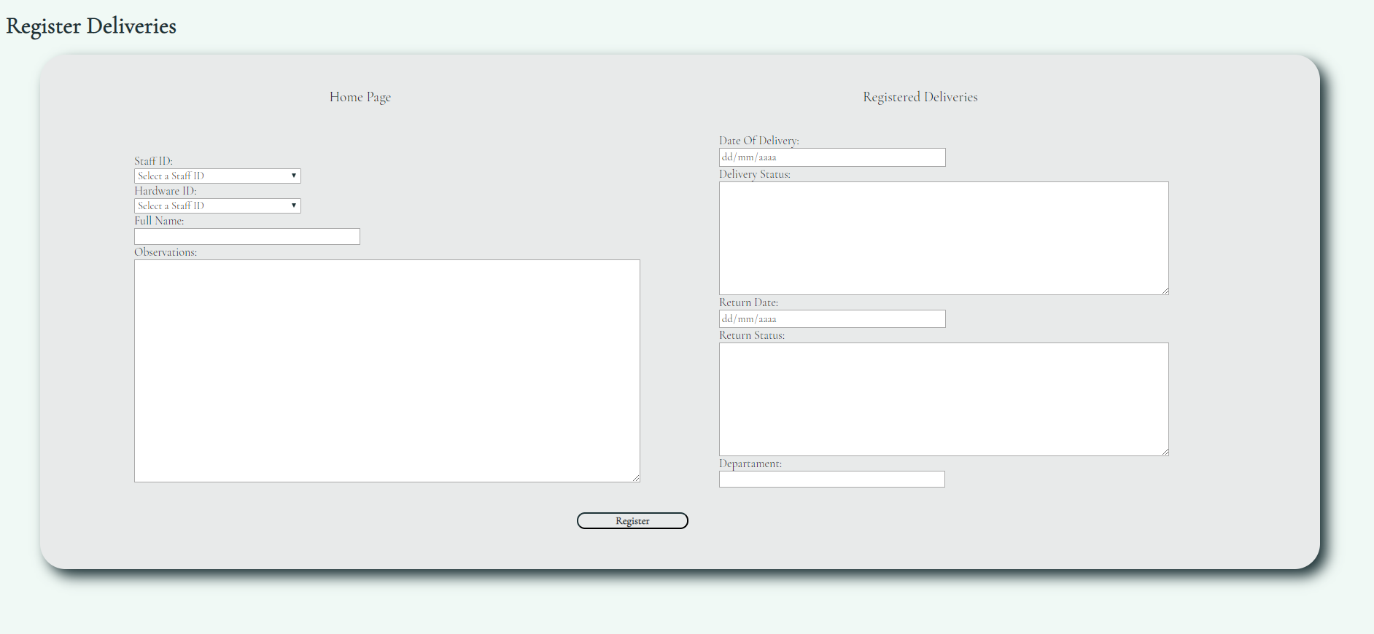

In the section to register the delivery we have your form to fill in the fields.Persona Id: Una lista con todas las id del personal registrado.

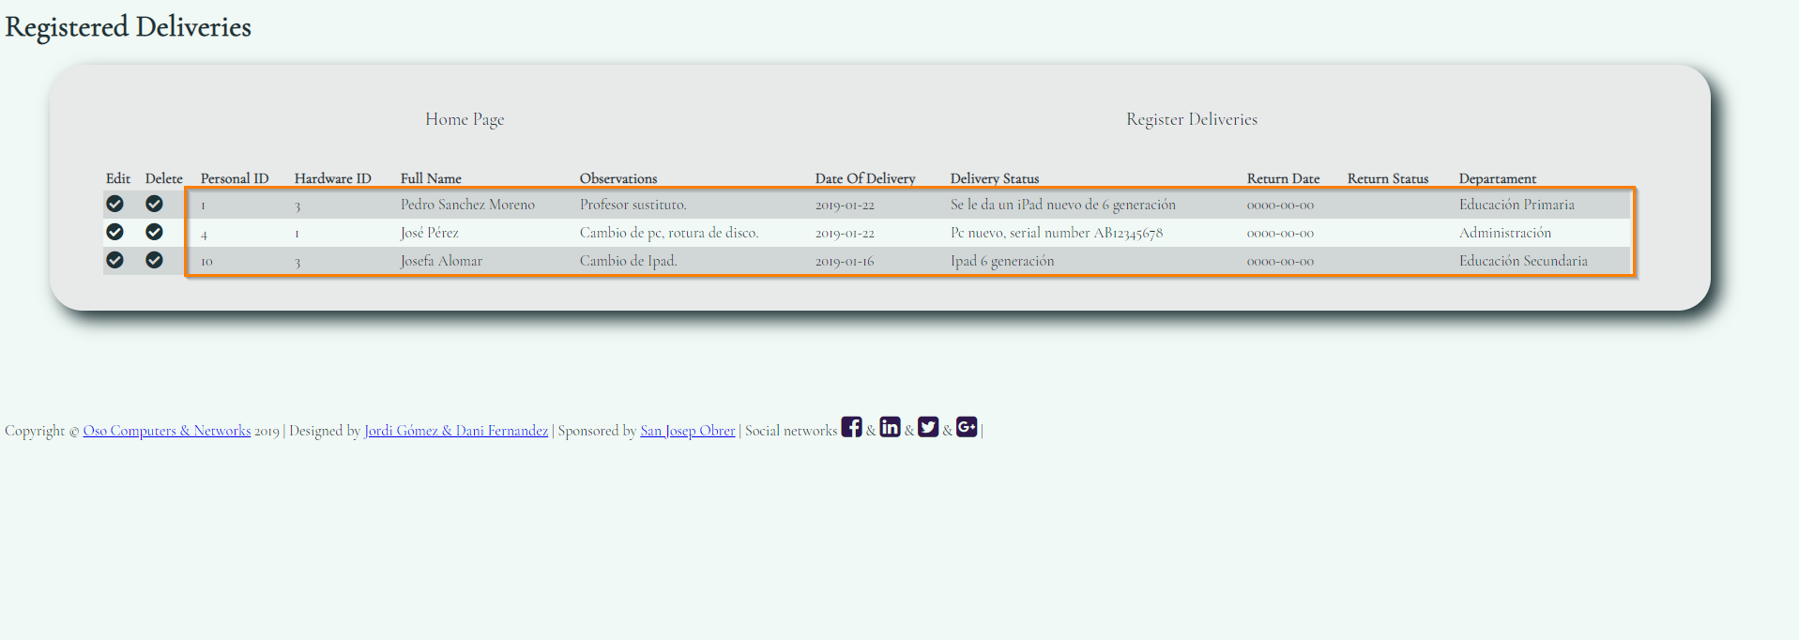

Again, we must ensure that the information we enter is as close as possible to what is shown in the image.

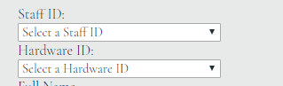

In the fields Hardware Id and Staff Id, we have added a select tag where the records we have in the database will appear.

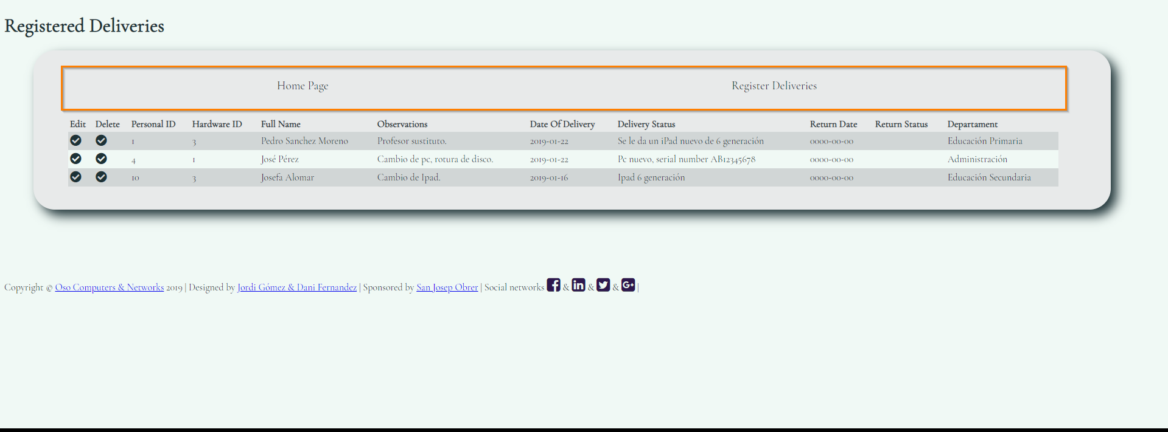

Something that we have not mentioned before, is that we can move through the different pages of the application through the navigation menu that we have cast on top of the form.

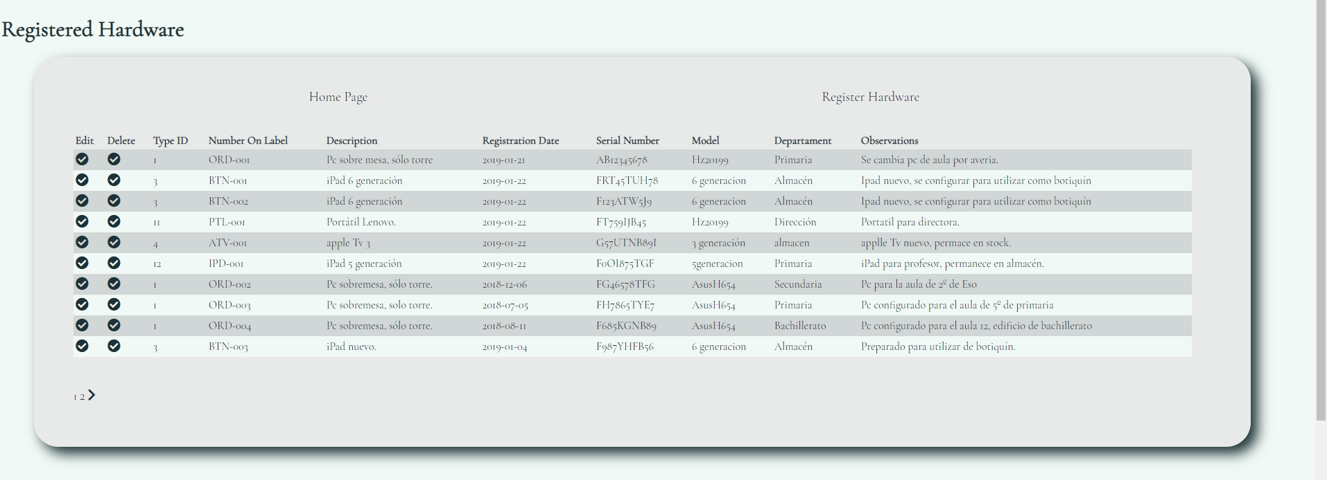

From here the application is the same as what we have been explaining previously. We see in the image the list of available hardware

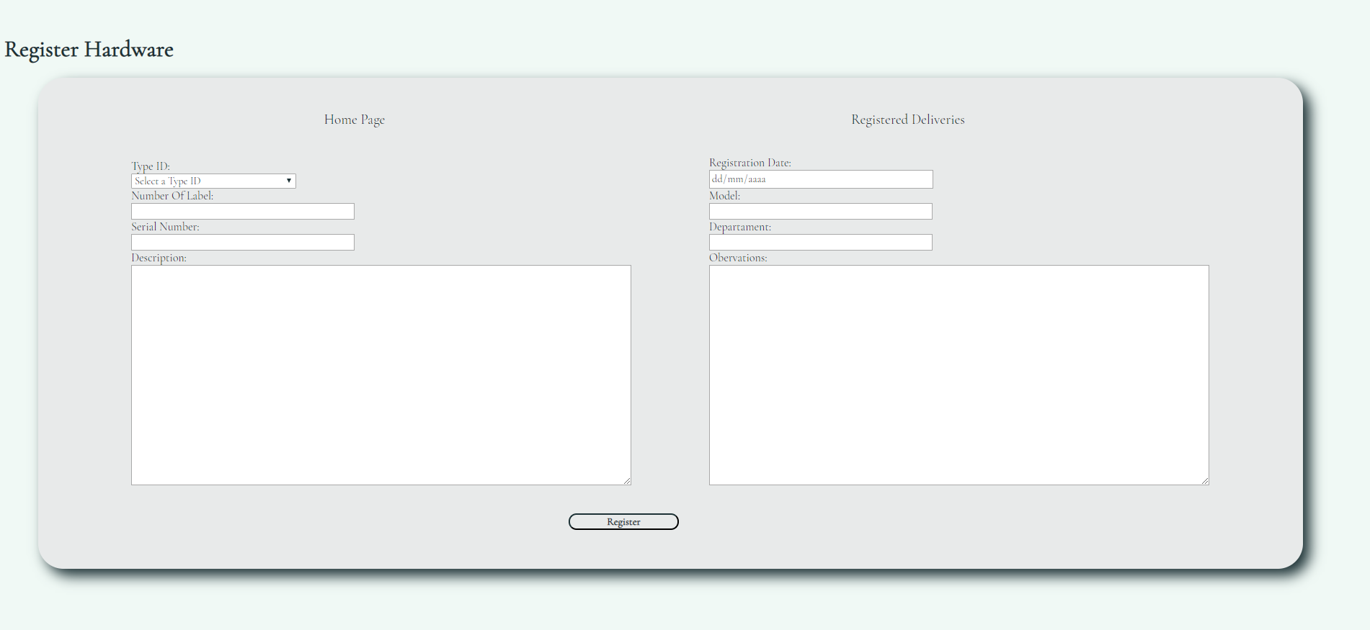

The input format will conform to what we show below



The fields such as serial number, model we have guided in those that are used normally when making the regular expression. The number on the label is based on the one the company will use to locate it, an example would be ORD-001.

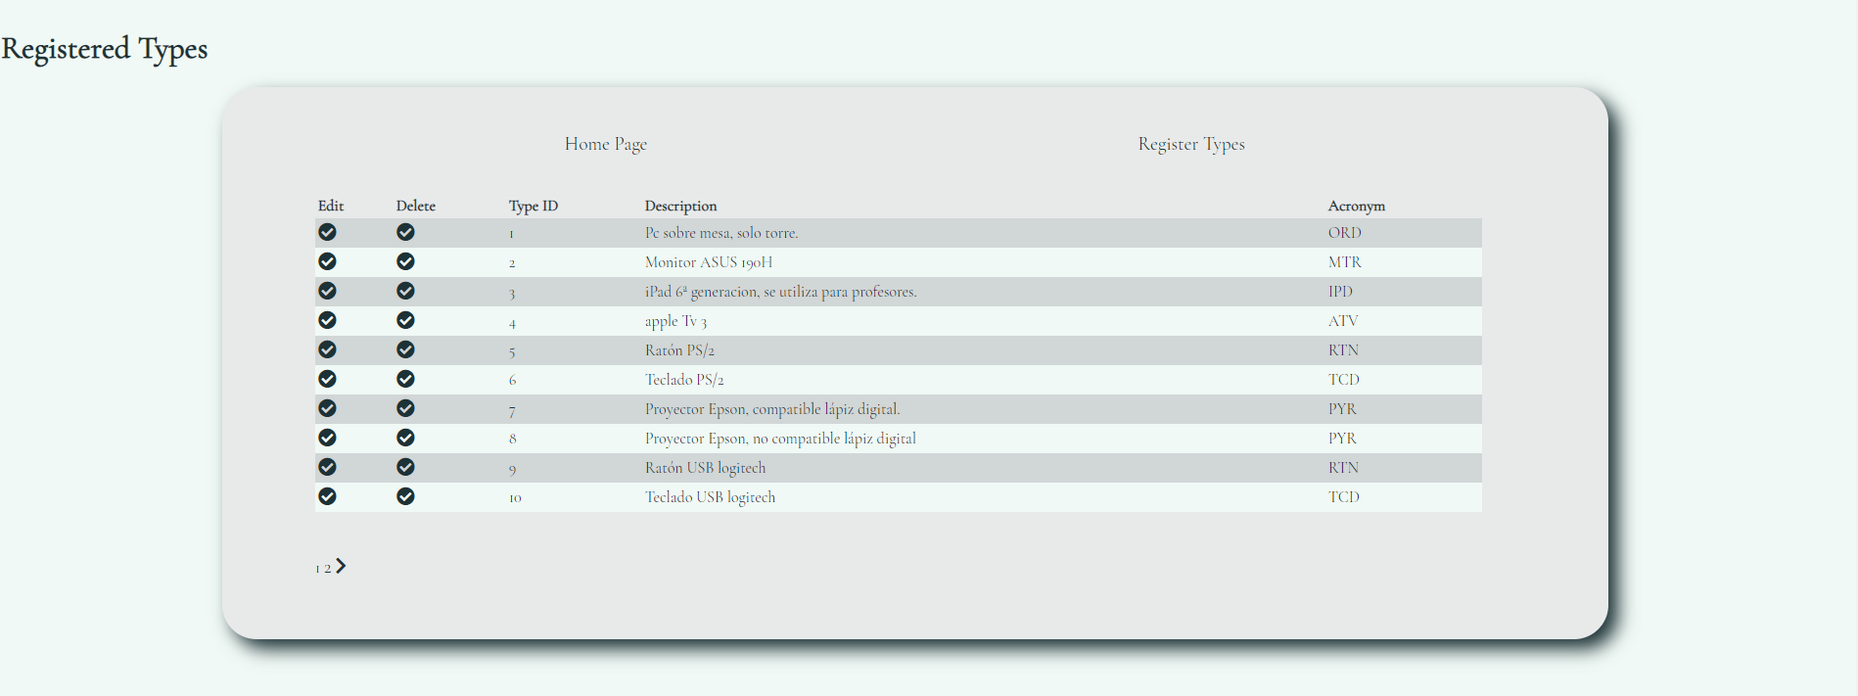

Finally we show the page of the registry types, where we find information about the different types of hardware with which the company will work.

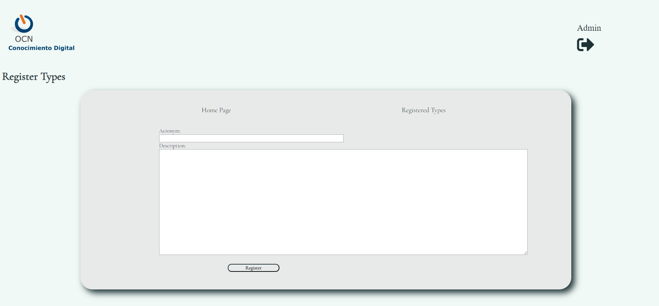

The input format of the fields, as always fitting the example we give.

SOCIAL NETWORKS

To publicize our application we have chosen twitter, where we can publish news of improvements we make in our app, or upload documents like this, in help mode to use it or tutorial videos.

<https://twitter.com/manager_device?s=08>

TEST ENVIRONMENT

Possibly at this point is where we have had more problems. We have tried a couple of pages of free hosting for websites, but we have not finished going well. So we ended up using cloud9, since a colleague told us that he had used it and it went well.

Once we uploaded our website to cloud9, we started to fill in the records and we were able to debug some code errors or in the regular expressions that we had done in the beginning.

Fixed all the dogs we upload to our github the definitive version of our app, where the first version will also be seen.

<https://phpdaniyjordi-jordigomez.c9users.io/Admin/login.php>

LOGO

We have used the Logo of the company, of one of our group members, since the application we have designed we have based on improving the application they use.

DISTRIBUTION OF TASK

We have distributed the tasks so that the two participants of the group played a bit of everything. At the time of making the application we have been guided in the examples of Larry Ullman that we have seen in class.

Jordi Gómez has been in charge of creating the social network where we are going to make our app known, he also took care of the documentation that was presented at the beginning of the practice. Has created the user of cloud9 and to implement the database on the page.

Daniel Fernández has been in charge of designing the Database, of all the final documentation of the project and the design of the graphic environment of the application.

The two members of the group have participated in the implementation of the PHP, HTML and CSS code.

PERSONAL OPINION

We do not believe that it will be a job of ten, because we have lacked time since we have had problems with another subject and that has affected the final result. But we believe that we comply with almost all the requirements that are requested in the rubric.

We have tested the application and we have corrected errors, that does not mean that due to the lack of time that we have commented there will be no more.

Where we have lost a lot of time has also been when it comes to finding a hosting, since everyone we have registered has not been able to use them. In the end we used cloud9 which was not our main idea.

In short, although the app has not been as expected from the beginning we think it is a pretty good app and good use, and fulfilling what we were asked.