ALGORITHM FOR PREDATION AND PATCH DECISIONS (Moya-Laraño and Carmona 10/07/2025)
The algorithm is described as nested from lowest (1) to highest (3) hierarchy level. 1) how to decide predation outcome (algorithm decision); 2) how animals decide what to attack/consume within a patch delimited by interaction area; and 3) how to decide how to travel from patch to patch based on foraging an conspecific benefits and threats (cell level within scope area).
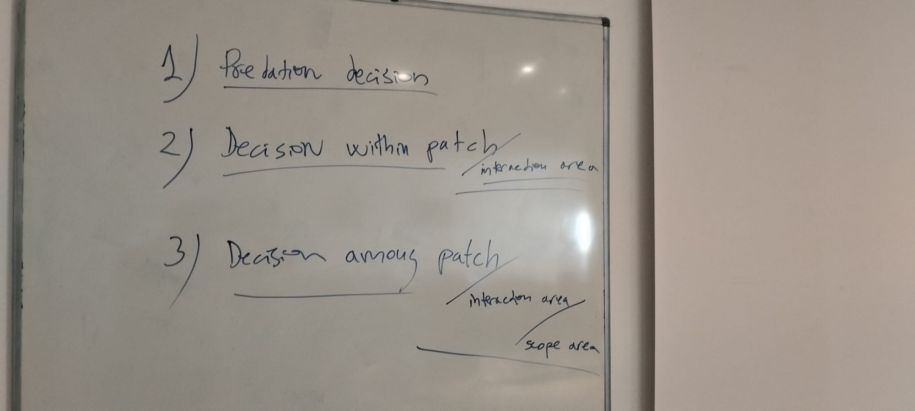

- Decision of predation outcome
All submodels involving probabilities (fractions) will have two possible alternative mechanisms, one multiplicative (product of fractions) and another additive (which will allow giving more weights to some variables than others, involving weighing parameters, and providing with more flexibility by allowing different mechanisms/assumptions; e.g., weight of 0 for Pfleeing makes whether fleeing or not negligible during simulations). The multiplicative model should also allow different submodels by allowing to set any of the terms as “null” (i.e.; not been computed; e.g.; assuming that the voracity of the prey does not affect the predator decision to hunt one or another prey in the interaction area). In all cases sum(weights) = 1.
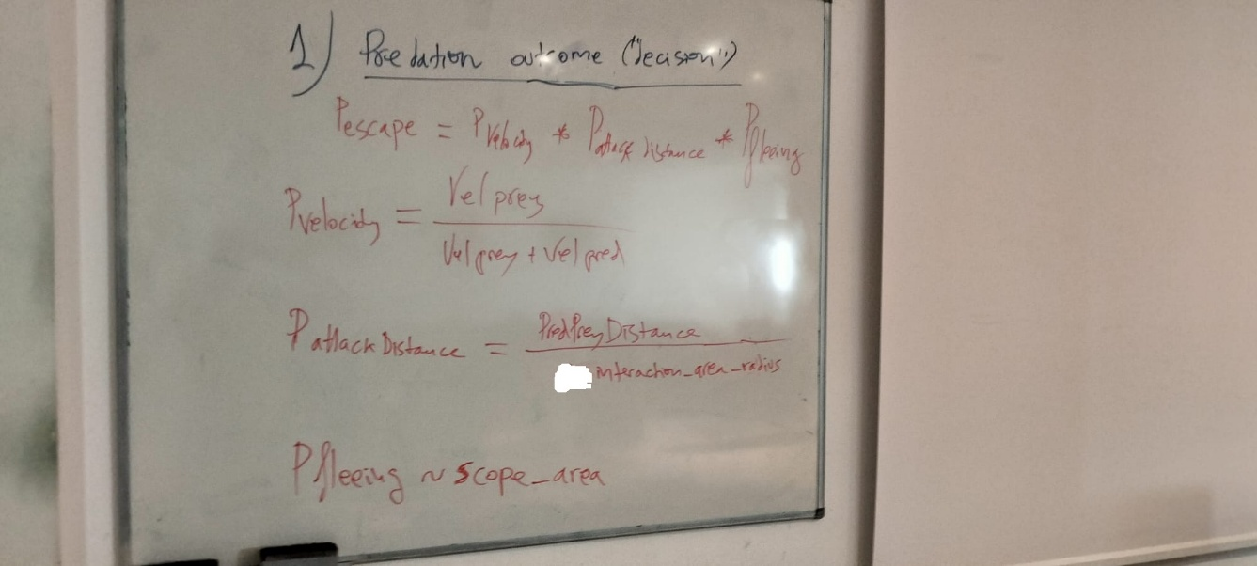

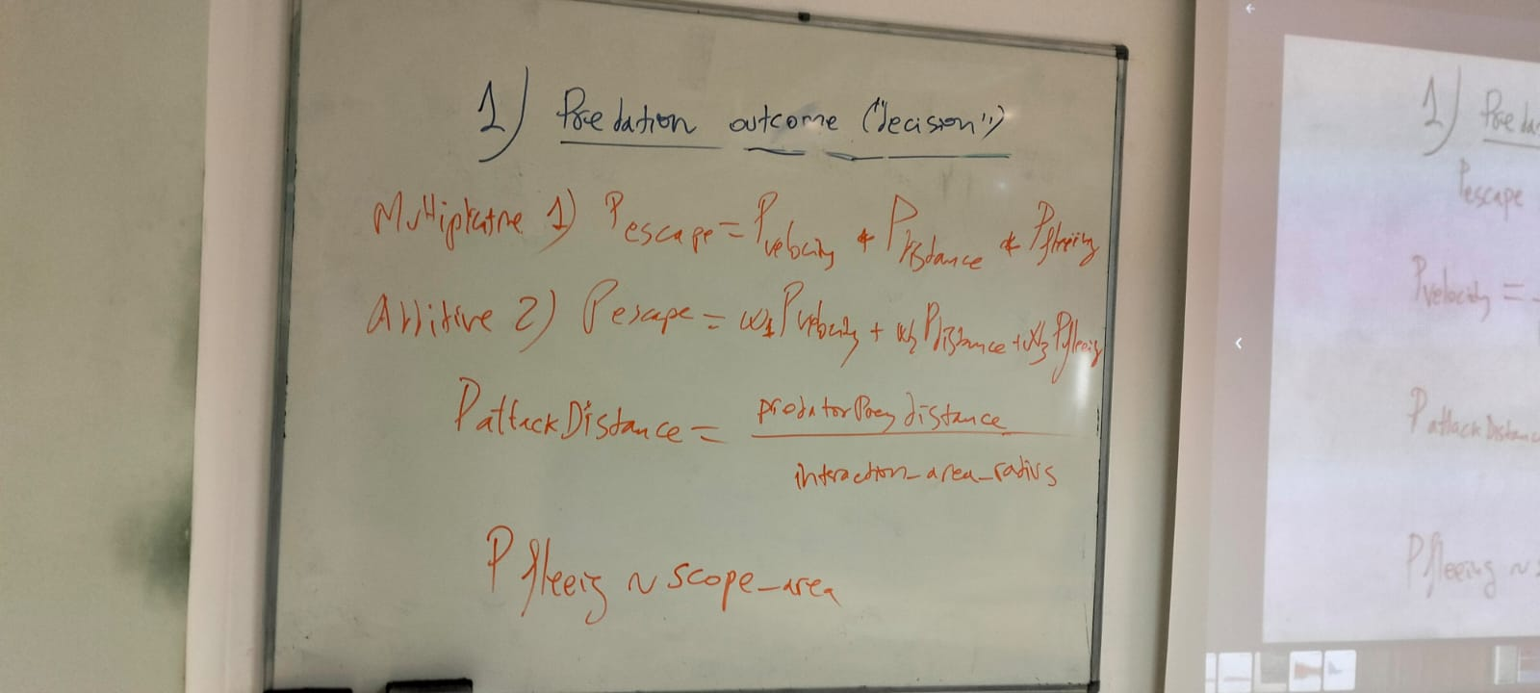
Once an attack occurs, the probability of the prey escaping will depend on the relative velocity (Pvel=Vel_prey/(Vel_prey+Vel_pred)) (Note: this is not the final equation. See below how extra-weight load is included in this equation), the relative distance between predator and prey (Pdist=predPreyDistance/interaction_area_radius) and the probability of fleeing for the prey, which in turn will depend on the prey scope area.
The scope area of any consumer is defined as the maximum area involving any perception of either predators or prey/resource, and we assume that it is independent on the biomass of the potential feeding item or threat. This area is defined by a perception distance or scope_area_radius defining a homogeneous area around the position of the individual. However, the level of perception decays with distance, defining a perception volume that increases with maximum perception distance. Thus, a potential feeding item or threat is perceived with more error as the distance increase, following the following stretchable exponential decay function:
P(distance) = exp(-(decayRate*distance)^beta) (1)
Where beta determines the shape of the perception volume, and when perception decay starts accelerating with distance:
beta=2.5 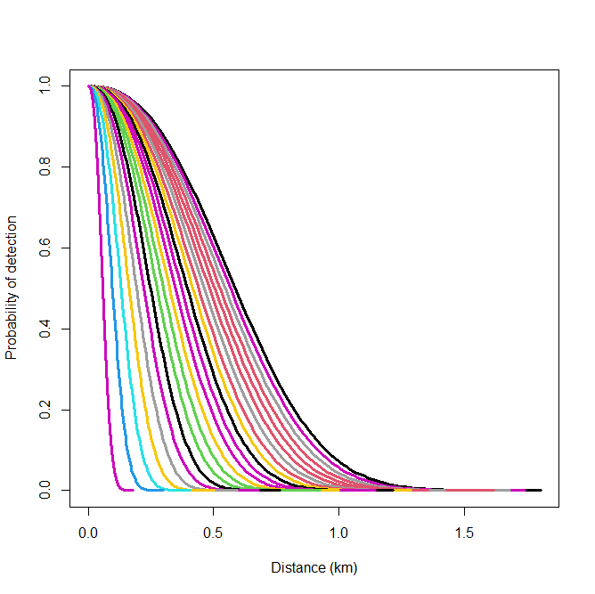

beta=15
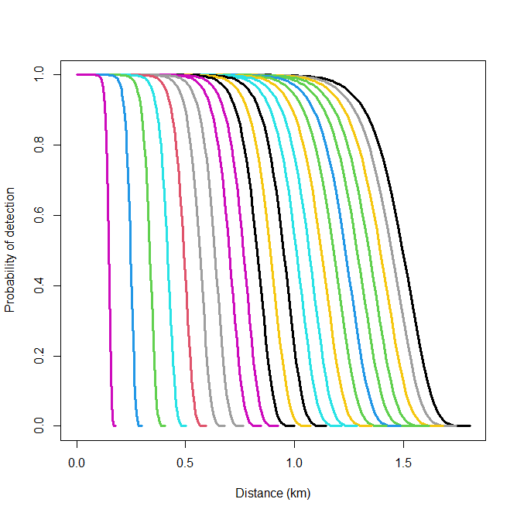
In order to force the probability to the range 0-1, we establish a parameter to truncate the zero probability value, epsilon = 0.00001 and solve for the decayRate of each curve as:
decayRate = (-log(epsilon))^(1/beta) / (scope_area_radius+epsilon) (2)
Perception distance (scope_area_radius) in turn is assumed to depend on the body mass of the animal, following an allometric relationship, and the figures above are for very large animals (units in Kg and Km) increasing in body mass from left to right. This is accomplished by an allometric relationship between scope_area_radius and animal body mass. The relationship is:
scope_area_radius = coeffMassScopeRadius*M^ scaleMassScopeRadius (3)
And for the figures above: coeffMassScopeRadius=0.01, scaleMassScopeRadius=0.75. Mass range: 0-22.000 Kg. This assumes that the largest terrestrial animal (a dinosaur) is able to perceive cues at a distance > 1.5 km. Since this is a strong assumption, we should coeffMassScopeRadius is a parameter and study how simulation outputs change with a range of parameter values.
Perception volume is used to directly calculate the probability of fleeing as defined by the predPreyDistance at the moment of attack. To this end the latter distance is plugged in equation 1 and the output directly considered as the probability of fleeing. If Pfleeing = 0; the probability of escaping by running away is zero. However, the PDF and the voracity status o each of the members of the pair will finally decide whether predation occurs. If Pfleeing>0 then predPreyDistance and running speeds are important to decide Pp. However, if predPreyDistance is high (above the scope area of the prey) and the prey will not perceive the predator attack, only PDF and voracities will decide.
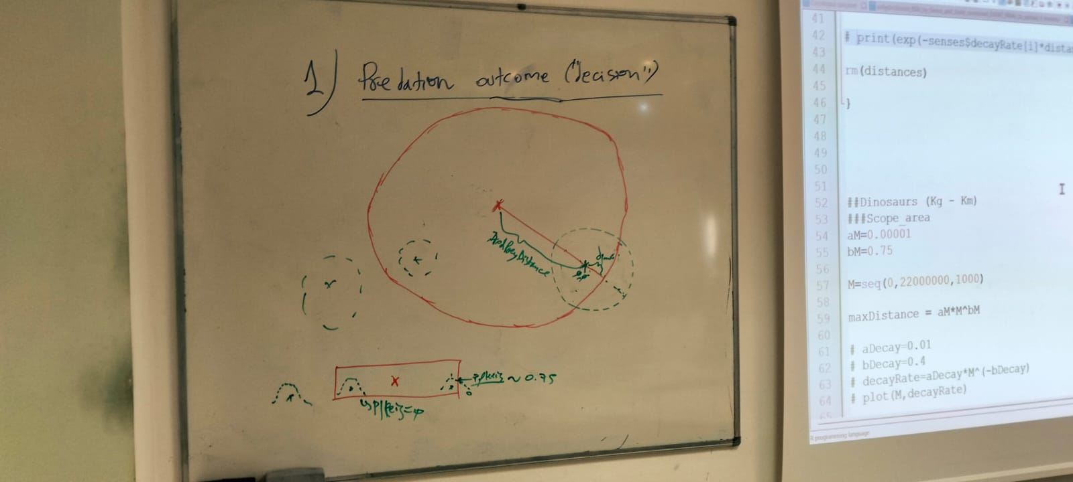

If the scope area (green dashed line) is completely included within the interaction area of the predator (continuous read line), the probability of fleeing becomes zero.
Now we get that the probability of the predator reaching the prey once an attack has occurred becomes: Preach = 1 – Pescape.
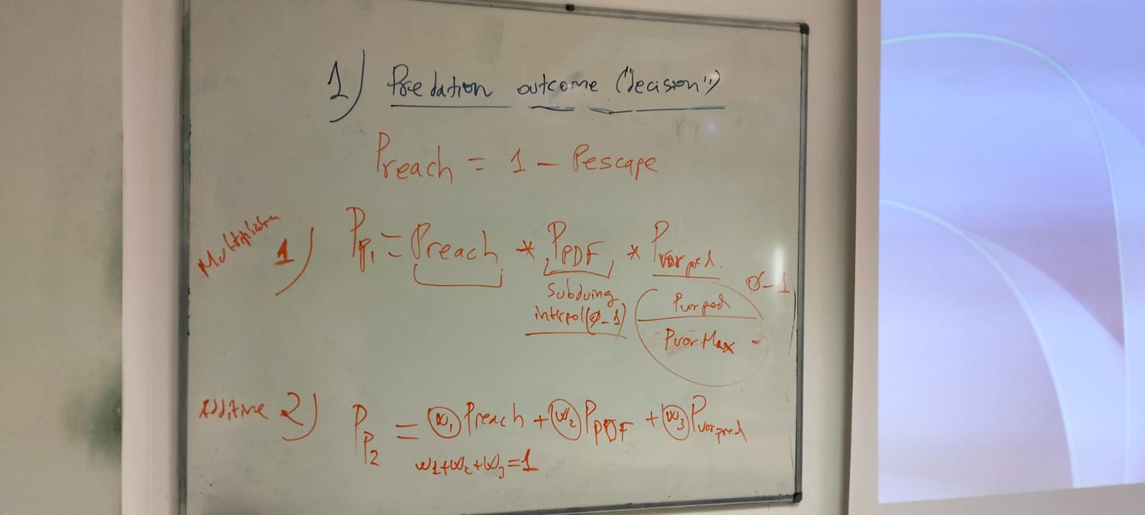
The predation probability (Pp) also has now multiplicative or additive components with weights adding up to one. Note: we are missing from the equation in this board the PvorPrey, which is calculated exactly as PvorPred above but with the data from the prey. We need to add it as a fourth term because this provides a local penalty to the more voracious animals (more active, more easily picked up – detected – for predation).
The PDF is a probability density function of a normal distribution, for which mean and standard deviation is obtained for terrestrial or aquatic arthropods or terrestrial vertebrates in Brose et al. 2005, 2006. The PDF value is rescaled to 0-1 to make it as comparable probability on the same scale of the other terms in the equation.
Resources that come from equations (not individuals), get a Pp = 1 by default.
Whether predation finally occurs or not further depends on the final edibility value (see “Decision within patch” below) which in addition of Ppredation has other parameters into consideration. But let’s first see how velocity is changed when extra-load (such as a large egg batch about to be laid) is carried around.
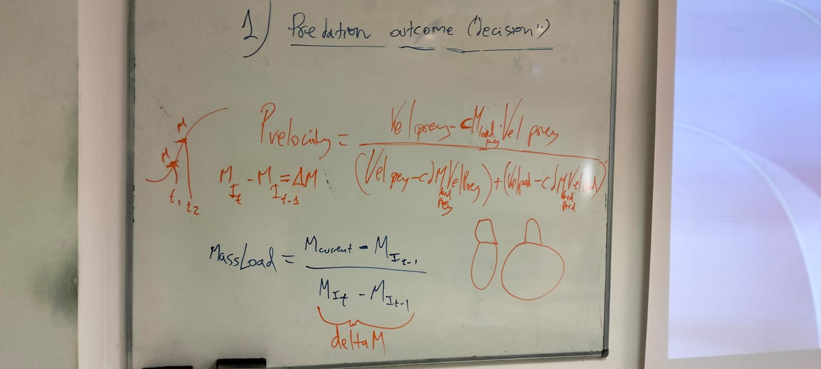
Note: the delta (d) in the denominator of Pvelocity is an error in this equation. The substraction terms are just c*MassLoad*Velocity. The equation above shows that parameter “c” tunes how much the MassLoad (fraction of the maximum load before molting or laying eggs) of an animal decreases its sprint speed when trying to hunt or escape. Mass load is the difference between the current mass and the mass at moulting at that instar, divided by the difference in masses between instars, which are estimated from the growth curve. For the same c value, larger mass loads impede running to a larger extend. This is a logical outcome. However, for instance in wolf spiders, there is evidence that carrying an egg sac vs. not carrying it does not change their speed, as they can accommodate to it flexibly. Note: need for examples in the literature. We can always set c=0 and the extra-load will have no effect.

- Decision within patch
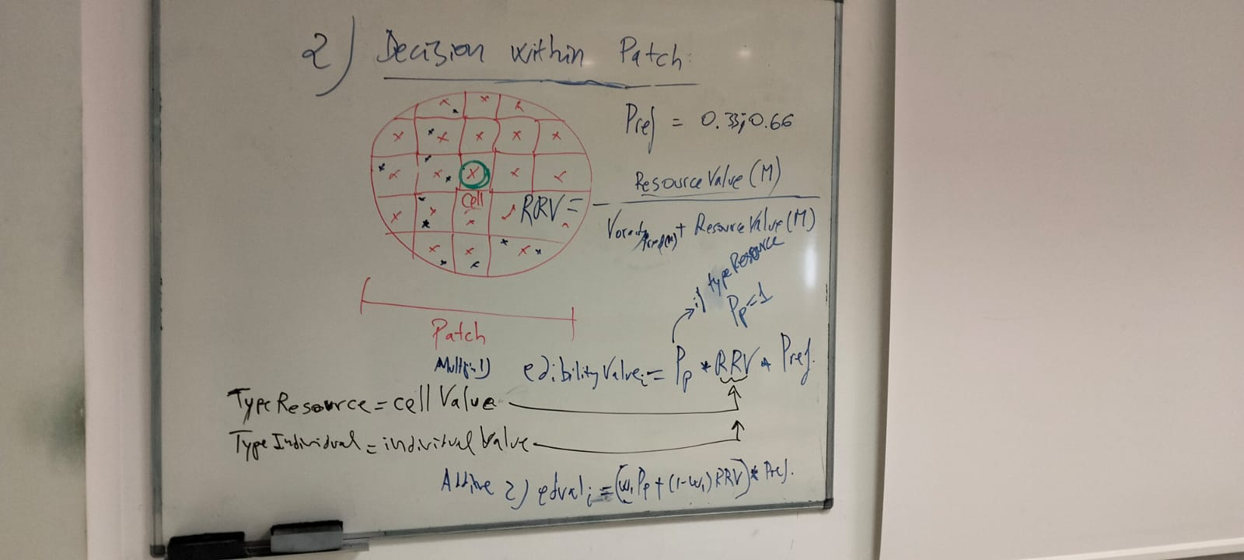

Within a patch (the interaction_area of the individual) all items are arranged from highest to lowest edibilityValue. The components of this value are PredationProbability (Pp, see above), Relative Resource Value (RRV, 0-1) and Preference (0-1). Again, these three items can be combined with a multiplicative or an additive model, the latter with weights adding up to one. However, the additivity (and weights) is applied only to Pp and RRV, and for obvious reasons the preference multiply to the sum of these two terms. Importantly, resource coming from equations are assessed at the cell level and individuals at the individual level. Thus, RRV may be always biased towards resources coming from equation values. In order to make them more comparable, one solution is to include their relative quality value in the equation. This is explained in the next board (bottom-right).
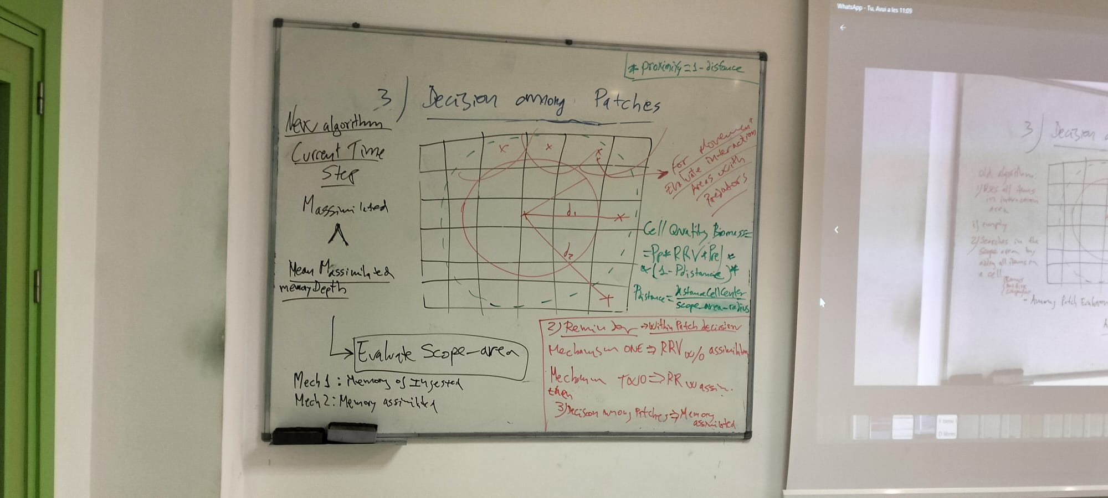
Make two choices, one in which assimilated value (assim trait + profitability trait) is not considered (non-adaptive assessment), and another in which optimal foraging is assumed and consumers assess the quality of the resource to estimate RRV, by including the value after assimilation. This way, food items with high water content (e.g., fungi vs. prey), or not very profitable (low profitability) are lower in the list. This feature will be called “qualityResourceAssessment” as a Boolean. Note: remember to include water content to assess profitability (but it should be there already).
The preference is also a value 0-0.999 and it must add up to 0.999 for all possible links of the species (i.e.; species it feeds upon). Because it multiplies to these other two variables, the exact meaning of a given value that must be taken is not immediately intuitive. However, if “alternative” prey resources from an equation equate to alternative prey, then we must give a similar preference to those relative to other prey. But, if we want the individual target prey to be less frequently attacked than the alternative (e.g.; because it represents the rest of prey species in the food web), then we must give alternative a much higher preference. If the resource from equation is a low quality one, and “qualityResourceAssessment” is set as “true” (mechanism 2) in the simulation, then, it will be ranked at a lower position even if preference is set at 0.5.

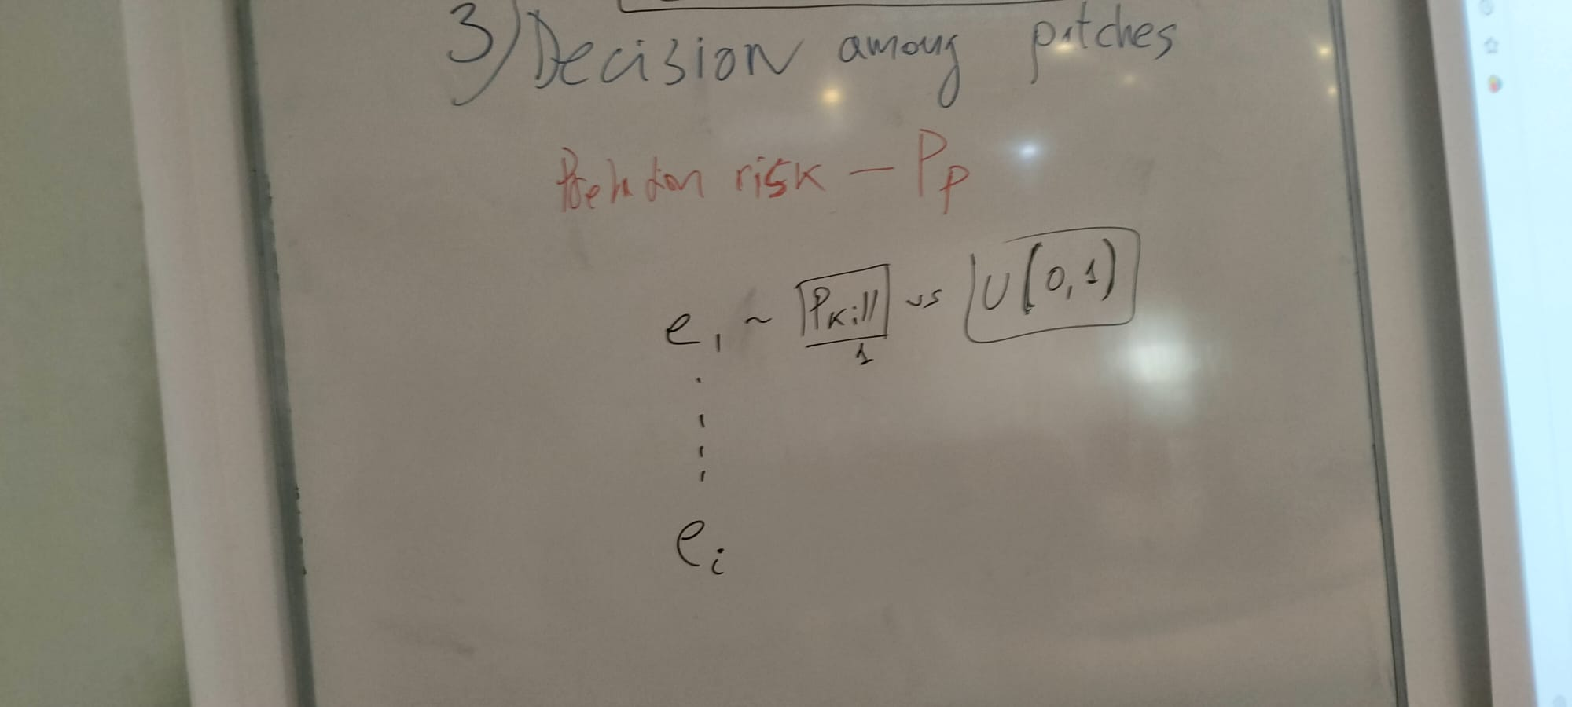
This is an added board which is referring to decision WITHIN patches. “killProbability” is a number compared to a random U(0,1). If “killProbability” is 1, the model is perfectly deterministic, otherwise, it becomes less and less likely (as killProbability goes down) that the most edible itme get consumed first.
- Decision among patches
This board below is how decisions are made of when and how to change foraging patches. Works at the cell level.
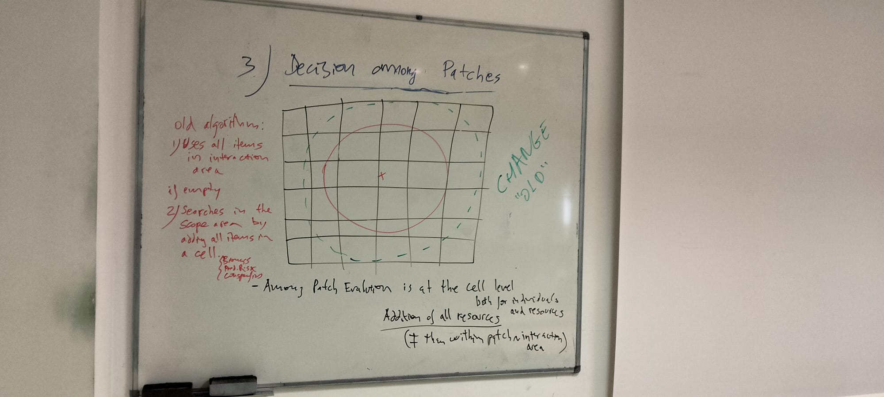
Only a few things from above will remain, as now we have to consider the new implementations from sections 1) and 2) above in addition to further amendments.
Instead of leaving a patch when all food in the interaction area has been consumed, an assessment comparing the mean ingestion in the last “memoryDepth” time to that of the last “timeStep” will be used. When ingestion in current “timeStep” is < mean “memoryDepth” time the patch will be abandoned. When “qualityResourceAssessment” is set to “true” (mechanism 2), the assessment during “memoryDepth” time will be at the assimilation (not dryMass ingested, mechanism 1) level.
In order to decide (within the scope are) at what cell to move, cells are ranked by quality by adding up all the resources present. Then Pproximity (1-Pdistance), where Pdistance = distanceToCellCenter/scope_area_radius, is also multiplying Pp, RRV and Pref to decide cellQuality rank. Again this ranking will have four weights in the additive version, all all 4 weights must add up to 1.
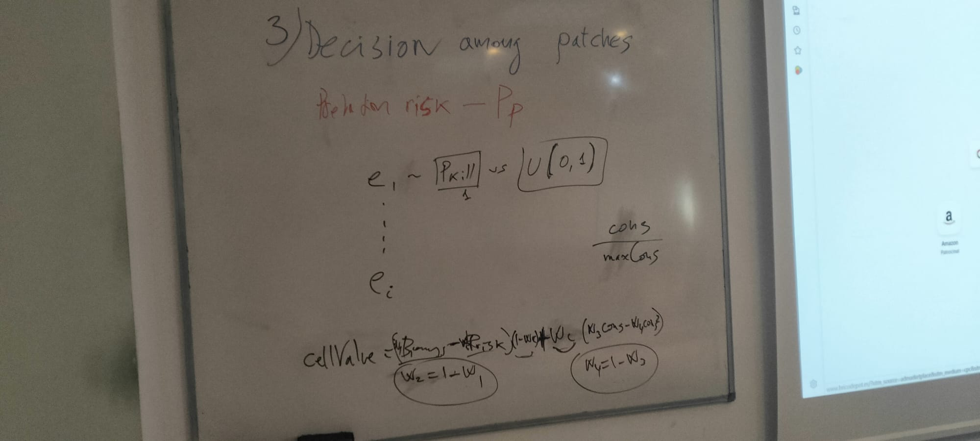
Here is how to rank cells by their value “cellValue” considering cellQualityBiomass (food), cellPredationRisk and cellConspecificBiomass. This is always a weighted function in which w2=1-w1 (if w1>w2 food is prevalent over predation risk, if w2>w1, predation risk is prevalnent over food), wc is a weight for choosing cells according to conspecific biomass (a high value means conspecifics are the rule over food or predation risk), and w4=1-w3 whether to follow a linear or a quadratic form to consider conspecific abundance to enter a cell. If w4>w3 conspecific avoidance prevails and when w4<w3 conspecific seeking prevails.
Conspecific biomass is a proportion according to the maximum recorded per cell in the simulation (which is dynamically updated). Thus maximum needs to be tracked and updated. Same for Biomass and Predation risk below.
Predation risk is a cell estimate of the sum of predation risks??? considering all predators that can feed on the animal potentially when the target animal would move to that cell. Predation risk is estimated as Predation probability (Pp) following the equation Preach*Ppdf*PvorPred*PvorPrey (or the weights version).
Important, all Preach, Ppdf, PvorPred and PvorPrey ~ Prisk, for weights to work on cell choice function we need to have relative estimates of cellPredationRisk (need to track a maximum). Thus Prisk = cellPredationRisk/maxCellPredationRisk. Same is true for PcellQualityBiomass = cellQualityBiomass/maxCellQualityBiomass (these maxims need to be updated through the simulation).
Further, the “cellValue” is updated with the perception volume as follows:

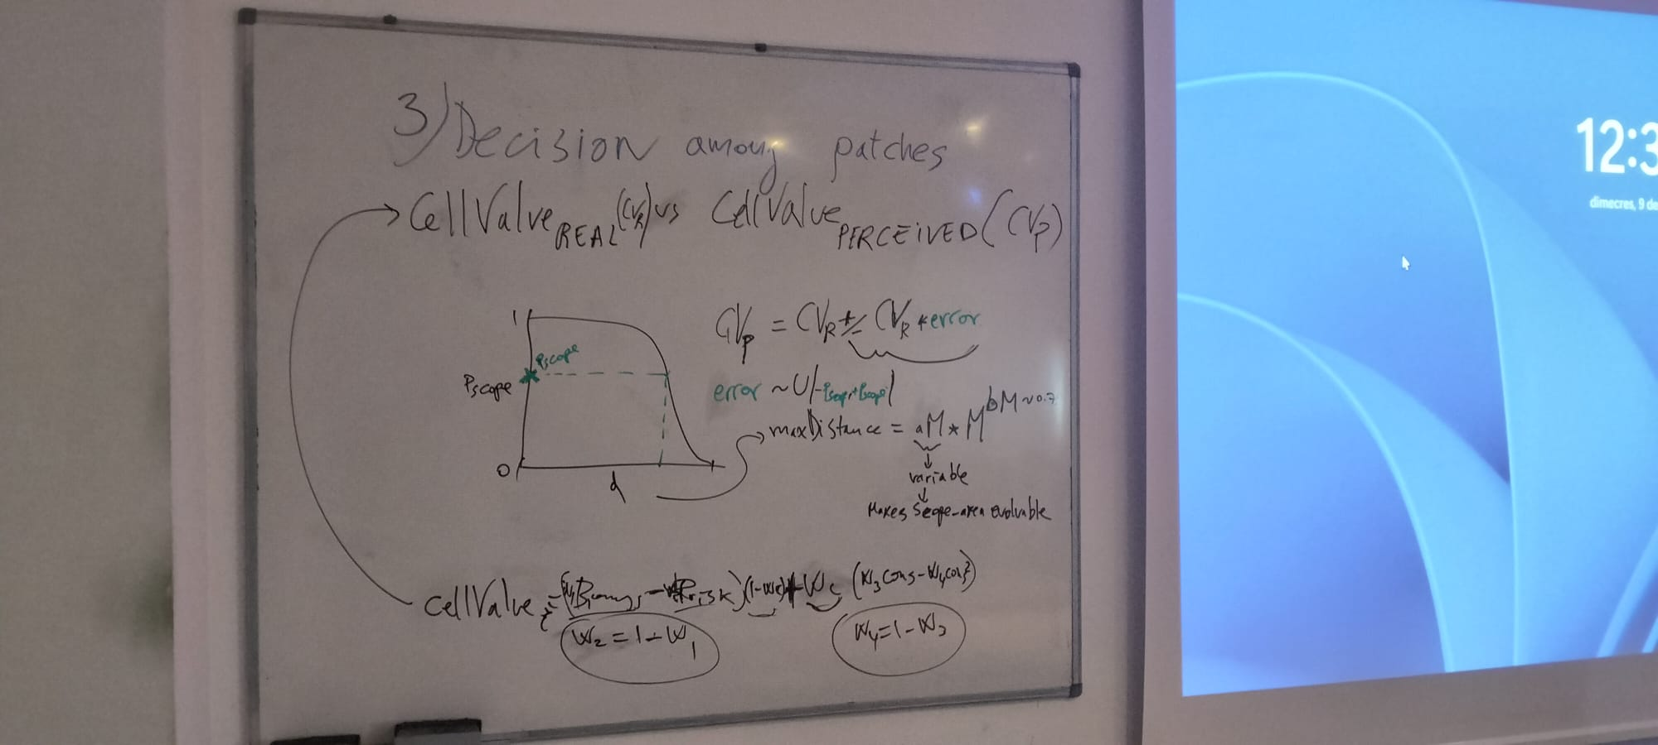
cellValuePerceived = cellValueReal + cellValueReal*error
where error comes from the scope volume function error ~ U(-(1-Pscope),(1-Pscope)). Note: the error is incorrect in the board, as Pscope is highest at closer distances the error needs to substract Pscope from 1. Thus, the scope area and the scope function (see above) determines the amount of error committed on the assessment of cellValue with distance. The closer a cell is to the limit of scope_area_radius the
Addition. Add memory to predation encounter counter to leave patches (interaction areas) with high predation risk. Thus, the criterion to leave a patch is if the rate of encounters with predators in a given timeStep is higher than the mean of memoryDepth. Dual criterion then, based on assimilated (or ingested, if mechanism 1) food, when is lower than the average memory depth and if predation is higher than the average memory depth. Importantly, the lower the value of “killProbability” the more stochastic the simulation is, but also the more experience animals gain from encountering predators.
Note: It is not possible to use interaction areas instead of cells to determine predation outcome when animals move from cell to cell. We considered that when travelling from cell to cell, animals are seeing by predators from the interaction areas of the latter, not at the cell level. However, this poses the problem of how to make animal pairs to interact only once. It breaks the cell arrangement that ensures that interactions occur only once per time step. Ok, decided to do it at the cell level.
Now, how to evaluate predation outcome when moving?
"exposedAttackProbability" : 0.001,
Same as with any predation event… all predators in the cell have a chance to attack with very low probability… Note: shouldn’t the predators in the entire itinerary be ordered by Pp? or at least at the cell level? How does it work?

How to evaluate patch (cell) quality
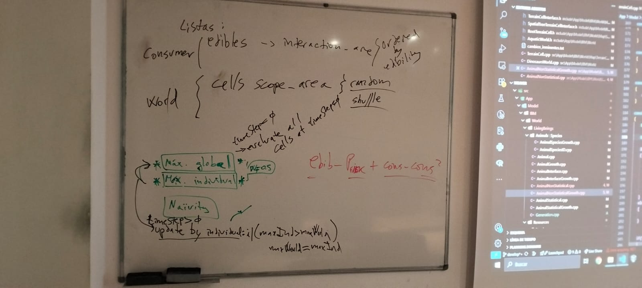

To evaluate the world as a whole, the maximum possible value of each of the evaluation elements (edibilityValue, predationRisk, conspecificValue) of a cell must be calculated.
For each instar of each species, the following steps must be performed:
First, the maximum value of each of the three elements is calculated at the individual and global levels. Individuals are initialized naïvely and then get experience. The global level gets updated from the experience of all individuals. Individuals will use in the denominator to assess patches (to have a fraction p<1) a mixture of their maximum patch value experienced and/or the global value, according to a weight. e.g. weightIndividualToGlobalPatchAssessment = 1, means all experiences are at the individual level and the global value is not used. weightIndividualToGlobalAssessment = 0; means all decisions are made with the global level in the denominator. This is important because in islands, the global level should be irrelevant over the individual level and viceversa, in a single patch world, the global level may matter most. The global value is first initialized during the heating up of the code, the individual value from the first timeStep, and then updated as the simulation proceeds.
Thus… Pedibility for patch i, for instance will be:
Pedibility_i = edibility_i/(weightIndividualToGlobalAssessment*maxPatchEdibilityIndividual + (1-weightIndividualToGlobalAssessment*maxPatchEdibilityGlobal))
Where edibility_i is the sum of all the edibilities in that patch (cell, all items count).
In the case of edibilityValue, we look for ontogenetic links with resources and prey for the individual, and calculate the added value of all items for each cell.
In the case of predationRisk, we look for ontogenetic links with predators and do the same procedure.
In the case of conspecificValue, we sum the biomass of conspecifics regardless of links, as links count only in predationRisk when cannibalism occurs in a predator.
To update the global status, when the maximum of one individual changes, this one is contrasted with the maximum global, and if it is higher, this individual maximum replaces the global maximum.
Important: the trophic efficiency rule of K is therefore removed from this new version. This rule should ideally emerge.
This way the evaluation of a cell consists of three values, whose range is between 0 and 1.

