Engineering Division [JOM]
Project Mangement [JOM]
Project Initiation Request
AuxPltTarragona
Date: 14/08/2026
Doc. Version: 1.0
Template version: 3.1

This template is based on PM² V3.1
For the latest version of this template please visit the PM² Portal

Document Control Information

Settings | Value
Document Title: | Project Initiation Request
Project Title: | AuxPltTarragona
Document Author: | Joaquín Ordieres (JOM)
Project Owner: | JOM
Project Manager: | TBD
Doc. Version: | 1.0
Sensitivity: | Basic
Date: | 14/08/2026

Document Approver(s) and Reviewer(s):
NOTE: All Approvers are required. Records of each approver must be maintained. All Reviewers in the list are considered required unless explicitly listed as Optional.
Name | Role | Action | Date
JOM | Project Owner | Approve | 14/08/2026

Document history:
The Document Author is authorized to make the following types of changes to the document without requiring that the document be re-approved:
- Editorial, formatting, and spelling
- Clarification

To request a change to this document, contact the Document Author or Owner.
Changes to this document are summarized in the following table in reverse chronological order (latest version first).
Revision | Date | Created by | Short Description of Changes
1.0 | 13708/2026 | JOM | Initial setup

Configuration Management: Document Location
The latest version of this controlled document is stored in Ms Teams: PIR.(AuxPltTarragona).(14-08-2026).(v1.0).docx.

Project Title: | Initial project title proposal.
Initiator: | JOM | DG / Unit: | Engineering Division
Project Owner (PO): | JOM | Date of Request: | 14/08/2026
Solution Provider (SP): | TBD | Approving Authority: | PO
Estimated Effort (PDs): | 600 PD | Target Delivery Date: | 04/12/2026
Type of Delivery: | ☐ In-house ☐ Outsourced ☐ Mix ☒ Not-known
Context/ Situation (Business Need/ Problem / Opportunity)
Iberquímica Tarragona operates an integrated and active petrochemical complex where continuous production units, such as Crude Distillation (Area A), Catalytic Cracking (Area B), and Alquilation (Area C), represent the site's primary profit drivers. The reliable and efficient operation of these core process units is entirely dependent on a robust, continuous, and high-quality supply of auxiliary services (utilities).
Business Need and Problem Identification:
The current auxiliary infrastructure, represented by the aging utility is no longer optimized to meet the demands of the modern site. Specific problems driving this request include:
- Operational Risk: The existing utility systems are nearing maximum capacity and demonstrate declining reliability, posing a direct threat to the production uptime and efficiency of Areas B and C.
- Inefficiency: Outdated technology in the current cooling and steam generation systems results in excessive operational expenditure (OPEX) in energy and water usage.
- Strategic Limitation: The site’s inability to further expand process capacity due to utility bottlenecks prevents capitalising on current market demands.
Consequently, Iberquímica requires an immediate and complete, optimized redesign and modernization of the Auxiliary Services Plant, re-engineering the critical subsystems (Raw Water Intake, Cooling, Steam Generation, Compressed Air, Chemical Dosing, and Firewater Network), integrated within the site’s infrastructure and strategic plan

Legal Basis
Design of this project constitutes an immediate, enforced legal imperative. Immediate upgrade of the auxiliary services is not discretionary; it is the mandatory prerequisite to maintain the IBERQUÍMICA TARRAGONA complex's legal license to operate.
Current legal obsolescence of utility infrastructure forces this enforced action based on critical regulatory barriers:
- SEVESO III Enforcement (RD 840/2015): The current Firewater and Compressed Air systems violate updated mandatory safety standards. Continued operation invalidates site-wide emergency plans, necessitating the immediate revocation of operation permits for Area B (FCC) and Area C (Alquilation).
- Environmental Authorization (Llei 20/2009 Catalonia & RD 1/2016): Catalan environmental authorities demand periodic Integrated Environmental Authorization (AAI) renewal. The current Steam and Cooling Tower operations do not fulfill European Best Available Techniques (BAT). This redesign is the legal condition precedent for AAI renewal; failure forces the immediate legal closure of continuous process lines in Area C.
- The project deliverable (3D design and budget) is mandatory to ensure that the immediate construction project (which is out of scope for the current project) complies with enforces Spanish codes: Pressure Equipment (RD 2060/2008), Chemical Storage (RD 656/2017), and Occupational Health and Safety (Ley 31/1995).

Outcomes (high level)
Upon completion of this project, IBERQUÍMICA TARRAGONA will possess a complete, validated Engineering Design and Costing Package for the modernized Auxiliary Services Plant. This package provides the indispensable technical and financial baseline required for the subsequent mobilization and physical construction phases.

The specific successful outcomes enabling this intended state are:
- Integrated Technical Design Basis: Delivery of comprehensive conceptual Process & Instrumentation Diagrams (P&IDs) and Equipment Dimensioning Reports for the six critical subsystems (Raw Water Intake, Cooling Water, Steam Generation, Compressed Air, Chemical Dosing, and Firewater Network), explicitly optimized for energy efficiency (BAT/MTD compliance) and modern safety codes.
- 3D Site Integration & Code Compliance: Provision of an integrated 3D Digital Model of the Auxiliary Services Plant (covering structure, equipment, and piping). This model must be explicitly validated for physical integration within the designated internal Tarragona site plot (image_15.png), demonstrating adherence to standard equipment codes (Pressure Equipment RD 2060/2008, Chemical Storage RD 656/2017).
- Data-Driven Investment Basis: A detailed, consistent Construction Budget Estimate (CAPEX). This estimate must be optimized to specifically incorporate the verified plot conditions (utilizing existing roads, assuming zero earthworks/leveling costs) and encompass the specific hardware costs required for legal compliance (SEVESO III).
- Strategic Enabler (Go/No-Go Milestone): The availability of high-confidence preliminary engineering data and cost estimation, enabling Iberquímica Executive Management to make a formal, risk-minimized, and legally sound Investment Decision regarding the transition to the full Engineering, Procurement, and Construction (EPC) phase by the December 4, 2026 deadline.

Impact (high level)
This engineering design phase defines the mandatory operational baseline that future Engineering, Procurement, and Construction (EPC) phases must achieve. Successful delivery of this optimized design package (AuxPltTarragona) will have the following high-level impacts on the IBERQUÍMICA TARRAGONA complex:
Legal Operational Security (Business Continuity):
- Impact: Eliminates the immediate risk of regulatory shutdown of continuous process lines in Area C (Alquilation) by establishing a legally compliant design baseline for Environmental (AAI renewal) and Safety (SEVESO III) certifications.

Restoration of Production Reliability:
- Impact: Guarantees that the critical utility supply will no longer be the primary bottleneck preventing continuous operation at full capacity for Areas B and C, thereby restoring site-wide production reliability and profit margins.

Optimization of Long-Term Operating Expenditures (OPEX):
- Impact: Forces the integration of European Best Available Techniques (BAT) during the design phase, locking in significant long-term savings in energy, water, and chemical usage that cannot be achieved during the physical construction or operational phases.

Capital Efficiency (Risk Reduction):
- Impact: Allows Iberquímica executive management to validate full, consistent Engineering, Procurement, and Construction (EPC) capital investment (CAPEX) with high confidence based on a design optimized for the specific Tarragona internal plot conditions.
The general setup is presented in the next picture, emphasizing the inner location into the existing industrial site:
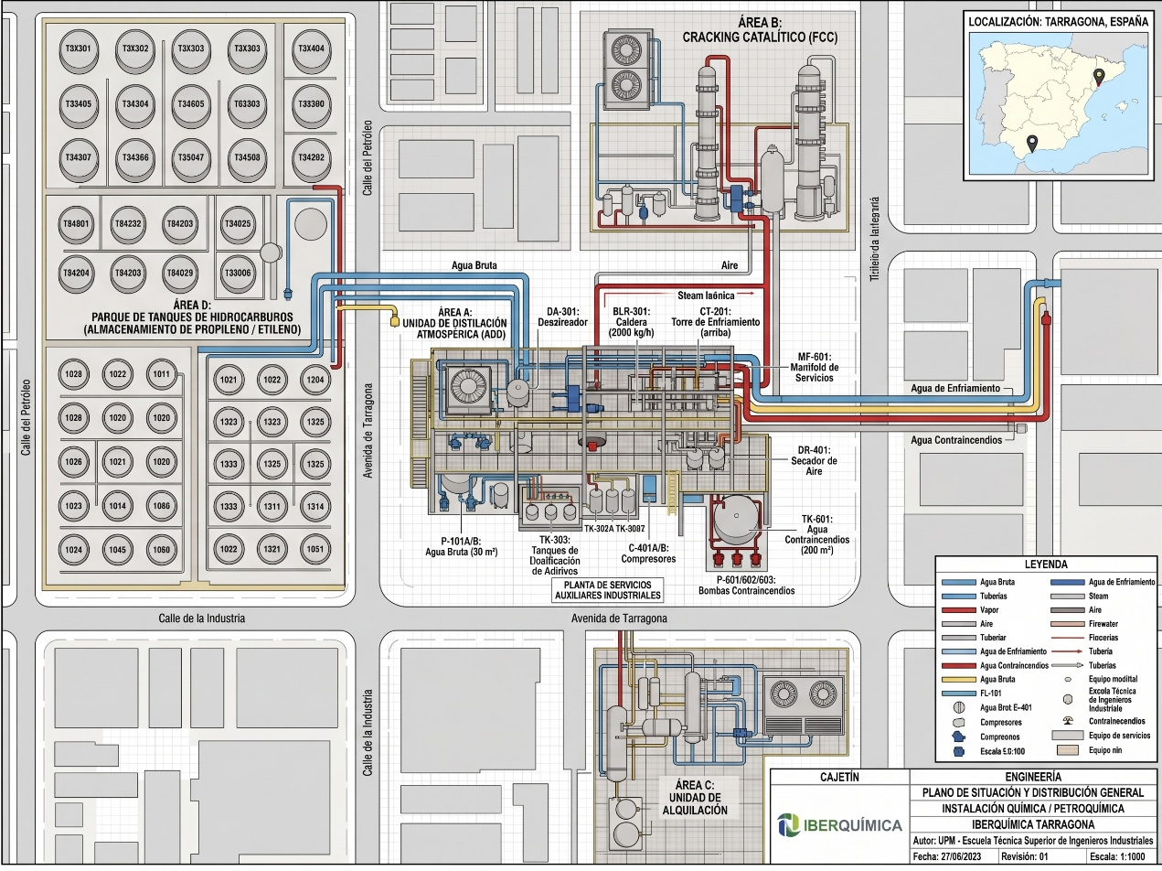

Success Criteria
The success of this engineering design project (AuxPltTarragona) will be measured by the technical validation and on-time delivery of the design package, confirming it meets the site’s mandatory operational and financial constraints by the December 4, 2026 deadline. The specific, measurable criteria for success are defined as follows:
1. On-Time Delivery Milestones:
- Successful acceptance by the Project Steering Committee (PSC) of all P&IDs and Dimensioning Reports by Milestone 1 (W3 Oct - October 23, 2026).
- Final delivery and acceptance of the Integrated 3D Model and Construction Budget by Project End (December 4, 2026).
2. P&ID & Dimensioning Acceptance (The "Operating Ranges"): Successful validation by Iberquímica Operations Dept. that the delivered P&IDs and dimensioning reports demonstrate the capability to achieve the following mandatory operational envelopes (The Design Basis):
- Steam Generation: Sustained output of 2,000 kg/h saturated steam at 10 bar(g).
- Cooling Water: A 500 kW thermal load dispersal capacity with 120 m³/h circulation and a verified 8 °C ΔT drop (35°C to 27°C). Chemical dosing range established from 5 to 50 L/h.
- Instrument Air: Reliable safe-shutdown capacity of 500 Nm³/h (100% backup verified) at 8 bar(g), with a guaranteed Dew Point of +3 °C.
- Water Intake: Maximum transfer envelope defined at 60 m³/h at 4 bar(g).
- Firewater Network: Verified dedicated storage of 200 m³ with a sustained delivery output of 200 m³/h at a network pressure of 12 bar(g) (restoring SEVESO III safety margins).
3. 3D Model Validation & Legal Adherence:
- The integrated 3D model is validated as physically constructible within the designated internal Tarragona plot boundary (see previous schema), demonstrating zero interference with existing boundary interfaces and perimeter roads.
- The final design explicitly references compliance with current Spanish mandatory codes (RD 2060/2008 for Pressure Equipment, RD 656/2017 for Chemical Storage).
4. Financial Estimate Accuracy:
- Successful acceptance of the final Construction Budget Estimate, with a confirmed accuracy of Class 4 (+30% / -20% or similar high-level estimate accuracy), providing a robust baseline suitable for direct executive appropriation for the physical construction phase.
Assumptions (high level)
The project plan, schedule, and the initial engineering cost estimate are founded upon the following assumptions. The Project Steering Committee (PSC) accepts that if any of these assumptions prove to be incorrect, the project timeline, resource requirements, and final deliverables will require immediate revision.

The assumptions supporting this engineering design phase (AuxPltTarragona) are:
- Validity of the Design Basis (StudentPack): It is assumed that the fundamental process requirements and equipment definitions provided in the "StudentPack" framework are accurate and sufficient to serve as the immediate Design Basis for generating conceptual P&IDs and Dimensioning Reports. No extensive process recalculations are included in this scope.
- Interface Consistency (Process Areas A/B/C/D): It is assumed that the physical and technical connection points with the existing process units (reference image_15.png boundaries) are accurately defined and available. The auxiliary plant design relies entirely on these assumed fixed interface boundaries.
- Accuracy of Site Geotechnical Data: Since the designated plot is internal to the active Tarragona complex, it is assumed that existing geotechnical and foundation data are readily available and accurate. No new topographical surveys or geotechnical studies are included in this planning phase.
- Zero Earthworks and Leveling Constraint: The project budget and schedule rely entirely on the assumption that no plot leveling or significant earthworks are required; the terrain is suitable for immediate foundation work upon conclusion of design.
- Perimeter Access and Roads Availability: It is assumed that the defined perimeter roads (e.g., Avenida de Tarragona) are existing, available, and structurally capable of supporting construction mobilization and heavy equipment transport without modification.
- Resource Availability for Third-Week October Milestone: The schedule assumes that the entire internal specialized technical team (the 12 engineering resources) will be fully dedicated and available to meet the mandatory P&ID/Memoria delivery deadline on October 23, 2026 (W3 Oct). No contingency is included for key resource unavailability during this window.

The expected design would look like the following (not mandatory)
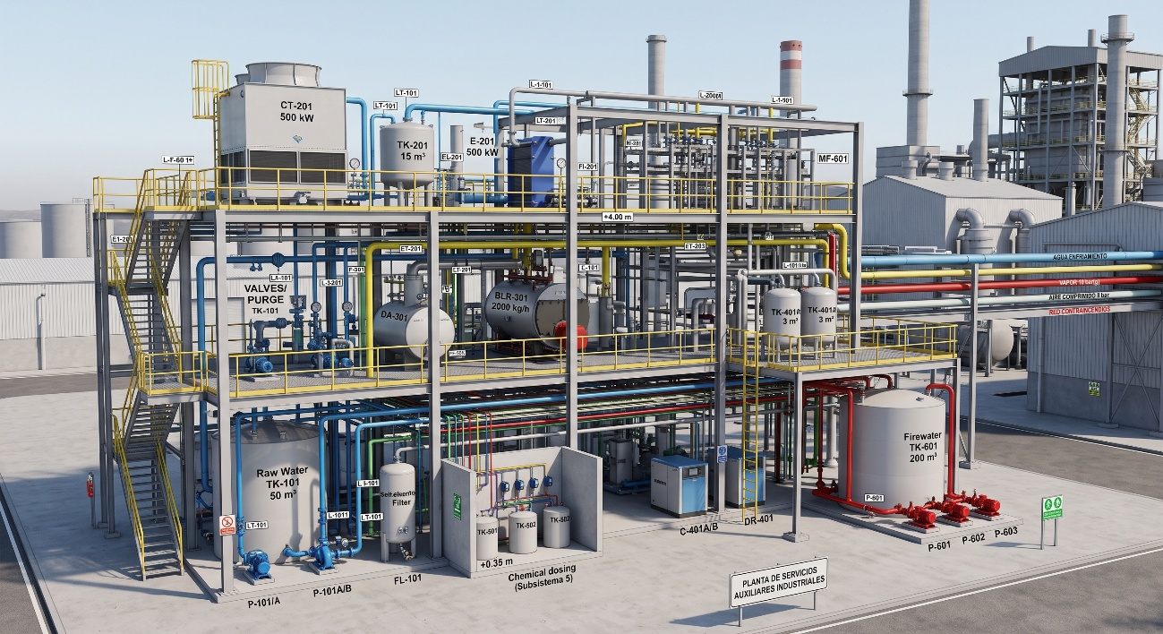
Constraints (high level)
This engineering design project (AuxPltTarragona) is subject to the following hard constraints. Failure to adhere to these limiting factors will invalidate the project outcome and prevent successful completion by the Steering Committee.
The specific internal and external constraints that must be strictly enforced are:
1. Firm Schedule and Timeline:
- Start Date Constraint: Project must start no later than September 10, 2026.
- Delivery Date Constraint: All final deliverables must be accepted and the project formally closed by December 4, 2026. This provides a strict, fixed window of 12 weeks of engineering design and integration.
- Mandatory Intermediate Milestone: Preliminary conceptual P&IDs and Dimensioning Reports for all six subsystems must be delivered for PSC review during the third week of October (by October 23, 2026).
2. Physical Boundary and Plot Area:
- Physical Constraint: The entire integrated 3D digital model, structural platforms, equipment footprints, internal maintenance access, and central rack (MF-601) must fit entirely within the designated internal Tarragona complex plot boundary (see previous layout in impact section).
- Validated Dimensions: This boundary is fixed at 55 meters (Width) x 75 meters (Length), providing a total constructible area of 4,125 m².
3. Engineering Deliverable Standard ("Proyecto Básico"):
- Documentation Constraint: The output of this project phase must meet the definition of official "Proyecto Básico" (Basic Engineering Project) documentation according to standard Spanish engineering practice. This means:
  - Conceptual designs must be developed sufficiently to allow a competent EPC contractor to provide a binding Class 4 CAPEX estimate.
  - The 3D model must be spatially correct but is not required to be fully detailed (e.g., standard fittings are shown conceptually, but isometric generation is out of scope).
  - The output must be sufficient for submission for the initial renewal of the site’s Integrated Environmental Authorization (AAI/Llei 20/2009 Catalonia).
4. Mandatory Service Quality and Operating Ranges:
- The conceptual designs (P&IDs and Memoria) must prove the capability to deliver services within the specific performance envelopes defined to restore complex reliability:
  - Steam Quality: 2,000 kg/h saturated steam at 10 bar(g).
  - Cooling Water: 500 kW dispersal with verified 8°C ΔT drop (35°C to 27°C reuse).
  - Instrument Air Quality: Safe-shutdown capacity of 500 Nm³/h at 8 bar(g) with guaranteed +3°C Dew Point.
  - Raw Water Intake: Maximum transfer envelope of 60 m³/h at 4 bar(g).
  - Firewater Network: Verified dedicated storage of 200 m³ with a sustained network output of 200 m³/h at 12 bar(g).
  - Note on Water Quality Impact: P&IDs will include the variable flow chemical dosing subsystem (TK-501/TK-502) capable of delivering 5 to 50 L/h of scale/corrosion inhibitors and hypochlorite to protect the infrastructure.
5. Budgeting Basis (Physical Site Conditions):
- Zero-Earthworks Constraint: The construction budget estimate must be calculated assuming zero cost for plot leveling or significant earthworks. Geotechnical data must assume the site is graded and structurally suitable for foundations.
- Zero-Access Roads Constraint: The construction budget must rely entirely on the existing perimeter roads (e.g., Avenida de Tarragona) for all mobilization and construction access. No budget for new access roads is permitted within this project scope.
Risks (high level)
The following initial business risks have been identified. These risks impact the underlying business case, financial viability, and strategic alignment of the project for IBERQUÍMICA TARRAGONA. Immediate management of these risks is required to ensure the subsequent construction phase remains a viable investment. The critical business risks are:
• Enforced Legal Closure of Core Production Assets (Operational Shutdown Risk):
- Risk: The primary business risk is that delays in this engineering phase prevent the timely renewal of the site’s Integrated Environmental Authorization (AAI) and SEVESO compliance certifications.
- Probable Business Impact: Mandatory legal closure of the continuous process lines in Area B (FCC) and Area C (Alquilation) due to lack of verified safety and environmental design. Total loss of production revenue for the complex.
- Initial Mitigation Strategy: Strict enforceability of the third-week October milestone (P&IDs and Memoria). Design reviews will prioritize legal compliance (SEVESO III/AAI) over optional optimization features to guarantee a "Proyecto Básico" that satisfies Catalan authorities.
• Invalidated Investment Case due to Inaccurate Estimation (Financial Risk):
- Risk: Due to the compressed 12-week timeline or potential resource coordination failures under the specialized framework, the quality of the "Proyecto Básico" design may be compromised.
- Probable Business Impact: A significantly compromised design basis leads to a highly inaccurate (worse than Class 4) Construction Budget Estimate. Executive management makes an investment decision based on flawed data, leading to major capital cost overruns and failure to achieve the intended Return on Investment (ROI) during the subsequent construction phase.
- Initial Mitigation Strategy: Establishment of standardized design freeze dates (Nov 20). Implementation of a dedicated integration resource role within the engineering team to ensure inter-subsystem consistency, improving the reliability of the spatial 3D model used for budgeting.
• Buildability Failure within Fixed Boundaries (Interface Risk):
- Risk: Undiscovered physical interferences or process incompatibilities at the assumed interfaces with existing boundaries or perimeter roads emerge during construction, invalidating the "zero earthworks/zero road construction" assumption.
- Probable Business Impact: Massive increase in Construction CAPEX to rectify site conditions, directly destroying the financial baseline of the investment decision. Construction delays causing further operational risk.
- Initial Mitigation Strategy: Immediate prioritization of physical boundary definition during Week 1 of planning. The 3D model validation success criterion will enforce mandatory, verified spatial integration over purely conceptual process superiority.
• Compromised Strategic OPEX Optimization (Long-term Financial Risk):
- Risk: The pressure to meet the December 4 deadline and the mandatory service ranges may result in prioritizing a design that is "buildable and code-compliant" but misses critical opportunities for energy efficiency and operational expenditure (OPEX) optimization.
- Probable Business Impact: While initial capital costs are within the estimate, Iberquímica Tarragona incurs millions of euros in unnecessary OPEX (energy, water, chemical usage) over the asset’s 25-year lifespan due to a rush design, compromising site competitiveness.
- Initial Mitigation Strategy: Mandatory inclusion of a dedicated BAT (Best Available Techniques) review session during the P&ID definition phase (Week 5), specifically challenging subsystem leads on long-term efficiency implications before design freeze.

