


3, Menara Sentral, Penang Street, 10200 Penang. Tel: 04-2621888
ASSIGNMENT COVER SHEET
Student Name: Jordon Yeon Choon Lye
Student ID:
Course Title: Design Patterns
Course Code: EDP5114
Course CRN: 52789
Semester / Year: Trimester 2 || January 2025
Lecturer:
Word Count:
Lecturer’s Comments:

(This completed cover sheet must be attached to the front of your assignment)
Plagiarism
Plagiarism is the misrepresentation of the work of others as one’s own (including ideas, arguments, words, diagrams, images or data). It includes the explicit claim that another person’s work as one’s own and the failure to adequately acknowledge the sources used. Plagiarism is an academic misconduct and will be penalized accordingly.

Declaration
I certify that this assignment is a result of my own independent work and investigation. The use of material from other sources has been properly and fully acknowledged in this assignment. A bibliography is appended. I fully understand the consequence of committing plagiarism, and if proven and in the absence if mitigating circumstances, it could include failure in the Year or part of my course or even withdrawal from the program.

I declare that this assignment is in full compliance of the above requirements.

Signature:_________ _________________ Date:__________28/04/2025_____________
- To score high marks, you must meet the requirements outlined in the assessment criteria. It is attached to your assignment question paper.
- Late submission might result in mark deduction of marks.

Contents

Contents 1
1.0 Introduction 2
2.0 Software Design 3
2.1 Use Case Diagram 4
2.2 Class Diagram 6
3.0 Design Patterns 8
3.1 – Factory Pattern (for creating animal objects dynamically) 9
3.2 – Singleton Pattern (for managing game state / score) 11
4.0 Conclusion 13
5.0 References 14

Introduction
The Animal Classification Game is an engaging educational JavaFX application designed to teach users about animal categorization through an interactive and visually appealing interface. The primary objective is to enable players, particularly younger audiences, to learn about different animal types by dragging and dropping animal images into their corresponding category boxes within a specified time limit. The game features four progressive levels, each increasing in complexity by introducing more animals and categories, challenging the player's knowledge and speed. Key functionalities include a drag-and-drop mechanism, a timer system with level-specific durations (15 seconds for Level 1, 20 for Level 2, 30 for Level 3, and 40 for Level 4), and a scoring system that rewards correct placements. The game also incorporates audio feedback with background music, customizable settings for volume and mute options, and a vibrant UI with colourful elements like rainbow arcs and paw print patterns to enhance user engagement. This report provides a comprehensive overview of the software design, including use case and class diagrams, the implementation of design patterns (Factory and Singleton), and a conclusion on the system's effectiveness. The design prioritizes modularity, scalability, and user-friendliness, ensuring an intuitive experience while maintaining robust functionality.

2.0 Software Design
The design process aimed to create a cohesive architecture that supports the game’s educational goals while ensuring maintainability and extensibility. By modelling user interactions and system components, the design facilitates clear communication of functionalities and relationships, enabling efficient development and potential future enhancements. The use case diagram captures the user’s actions, such as starting the game, adjusting settings, and classifying animals, while the class diagram provides a blueprint of the core entities, their properties, and interconnections, ensuring a robust and flexible system structure.

2.1 Use Case Diagram
The use case diagram illustrates the interactions between the user, the sole actor in the system, and the various functionalities of the Animal Classification Game. It serves as a visual representation of how the user engages with the game, capturing key actions such as initiating gameplay, adjusting settings, classifying animals, resetting the game, exiting, and viewing results. This structure ensures that the user’s journey through the game is intuitive, with clear pathways for both core gameplay and supplementary actions like settings adjustments or exit confirmations. The diagram effectively communicates the system’s behavioural requirements, guiding the implementation of user-centric features.
Diagram:
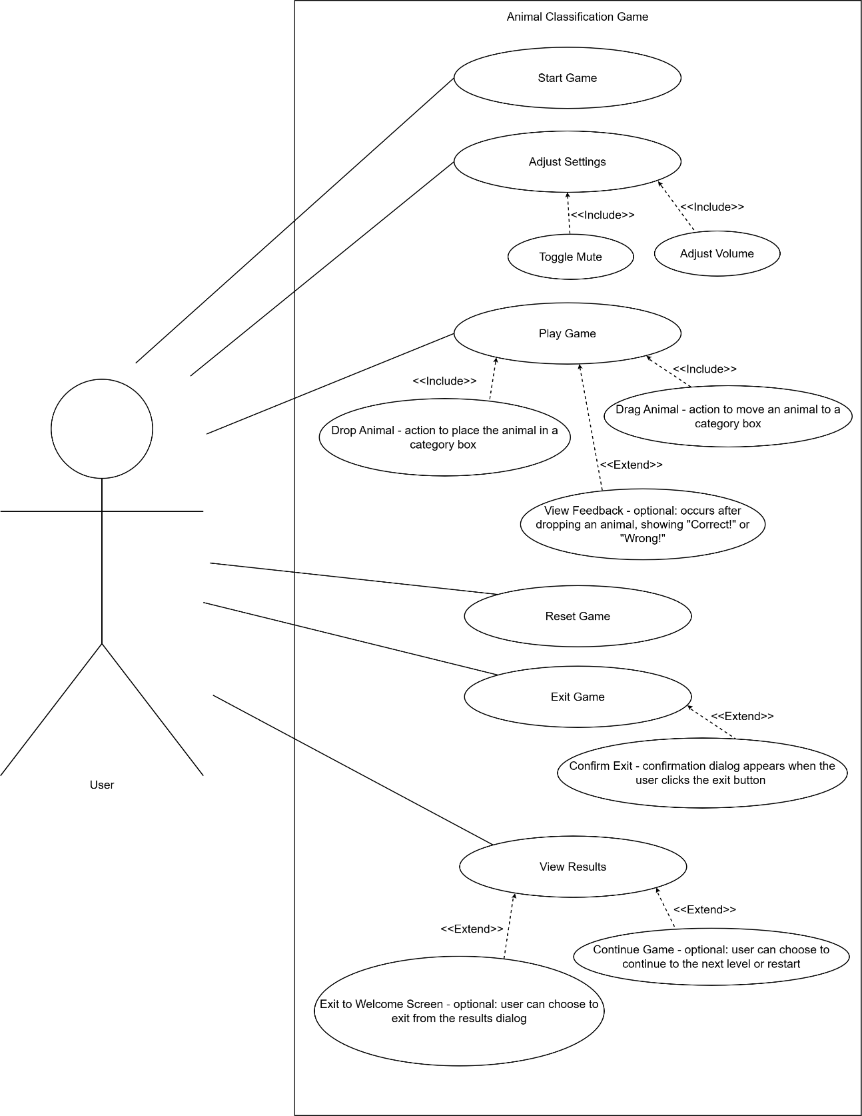

2.2 Class Diagram
The AnimalClassificationGame class orchestrates the game’s flow, managing lists of Animal and CategoryBox objects, while the GameState class maintains a single instance for consistent state tracking. This structured design supports modularity, allowing for easy maintenance and potential expansion, such as adding new animal types or levels.
Below is the detailed information for the class diagram, including class names, attributes, operations (methods), and relationships (Inheritance, Association, Aggregation, Composition, Dependency). Attributes and operations are marked with visibility indicators: + for public, - for private, and # for protected, following UML notation.
Diagram:
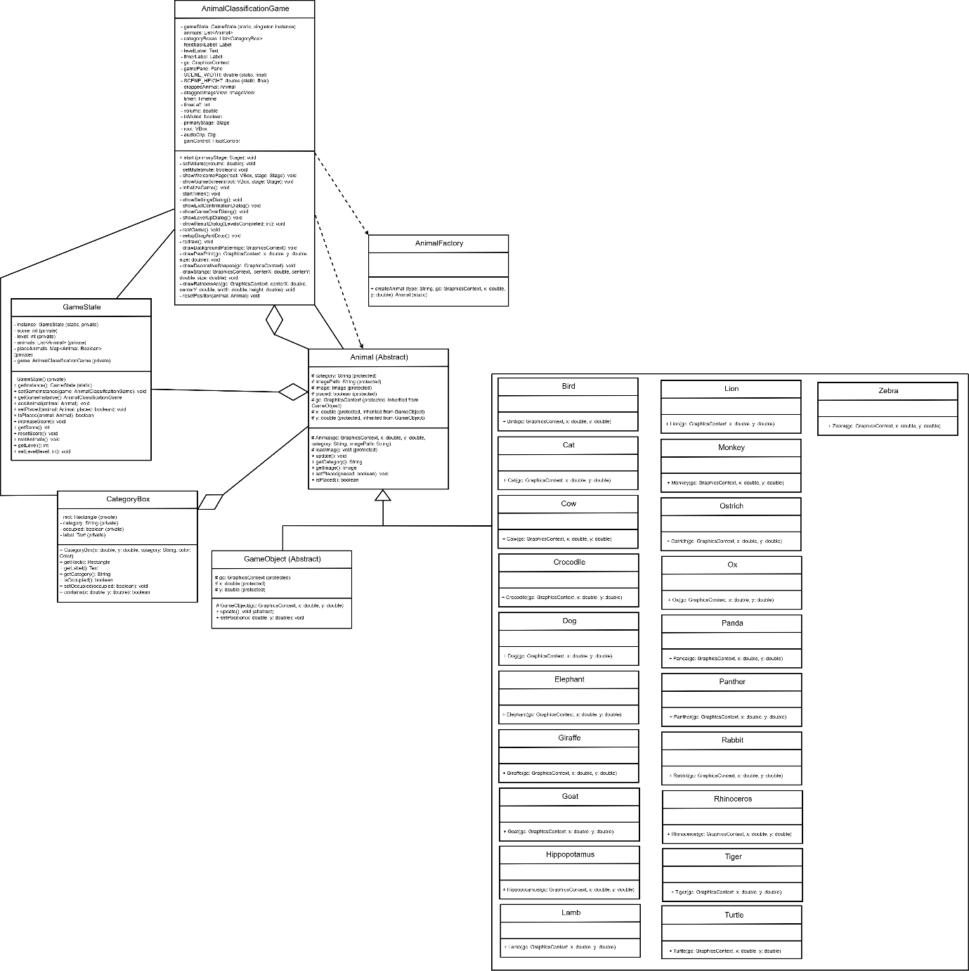
Can zoom in to see clearer information. Class diagram of my AnimalClassificationGame

3.0 Design Patterns
This section explores the design patterns implemented in the Animal Classification Game to enhance its modularity, scalability, and maintainability. Specifically, the game employs the Factory Pattern for dynamic object creation and the Singleton Pattern for centralized state management. These patterns address common software engineering challenges, such as delegate instantiation and state consistency, by providing structured solutions that align with the game’s requirements. The Factory Pattern streamlines the creation of various animal types, while the Singleton Pattern ensures a unified game state across all levels and interactions. Detailed explanations of each pattern’s implementation, including code references and their benefits, are provided to illustrate their impact on the system’s design.

3.1 – Factory Pattern (for creating animal objects dynamically)
For the factory pattern that I used to created animal objects dynamically based on the animal type as I have different kind of animals. This pattern I implemented in “AnimalFactory.java” class, for specify the createAnimal method, which take a string type and return the corresponding “Animal” subclass instance of my 21 animal’s class.
Code location:
File: AnimalFactory.java
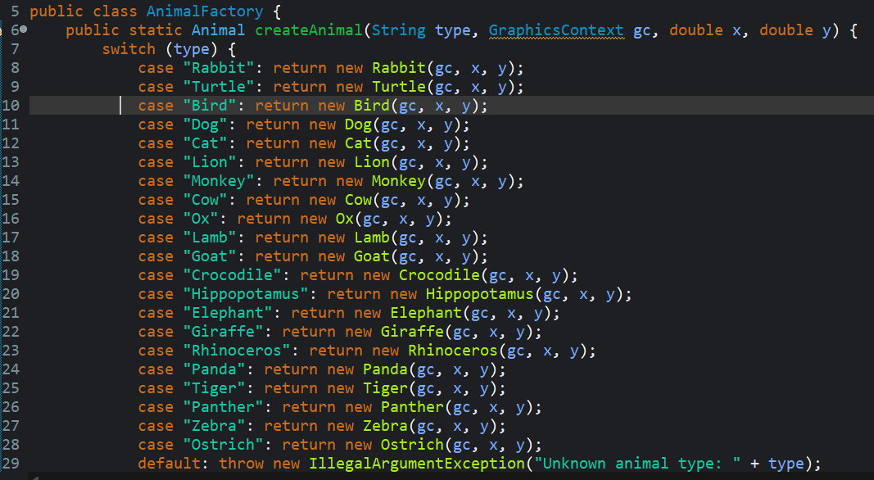
Method: createAnimal(String type, GraphicsContext gc, double x, double y)
Usage in the main class “AnimalClassificationGame.java”
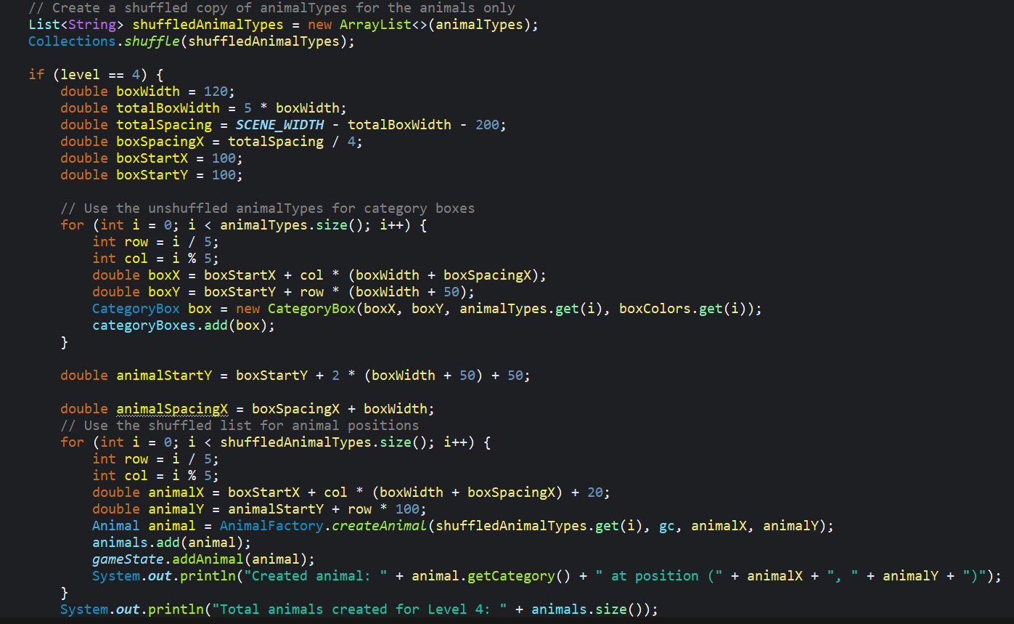
The Factory Pattern encapsulates object creation logic, allowing the game to instantiate different animal types without directly referencing their constructors. This promotes flexibility, as new animal types can be added by updating the switch statement in AnimalFactory without modifying other parts of the code. The createAnimal method acts as a centralized factory, returning the appropriate Animal subclass based on the input string.

3.2 – Singleton Pattern (for managing game state / score)
For the singleton pattern I used to manage the game state and scoring point, to ensuring a single instance of the GameState.java class exists throughout the application. This pattern is implemented in the GameState.java, which keep the game score correct, and each level will having handle different score, and animal placement status too.
Code location: File: GameState.java
First part:
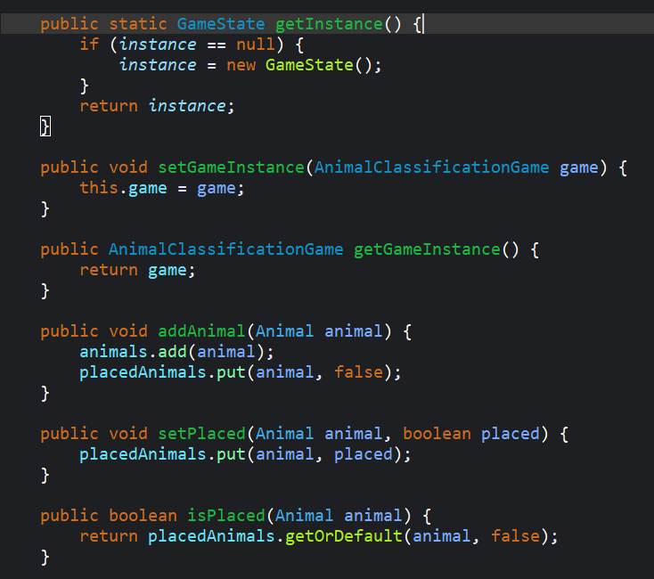
Second part:
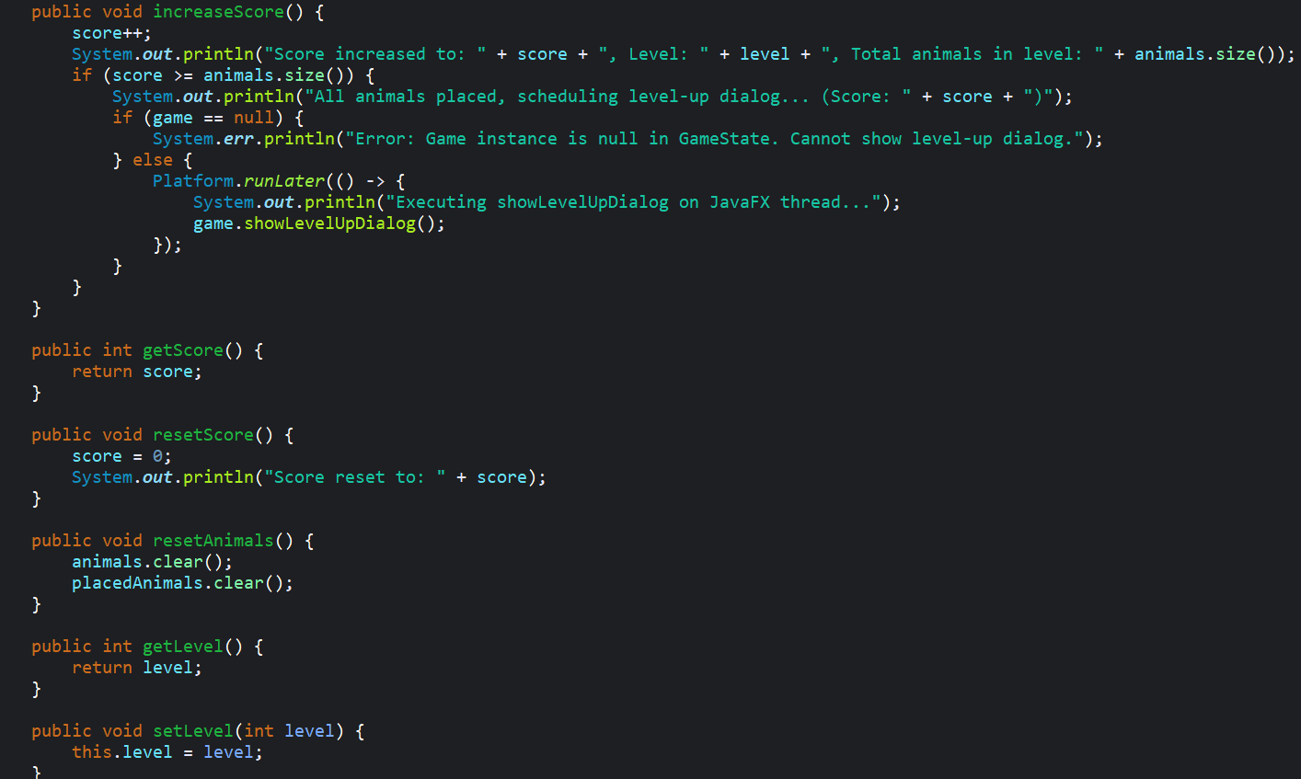
Example: private static field: “private static GameState instance;” , “private constructor: private GameState() {}” , “public static method: public static GameState getInstance()”
This GameState code part are using on the main class as well: AnimalClassificationGame.java
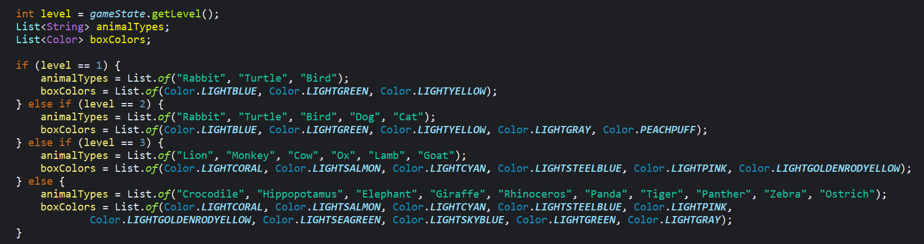
Example: each level will have different animalTypes by their level 1 to 4
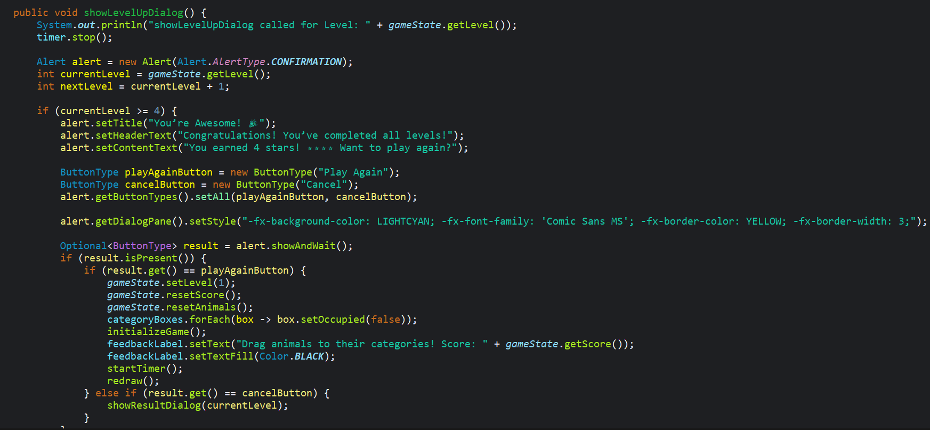
Example this part is for: show level up dialog when the gamestate hit then get level or timer hit, it might also affected very well handling. If user have completed all 4 levels it will alert a dialog. Next, for the button of reset or play again button it will read the game state to set the level back to 1 and reset the score as will.
The Singleton Pattern ensures that only one GameState instance exists, providing a global point of access to manage the game's state (score, level, and animal placements). The private constructor prevents external instantiation, and the getInstance method lazily initializes the instance. This design guarantees consistency, as all parts of the application (e.g., scoring, level progression) interact with the same GameState object.

4.0 Conclusion
The Animal Classification Game is a well-crafted educational tool that effectively combines interactive gameplay with learning objectives. By leveraging JavaFX, the game delivers a visually appealing and responsive user experience, enhanced by features like animated dialogs, background music, and a star-based reward system tailored for younger players. The software design, detailed in the use case and class diagrams, demonstrates a modular and scalable architecture that supports the game’s core functionalities while allowing for future expansions. The Factory Pattern simplifies the creation of diverse animal objects, reducing code duplication and improving maintainability, while the Singleton Pattern ensures consistent management of game state across all levels. The implementation of level-specific timers, randomized animal positions, and intuitive drag-and-drop mechanics further enhances the game’s engagement and educational value. Potential future improvements include adding a lives system, incorporating more animal categories, or introducing multiplayer modes to foster collaborative learning. Overall, the game achieves its goal of making animal classification fun and accessible, providing a solid foundation for further development and refinement.

5.0 References
Fakhroutdinov, K. (n.d.). Abstract factory creational software design pattern UML class diagram example. https://www.uml-diagrams.org/design-pattern-abstract-factory-uml-class-diagram-example.html
GeeksforGeeks. (2025a, January 3). Class Diagram | Unified Modeling Language (UML). GeeksforGeeks. https://www.geeksforgeeks.org/unified-modeling-language-uml-class-diagrams/
GeeksforGeeks. (2025b, January 3). Singleton Method design pattern. GeeksforGeeks. https://www.geeksforgeeks.org/singleton-design-pattern/
KooR.fr. (n.d.). KooR.fr - Le design pattern � Singleton � - Le tutoriel sur le langage de programmation Java. https://koor.fr/Java/Tutorial/java_design_patterns_singleton.wp
Kumar, P. (2022, November 5). Java Singleton Design Pattern Best Practices with Examples. DigitalOcean. https://www.digitalocean.com/community/tutorials/java-singleton-design-pattern-best-practices-examples
Rc. (n.d.). Animal-Shelter-Project/README.md at master · rc9207/Animal-Shelter-Project. GitHub. https://github.com/rc9207/Animal-Shelter-Project/blob/master/README.md
UML Class Diagram Tutorial. (2025, March 26). Lucidchart. https://www.lucidchart.com/pages/uml-class-diagram
UML Use Case Diagram Tutorial. (2025, February 24). Lucidchart. https://www.lucidchart.com/pages/uml-use-case-diagram

Use case diagrams - Use case diagrams online, examples, and tools. (n.d.-a). https://www.smartdraw.com/use-case-diagram/?srsltid=AfmBOoozy5kkfWWjlbdr6tlodClff421PdR4hbZWbmttHldVgEv1RgVd
Use case diagrams - Use case diagrams online, examples, and tools. (n.d.-b). https://www.smartdraw.com/use-case-diagram/?srsltid=AfmBOoozy5kkfWWjlbdr6tlodClff421PdR4hbZWbmttHldVgEv1RgVd
What is a UML Diagram? | Different Types and Benefits | Miro. (n.d.). https://miro.com/. https://miro.com/diagramming/what-is-a-uml-diagram/
What is Class Diagram? (n.d.). https://www.visual-paradigm.com/guide/uml-unified-modeling-language/what-is-class-diagram/
What is Unified Modeling Language (UML)? (n.d.). https://www.visual-paradigm.com/guide/uml-unified-modeling-language/what-is-uml/
What is Use Case Diagram? (n.d.). https://www.visual-paradigm.com/guide/uml-unified-modeling-language/what-is-use-case-diagram/
Wikipedia contributors. (2025, March 23). Unified modeling language. Wikipedia. https://en.wikipedia.org/wiki/Unified_Modeling_Language

