# INTRODUCTION

The aim of this study is to build software for student memorisation of foreign vocabulary, record the reviews and finally to analyse the review data with machine learning algorithms to predict the chance that a student will correctly recall a particular word.

This is achieved with a review mechanism called Spaced Repetition.

# SPACED REPETITION

## What is Spaced Repetition?

Spaced Repetition is a method of reviewing facts for rote memorisation based on the psychological “Spacing Effect” of memory. Knowing that each review of a fact solidifies the fact in the person’s memory, we can review the fact at increasingly longer and longer periods to retain that fact. This avoids the unnecessary need to review facts every single day, instead aiming to review facts only when necessary.

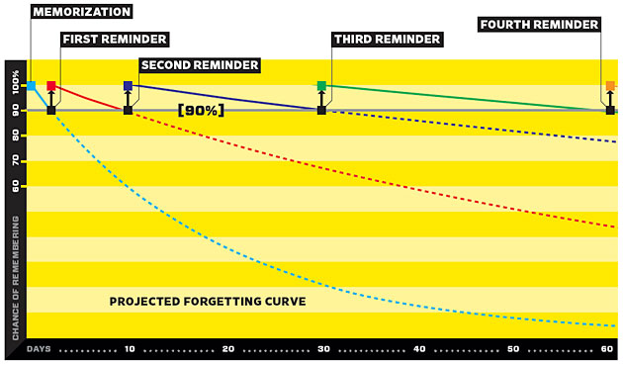**How does it work?**

Figure 1: Projected Forgetting Curve

When you review a fact on a flash-card, the following review is scheduled based on how long since you last reviewed the fact, and whether you correctly recalled the fact. Computer software generally follows a simple algorithm to schedule reviews for the future and keeps a database with several variables pertaining to each fact. This database essentially becomes a model of the user’s knowledge of all facts.

# REVIEW SOFTWARE (MEMBIT)

Software was developed which implements the well-known SuperMemo spaced repetition scheduling algorithm for the nearly 100 students in JAPN1023 to review vocabulary while recording every review. The software was populated with 240 vocabulary facts from the course textbook.

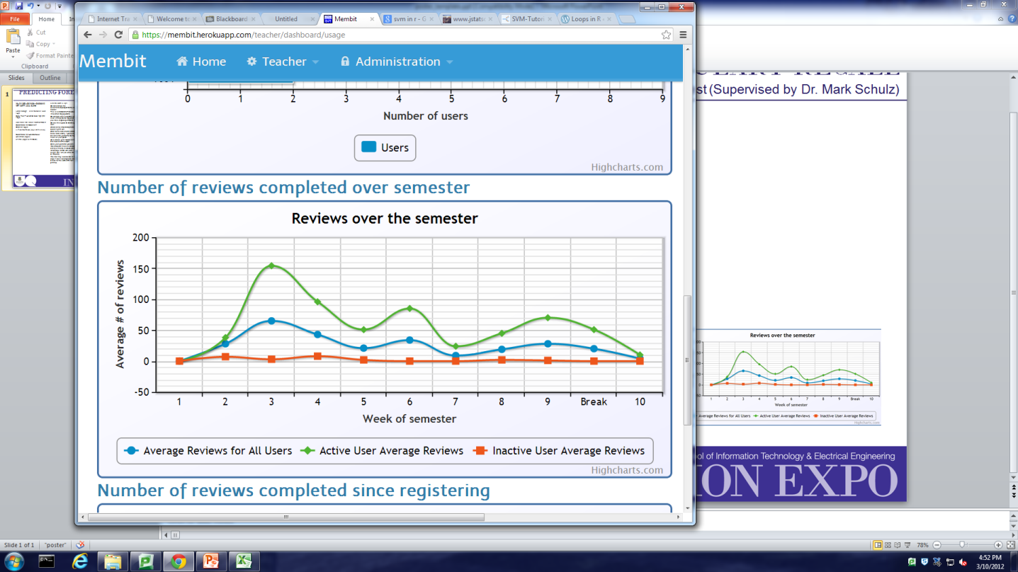Students have been using the software since Week 2 of semester. As of week 11, over 7500 reviews have been recorded.

Figure 2: Use of Membit over this semester

# PREDICTION OF ANSWERS

## Logging of Reviews

Easiness Factor

Interval

Overdue Time

Review Correct

# of times correct/incorrect

Review Number

The following data is recorded and used as inputs for the machine learning algorithms:

* Word easiness factor (EF)
* Word Interval
* Overdue time
* Review number
* Incorrect and correct counts
* Previous answer
* Previous time taken to answer

Stored alongside the following outputs:

* User Response (graded from 0 – 5)
* User Response correct (True/False based on response)

**Results**

Currently the model is accurately predicting whether the user correctly recalls a fact for 67% of reviews. This is a 34% improvement over chance; given that the study involves humans and their unpredictability this is not an insignificant result.

Through some further analysis and filtering of the data it may be possible to improve this result.