Jordan Whitaker

BAN 530

Report

Analysis of the Impact of COVID-19 in Developed Countries

Executive Summary:

The analysis in this report will highlight the knowledge gained throughout the Master of Science in Business Analytics program. The components of the report will reflect the entire curriculum via three major themes: descriptive analytics, predictive analytics, and prescriptive analytics. These analytical themes will be used to provide insight to why there were varying affects in the impacts of the COVID-19 pandemic. ….NOT SURE WHAT ELSE TO ADD…

Introduction:

This report will seek to understand in an unbiased and objective way why the most developed countries in the world were affected differently by the COVID-19 pandemic. In a time of partisanship and a twenty-four-hour news cycle, the world has had few advocates focusing strictly on the data and a positive path forward. Across the world, a microscope has been placed on developed countries and how well they have controlled the pandemic within their borders. The findings in this report will show the stark contrast of how developed countries were affected by the pandemic. In this report, a developed country is defined as a country with a Human Development Index (HDI), greater than 0.915. The HDI metric is a criterion for assessing the state of development in a country by not focusing solely on the economic growth. HDI has been used to create an even scale when comparing countries with different economic situations. The United Nations Development Program defines the HDI as “a summary measure of average achievement in key dimensions of human development: a long and healthy life, being knowledgeable and have a decent standard of living. The HDI is the geometric mean of normalized indices for each of the three dimensions.” (United Nations, 2020). To understand how these countries were affected so differently by COVID-19, it is important to investigate the specific characteristics of each country.

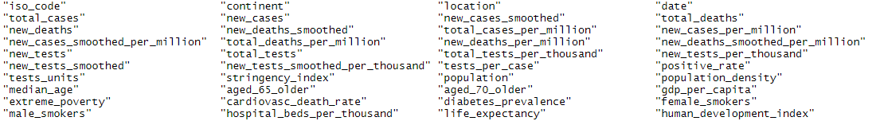 The dataset is a comprehensive record of 211 countries dating from December 31, 2019 to October 18, 2020. There are 50,350 observations and 41 variables in the dataset. To review all variables in the dataset, please refer to Figure 1.1.

Figure .1

As was mentioned earlier, the scope of this analysis will focus on countries with an HDI > 0.915. This now refines the dataset to 4,728 observations and contains the following countries: Australia, Belgium, Canada, Finland, Germany, Hong Kong, Iceland, Ireland, Lichtenstein, Netherlands, New Zealand, Norway, Singapore, Switzerland, United Kingdom, and United States. With a defined scope

This objective analysis will occur in three phases. First, descriptive analytics

Also, it will also provide a predictive measure for determining future case counts, as well as a prescriptive to determine what actions a country can take to reduce case counts

, out of these 41 variables, it is hypothesized that the following variables will be critical elements to investigate why developed countries had varying outcomes of COVID-19. These variables are: total cases (smoothed), new cases, total deaths, new deaths, new cases per million, total deaths per million, total tests, new tests, new tests per thousand, total tests per thousand, tests per case, positive rate, stringency index, population, age 65 or older, age 70 or older, male smokers, female smokers, cardiovascular death rate, diabetes prevalence, life expectancy, and handwashing facilities.