Team Members
● Maddison Montijo
● Fernando Contreras Corzo
● Oscar Avina
● Jordyn Rylander

Case Study Selected
Outland Adventures — an outdoor adventure company founded by Blythe Timmerson and Jim Ford. The company arranges guided trips, provides equipment for rent or purchase, and manages marketing and inventory. They have conducted treks in Africa, Asia, and Southern Europe and are looking to optimize their operations through a well-structured database.

Business Rules
The following business rules were identified from the case study and used to design the ERD:
● A customer may book one or more trips
● Each booking is made by one customer
● Each booking is for one scheduled trip
● Employee roles include guide, marketing, inventory, software developer, and admin
● A customer can make many equipment purchases
● A customer can either rent or buy equipment
● Equipment older than 5 years must be inspected, replaced, or tagged
● Trips are conducted in specific locations across Africa, Asia, and Southern Europe
● Each trip is led by one guide (employee)
● Each equipment transaction must be linked to one customer.
● Equipment inventory must track the quantity and condition of each item.

Assumptions
The following assumptions were made when designing the ERD:
● Each employee has exactly one role
● A trip has one assigned guide from the employee table
● Equipment age is calculated from the purchase_date field in the equipment table
● The needs_inspection flag in the equipment table marks items older than 5 years
● Transaction type in the equipment_purchase table distinguishes between rent and buy
● A customer can exist in the system without having made a booking or equipment purchase
● The location field in the trip table stores the specific destination, and region stores the broader area (Africa, Asia, Southern Europe) to allow trend analysis by region

Entity Relationship Diagram (ERD)
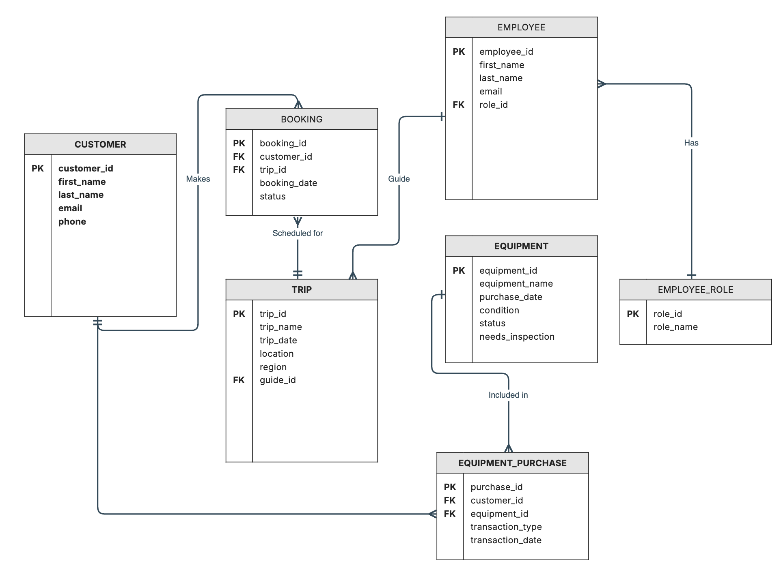
Entity Descriptions
- Customer
Stores customer information including name, email, and phone. A customer can make many bookings and many equipment purchases.

- Booking
Links a customer to a scheduled trip. Each booking belongs to one customer and one trip, and tracks the booking date and status.

- Trip
Represents a scheduled adventure trip. Includes the trip name, date, specific location, and region (Africa, Asia, or Southern Europe) to allow trend analysis by location. Each trip is assigned one guide from the employee table.

- Equipment
Stores information about available equipment including name, condition, purchase date, status, and a needs_inspection flag for items older than 5 years.

- Equipment_Purchase
Links a customer to equipment with a transaction_type field indicating whether the item was rented or purchased outright.

- Employee
Stores employee information including name and email. Each employee is assigned exactly one role from the Employee_Role table.

- Employee_Role
Stores the available employee roles: guide, marketing, inventory, software developer, and admin. Based on the case study, current employees include guides Mac and Duke, marketing lead Anita, inventory manager Dimitrios, software developer Mei, and admins Blythe and Jim.

GitHub Repository: https://github.com/fernandojosecc/CSD-310

