|  |  |  |  |  |  |  |  |  |
| --- | --- | --- | --- | --- | --- | --- | --- | --- |
| **Fill the Information Below** | | | | | | | | |
| Company: **Rezayat Company Limited** | | | | | Date: 3/8/2021 | | | |
| Location: Sport Center , | | | | | Time: 02:05 PM | | | |
| Project/ Site Name: Catering Auditorium & Recreation Facilities : **097-C76R** | | | | | Worst Potential Severity: 2 Actual Severity: 3 | | | |
| **Person(s) Involved:** | **✓** | **Employee** |  | **Contractor** |  | **Others** | |  |
| 1. Hussein Gendi Ramadan Farag (30040448) | | | 3. | | | | | |
| 2. | | | Other(s). | | | | | |
| **Type of Incident:** | | | | | | | | |
| Near Miss | | | | | | | | |
| **Injury Location by Body Parts (Select one or more if necessary):** | | | | | | | | |
| Head |  | Chest |  | Hand |  | Eyes |  | |
| Face |  | Leg |  | Arm |  | Hip |  | |
| Neck |  | Abdomen |  | Wrist |  | Ankle/Foot |  | |
| Back |  | Stomach |  | Elbow |  | Knee |  | |
| Nose/ Ears |  | Shoulder |  | Fingers/ Thumb |  | Toes |  | |
| **Type of Injury Sustained (Select one or more if necessary):** | | | | | | | | |
| Fracture |  | Cut/ Laceration |  | Scalping |  | Bruising |  | |
| Loss of Sight |  | Loss of Consciousness |  | Heat |  | Amputation |  | |
| Dislocation |  | Crush Injury |  | Cold |  | Other |  | |
| Abrasion |  | Suffocation |  | Burn |  |  |  | |
| **Immediate Cause(s) (Select one or more if necessary):** | | | | | | | | |
| Safety Rule Violated |  | Lack of Resources |  | Drugs/ Alcohol Related |  | Inadequate Visibility |  | |
| Lack of Task Skill |  | Method Deviation |  | Poor Housekeeping |  | Employee Morale |  | |
| Lack of Supervision | **✓** | Poor Weather Conditions |  | Inadequate Lighting |  | Employee Attitude |  | |
| Improper Lifting (MH) |  | Lack of Task Knowledge |  | Poor Team Work |  | Behavior Problem |  | |
| Not Paying Attention |  | Lack of Communication | **✓** | No Risk Assessment |  | Poor Ground Conditions |  | |
| Human Error | **✓** | Incorrect Tools/Equip |  | Defective Equipment |  | Improper Lifting (crane) |  | |
| Inadequate PPE |  | Defective Tools |  | Unprotected excavation |  | Unprotected Edge |  | |
| Animals |  | Violence |  | Horseplay |  | Improper/ Poor Slinging |  | |
| Heat Stress |  | STF Above Ground |  | STF on the Same Level |  | Manual Handling |  | |
| Misuse of Hand Tools |  | Grinding/ Welding |  | Knives/ Sharps |  | Hit by Vehicle |  | |
| Hit by Static Machinery |  | Heavy Equipment |  | Splashes from C.P.O.L. |  | Other(s) : |  | |
| Stress |  | Fatigue |  | Vandalism |  |  |  | |
| **Equipment(s) Involved:** | | | | | | | | |
| Light Vehicle: |  | Heavy Vehicle: |  | Plant Equipment: |  | Static Plant Equipment: |  | |
| Building: |  | Structure: |  | Scaffold: | **✓** | Excavation: |  | |
| Other(s): |  |  |  |  |  |  |  | |
| **Description of the Event:** | | | | | | | | |
| At Around 2.05 PM Mr. Husain Was removing the Colum Shuttering to fix the space frame structure near part of staircase area while removing the same one plywood removed from the tie rod and fell down from the second floor no property damage and no injury reported but it has the potential to cause a major Injury /Accident. | | | | | | | | |
| **Immediate Action(s) Taken to Prevent Reoccurrence (If Any):** | | | | | | | | |
| |  | | --- | |  | |  |  |  | | --- | | Immediately barricaded area to avoid the people move in that area give instruction to the foreman and his team to use the rope to protect and avoid the recurrence while removing or Erecting the shuttering in edge. | | | | | | | | | |
| **Person Created the Report:** | | | | | | | | |
| Name: Arun K. Thampy | | Position: Safety Officer | | Signature: | | Date:8-3-2021 | | |
|  | |  | |  | |  | | |

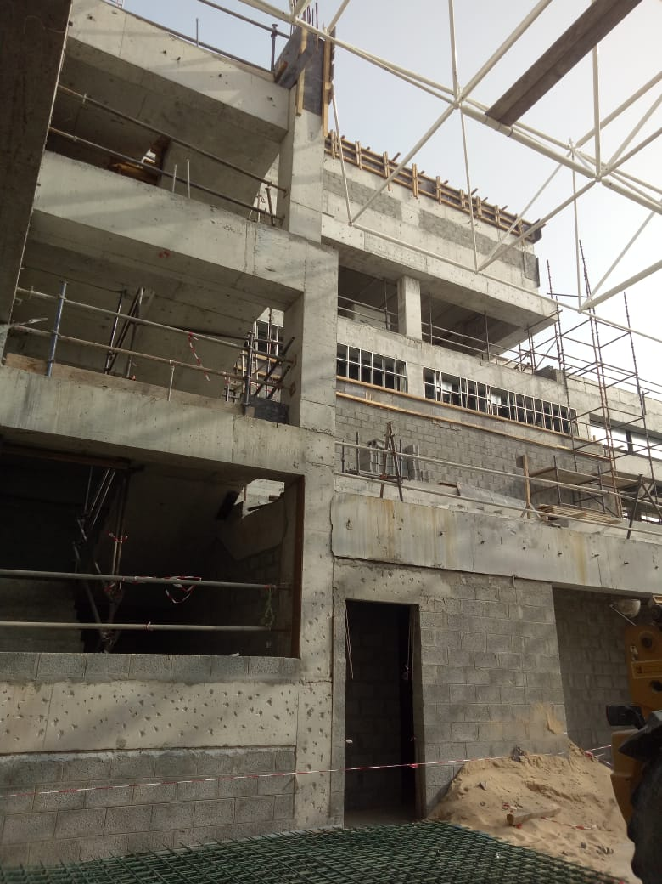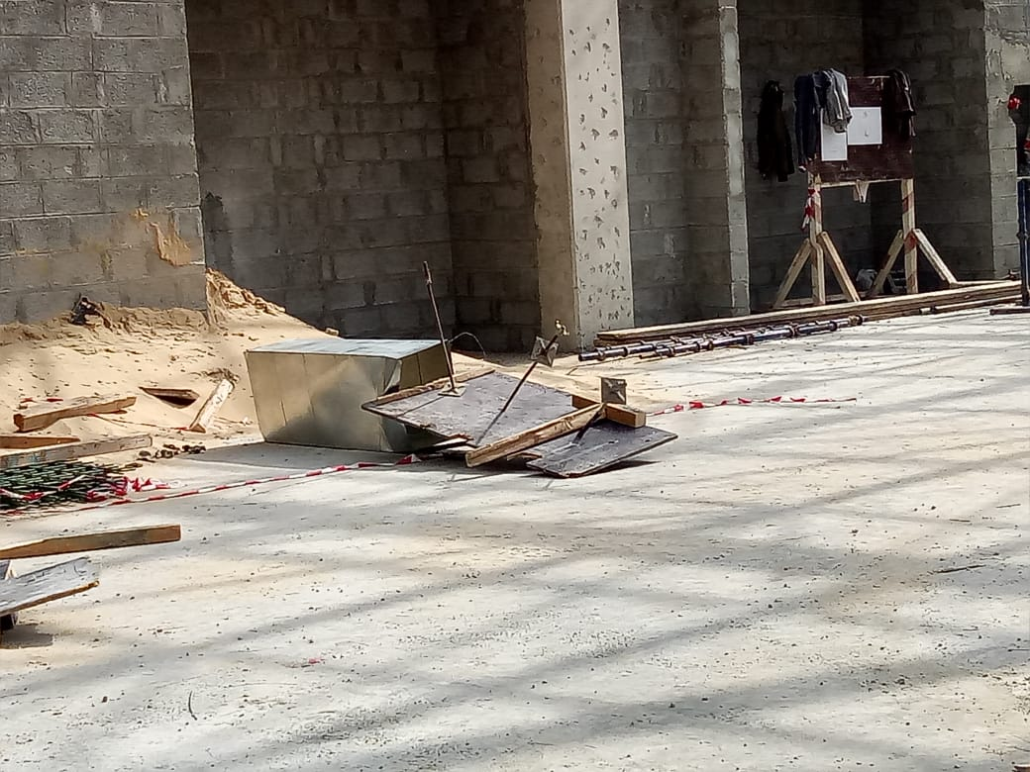

**10.4M.**