|  |  |  |  |  |  |  |  |  |  |  |  |  |  |  |
| --- | --- | --- | --- | --- | --- | --- | --- | --- | --- | --- | --- | --- | --- | --- |
| **Name of Employee** | Waled Mohamed Moustafa  Rolando Lacanaria  Faiz Alam | | | **Badge No.** | | 30036493  31033617  30039806 | | | | | | | **Actual**  **Severity:** | 1 |
| **Safety Awareness Training Date** | 7/12/2021 | | | **Proof of Training** | | Daily Start of work Meeting | | | | | | | **Worst Potential**  **Severity:** | 1 |
| **Name of Line Manager** | Erwin Mediana Sagun | | | **Badge No.** | | 30037528 | | | **Profession/ Designation** | | | | Project Incharge | |
| **Name of Supervisor** | Waled Mohamed Moustafa | | | **Badge No.** | | 30036493 | | | | | | | | |
| **Division / Department** | Construction and Maintenance | | | **Project**  **Name** | | Wadi Sharma Pipeline Protection | | | **Project**  **Location** | | | | Wadi Sharma | |
| **Place of the Incident/Injury** | JOBSITE | | | **Date of**  **Incident** | | 7/12/2021 | | | **Time of**  **Incident** | | | | 10.40am | |
| **Nature of the Incident/Injury** | **Occupational Incident/Injury** | Yes | | | | **Near Miss** | | | **Other, please specify:**  **Property Damage (Client)** | | | | | |
| **Road Traffic Incident/ Injury** | No | | | | No | | |
| **Brief Description of the Incident/Injury** | On 12 July, after conducting the daily Safe start briefing, Safety officer informed Project manager to hold the activities as he leaving the site for vaccination. Project manager says, will continue the work in the presence of Supervisor. So, safety officer instructed supervisor not to allow the heavy equipment inside the cable location and left the site for vaccination. Around 10.40 am, back hoe loader entered into cable location with the permission of supervisor for removing some hard rocks. At that time Mr. Rolando -assistant foreman instructed Operator to remove the excavated soil dumped above the cable area. While removing the soil, the fiber optical cable which is buried under the soil 10cm below got damaged. The accident was not reported to Project manager and safety officer by the operator and supervisor. Client reached the accident spot after the disconnection of communication line at their workstation and make a call to project manager to come to site with supervisor and safety officer. | | | | | | | | | | | | | |
| **Details of the Injury (Specify affected body parts)** | **N/A** | | | | | | | | | | | | | |
| **First Aid Given?** | No | | **Name of First Aider** | | | | | N/A | | | | | | |
| **Name of Hospital where patient was treated/transferred** | N/A | | | | | | | **Address/Location of the hospital** | | N/A | | | | |
| **Medical leave given by administering Hospital/Clinic or Doctor** | No | | **Number of Days** | | No | | **Hospitalization** | | | | | No | | |
| **Property damage** | Yes | | **Estimated**  **percentage of damage** | | 100% | | **Estimated Cost of damaged (SAR)** | | | | | 2000 | | |
| **Property Details** | **Type / Function of the property** | | Communication line | | | | **Location of affected property** | | | | | Fiber optical cable | | |
| **Name of Manufacturer** | |  | | | | | | | | | | | |
| **Model of the Property** | |  | | | | | **Plate Number** | | | N/A | | | |
| **Vehicle Registration**  **Number** | | N/A | | | | | **Company Fleet Number** | | | N/A | | | |

|  |  |  |  |  |  |  |  |  |  |  |
| --- | --- | --- | --- | --- | --- | --- | --- | --- | --- | --- |
| **Was Pre- Task / Toolbox meeting conducted** | | Yes | | | | **Was the person using required Personal Protective Equipment (PPE)** | | | Yes | |
| **Specify the Personal Protective Equipment (PPE)** | | | Helmet, Hand gloves, Safety Glass and Safety Shoes | | | | | | | |
| **What was the injured person/employee doing at the time of the incident?** | | | | Supervisor resting in rest shelter and Operator using backhoe loader | | | | | | |
| **What was the machine/equipment doing at the time of the incident?** | | | | Removing the soil heap using backhoe loader which was collected during excavation | | | | | | |
| **What was the material/s / substance/s doing at the time of the incident** | | | | Fiber optic cable buried under the soil | | | | | | |
| **Immediate Cause/s of the Incident/injury:**   * Safety Rule Violated Lack of communication * Heavy Equipment Lack of Supervision | | | | | | | | | | |
| **Root Cause/s of the Incident/injury:** | **People:**   * Fail to follow the instruction from safety officer by the Supervisor and Operator. * Fail to supervise the work activities in the location by the Supervisor. | | | | | | | | | |
| **Process / Procedure:**   * During excavation, soils were dumped above the existing utilities lines. * Used Heavy equipment nearby existing utilities line to remove the dumped soil * Fail to arrange proper identification/markings/barriers regarding the presence of cables to restrict Heavy equipment movement. * Fail to report the incident at time by the workforce to PM and Safety. | | | | | | | | | |
| **Equipment:**  N/A | | | | | | | | | |
| **Workplace:**  N/A | | | | | | | | | |
| **Corrective Action to prevent reoccurrence:** | **Elimination:**   * Excavated soils should not be dumped above the existing utilities lines | | | | | | | | | |
| **Substitution:**   * Manual removal of soil must be done instead of using heavy equipment. | | | | | | | | | |
| **Engineering Control:**   * Provision of hard barricades with appropriate signages in the cable location to restrict the entry of Heavy equipment | | | | | | | | | |
| **Administrative Control:**   * Training provided to the Operator and Supervisor for not violating the safety rules and to maintain proper supervision at worksite. * Conducted stand down meeting for the workforce to report the incidents at time * Punitive action initiated against supervisor/assistant foreman/WPR and operators as per HR policy | | | | | | | | | |
| **PPE:** | | | | | | | | | |
| **Were there any witnesses?** | None | | **Type of witness/s** | | **Employee** | | |  | **Public** |  |
| **Witness Details**  NONE | | | | | **Badge**  **Number** | |  | **Mobile**  **Number** |  | |
| **Witness Statement:** | | | | | | | | | | |

|  |  |  |  |
| --- | --- | --- | --- |
| **Initial Investigation Conducted by:**  **Rejenson Fernando** | **Noted by:** | **Date** | 7/14/2021 |

**Additional Details:**

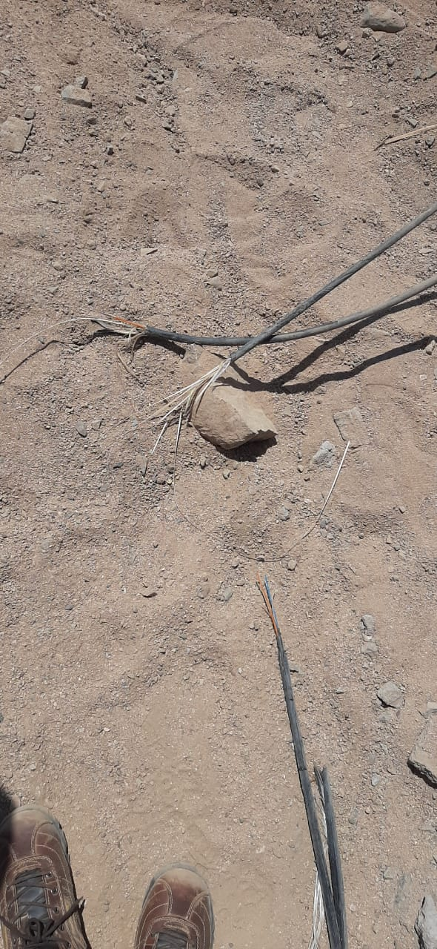 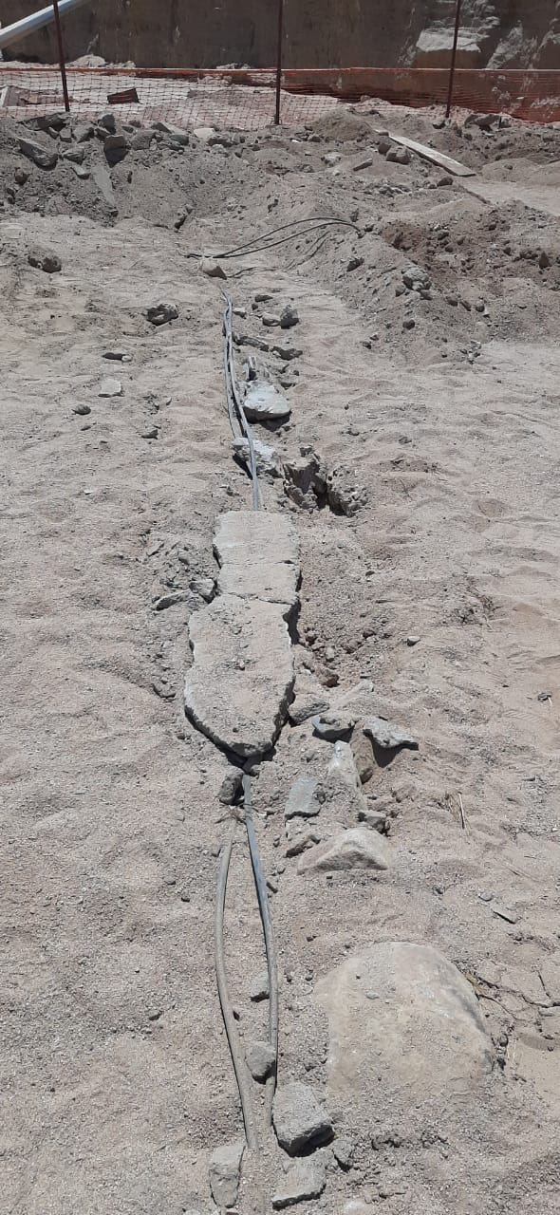

|  |  |  |  |
| --- | --- | --- | --- |
| **Investigation Report Verified by:** | **Noted by:** | **Date** | **7/14/2021** |