|  |  |  |  |  |  |  |  |  |
| --- | --- | --- | --- | --- | --- | --- | --- | --- |
| **Fill the Information Below** | | | | | | | | |
| Company: **Rezayat Company Limited** | | | | | Date: 5/1/2021 | | | |
| Location: **Area 1 (Part 2)** | | | | | Time: 10:00 AM | | | |
| Project/ Site Name: Catering Auditorium & Recreation Facilities : **097-C76R** | | | | | Worst Potential Severity: 3 Actual Severity: 3 | | | |
| **Person(s) Involved:** | **✓** | **Employee** |  | **Contractor** |  | **Others** | |  |
| 1. Dinesh Yadav (carpenter) (36137) | | | 3. | | | | | |
| 2. | | | Other(s). | | | | | |
| **Type of Incident:** | | | | | | | | |
| MTC | | | | | | | | |
| **Injury Location by Body Parts (Select one or more if necessary):** | | | | | | | | |
| Head |  | Chest |  | Hand | **✓** | Eyes |  | |
| Face |  | Leg |  | Arm |  | Hip |  | |
| Neck |  | Abdomen |  | Wrist |  | Ankle/Foot |  | |
| Back |  | Stomach |  | Elbow |  | Knee |  | |
| Nose/ Ears |  | Shoulder |  | Fingers/ Thumb |  | Toes |  | |
| **Type of Injury Sustained (Select one or more if necessary):** | | | | | | | | |
| Fracture |  | Cut/ Laceration | **✓** | Scalping |  | Bruising |  | |
| Loss of Sight |  | Loss of Consciousness |  | Heat |  | Amputation |  | |
| Dislocation |  | Crush Injury |  | Cold |  | Other(s) |  | |
| Abrasion |  | Suffocation |  | Burn |  |  |  | |
| **Immediate Cause(s) (Select one or more if necessary):** | | | | | | | | |
| Safety Rule Violated |  | Lack of Resources |  | Drugs/ Alcohol Related |  | Inadequate Visibility |  | |
| Lack of Task Skill |  | Method Deviation |  | Poor Housekeeping |  | Employee Morale |  | |
| Lack of Supervision |  | Poor Weather Conditions |  | Inadequate Lighting |  | Employee Attitude |  | |
| Improper Lifting (MH) |  | Lack of Task Knowledge |  | Poor Team Work |  | Behavior Problem |  | |
| Not Paying Attention |  | Lack of Communication |  | No Risk Assessment |  | Poor Ground Conditions |  | |
| Human Error | **✓** | Incorrect Tools/Equip | **✓** | Defective Equipment |  | Improper Lifting (crane) |  | |
| Inadequate PPE |  | Defective Tools |  | Unprotected excavation |  | Unprotected Edge |  | |
| Animals |  | Violence |  | Horseplay |  | Improper/ Poor Slinging |  | |
| Heat Stress |  | STF Above Ground |  | STF on the Same Level |  | Manual Handling |  | |
| Misuse of Hand Tools |  | Grinding/ Welding |  | Knives/ Sharps | **✓** | Hit by Vehicle |  | |
| Hit by Static Machinery |  | Heavy Equipment |  | Splashes from C.P.O.L. |  | Other(s) : |  | |
| Stress |  | Fatigue |  | Vandalism |  |  |  | |
| **Equipment(s) Involved:** | | | | | | | | |
| Light Vehicle: |  | Heavy Vehicle: |  | Plant Equipment: |  | Static Plant Equipment: |  | |
| Building: |  | Structure: |  | Scaffold: |  | Excavation: |  | |
| Other(s): |  |  |  |  |  |  |  | |
| **Description of the Event:** | | | | | | | | |
| While removing the concrete from the shuttering plate, IP was hitting the shuttering plate with hammer. During this activity he accidently hit his right hand which was placed on the shuttering plate and it was pinched between hammer and shuttering plate. At that time he didn’t noticed the injury. After some time he removed his gloves and noticed the injury. He got a cut in his right hand. He went to site’s first aid room where he was given first aid. He was taken to Al-mana hospital for further treatment. He got three stitches. | | | | | | | | |
| **Immediate Action(s) Taken to Prevent Reoccurrence (If Any):** | | | | | | | | |
| Accident was investigated.  Workers were advised to use appropriate tools for the activity.  Workers were advised not to place their hands in line of fire.  Use gloves all the time while working. | | | | | | | | |
| **Person Created the Report:** | | | | | | | | |
| Name: Sufyan Javed | | Position: Safety Officer | | Signature: Waqas Gilani | | Date: 5/1/2021 | | |
|  | |  | |  | |  | | |

**Injury**

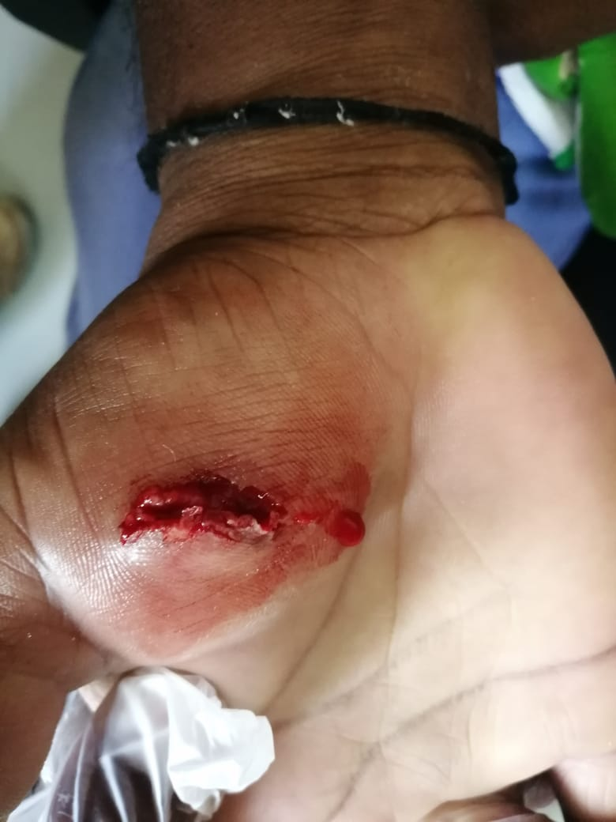

**Gloves**

