|  |  |  |  |  |  |  |  |  |
| --- | --- | --- | --- | --- | --- | --- | --- | --- |
| **Fill the Information Below** | | | | | | | | |
| Company: **Rezayat Company Limited** | | | | | Date: 15-02-2021 | | | |
| Location: **Auditorium** | | | | | Time: 04:00 PM | | | |
| Project/ Site Name: Catering Auditorium & Recreation Facilities : **097-C76R** | | | | |  | | | |
| **Person(s) Involved:** | **✓** | **Employee** |  | **Contractor** |  | **Others** | |  |
| 1. Rakib Md Khokan (Rental Employee)(Dar-ul-Isbat) | | | 3. | | | | | |
| 2. | | |  | | | | | |
| **Type of Incident:** | | | | | | | | |
| Fatality |  | Lost Time Injury |  | Dangerous Occurrence |  | First Aid/**Medical Treatment** | **✓** | |
| **Injury Location by Body Parts (Select one or more if necessary):** | | | | | | | | |
| Head |  | Chest |  | Hand |  | Eyes |  | |
| Face |  | Leg |  | Arm |  | Hip |  | |
| Neck |  | Abdomen |  | Wrist |  | Ankle/Foot |  | |
| Back |  | Stomach |  | Elbow |  | Knee |  | |
| Nose/ Ears |  | Shoulder |  | Fingers/ Thumb | **✓** | Toes |  | |
| **Type of Injury Sustained (Select one or more if necessary):** | | | | | | | | |
| Fracture |  | Cut/ Laceration | **✓** | Scalping |  | Bruising |  | |
| Loss of Sight |  | Loss of Consciousness |  | Heat |  | Amputation |  | |
| Dislocation |  | Crush Injury |  | Cold |  | **Other(s) (Near miss)** |  | |
| Abrasion |  | Suffocation |  | Burn |  |  |  | |
| **Immediate Cause(s) (Select one or more if necessary):** | | | | | | | | |
| Safety Rule Violated |  | Lack of Resources |  | Drugs/ Alcohol Related |  | Inadequate Visibility |  | |
| Lack of Task Skill |  | Method Deviation |  | Poor Housekeeping |  | Employee Morale |  | |
| Lack of Supervision | **✓** | Poor Weather Conditions |  | Inadequate Lighting |  | Employee Attitude |  | |
| Improper Lifting (MH) |  | Lack of Task Knowledge | **✓** | Poor Team Work |  | Behavior Problem |  | |
| Not Paying Attention | **✓** | Lack of Communication |  | No Risk Assessment |  | Poor Ground Conditions |  | |
| Human Error | **✓** | Incorrect Tools/Equip |  | Defective Equipment |  | Improper Lifting (crane) |  | |
| Inadequate PPE |  | Defective Tools |  | Unprotected excavation |  | Unprotected Edge |  | |
| Animals |  | Violence |  | Horseplay |  | Improper/ Poor Slinging |  | |
| Heat Stress |  | STF Above Ground |  | STF on the Same Level |  | Manual Handling |  | |
| Misuse of Hand Tools |  | Grinding/ Welding |  | Knives/ Sharps | **✓** | Hit by Vehicle |  | |
| Hit by Static Machinery |  | Heavy Equipment |  | Splashes from C.P.O.L. |  | Other(s) |  | |
| Stress |  | Fatigue |  | Vandalism |  |  |  | |
| **Equipment(s) Involved:** | | | | | | | | |
| Light Vehicle: |  | Heavy Vehicle: |  | Plant Equipment: |  | Static Plant Equipment: |  | |
| Building: |  | Structure: |  | Scaffold: |  | Excavator: |  | |
| Other(s): **Circular Saw** | **✓** |  |  |  |  |  |  | |
| **Description of the Event:** | | | | | | | | |
| While cutting the plywood with circular saw, Mr. Rakib (IP) turned on the circular saw and tried to raise the guard of the machine with his left hand, at that time his left hand’s gloves caught in teeth of the blade and pulled his middle finger inside.  His middle finger got a deep cut. He was given first aid in the sites first aid room and was sent to hospital where he got four stiches. | | | | | | | | |
| **Immediate Action(s) Taken to Prevent Reoccurance (If Any):** | | | | | | | | |
| Accident was investigated.  Workers advised to adjust the guard before turning on the machine.  Foreman was advised to depute only one experienced personnel for using circular saw.  Engineers were advised replace the MAKITA circular saw with HILTI, as while operating the HILTI’s circular saw the guard does not needs to be adjusted. | | | | | | | | |
| **Person Created the Report:** | | | | | | | | |
| Name**: Waqas Gillani** | | Position: **Safety Engineer** | | Signature: Krishna | | Date: 15/02/2021 | | |
|  | |  | |  | |  | | |

**Injury**

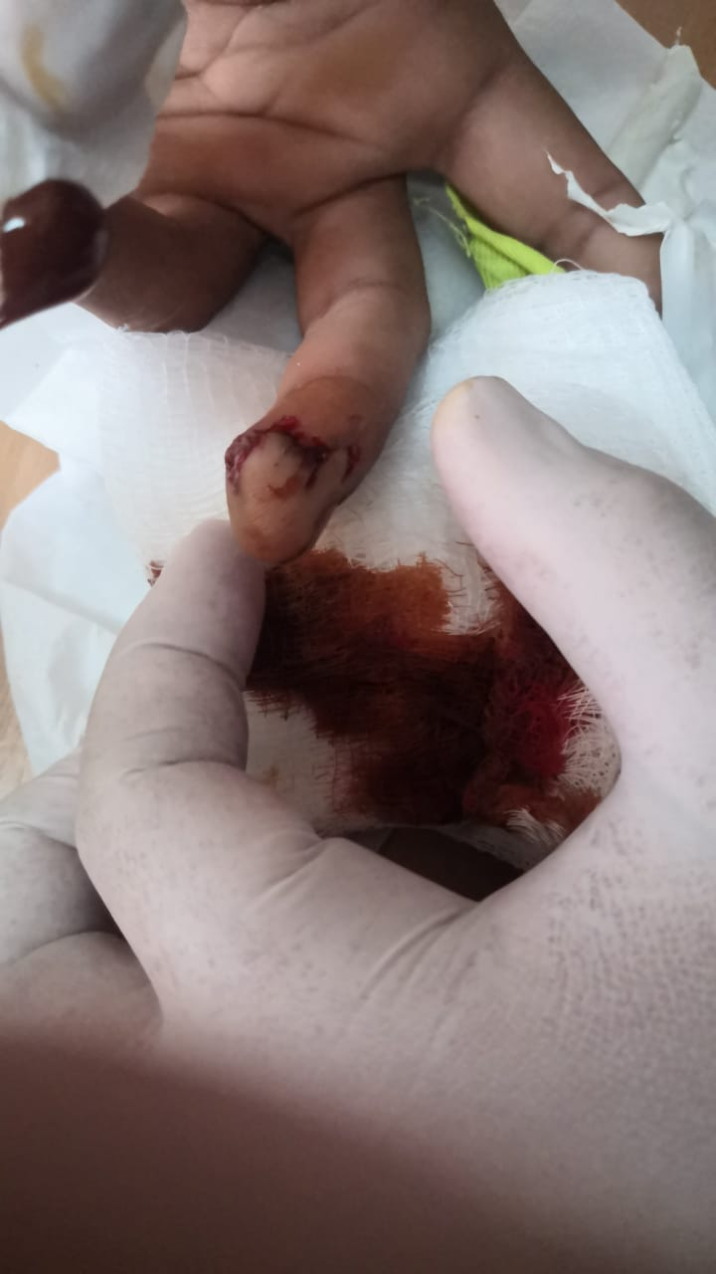

**Gloves**

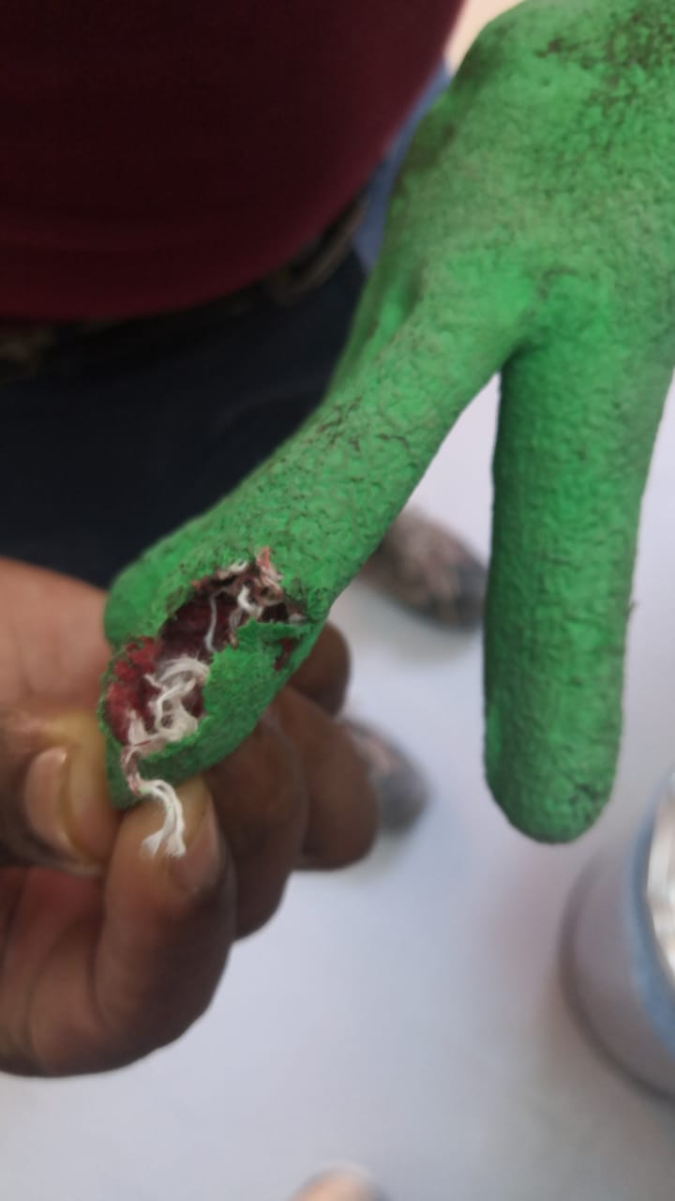

**Normal Resting Position of Guard**

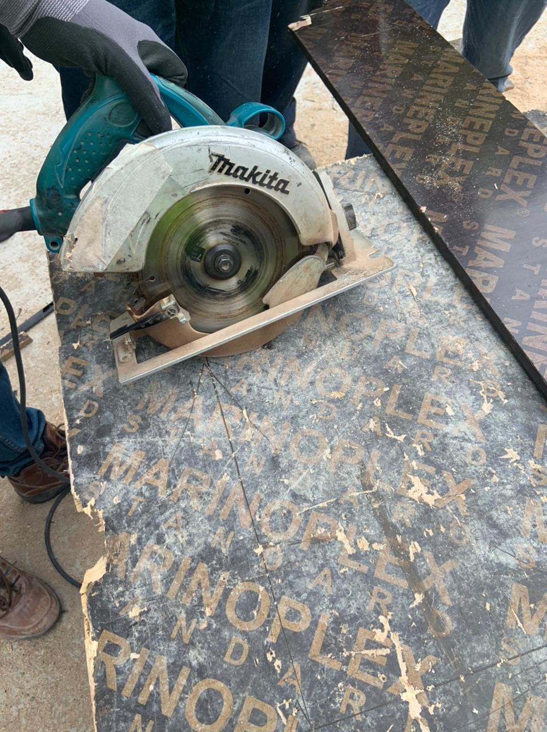

**Position to Adjust the Guard Before Starting Circular Saw**

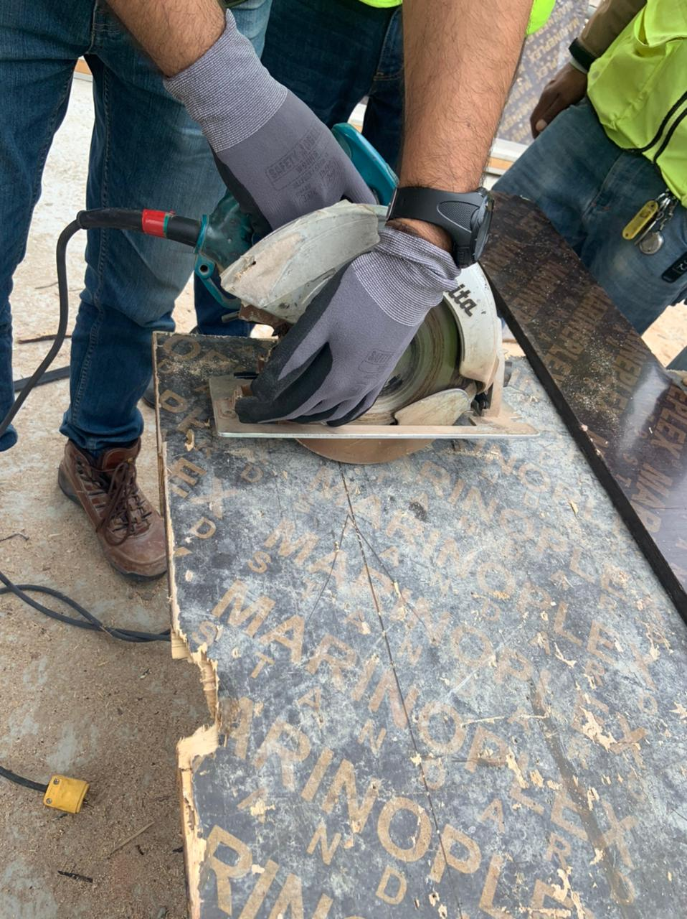

**Position of hand while the accident happened**

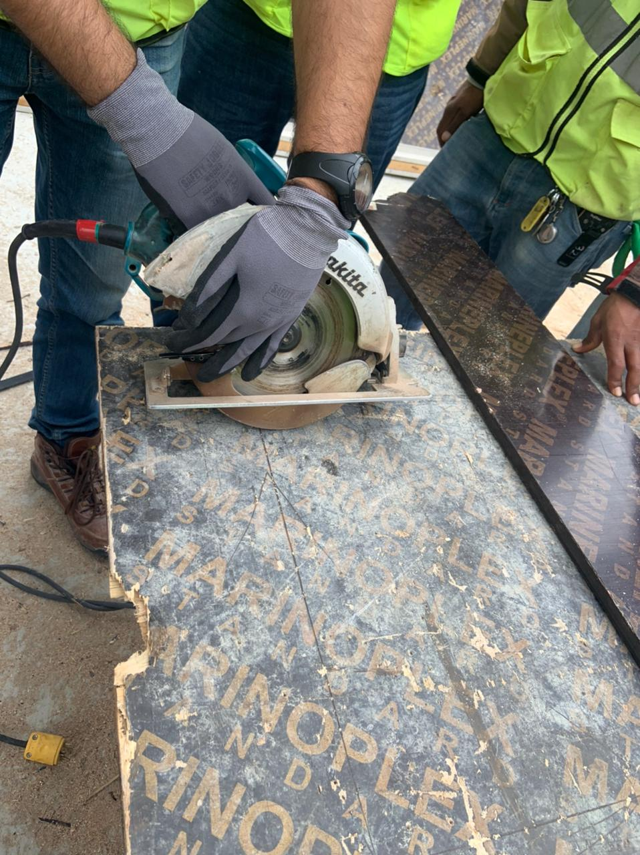

**Position of guard before starting the Circular Saw**

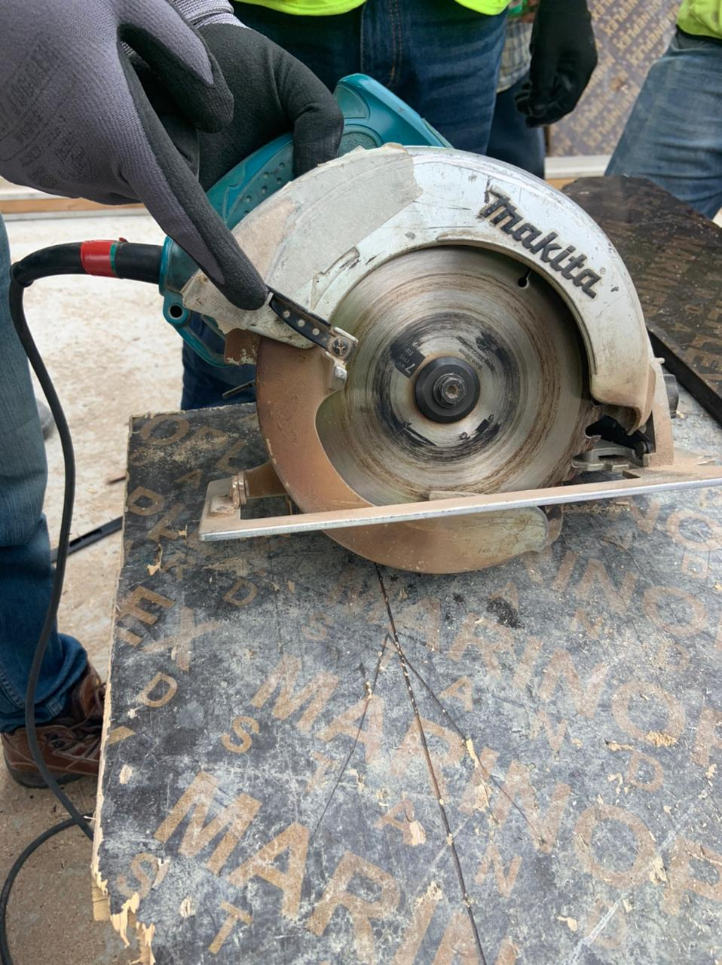

**HILTI’s Circular Saw**

**No Gap in the guard**

**No need for Pre-adjustment**

