|  |  |  |  |  |  |  |  |  |
| --- | --- | --- | --- | --- | --- | --- | --- | --- |
| **Fill the Information Below** | | | | | | | | |
| Company: **Rezayat Company Limited** | | | | | Date: 4/29/2021 | | | |
| Location: **Area 1 (Part 1)** | | | | | Time: 08:10 | | | |
| Project/ Site Name: Catering Auditorium & Recreation Facilities : **097-C76R** | | | | | Worst Potential Severity: 5 Actual Severity: 3 | | | |
| **Person(s) Involved:** |  | **Employee** | **✓** | **Contractor** |  | **Others** | |  |
| 1. EPC Trailer driver (Babar Ali) | | | 3. | | | | | |
| 2. | | | Other(s). | | | | | |
| **Type of Incident:** | | | | | | | | |
| Property Damage | | | | | | | | |
| **Injury Location by Body Parts (Select one or more if necessary):** | | | | | | | | |
| Head |  | Chest |  | Hand |  | Eyes |  | |
| Face |  | Leg |  | Arm |  | Hip |  | |
| Neck |  | Abdomen |  | Wrist |  | Ankle/Foot |  | |
| Back |  | Stomach |  | Elbow |  | Knee |  | |
| Nose/ Ears |  | Shoulder |  | Fingers/ Thumb |  | Toes |  | |
| **Type of Injury Sustained (Select one or more if necessary):** | | | | | | | | |
| Fracture |  | Cut/ Laceration |  | Scalping |  | Bruising |  | |
| Loss of Sight |  | Loss of Consciousness |  | Heat |  | Amputation |  | |
| Dislocation |  | Crush Injury |  | Cold |  | Other(s) |  | |
| Abrasion |  | Suffocation |  | Burn |  |  |  | |
| **Immediate Cause(s) (Select one or more if necessary):** | | | | | | | | |
| Safety Rule Violated |  | Lack of Resources |  | Drugs/ Alcohol Related |  | Inadequate Visibility |  | |
| Lack of Task Skill |  | Method Deviation |  | Poor Housekeeping |  | Employee Morale |  | |
| Lack of Supervision | **✓** | Poor Weather Conditions |  | Inadequate Lighting |  | Employee Attitude |  | |
| Improper Lifting (MH) |  | Lack of Task Knowledge |  | Poor Team Work |  | Behavior Problem |  | |
| Not Paying Attention |  | Lack of Communication |  | No Risk Assessment |  | Poor Ground Conditions | **✓** | |
| Human Error |  | Incorrect Tools/Equip |  | Defective Equipment |  | Improper Lifting (crane) |  | |
| Inadequate PPE |  | Defective Tools |  | Unprotected excavation |  | Unprotected Edge |  | |
| Animals |  | Violence |  | Horseplay |  | Improper/ Poor Slinging | **✓** | |
| Heat Stress |  | STF Above Ground |  | STF on the Same Level |  | Manual Handling |  | |
| Misuse of Hand Tools |  | Grinding/ Welding |  | Knives/ Sharps |  | Hit by Vehicle |  | |
| Hit by Static Machinery |  | Heavy Equipment |  | Splashes from C.P.O.L. |  | Other(s) : |  | |
| Stress |  | Fatigue |  | Vandalism |  |  |  | |
| **Equipment(s) Involved:** | | | | | | | | |
| Light Vehicle: |  | Heavy Vehicle: Trailer | **✓** | Plant Equipment: |  | Static Plant Equipment: |  | |
| Building: |  | Structure: |  | Scaffold: |  | Excavation: |  | |
| Other(s): |  |  |  |  |  |  |  | |
| **Description of the Event:** | | | | | | | | |
| While shifting the precast panels on the trailer from laydown to Area 1. The trailer was passing from the road side of part1 from Al-Kifah’s side, when it passed over the uneven surface and the trailer slightly tilted to the right side that made one of the precast panel on the right side unbalanced and it fell down from the trailer. (See the attached photos)  Fortunately no injury occurred as no one was present near the trailer. The precast wall panel was completely damaged. | | | | | | | | |
| **Immediate Action(s) Taken to Prevent Reoccurrence (If Any):** | | | | | | | | |
| Incident was investigated with the responsible RCL site engineer and contractor engineer.  Advised site superintendent to add base course and compact all the surfaces and roads where heavy vehicle movement is expected.  All potholes must be eliminated from the roads used by precast trailers.  The load must be tied with chain by a skilled person and additional belt must be tied with all the loads.  Load tying method must be verified by the contractor safety staff before entering the site.  Flagman must be deputed with the trailer before entering the trailer onto the site. | | | | | | | | |
| **Person Created the Report:** | | | | | | | | |
| Name: Waqas Gillani | | Position: Safety Engineer | | Signature: Waqas Gilani | | Date: 4/29/2021 | | |
|  | |  | |  | |  | | |

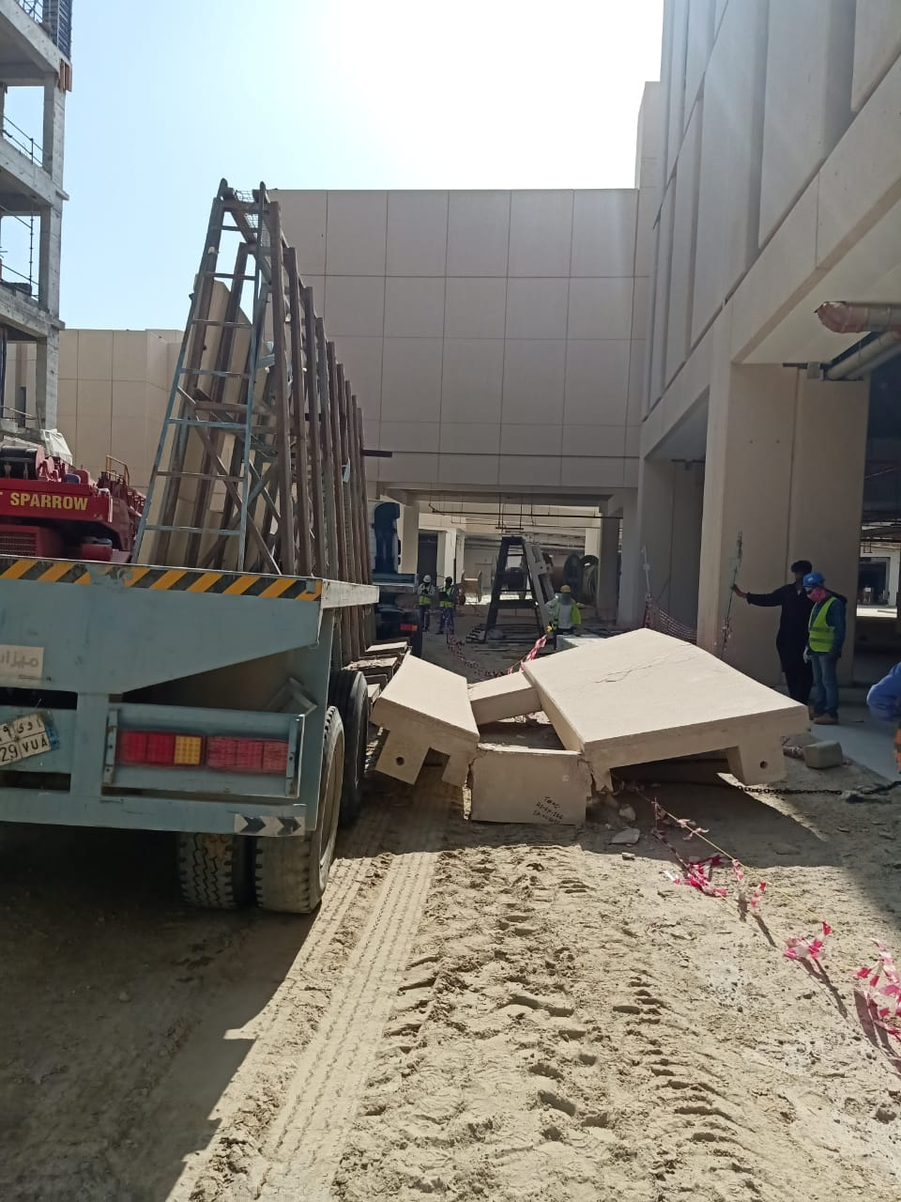

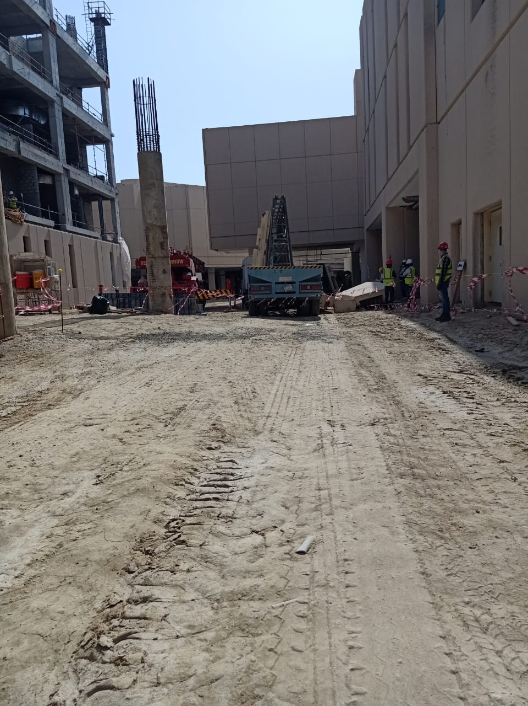

**Slight gradient in the road access**

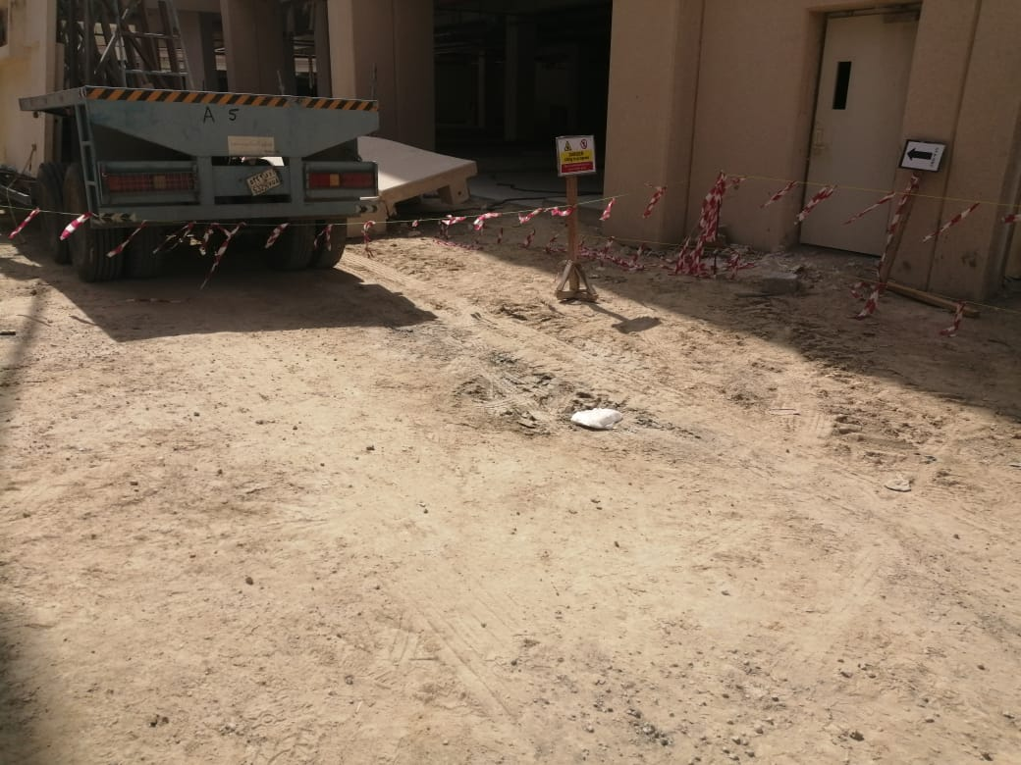

**Uneven surfaces or potholes in the vehicle access**

