|  |  |  |  |  |  |  |  |  |  |  |  |  |  |  |
| --- | --- | --- | --- | --- | --- | --- | --- | --- | --- | --- | --- | --- | --- | --- |
| **Name of Employee** | Shahzaman | | | **Badge No.** | | 30037025 | | | | | | | **Actual**  **Severity:** | 1 |
| **Safety Awareness Training Date** | 10/12/2021 | | | **Proof of Training** | | Project Safety Orientation | | | | | | | **Worst Potential**  **Severity:** | 5 |
| **Name of Line Manager** | Wandrilo Padrillan Aldemita | | | **Badge No.** | | 31031644 | | | **Profession/ Designation** | | | | Project Manager | |
| **Name of Supervisor** | Elsayed Mohamed Dif | | | **Badge No.** | | 30038422 | | | | | | | | |
| **Division / Department** | Construction and Division | | | **Project**  **Name** | | Quran Charity hotel façade design and Build | | | **Project**  **Location** | | | | AL Ula | |
| **Place of the Incident/Injury** | En route to Al Ula | | | **Date of**  **Incident** | | 10/29/2021 | | | **Time of**  **Incident** | | | | 3.30pm | |
| **Nature of the Incident/Injury** | **Occupational Incident/Injury** | No | | | | **Near Miss** | | | **Other, please specify:** | | | | | |
| **Road Traffic Incident/ Injury** | Yes | | | | No | | |
| **Brief Description of the Incident/Injury** | On 29 Oct around 3.30pm, It has been reported by Dyna driver Mr.Shazaman that both the tires on rear left side of vehicle # 7402 VHA were burst out in the middle of road during the travel from Yanbu to Al Ula. Fortunately driver controlled the vehicle and parked aside of the road and reported to project safety officer and Site Engineer for further action. | | | | | | | | | | | | | |
| **Details of the Injury (Specify affected body parts)** | None | | | | | | | | | | | | | |
| **First Aid Given?** | No | | **Name of First Aider** | | | | | N/A | | | | | | |
| **Name of Hospital where patient was treated/transferred** | N/A | | | | | | | **Address/Location of the hospital** | | N/A | | | | |
| **Medical leave given by administering Hospital/Clinic or Doctor** | No | | **Number of Days** | | No | | **Hospitalization** | | | | | No | | |
| **Property damage** | Yes | | **Estimated**  **percentage of damage** | |  | | **Estimated Cost of damaged (SAR)** | | | | | To be estimated | | |
| **Property Details** | **Type / Function of the property** | | Transport | | | | **Location of affected property** | | | | | Left side rear tires | | |
| **Name of Manufacturer** | | Mitsbuishi Fuso | | | | | | | | | | | |
| **Model of the Property** | | Canteer | | | | | **Plate Number** | | | 7402VHA | | | |
| **Vehicle Registration**  **Number** | | 7402 VHA | | | | | **Company Fleet Number** | | | RTE 2202 | | | |

|  |  |  |  |  |  |  |  |  |  |  |  |
| --- | --- | --- | --- | --- | --- | --- | --- | --- | --- | --- | --- |
| **Was Pre- Task / Toolbox meeting conducted** | | No | | | | **Was the person using required Personal Protective Equipment (PPE)** | | | No | | |
| **Specify the Personal Protective Equipment (PPE)** | | | N/A | | | | | | | | |
| **What was the injured person/employee doing at the time of the incident?** | | | | Driving the vehicle | | | | | | | |
| **What was the machine/equipment doing at the time of the incident?** | | | | On road from Yanbu to Al Ula | | | | | | | |
| **What was the material/s / substance/s doing at the time of the incident** | | | | In a circular motion | | | | | | | |
| **Immediate Cause/s of the Incident/injury:**   * Lack of Supervision * Not Paying Attention * Improper loading of cargo which scuffs the tires and led to burst | | | | | | | | | | | |
| **Root Cause/s of the Incident/injury:** | **People:**   * Warehouse in charge fail to load the cargo equally on the truck bed. * Driver fail to pre inspect the truck load for equal distribution before start. | | | | | | | | | | |
| **Process / Procedure:**  N/A | | | | | | | | | | |
| **Equipment:** N/A | | | | | | | | | | |
| **Workplace:** N/A | | | | | | | | | | |
| **Corrective Action to prevent reoccurrence:** | **Elimination:**  Cargo should be equally distributed on the truck bed | | | | | | | | | | |
| **Substitution:** N/A | | | | | | | | | | |
| **Engineering Control:** N/A | | | | | | | | | | |
| **Administrative Control:**   * Instruction given to warehouse in charge for equal distribution of cargo on truck bed * Instruction given to driver to pre-inspect the truck bed for the cargo distribution | | | | | | | | | | |
| **PPE:** | | | | | | | | | | |
| **Were there any witnesses?** | Yes | | **Type of witness/s** | | **Employee** | | | yes | | **Public** |  |
| **Witness Details**  Balwant Rai Sapla | | | | | **Badge**  **Number** | | 30039038 | **Mobile**  **Number** | | 0572116186 | |
| **Witness Statement:**  During the journey from Yanbu to Alulawith the Dyna 7402VHA, suddenly both the tires on left rear side has been burst. Fortunately driver controlled the vehicle and safely parker aside of the road and informed to safety officer and site Engineer. As per Safety officer request pictures has been taken and send to him. | | | | | | | | | | | |

|  |  |  |
| --- | --- | --- |
| **Initial Investigation Conducted by:**  Rejenson Fernando | **Date** | 11/20/2021 |

**Additional Details:**

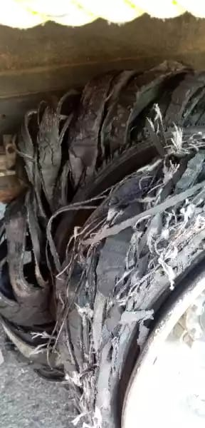 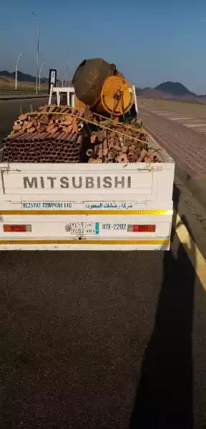

**Picture 2- Rounded part have more load which is replaced to other side after changing both the tires.**

|  |  |  |  |  |
| --- | --- | --- | --- | --- |
| **Investigation Report Verified by:**  **Wandrilo Aldemita** | | | **Date** | **11/20/2021** |
| **Rating of Investigation** | **Best Practice:** | **OK:** | **NOT OK** | |
| **Note: Attach Initial Report Along with this report.**  **Rating Done by: Date:** | | | | |