|  |  |  |  |  |  |  |  |  |
| --- | --- | --- | --- | --- | --- | --- | --- | --- |
| **Fill the Information Below** | | | | | | | | |
| Company: **Rezayat Company Limited** | | | | | Date: 5/26/2021 | | | |
| Location: **Auditorium (Part 2)** | | | | | Time: 08.37 AM | | | |
| Project/ Site Name: Catering Auditorium & Recreation Facilities : **097-C76R** | | | | | Worst Potential Severity: 3 Actual Severity: 3 | | | |
| **Person(s) Involved:** | **✓** | **Employee** |  | **Contractor** |  | **Others** | |  |
| 1. Kalaichelvan Jeyapalan (Badge no. 30038511) | | | 3. | | | | | |
| 2. | | | Other(s). | | | | | |
| **Type of Incident:** | | | | | | | | |
| MTC | | | | | | | | |
| **Injury Location by Body Parts (Select one or more if necessary):** | | | | | | | | |
| Head |  | Chest |  | Hand | **✓** | Eyes |  | |
| Face |  | Leg |  | Arm |  | Hip |  | |
| Neck |  | Abdomen |  | Wrist |  | Ankle/Foot |  | |
| Back |  | Stomach |  | Elbow |  | Knee |  | |
| Nose/ Ears |  | Shoulder |  | Fingers/ Thumb |  | Toes |  | |
| **Type of Injury Sustained (Select one or more if necessary):** | | | | | | | | |
| Fracture |  | Cut/ Laceration | **✓** | Scalping |  | Bruising |  | |
| Loss of Sight |  | Loss of Consciousness |  | Heat |  | Amputation |  | |
| Dislocation |  | Crush Injury |  | Cold |  | Other(s) Avulsion |  | |
| Abrasion |  | Suffocation |  | Burn |  |  |  | |
| **Immediate Cause(s) (Select one or more if necessary):** | | | | | | | | |
| Safety Rule Violated |  | Lack of Resources |  | Drugs/ Alcohol Related |  | Inadequate Visibility |  | |
| Lack of Task Skill |  | Method Deviation |  | Poor Housekeeping |  | Employee Morale |  | |
| Lack of Supervision |  | Poor Weather Conditions |  | Inadequate Lighting |  | Employee Attitude |  | |
| Improper Lifting (MH) |  | Lack of Task Knowledge |  | Poor Team Work |  | Behavior Problem |  | |
| Not Paying Attention | **✓** | Lack of Communication |  | No Risk Assessment |  | Poor Ground Conditions | **✓** | |
| Human Error | **✓** | Incorrect Tools/Equip |  | Defective Equipment |  | Improper Lifting (crane) |  | |
| Inadequate PPE |  | Defective Tools |  | Unprotected excavation |  | Unprotected Edge |  | |
| Animals |  | Violence |  | Horseplay |  | Improper/ Poor Slinging |  | |
| Heat Stress |  | STF Above Ground |  | STF on the Same Level |  | Manual Handling |  | |
| Misuse of Hand Tools |  | Grinding/ Welding |  | Knives/ Sharps | **✓** | Hit by Vehicle |  | |
| Hit by Static Machinery |  | Heavy Equipment |  | Splashes from C.P.O.L. |  | Other(s) : |  | |
| Stress |  | Fatigue |  | Vandalism |  |  |  | |
| **Equipment(s) Involved:** | | | | | | | | |
| Light Vehicle: |  | Heavy Vehicle: |  | Plant Equipment: |  | Static Plant Equipment: |  | |
| Building: |  | Structure: |  | Scaffold: |  | Excavation: |  | |
| Other(s): |  |  |  |  |  |  |  | |
| **Description of the Event:** | | | | | | | | |
| **While fixing the PVC sleeve on top of the slab, the IP was sitting on timber (as shown in the picture) while performing the activity. While fixing the sleeve he got unbalanced and accidentally placed his right hand on the protruding binding wire nearby. The binding wire went inside the gloves and hit his hand, which resulted in a cut to his right hand.**  **He received first aid in the site first aid room and was sent to hospital where he received six stitches and a tetanus shot.** | | | | | | | | |
| **Immediate Action(s) Taken to Prevent Reoccurrence (If Any):** | | | | | | | | |
| **All the binding wires must be bended by the civil team.**  **Proper seating arrangement must be provided for works to avoid tiring posture and to avoid unbalancing.**  **Good quality anti cut gloves must be provided.** | | | | | | | | |
| **Person Created the Report:** | | | | | | | | |
| Name: Arif Khan | | Position: Safety Officer | | Signature: Waqas Gillani | | Date: 5/26/2021 | | |
|  | |  | |  | |  | | |

**Injury**

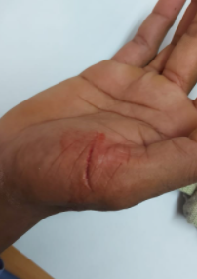

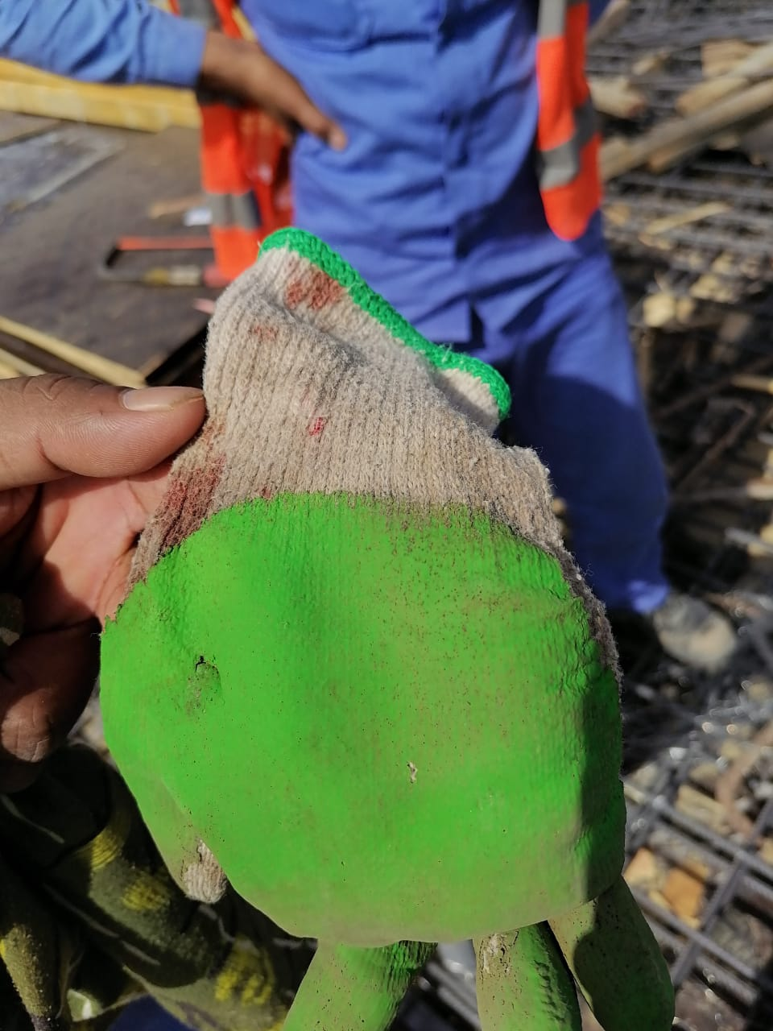

**Place of incident**

