|  |  |  |  |  |  |  |  |  |  |  |  |  |  |  |
| --- | --- | --- | --- | --- | --- | --- | --- | --- | --- | --- | --- | --- | --- | --- |
| **Name of Employee** | Mohammad Babu Mia | | | **Badge No.** | | 30040802 | | | | | | | **Actual**  **Severity:** | 2 |
| **Safety Awareness Training Date** | 6/24/2021 | | | **Proof of Training** | | **Safety Tool Box talk** | | | | | | | **Worst Potential**  **Severity:** | 2 |
| **Name of Line Manager** | Mohamed Abdelmoniem A Arafa | | | **Badge No.** | | 30040488 | | | **Profession/ Designation** | | | | Project Manager | |
| **Name of Supervisor** | Mohammed Naveed Pasha | | | **Badge No.** | | 31031389 | | | | | | | | |
| **Division / Department** | Construction and Maintenance | | | **Project**  **Name** | | Corrosion Repair | | | **Project**  **Location** | | | | RC YANBU | |
| **Place of the Incident/Injury** | RC Ibn Boundary wall area | | | **Date of**  **Incident** | | 7/8/2021 | | | **Time of**  **Incident** | | | | 10.30 am | |
| **Nature of the Incident/Injury** | **Occupational Incident/Injury** | Yes | | | | **Near Miss** | | | **Other, Please specify :** | | | | | |
| **Road Traffic Incident/ Injury** | No | | | | No | | |
| **Brief Description of the Incident/Injury** | Around 11.30 am, Mohammed Babu Mia-helper cutting the steels from the demolished area to separate steels and concrete debris. Without completing the cutting of whole steel, he used both of his hands to separate the steel where right end of steel slips on his left-hand elbow resulting with laceration injury. Immediate First Aid has been given at site Store and taken to Male nurse for further care. | | | | | | | | | | | | | |
| **Details of the Injury (Specify affected body parts)** | **Left hand Elbow** | | | | | | | | | | | | | |
| **First Aid Given?** | Yes | | **Name of First Aider** | | | | | Krishna Mohan Gupta | | | | | | |
| **Name of Hospital where patient was treated/transferred** | SAFA HOSPITAL | | | | | | | **Address/Location of the hospital** | | YANBU | | | | |
| **Medical leave given by administering Hospital/Clinic or Doctor** | Yes | | **Number of Days** | | 5 | | **Hospitalization** | | | | | No | | |
| **Property damage** | No | | **Estimated**  **percentage of damage** | |  | | **Estimated Cost of damaged (SAR)** | | | | |  | | |
| **Property Details** | **Type / Function of the property** | |  | | | | **Location of affected property** | | | | |  | | |
| **Name of Manufacturer** | | N/A | | | | | | | | | | | |
| **Model of the Property** | |  | | | | | **Plate Number** | | |  | | | |
| **Vehicle Registration**  **Number** | |  | | | | | **Company Fleet Number** | | |  | | | |

|  |  |  |  |  |  |  |  |  |  |  |  |
| --- | --- | --- | --- | --- | --- | --- | --- | --- | --- | --- | --- |
| **Was Pre- Task / Toolbox meeting conducted** | | Yes | | | | **Was the person using required Personal Protective Equipment (PPE)** | | | Yes | | |
| **Specify the Personal Protective Equipment (PPE)** | | | Helmet, Safety Shoes, Hand gloves, Safety Glass and Uniform | | | | | | | | |
| **What was the injured person/employee doing at the time of the incident?** | | | | Cutting the steels from the concrete debris | | | | | | | |
| **What was the machine/equipment doing at the time of the incident?** | | | | N/A | | | | | | | |
| **What was the material/s / substance/s doing at the time of the incident** | | | | Concrete debris with steels in the ground | | | | | | | |
| **Immediate Cause/s of the Incident/injury:**     * Method Deviation * Knives/Sharp- edged steels | | | | | | | | | | | |
| **Root Cause/s of the Incident/injury:** | **People:** Fail to assess the workplace the hazards and not followed safe working methods | | | | | | | | | | |
| **Process / Procedure:**  Fail to cut the steels completely with the grinder machine | | | | | | | | | | |
| **Equipment:** | | | | | | | | | | |
| **Workplace:** | | | | | | | | | | |
| **Corrective Action to prevent reoccurrence:** | **Elimination:**  Instructed to cut the steels completely with the power tool. | | | | | | | | | | |
| **Substitution:** | | | | | | | | | | |
| **Engineering Control:** | | | | | | | | | | |
| **Administrative Control:**  Refresher training on assessment of Workplace hazards and safe work methods before start of job. | | | | | | | | | | |
| **PPE:** | | | | | | | | | | |
| **Were there any witnesses?** | None | | **Type of witness/s** | |  | | | Yes | | **Public** |  |
| **Witness Details** | | | | | **Badge**  **Number** | |  | **Mobile**  **Number** | |  | |
| **Witness Statement:** | | | | | | | | | | | |

|  |  |  |  |
| --- | --- | --- | --- |
| **Initial Investigation Conducted by:**  **Rejenson Fernando** | **Noted by:** | **Date** | 7/31/2021 |

**Additional Details:**

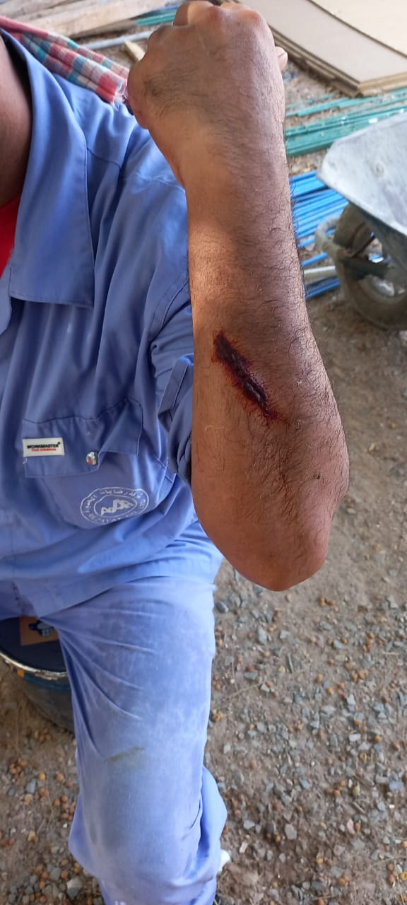

|  |  |  |  |
| --- | --- | --- | --- |
| **Investigation Report Verified by**  **Mohammad Arafa** | **Noted by:** | **Date** | **7/31/2021** |