|  |  |  |  |  |  |  |  |  |
| --- | --- | --- | --- | --- | --- | --- | --- | --- |
| **Fill the Information Below** | | | | | | | | |
| Company: **Rezayat Company Limited** | | | | | Date: 6/20/2021 | | | |
| Location: **Area 1 (Part1 – 1st floor)** | | | | | Time: 08:30 AM | | | |
| Project/ Site Name: Catering Auditorium & Recreation Facilities : **097-C76R** | | | | | Worst Potential Severity: 3 Actual Severity: 2 | | | |
| **Person(s) Involved:** | **✓** | **Employee** |  | **Contractor** |  | **Others** | |  |
| 1. Afzal Hossain (30041079) | | | 3. | | | | | |
| 2. | | | Other(s). | | | | | |
| **Type of Incident:** | | | | | | | | |
| First Aid Case | | | | | | | | |
| **Injury Location by Body Parts (Select one or more if necessary):** | | | | | | | | |
| Head |  | Chest |  | Hand |  | Eyes |  | |
| Face |  | Leg |  | Arm |  | Hip |  | |
| Neck |  | Abdomen |  | Wrist |  | Ankle/Foot |  | |
| Back |  | Stomach |  | Elbow |  | Knee | **✓** | |
| Nose/ Ears |  | Shoulder |  | Fingers/ Thumb |  | Toes |  | |
| **Type of Injury Sustained (Select one or more if necessary):** | | | | | | | | |
| Fracture |  | Cut/ Laceration |  | Scalping |  | Bruising | **✓** | |
| Loss of Sight |  | Loss of Consciousness |  | Heat |  | Amputation |  | |
| Dislocation |  | Crush Injury |  | Cold |  | Other(s) |  | |
| Abrasion |  | Suffocation |  | Burn |  |  |  | |
| **Immediate Cause(s) (Select one or more if necessary):** | | | | | | | | |
| Safety Rule Violated | **✓** | Lack of Resources |  | Drugs/ Alcohol Related |  | Inadequate Visibility |  | |
| Lack of Task Skill |  | Method Deviation | **✓** | Poor Housekeeping |  | Employee Morale |  | |
| Lack of Supervision | **✓** | Poor Weather Conditions |  | Inadequate Lighting |  | Employee Attitude |  | |
| Improper Lifting (MH) |  | Lack of Task Knowledge |  | Poor Team Work |  | Behavior Problem |  | |
| Not Paying Attention |  | Lack of Communication |  | No Risk Assessment |  | Poor Ground Conditions |  | |
| Human Error |  | Incorrect Tools/Equip |  | Defective Equipment |  | Improper Lifting (crane) |  | |
| Inadequate PPE |  | Defective Tools |  | Unprotected excavation |  | Unprotected Edge |  | |
| Animals |  | Violence |  | Horseplay |  | Improper/ Poor Slinging |  | |
| Heat Stress |  | STF Above Ground |  | STF on the Same Level |  | Manual Handling |  | |
| Misuse of Hand Tools |  | Grinding/ Welding |  | Knives/ Sharps |  | Hit by Vehicle |  | |
| Hit by Static Machinery |  | Heavy Equipment |  | Splashes from C.P.O.L. |  | Other(s) : |  | |
| Stress |  | Fatigue |  | Vandalism |  |  |  | |
| **Equipment(s) Involved:** | | | | | | | | |
| Light Vehicle: |  | Heavy Vehicle: |  | Plant Equipment: |  | Static Plant Equipment: |  | |
| Building: |  | Structure: |  | Scaffold: |  | Excavation: |  | |
| Other(s): **A-Type** **Ladder** | **✓** |  |  |  |  |  |  | |
| **Description of the Event:** | | | | | | | | |
| IP was carrying out chipping activity on the A-Type ladder with the help of Jack hammer (As shown in the picture). While he was coming down from the ladder his foot slipped from the 3rd last step of the ladder, he was not able to hold onto the ladder and he fell down to the floor. His left knee hit the floor. As a result he got minor bruises on the left knee.  He got first aid treatment in the Site’s first aid room. | | | | | | | | |
| **Immediate Action(s) Taken to Prevent Reoccurrence (If Any):** | | | | | | | | |
| Incident was investigated.  Ladder safety training was conducted with mason team.  No tools or materials must be handled while climbing or descending the ladder.  Advised workers that while working or standing on the ladder, facing in opposite side the ladder is not allowed.  Mobile scaffoldings must be provided instead of working on ladders for long durations. | | | | | | | | |
| **Person Created the Report:** | | | | | | | | |
| Name: Arif Khan | | Position: Safety Officer | | Signature: Waqas Gilani | | Date: 6/20/2021 | | |
|  | |  | |  | |  | | |

**Working Scenario**

 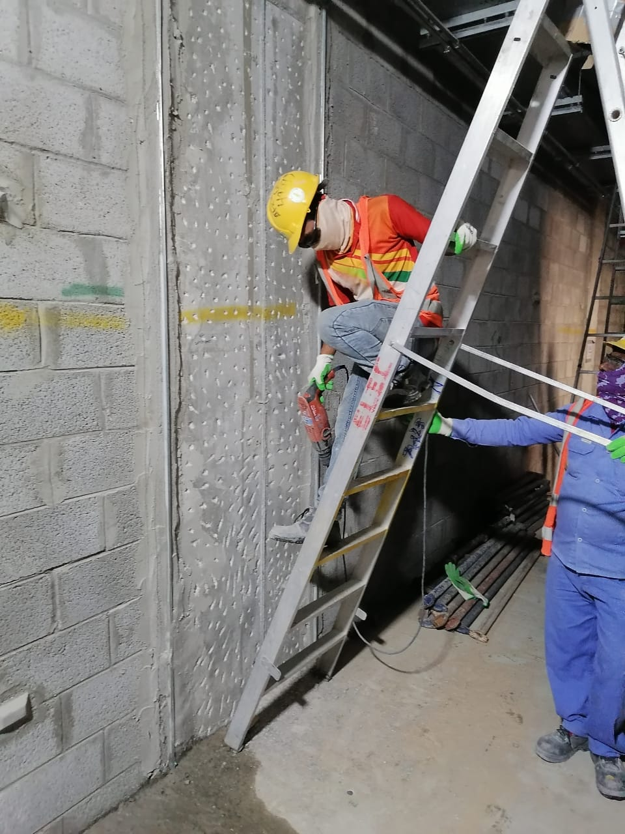

**Foot slipped while coming down**

**Facing in the opposite direction of the ladder**