|  |  |  |  |  |  |  |  |  |  |  |  |  |  |  |
| --- | --- | --- | --- | --- | --- | --- | --- | --- | --- | --- | --- | --- | --- | --- |
| **Name of Employee** | Muhammad Nur | | | **Badge No.** | | 30040805 | | | | | | | **Actual**  **Severity:** | 1 |
| **Safety Awareness Training Date** | 7/16/2022 | | | **Proof of Training** | | Safety Induction and PTB | | | | | | | **Worst Potential**  **Severity:** | 4 |
| **Name of Line Manager** | Rafeeq Ahamad Perumal | | | **Badge No.** | | 30104075 | | | **Profession/ Designation** | | | | Project Manager | |
| **Name of Supervisor** | Mohamed Abdou | | | **Badge No.** | | 30035435 | | | | | | | | |
| **Division / Department** | Construction | | | **Project**  **Name** | | Construction of public Housing | | | **Project**  **Location** | | | | Yanbu | |
| **Place of the Incident/Injury** | Worksite | | | **Date of**  **Incident** | | 7/16/2021 | | | **Time of**  **Incident** | | | | 5.30pm | |
| **Nature of the Incident/Injury** | **Occupational Incident/Injury** | Yes | | | | **Near Miss** | | | **Other, please specify:** | | | | | |
| **Road Traffic Incident/ Injury** | No | | | | No | | |
| **Brief Description of the Incident/Injury** | Muhammad Nur -Helper got light bruise in his right hand middle finger while switching off the equipment (Jumping compactor) by the incorrect method advised by mechanic personnel where he tries to disconnect the power source with damaged cable by touching the equipment body which is very close to rotating parts. | | | | | | | | | | | | | |
| **Details of the Injury (Specify affected body parts)** | Right hand middle finger | | | | | | | | | | | | | |
| **First Aid Given?** | Yes | | **Name of First Aider** | | | | | Rejenson Fernando | | | | | | |
| **Name of Hospital where patient was treated/transferred** | N/A | | | | | | | **Address/Location of the hospital** | | N/A | | | | |
| **Medical leave given by administering Hospital/Clinic or Doctor** | No | | **Number of Days** | | No | | **Hospitalization** | | | | | No | | |
| **Property damage** | No | | **Estimated**  **percentage of damage** | |  | | **Estimated Cost of damaged (SAR)** | | | | |  | | |
| **Property Details** | **Type / Function of the property** | |  | | | | **Location of affected property** | | | | |  | | |
| **Name of Manufacturer** | |  | | | | | | | | | | | |
| **Model of the Property** | |  | | | | | **Plate Number** | | |  | | | |
| **Vehicle Registration**  **Number** | |  | | | | | **Company Fleet Number** | | |  | | | |

|  |  |  |  |  |  |  |  |  |  |  |  |
| --- | --- | --- | --- | --- | --- | --- | --- | --- | --- | --- | --- |
| **Was Pre- Task / Toolbox meeting conducted** | | Yes | | | | **Was the person using required Personal Protective Equipment (PPE)** | | | Yes | | |
| **Specify the Personal Protective Equipment (PPE)** | | | Safety Helmet, Shoes, Goggles, Ear plug and Hand gloves | | | | | | | | |
| **What was the injured person/employee doing at the time of the incident?** | | | | Shutting down the Jumping compactor | | | | | | | |
| **What was the machine/equipment doing at the time of the incident?** | | | | Jumping compactor was in operation | | | | | | | |
| **What was the material/s / substance/s doing at the time of the incident** | | | | N/A | | | | | | | |
| **Immediate Cause/s of the Incident/injury:**  Damaged cable  Rotating part was not completed guarded | | | | | | | | | | | |
| **Root Cause/s of the Incident/injury:** | **People:**  Fail to report the defective ON OFF switch cable to the supervisor/Safety | | | | | | | | | | |
| **Process / Procedure:**  Mechanic personnel advised incorrect method for shutting down | | | | | | | | | | |
| **Equipment:**  On OFF switch cable has been damaged  Inappropriate Safety Guard for the Rotating parts | | | | | | | | | | |
| **Workplace:** N/A | | | | | | | | | | |
| **Corrective Action to prevent reoccurrence:** | **Elimination:**  Instructed to report any defective items from the equipment | | | | | | | | | | |
| **Substitution: N/A** | | | | | | | | | | |
| **Engineering Control:**  Replaced the apt guard for the rotating parts of the equipment  ON OFF switch cable was replaced | | | | | | | | | | |
| **Administrative Control:**  Refresher training provided to the mechanic personnel for not to advise incorrect methods | | | | | | | | | | |
| **PPE:** | | | | | | | | | | |
| **Were there any witnesses?** | None | | **Type of witness/s** | | **Employee** | | |  | | **Public** |  |
| **Witness Details** | | | | | **Badge**  **Number** | |  | **Mobile**  **Number** | |  | |
| **Witness Statement:** | | | | | | | | | | | |

|  |  |  |  |
| --- | --- | --- | --- |
| **Initial Investigation Conducted by:**  **Rejenson Fernando** | **Noted by:** | **Date** | 7/19/2021 |

**Additional Details:**

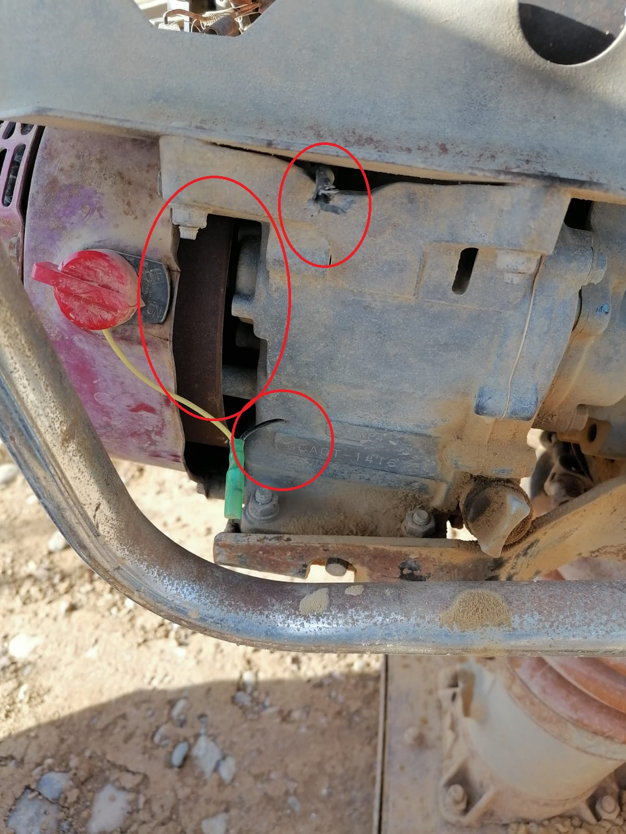 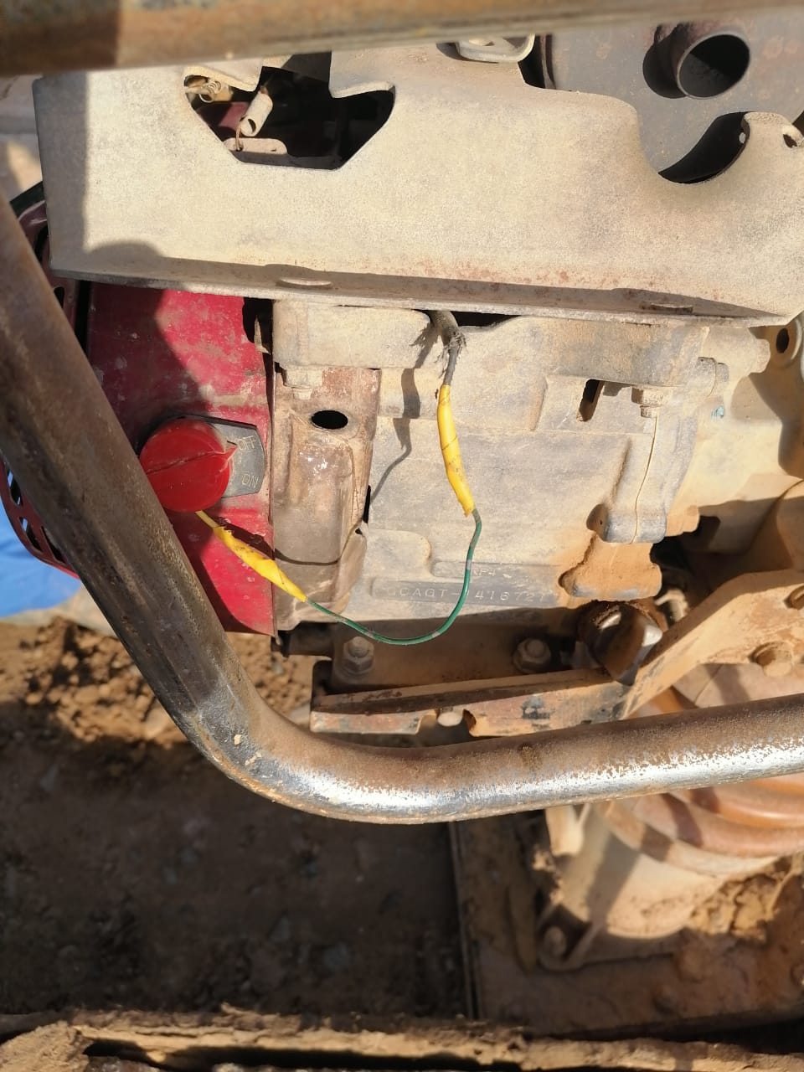

|  |  |  |  |  |
| --- | --- | --- | --- | --- |
| **Investigation Report Verified by:**  **Rafeeq Ahmed Perumal** | | **Noted by:** | **Date** | **7/19/2021** |
| **Rating of Investigation** | **Best Practice:** | **OK:** | **NOT OK** | |
| **Note: Attach Initial Report Along with this report.**  .-  **Rating Done by: Date:** | | | | |