|  |  |  |  |  |  |  |  |  |  |  |  |  |  |  |
| --- | --- | --- | --- | --- | --- | --- | --- | --- | --- | --- | --- | --- | --- | --- |
| **Name of Employee** | Steven Anthony | | | **Badge No.** | | 30037832 | | | | | | | **Actual**  **Severity:** | 1 |
| **Safety Awareness Training Date** | 8/8/2021 | | | **Proof of Training** | | Weekly safety meeting | | | | | | | **Worst Potential**  **Severity:** | 2 |
| **Name of Line Manager** | Osama Abdelwahid | | | **Badge No.** | | 30036232 | | | **Profession/ Designation** | | | | Supervisor | |
| **Name of Supervisor** | Osama Abdelwahid | | | **Badge No.** | | 30036232 | | | | | | | | |
| **Division / Department** | Maintenance | | | **Project**  **Name** | | Sabic Housing Restoration | | | **Project**  **Location** | | | | RC-Yanbu | |
| **Place of the Incident/Injury** | RC- Housing area | | | **Date of**  **Incident** | | 8/10/2021 | | | **Time of**  **Incident** | | | | 4.20pm | |
| **Nature of the Incident/Injury** | **Occupational Incident/Injury** | Yes | | | | **Near Miss** | | | **Other, please specify:** | | | | | |
| **Road Traffic Incident/ Injury** | Yes | | | | No | | |
| **Brief Description of the Incident/Injury** | On 10-Aug-2021, 4.20pm, When LV driver Mr. Steven Anthony returning to workshop with technicians from Radva 4 Al Shifa street area, He saw one Dyna stopped on the same lane of the road without any signals. He makes horn from his vehicle for getting the signal from dyna operator where he couldn’t get any response. So, he changed the second lane to move forward where suddenly dyna took reverse without giving any signals and hit the pickup 5539 HAB at rear right side of tail bed resulting with scratches | | | | | | | | | | | | | |
| **Details of the Injury (Specify affected body parts)** | **No** | | | | | | | | | | | | | |
| **First Aid Given?** | No | | **Name of First Aider** | | | | | N?A | | | | | | |
| **Name of Hospital where patient was treated/transferred** | N/A | | | | | | | **Address/Location of the hospital** | | N/A | | | | |
| **Medical leave given by administering Hospital/Clinic or Doctor** | No | | **Number of Days** | | No | | **Hospitalization** | | | | | No | | |
| **Property damage** | Yes | | **Estimated**  **percentage of damage** | | - | | **Estimated Cost of damaged (SAR)** | | | | | 1412 | | |
| **Property Details** | **Type / Function of the property** | | Transportation | | | | **Location of affected property** | | | | | Rear right side of tail bed | | |
| **Name of Manufacturer** | | Toyota | | | | | | | | | | | |
| **Model of the Property** | | Hilux | | | | | **Plate Number** | | | 5539 HAB | | | |
| **Vehicle Registration**  **Number** | | 5539HAB | | | | | **Company Fleet Number** | | | 2367 | | | |

|  |  |  |  |  |  |  |  |  |  |  |  |  |
| --- | --- | --- | --- | --- | --- | --- | --- | --- | --- | --- | --- | --- |
| **Was Pre- Task / Toolbox meeting conducted** | | No | | | | | **Was the person using required Personal Protective Equipment (PPE)** | | | Yes | | |
| **Specify the Personal Protective Equipment (PPE)** | | | | Safety Shoe, Uniform | | | | | | | | |
| **What was the injured person/employee doing at the time of the incident?** | | | | | Driving the vehicle | | | | | | | |
| **What was the machine/equipment doing at the time of the incident?** | | | | | Stopped on the same lane of the road | | | | | | | |
| **What was the material/s / substance/s doing at the time of the incident** | | | | | N/A | | | | | | | |
| **Immediate Cause/s of the Incident/injury:**   * Lack of communication * Hit by vehicle | | | | | | | | | | | | |
| **Root Cause/s of the Incident/injury:** | **People:**   * Fail to follow the traffic rules and regulations. | | | | | | | | | | | |
| **Process / Procedure:**   * Fail to alert with the signals (Communication) while reversing-Dyna Operator. * Fail to follow the safe distance between two vehicles- Pickup operator | | | | | | | | | | | |
| **Equipment:** | | | | | | | | | | | |
| **Workplace:** | | | | | | | | | | | |
| **Corrective Action to prevent reoccurrence:** | **Elimination:**   * Proper signals/alert must be provided during reverse -Dyna Operator | | | | | | | | | | | |
| **Substitution:**  N/A | | | | | | | | | | | |
| **Engineering Control:**  N/A | | | | | | | | | | | |
| **Administrative Control:**   * Instructed to follow the Road traffic rules always * Refresh training for safe driving techniques and maintain proper communications/Safe distance. | | | | | | | | | | | |
| **PPE:** N/A | | | | | | | | | | | |
| **Were there any witnesses?** | Yes | | **Type of witness/s** | | | **Employee** | | | Yes | | **Public** |  |
| **Witness Details**  Chudamani Dulal | | | | | | **Badge**  **Number** | | 30036878 | **Mobile**  **Number** | | 0572107878 | |
| **Witness Statement:**  After duty when returning to workshop with pickup 5539 HAB near Radwa 4 al Shifa street, we found one dyna was stopped on the lane where we moving and no any signals, Diver make alert with horn and didn’t get any response. So, he tries to take another lane for moving forward where suddenly dyna took reverse with giving any signals and hit the pickup. | | | | | | | | | | | | |

|  |  |  |  |
| --- | --- | --- | --- |
| **Initial Investigation Conducted by:**  **Rejenson Fernando** | **Noted by:** | **Date** | 8/12/2021 |

**Additional Details:**

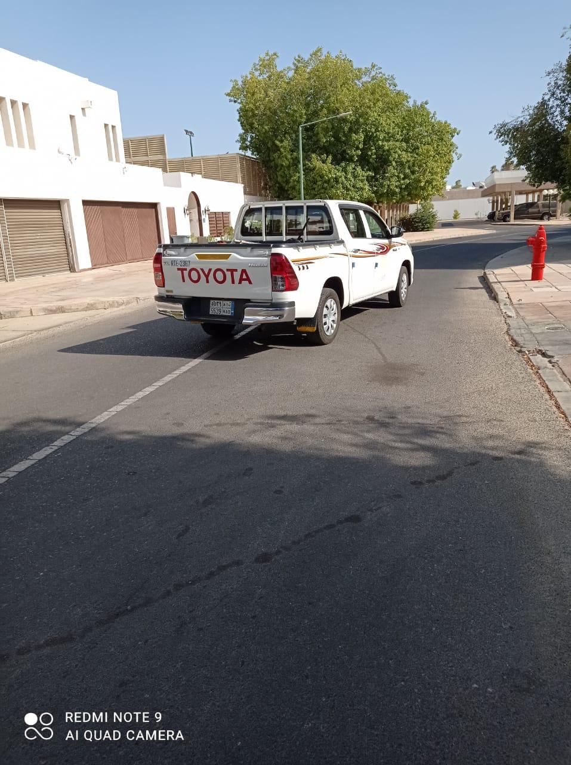 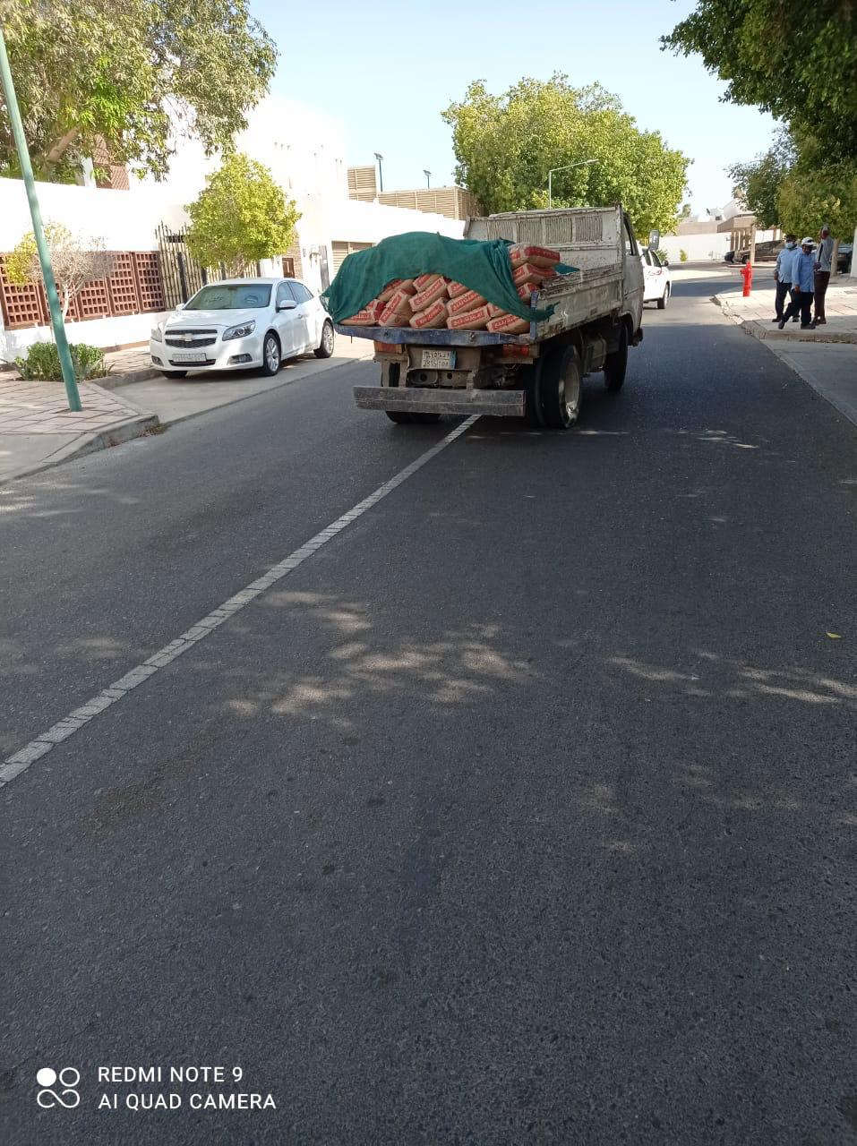

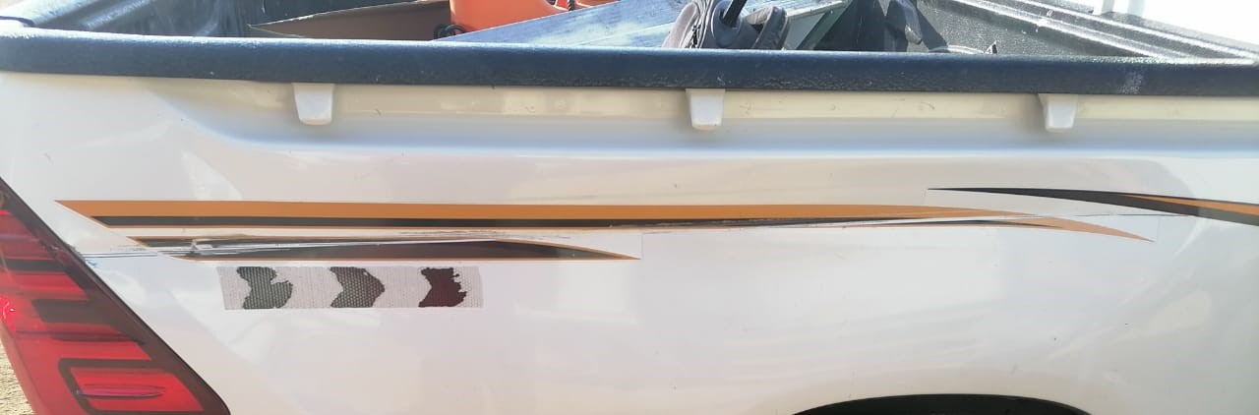

|  |  |  |  |  |
| --- | --- | --- | --- | --- |
| **Investigation Report Verified by:** | | **Noted by:** | **Date** | **8/31/2021** |
| **Rating of Investigation** | **Best Practice:** | **OK:** | **NOT OK** | |
| **Note: Attach Initial Report Along with this report.**  .-  **Rating Done by: Date:** | | | | |