|  |  |  |  |  |  |  |  |  |
| --- | --- | --- | --- | --- | --- | --- | --- | --- |
| **Fill the Information Below** | | | | | | | | |
| Company: **Rezayat Company Limited** | | | | | Date: 24-02-2021 | | | |
| Location: **Auditorium** | | | | | Time: 09:00 AM | | | |
| Project/ Site Name: Catering Auditorium & Recreation Facilities : **097-C76R** | | | | |  | | | |
| **Person(s) Involved:** | **✓** | **Employee** |  | **Contractor** |  | **Others** | |  |
| 1. Akhilesar Chaudhry (Rigger) (44064285) | | | 3. | | | | | |
| 2. Popat (Tower crane Operator) | | |  | | | | | |
| **Type of Incident:** | | | | | | | | |
| Fatality |  | Lost Time Injury |  | Dangerous Occurrence |  | First Aid/Medical Treatment |  | |
| **Injury Location by Body Parts (Select one or more if necessary):** | | | | | | | | |
| Head |  | Chest |  | Hand |  | Eyes |  | |
| Face |  | Leg |  | Arm |  | Hip |  | |
| Neck |  | Abdomen |  | Wrist |  | Ankle/Foot |  | |
| Back |  | Stomach |  | Elbow |  | Knee |  | |
| Nose/ Ears |  | Shoulder |  | Fingers/ Thumb |  | Toes |  | |
| **Type of Injury Sustained (Select one or more if necessary):** | | | | | | | | |
| Fracture |  | Cut/ Laceration |  | Scalping |  | Bruising |  | |
| Loss of Sight |  | Loss of Consciousness |  | Heat |  | Amputation |  | |
| Dislocation |  | Crush Injury |  | Cold |  | **Other(s) (Near miss)** | **✓** | |
| Abrasion |  | Suffocation |  | Burn |  |  |  | |
| **Immediate Cause(s) (Select one or more if necessary):** | | | | | | | | |
| Safety Rule Violated |  | Lack of Resources |  | Drugs/ Alcohol Related |  | Inadequate Visibility |  | |
| Lack of Task Skill |  | Method Deviation |  | Poor Housekeeping |  | Employee Morale |  | |
| Lack of Supervision | **✓** | Poor Weather Conditions |  | Inadequate Lighting |  | Employee Attitude |  | |
| Improper Lifting (MH) |  | Lack of Task Knowledge |  | Poor Team Work |  | Behavior Problem |  | |
| Not Paying Attention | **✓** | Lack of Communication |  | No Risk Assessment |  | Poor Ground Conditions |  | |
| Human Error | **✓** | Incorrect Tools/Equip |  | Defective Equipment |  | Improper Lifting (crane) |  | |
| Inadequate PPE |  | Defective Tools |  | Unprotected excavation |  | Unprotected Edge |  | |
| Animals |  | Violence |  | Horseplay |  | Improper/ Poor Slinging |  | |
| Heat Stress |  | STF Above Ground |  | STF on the Same Level |  | Manual Handling |  | |
| Misuse of Hand Tools |  | Grinding/ Welding |  | Knives/ Sharps |  | Hit by Vehicle |  | |
| Hit by Static Machinery |  | Heavy Equipment |  | Splashes from C.P.O.L. |  | Other(s) |  | |
| Stress |  | Fatigue |  | Vandalism |  |  |  | |
| **Equipment(s) Involved:** | | | | | | | | |
| Light Vehicle: |  | Heavy Vehicle: |  | Plant Equipment: |  | Static Plant Equipment: |  | |
| Building: |  | Structure: |  | Scaffold: |  | Excavator: |  | |
| Other(s): **Tower Crane** | **✓** |  |  |  |  |  |  | |
| **Description of the Event:** | | | | | | | | |
| While the mobile crane (100 ton) was engaged in the activity to remove the shuttering in part 2, nearby there was tower crane activity was also going on to install Hollow core. The Tower crane operator gave the signal to the operator to swing the boom to left side. The tower crane operator swung the boom and it hit slightly with the boom of the mobile crane (that was stationary at that time). | | | | | | | | |
| **Immediate Action(s) Taken to Prevent Reoccurance (If Any):** | | | | | | | | |
| Stopped the work and incident was investigated.  No parallel crane activities must be allowed nearby (Only one crane to work in one single location).  Competent rigger must be deputed for tower crane activities.  Rigger was terminated as it was a repeated mistake from his side. | | | | | | | | |
| **Person Created the Report:** | | | | | | | | |
| Name**: Waqas Gillani** | | Position: **Safety Engineer** | | Signature: Krishna | | Date: 24/02/2021 | | |
|  | |  | |  | |  | | |

**Incident Scenario**

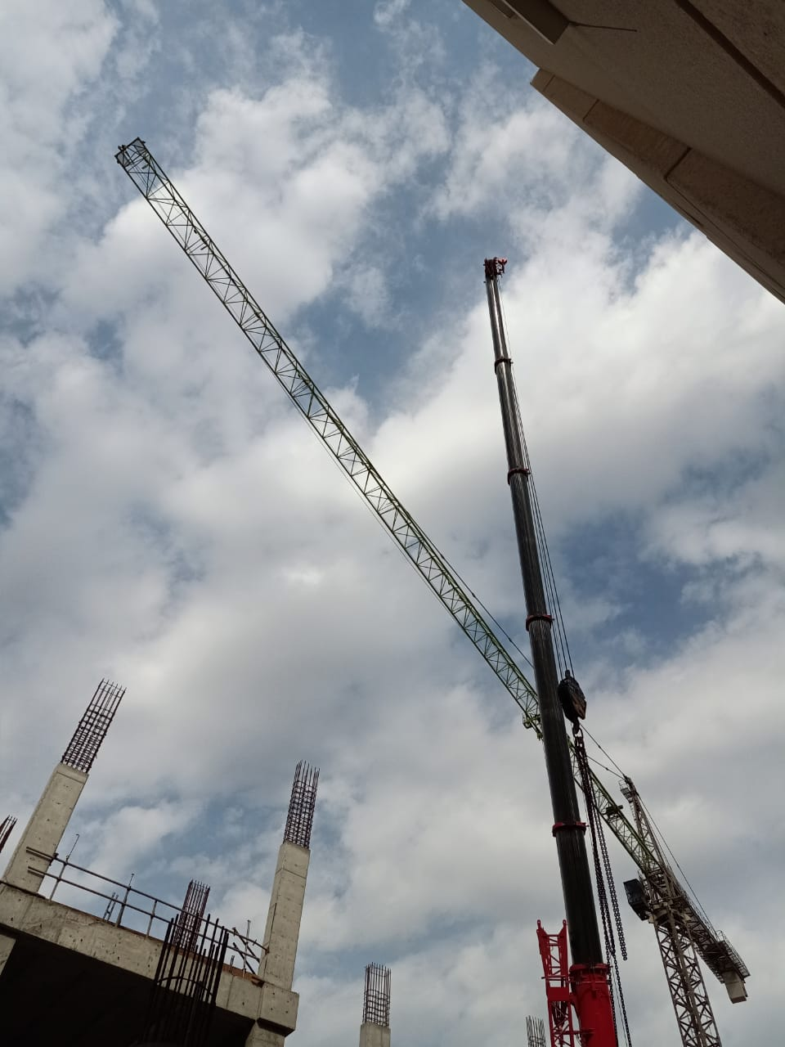

**Previous Incident from April 15, 2020**

