|  |  |  |  |  |  |  |  |  |
| --- | --- | --- | --- | --- | --- | --- | --- | --- |
| **Fill the Information Below** | | | | | | | | |
| Company: **Rezayat Company Limited** | | | | | Date: 6/27/2021 | | | |
| Location: **Area 3 (Central Kitchen )** | | | | | Time: 07:45 AM | | | |
| Project/ Site Name: Catering Auditorium & Recreation Facilities : **097-C76R** | | | | | Worst Potential Severity: 3 Actual Severity: 2 | | | |
| **Person(s) Involved:** | **✓** | **Employee** |  | **Contractor** |  | **Others** | |  |
| 1. Mohammad Hasnain (30040429) | | | 3. | | | | | |
| 2. | | | Other(s). | | | | | |
| **Type of Incident:** | | | | | | | | |
| First Aid Case | | | | | | | | |
| **Injury Location by Body Parts (Select one or more if necessary):** | | | | | | | | |
| Head |  | Chest |  | Hand |  | Eyes |  | |
| Face |  | Leg |  | Arm |  | Hip |  | |
| Neck |  | Abdomen |  | Wrist |  | Ankle/Foot |  | |
| Back |  | Stomach | **✓** | Elbow |  | Knee |  | |
| Nose/ Ears |  | Shoulder |  | Fingers/ Thumb |  | Toes |  | |
| **Type of Injury Sustained (Select one or more if necessary):** | | | | | | | | |
| Fracture |  | Cut/ Laceration |  | Scalping |  | Bruising |  | |
| Loss of Sight |  | Loss of Consciousness |  | Heat |  | Amputation |  | |
| Dislocation |  | Crush Injury |  | Cold |  | Other(s) |  | |
| Abrasion | **✓** | Suffocation |  | Burn |  |  |  | |
| **Immediate Cause(s) (Select one or more if necessary):** | | | | | | | | |
| Safety Rule Violated | **✓** | Lack of Resources |  | Drugs/ Alcohol Related |  | Inadequate Visibility |  | |
| Lack of Task Skill |  | Method Deviation |  | Poor Housekeeping |  | Employee Morale |  | |
| Lack of Supervision | **✓** | Poor Weather Conditions |  | Inadequate Lighting |  | Employee Attitude |  | |
| Improper Lifting (MH) |  | Lack of Task Knowledge |  | Poor Team Work |  | Behavior Problem |  | |
| Not Paying Attention |  | Lack of Communication |  | No Risk Assessment |  | Poor Ground Conditions |  | |
| Human Error |  | Incorrect Tools/Equip |  | Defective Equipment |  | Improper Lifting (crane) |  | |
| Inadequate PPE |  | Defective Tools |  | Unprotected excavation |  | Unprotected Edge |  | |
| Animals |  | Violence |  | Horseplay |  | Improper/ Poor Slinging |  | |
| Heat Stress |  | STF Above Ground |  | STF on the Same Level |  | Manual Handling |  | |
| Misuse of Hand Tools |  | Grinding/ Welding |  | Knives/ Sharps |  | Hit by Vehicle |  | |
| Hit by Static Machinery |  | Heavy Equipment |  | Splashes from C.P.O.L. |  | Other(s) : |  | |
| Stress |  | Fatigue |  | Vandalism |  |  |  | |
| **Equipment(s) Involved:** | | | | | | | | |
| Light Vehicle: |  | Heavy Vehicle: |  | Plant Equipment: |  | Static Plant Equipment: |  | |
| Building: |  | Structure: |  | Scaffold: |  | Excavation: |  | |
| Other(s): **Telehandler** | **✓** | Ladder | **✓** |  |  |  |  | |
| **Description of the Event:** | | | | | | | | |
| IP was unloading CMU blocks from the bucket of telehandler, on the rooftop on central kitchen (inclined roof of sandwich panel). IP was standing on A-type ladder which was supported on the bucket of the telehandler (as shown in the picture). At that time the ladder got slipped and lower portion of the ladder got bended. IP grabbed the bucket and hung onto it and the lower portion of the bucket hit on his stomach. He got abrasion injury as a result. He was taken site’s first aid room to get treatment. | | | | | | | | |
| **Immediate Action(s) Taken to Prevent Reoccurrence (If Any):** | | | | | | | | |
| Incident was investigated.  Instructions were given on the safe use of ladders and manual handling.  Ladder must not rest on the mobile equipment.  Ladder must be hold by someone to prevent fall.  Ladder must be carefully placed on the inclined floor to distribute the load equally towards the bottom of the ladder.  Inspect the ladder for any damage before each use. | | | | | | | | |
| **Person Created the Report:** | | | | | | | | |
| Name: Suraj RajMohan Nair | | Position: Safety Officer | | Signature: Waqas Gilani | | Date: 6/27/2021 | | |
|  | |  | |  | |  | | |

**Injury**

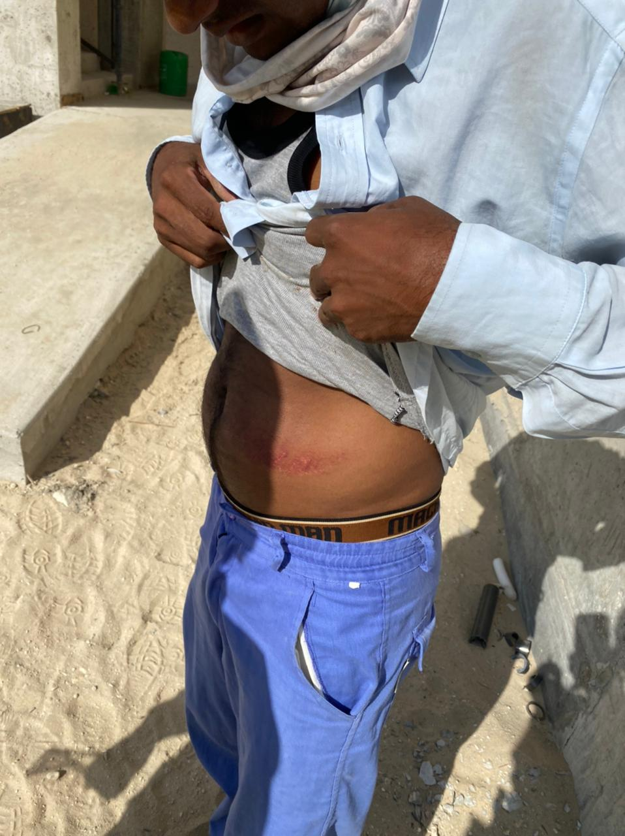

**Scenario of Incident**

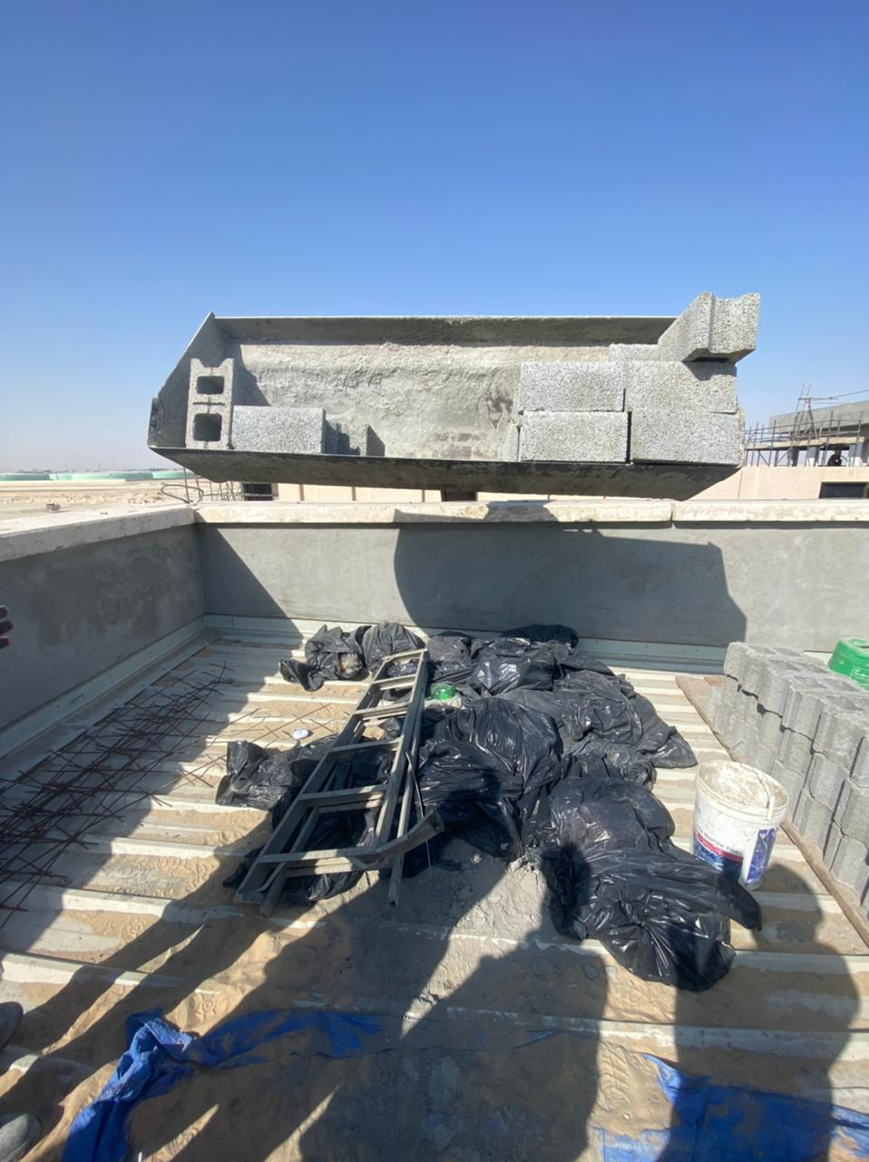

**Ladder got damaged**

