Name of Employee | Guess bahadur |  |  |  |  |  |  | Badge No. |  |  | 30032643 |  |  |  |  |  | Profession/ Designation |  |  |  | Man-lift Operator
Safety Awareness Training Date | 16/01/2019 |  |  |  |  |  |  | Proof of Training |  |  | Induction Register
Name of Line Manager | Engr. Wessam |  |  |  |  |  |  | Badge No. |  |  | 40315
Name of Supervisor | Mehmood |  |  |  |  |  |  | Badge No. |  |  | 31034797
Division / Department | Civil |  |  |  |  |  |  | Project  Name |  |  | 097-C76R |  |  |  |  |  | Project  Location |  |  |  | JUC
Place of the Incident/Injury | Area 3 |  |  |  |  |  |  | Date of  Incident |  |  | 10-10-2020 |  |  |  |  |  | Time of  Incident |  |  |  | 07:15 AM
Nature of the Incident/Injury | Occupational Incident/Injury |  |  |  | Yes |  |  | No |  |  | Near Miss |  |  |  |  |  | Other, Please specify :
Nature of the Incident/Injury | Road Traffic Incident/ Injury |  |  |  | Yes |  |  | No |  |  | Yes |  |  | ✔ | No
Brief Description of the Incident/Injury | During the precast window cleaning and finishing, the man-lift operator moved the man-lift near to the excavation edge, the ground was not well compacted and levelled. The man-lift got stuck in the loose and uneven soil as the soil collapsed slightly towards the excavation. The man-lift became unstable slightly leaning towards the excavation. Civil team attempted to remove the man-lift with forklift, which caused damage to the hydraulic pipe and wheel rim. Hydraulic oil spilled inside the excavation.
Details of the Injury (Specify affected body parts) | N/A
First Aid Given? | Yes |  | No | ✔ |  | Name of First Aider
Name of Hospital where patient was treated/transferred | N/A |  |  |  |  |  |  |  |  |  |  |  | Address/Location of the hospital |  |  |  |  | N/A
Medical leave given by administering Hospital/Clinic or Doctor | Yes |  | No |  |  | Number of Days |  |  |  |  |  | Hospitalization |  |  |  |  |  |  |  | Yes |  |  | No
Property damage | Yes | ✔ | No |  |  | Estimated  percentage of damage |  |  |  |  |  | Estimated Cost of damaged (SAR)
Property Details | Type / Function of the property |  |  |  |  | Manlift |  |  |  |  |  | Location of affected property |  |  |  |  |  |  |  | Hydraulic pipe, Wheel rim
Property Details | Name of Manufacturer |  |  |  |  | TEREX
Property Details | Model of the Property |  |  |  |  | S-45 |  |  |  |  |  |  | Plate Number |  |  |  |  |  | N/A
Property Details | Vehicle Registration  Number |  |  |  |  | N/A |  |  |  |  |  |  | Company Fleet Number |  |  |  |  |  | ML-147

Was Pre- Task / Toolbox meeting conducted |  |  |  | Yes | ✔ | No |  |  | Was the person using required Personal Protective Equipment (PPE) |  |  | Yes |  | ✔ | No
Specify the Personal Protective Equipment (PPE) |  |  |  |  | Safety Shoes, Safety Goggles, Helmet, Vest, Gloves
What was the injured person/employee doing at the time of the incident? |  |  |  |  |  |  | N/A
What was the machine/equipment doing at the time of the incident? |  |  |  |  |  |  | Man-lift was used for the cleaning of precast windows in warehouse building
What was the material/s / substance/s doing at the time of the incident |  |  |  |  |  |  | N/A
Immediate Cause/s of the Incident/injury:

Un-compacted, uneven and loose soil for man-lift movement.
Movement of man-lift near the edge of the excavation.
Root Cause/s of the Incident/injury:

People: Man-lift operator was having valid TUV and license. Man-lift operator and foreman did not assessed the ground condition before activity.

Process / Procedure: Procedure was not followed as the ground compaction was not ensured and the ground was not in good condition to operate the man-lift.

Equipment: Equipment was in good condition.

Workplace: Workplace was not OK as the ground was not compacted and the excavation edges were nor hard barricaded.

Corrective Action to prevent reoccurrence:

Elimination: Avoid work at height.

Substitution: Scaffoldings can be used for such works.

Engineering Control: Excavation edges must be hard barricaded and soil must be well compacted.

Administrative Control: Adequate supervision and communication by the foreman and operator.

PPE: Safety harness must be used for man-lift operation.

Were there any witnesses? | Yes | ✔ | None |  | Type of witness/s |  |  | Employee |  |  | ✔ |  | Public
Witness Details  Wahid Ansari |  |  |  |  |  |  |  | Badge  Number |  | 32643 | Mobile  Number
Witness Statement: Man-lift operator moved equipment without any communication with the foreman and as a result stuck in loose soil.

Initial Investigation Conducted by: Krishna Pillai (SM) | Noted by: Mustafa Ali (PM) | Date | 10-10-2020

Additional Details:
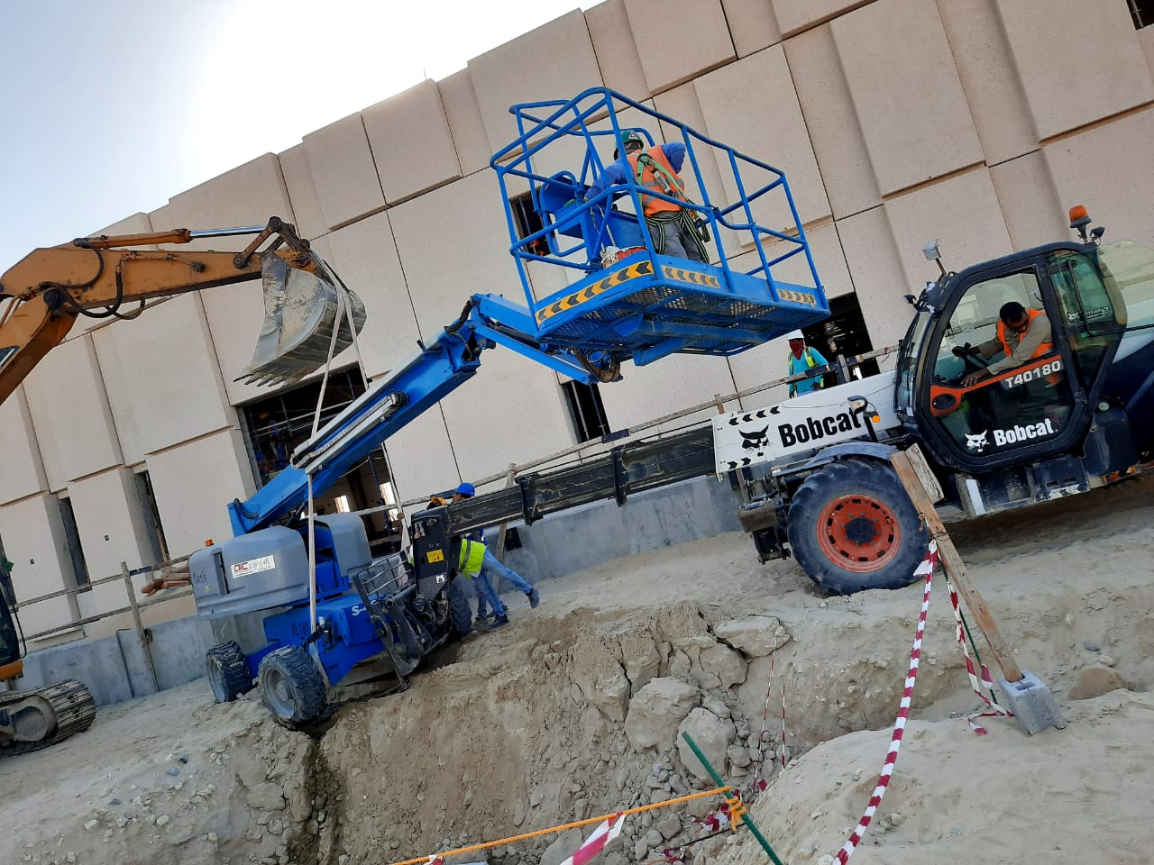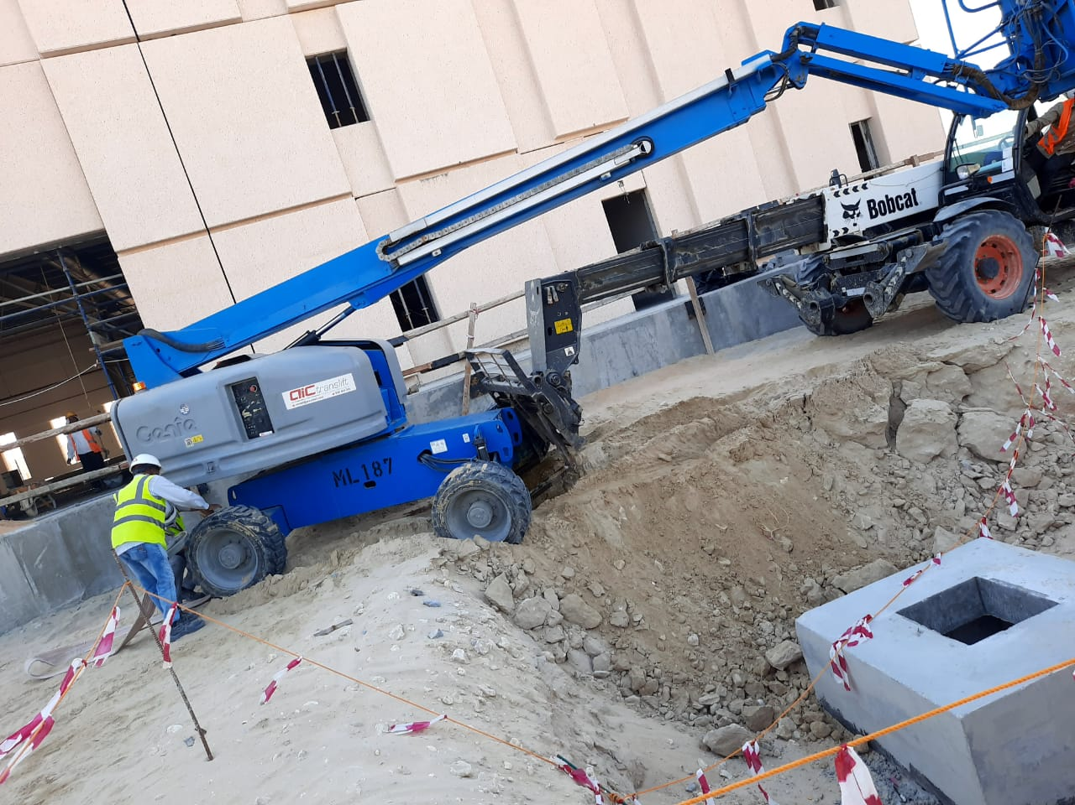

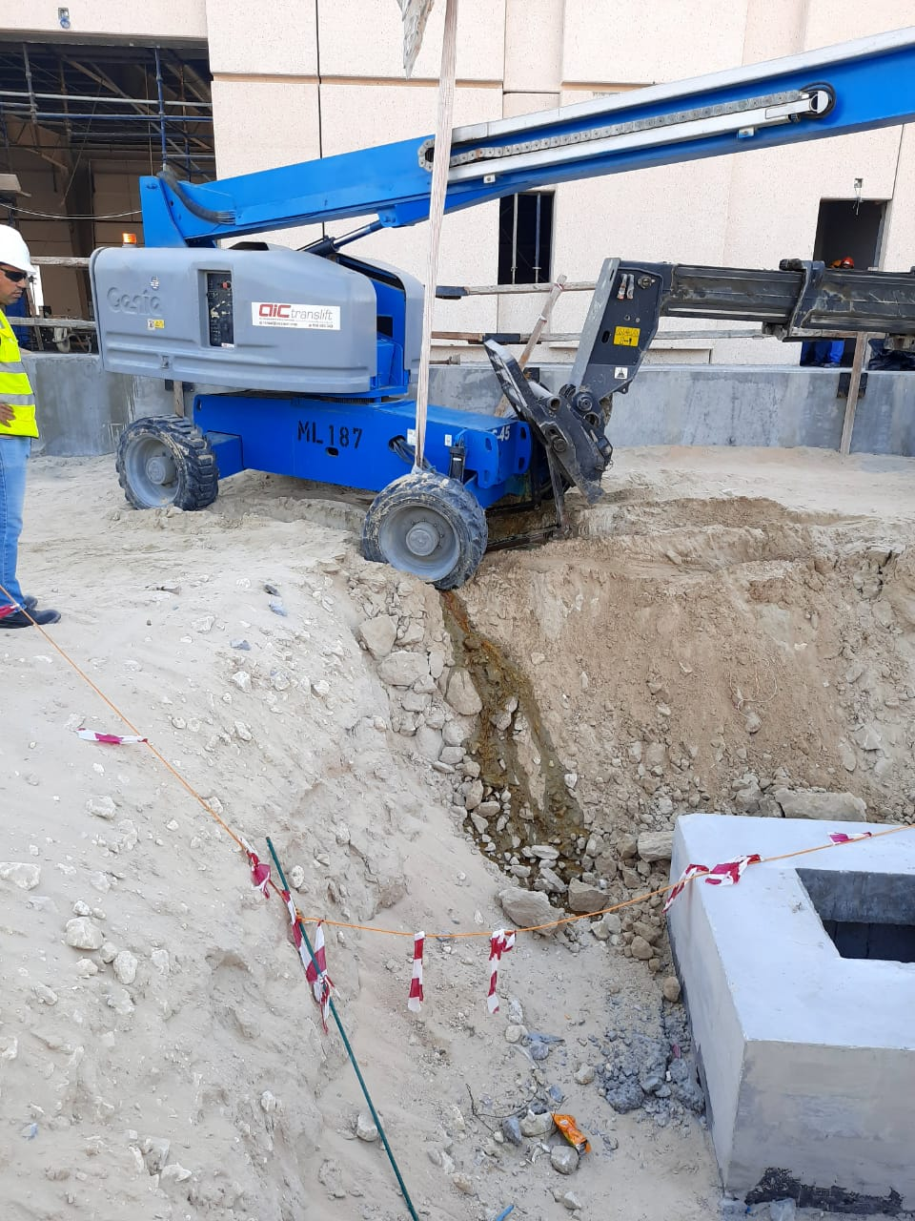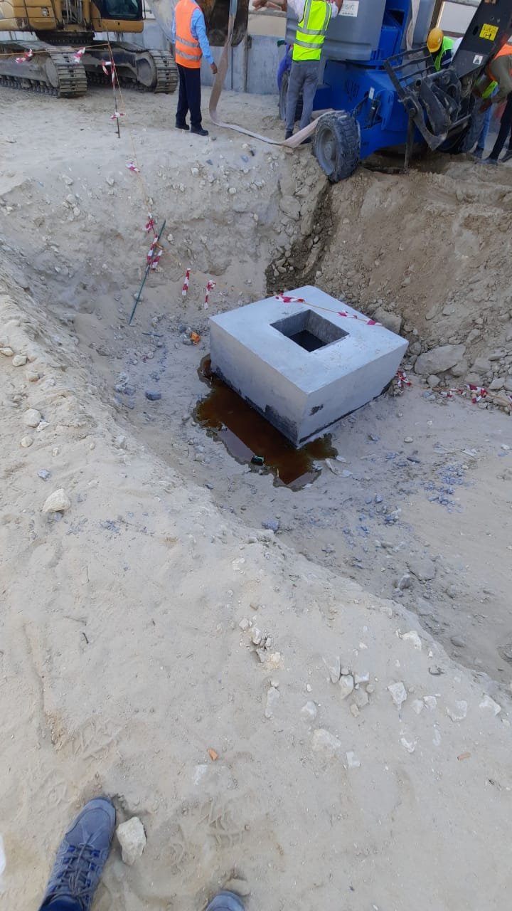

Investigation Report Verified by: | Noted by: | Date

