|  |  |  |  |  |  |  |  |  |
| --- | --- | --- | --- | --- | --- | --- | --- | --- |
| **Fill the Information Below** | | | | | | | | |
| Company:Rezayat co ltd | | | | | Date:11/18/2020 | | | |
| Location:Sadara Plant (Turnn Around area ) | | | | | Time: 09:32am | | | |
| Project/ Site Name: ISOGTA-21 Asphalting project | | | | | Worst Potential Severity:4 Actual Severity:3 | | | |
| **Person(s) Involved:** | **1** | **Employee** |  | **Contractor** |  | **Others** | |  |
| 1. Backhoe Operator | | | 3. | | | | | |
| 2. | | | Other(s). | | | | | |
| **Type of Incident:** | | | | | | | | |
| Ill Health | | | | | | | | |
| **Injury Location by Body Parts(Select one or more if necessary):** | | | | | | | | |
| Head |  | Chest |  | Hand |  | Eyes |  | |
| Face |  | Leg |  | Arm |  | Hip |  | |
| Neck |  | Abdomen |  | Wrist |  | Ankle/Foot |  | |
| Back |  | Stomach |  | Elbow |  | Knee |  | |
| Nose/ Ears |  | Shoulder |  | Fingers/ Thumb |  | Toes |  | |
| **Type of Injury Sustained(Select one or more if necessary):** | | | | | | | | |
| Fracture |  | Cut/ Laceration |  | Scalping |  | Bruising |  | |
| Loss of Sight |  | Loss of Consciousness |  | Heat |  | Amputation |  | |
| Dislocation |  | Crush Injury |  | Cold |  | Other(s) |  | |
| Abrasion |  | Suffocation |  | Burn |  |  |  | |
| **Immediate Cause(s) (Select one or more if necessary):** | | | | | | | | |
| Safety Rule Violated |  | Lack of Resources |  | Drugs/ Alcohol Related |  | Inadequate Visibility |  | |
| Lack of Task Skill |  | Method Deviation |  | Poor Housekeeping |  | Employee Morale |  | |
| Lack of Supervision |  | Poor Weather Conditions | **🗸** | Inadequate Lighting |  | Employee Attitude |  | |
| Improper Lifting (MH) |  | Lack of Task Knowledge |  | Poor Team Work |  | Behavior Problem |  | |
| Not Paying Attention |  | Lack of Communication |  | No Risk Assessment |  | Poor Ground Conditions |  | |
| Human Error |  | Incorrect Tools/Equip |  | Defective Equipment |  | Improper Lifting (crane) |  | |
| Inadequate PPE |  | Defective Tools |  | Unprotected excavation |  | Unprotected Edge |  | |
| Animals |  | Violence |  | Horseplay |  | Improper/ Poor Slinging |  | |
| Heat Stress |  | STF Above Ground |  | STF on the Same Level |  | Manual Handling |  | |
| Misuse of Hand Tools |  | Grinding/ Welding |  | Knives/ Sharps |  | Hit by Vehicle |  | |
| Hit by Static Machinery |  | Heavy Equipment | **🗸** | Splashes from C.P.O.L. |  | Other(s) : | **🗸** | |
| Stress |  | Fatigue |  | Vandalism |  |  |  | |
| **Equipment(s) Involved:** | | | | | | | | |
| Light Vehicle: |  | Heavy Vehicle: |  | Plant Equipment: | **🗸** | Static Plant Equipment: |  | |
| Building: |  | Structure: |  | Scaffold: |  | Excavation: |  | |
| Other(s): |  |  |  |  |  |  |  | |
| **Description of the Event:** | | | | | | | | |
| At 18-Nov-2020 around 09:32, am our RCL operator name Abid Hossain Badge # 31035830 was operating the Backhoe with plate# 4567 AAA. And was going to gate # 7 from Turn around area but while going to gate #7 suddenly wind speed become high and because of high wind speed left side window closed with high impact and due to this high impact window mirror broken. | | | | | | | | |
| **Immediate Action(s) Taken to Prevent Reoccurrence (If Any):** | | | | | | | | |
| * Operator informed to rcl safety and stopped backhoe * Project manager has been informed about this * Operator was suggested to park the backhoe rcl lay down until further notice * Operator was suggested not open window during operating backhoe | | | | | | | | |
| **Person Created the Report:** | | | | | | | | |
| Name: Muhammad Abubakar | | Position: Safety Office | | Signature: | | Date:11/18/2020 | | |
|  | |  | |  | |  | | |

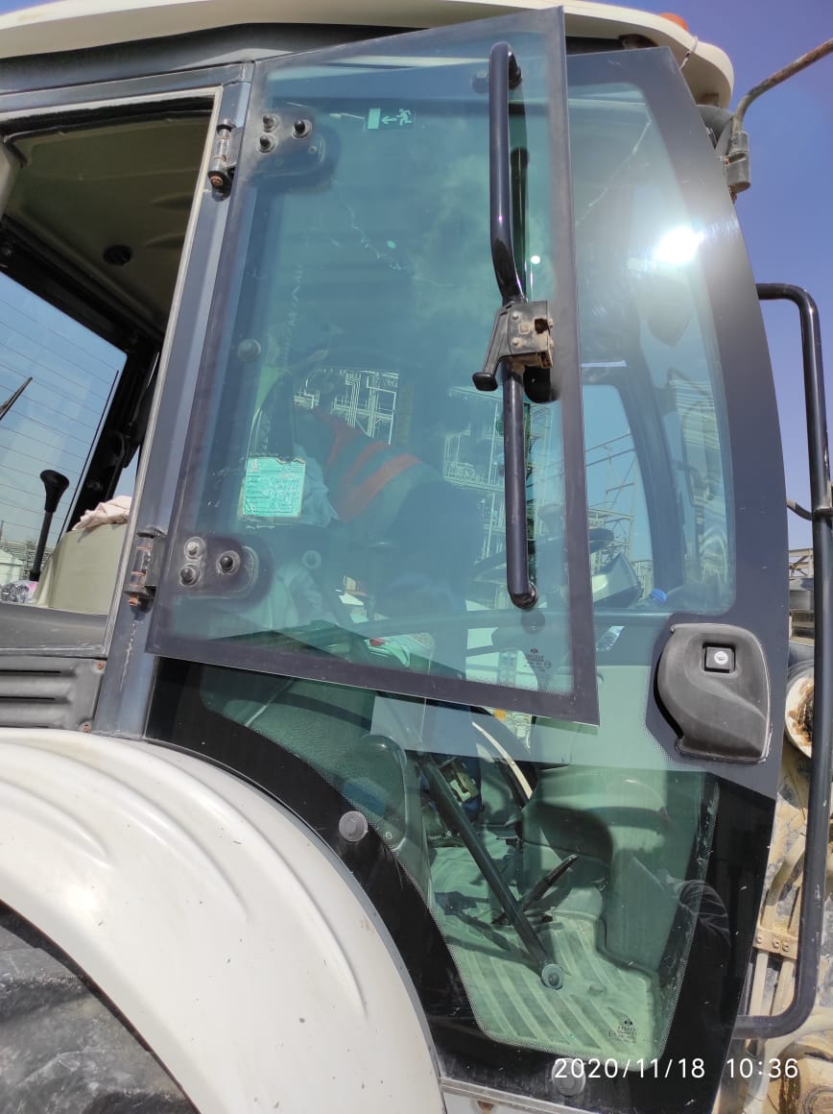Additional information:

As per Manufacturer 1

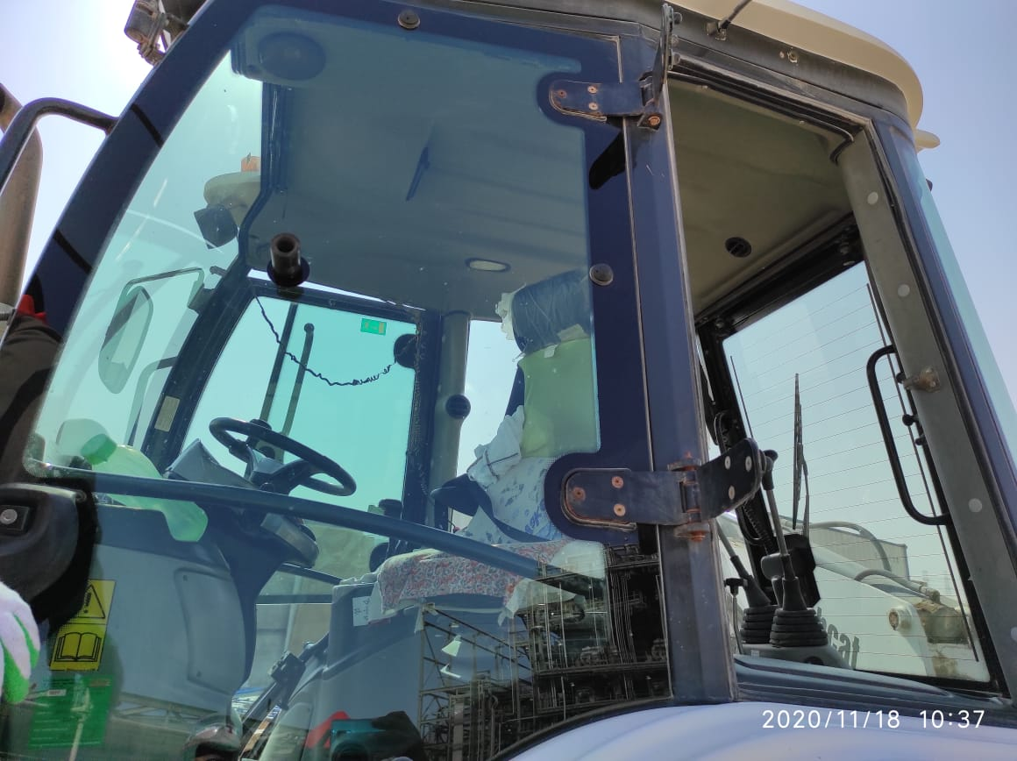

After Incident