|  |  |  |  |  |  |  |  |  |  |  |  |  |  |  |
| --- | --- | --- | --- | --- | --- | --- | --- | --- | --- | --- | --- | --- | --- | --- |
| **Name of Employee** | MOUKTHAR HAMED | | | **Badge No.** | | **30036474** | | | | | | | **Actual**  **Severity:** | 2 |
| **Safety Awareness Training Date** | 11/24/2020 | | | **Proof of Training** | | **Yes** | | | | | | | **Worst Potential**  **Severity:** | 2 |
| **Name of Line Manager** | MOHAMED HASSAN GALAL | | | **Badge No.** | | 30040416 | | | **Profession/ Designation** | | | | **Engineer -III Civil Const** | |
| **Name of Supervisor** | MOHAMMED NAVEED PASHA | | | **Badge No.** | | 31031389 | | | | | | | | |
| **Division / Department** | Construction | | | **Project**  **Name** | | Corrosion Repair & Protective Works | | | **Project**  **Location** | | | | RC YANBU | |
| **Place of the Incident/Injury** | RC Housing Area | | | **Date of**  **Incident** | | 11/24/2020 | | | **Time of**  **Incident** | | | | 10.00am | |
| **Nature of the Incident/Injury** | **Occupational Incident/Injury** | Yes | | | | **FIRST AID** | | | **Other, Please specify:** | | | | | |
| **Road Traffic Incident/ Injury** | No | | | | No | | |
| **Brief Description of the Incident/Injury** | Mr.Moukthar Hamed was assigned for removing the debris from excavated area(50cm depth) after the demolition work adjacent to the building side wall. While removing the debris using shovel, his left-hand thumb finger was hits nearby corroded sharp steel from the demolished structure resulted with small cut on his thumb finger. Immediately First Aid was given from the camp clinic. | | | | | | | | | | | | | |
| **Details of the Injury (Specify affected body parts)** | **THUMB FINGER (Left Hand)** | | | | | | | | | | | | | |
| **First Aid Given?** | Yes | | **Name of First Aider** | | | | | KRISHNA MOHAN GUPTA | | | | | | |
| **Name of Hospital where patient was treated/transferred** | NO | | | | | | | **Address/Location of the hospital** | | NO | | | | |
| **Medical leave given by administering Hospital/Clinic or Doctor** | No | | **Number of Days** | | N/A | | **Hospitalization** | | | | | No | | |
| **Property damage** | No | | **Estimated**  **percentage of damage** | |  | | **Estimated Cost of damaged (SAR)** | | | | |  | | |
| **Property Details** | **Type / Function of the property** | |  | | | | **Location of affected property** | | | | |  | | |
| **Name of Manufacturer** | |  | | | | | | | | | | | |
| **Model of the Property** | |  | | | | | **Plate Number** | | |  | | | |
| **Vehicle Registration**  **Number** | |  | | | | | **Company Fleet Number** | | |  | | | |

|  |  |  |  |  |  |  |  |  |  |  |  |
| --- | --- | --- | --- | --- | --- | --- | --- | --- | --- | --- | --- |
| **Was Pre- Task / Toolbox meeting conducted** | | Yes | | | | **Was the person using required Personal Protective Equipment (PPE)** | | | Yes | | |
| **Specify the Personal Protective Equipment (PPE)** | | | Hand Gloves (Cotton) | | | | | | | | |
| **What was the injured person/employee doing at the time of the incident?** | | | | Removing the debris from the excavation. | | | | | | | |
| **What was the machine/equipment doing at the time of the incident?** | | | |  | | | | | | | |
| **What was the material/s / substance/s doing at the time of the incident** | | | |  | | | | | | | |
| **Immediate Cause/s of the Incident/injury:**   * **Not pay Attention** * **Knives/Sharp- edged steels** | | | | | | | | | | | |
| **Root Cause/s of the Incident/injury:** | **People**: Fail to notice the sharp steel from the adjacent demolished structure | | | | | | | | | | |
| **Process / Procedure:** Fail to cut the corroded steels once demolition work completed. | | | | | | | | | | |
| **Equipment:** Poor Quality of gloves used at work site | | | | | | | | | | |
| **Workplace: N/A** | | | | | | | | | | |
| **Corrective Action to prevent reoccurrence:** | **Elimination:** Instructed to cut (eliminate the hazard) the corroded steels once demolition work completed | | | | | | | | | | |
| **Substitution: N/A** | | | | | | | | | | |
| **Engineering Control: N/A** | | | | | | | | | | |
| **Administrative Control:** Refresher training on pre- inspection of Workplace hazards before start of job. | | | | | | | | | | |
| **PPE:**  Quality of gloves need to be changed where it is addressed to management to change from cotton gloves to rubber coated gloves. | | | | | | | | | | |
| **Were there any witnesses?** | Yes | | **Type of witness/s** | | **Employee** | | | YES | | **Public** |  |
| **Witness Details :**  IKBAL KAZI YAKUB | | | | | **Badge**  **Number** | | 30038574 | **Mobile**  **Number** | | 0571298875 | |
| **Witness Statement:** When I demolished the structure wall andMoukhtar was started to remove the debris from the excavated area using shovel where his left-hand thumb finger strikes the steel and getinjured. | | | | | | | | | | | |

|  |  |  |  |
| --- | --- | --- | --- |
| **Initial Investigation Conducted by:**  **Ejaz Akthar** | **Noted by:**  **Rejenson Fernando** | **Date** | 11/28/2020 |

**Additional Details:**

**PHOTOS FOR REFERENCE**

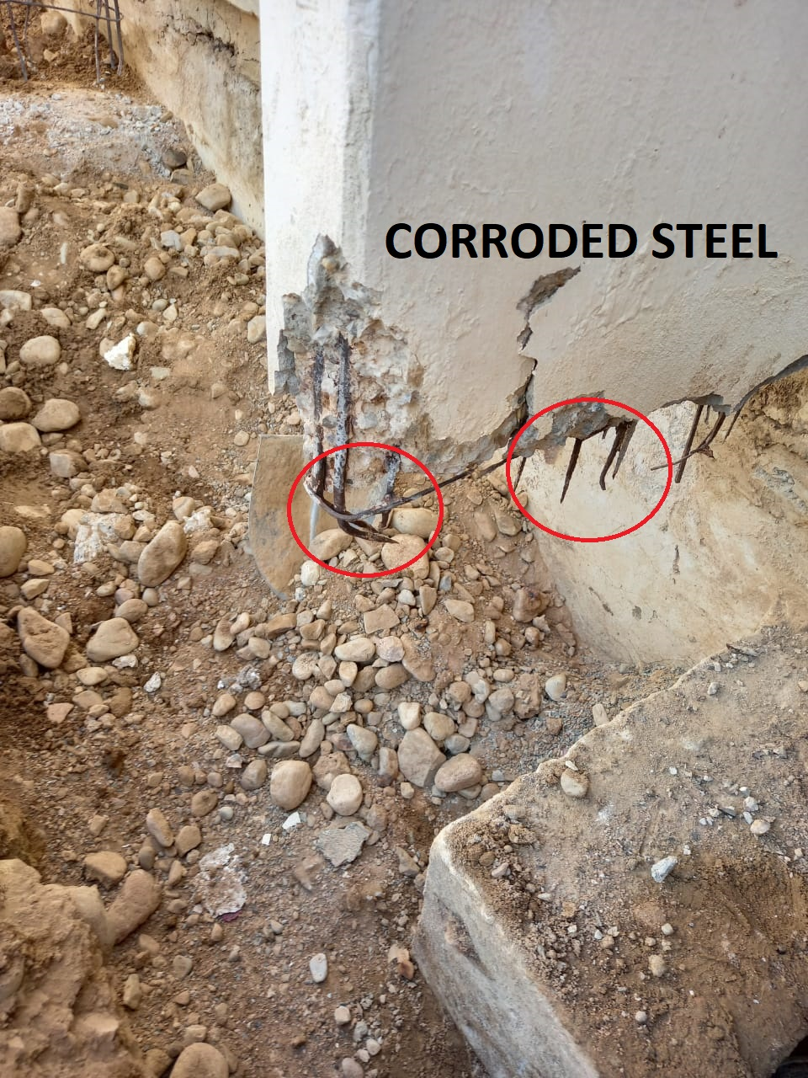 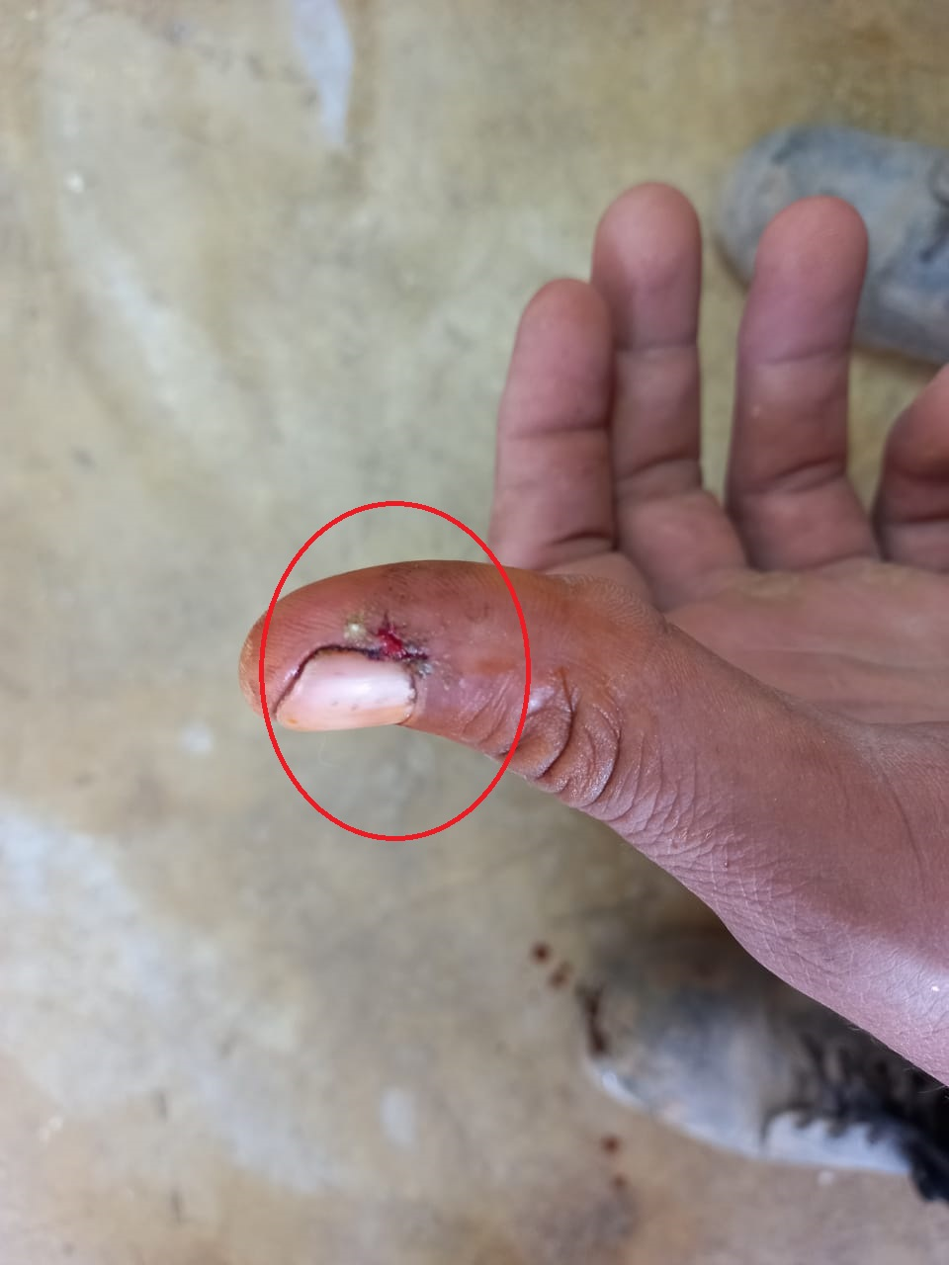

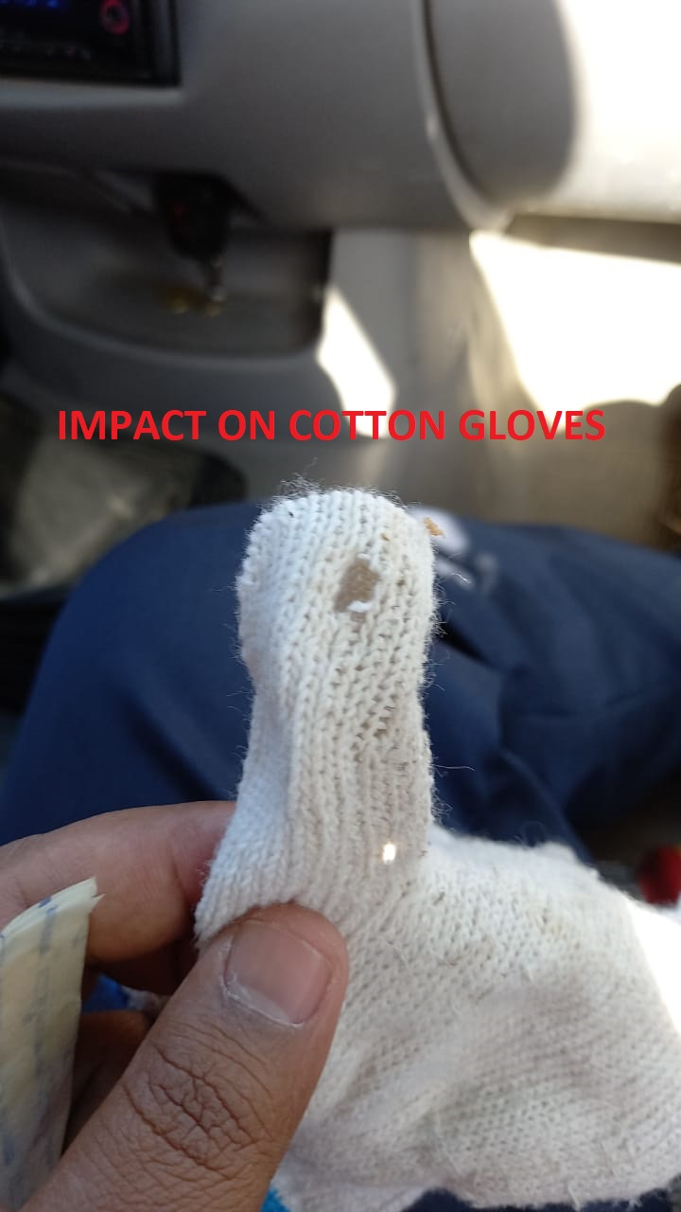 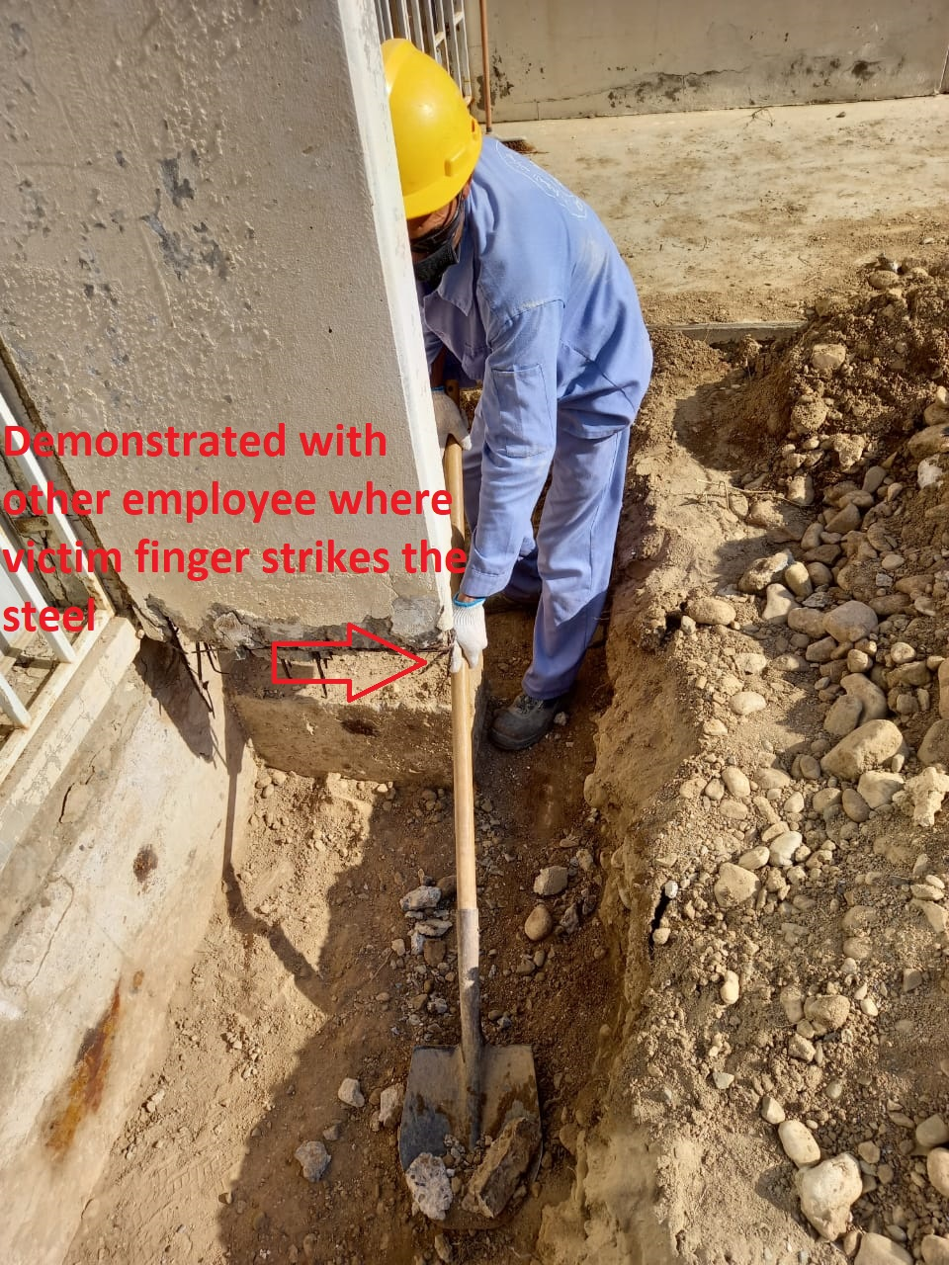

|  |  |  |  |
| --- | --- | --- | --- |
| **Investigation Report Verified by:**  **Mohammad Galal** | **Noted by:** | **Date** | **11/29/2020** |